Logo Design

It was established in our wireframes that we wanted a logo to be present in the top-left of the page. This document details the design process of the logo.

Firstly, a mind-map was constricted to throw out some ideas.

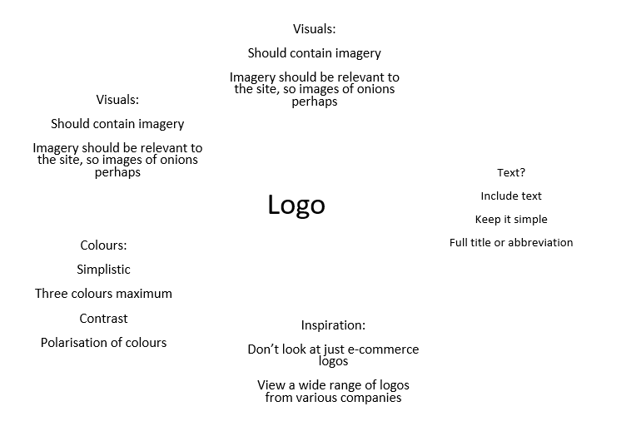

The first logo we designed was this:

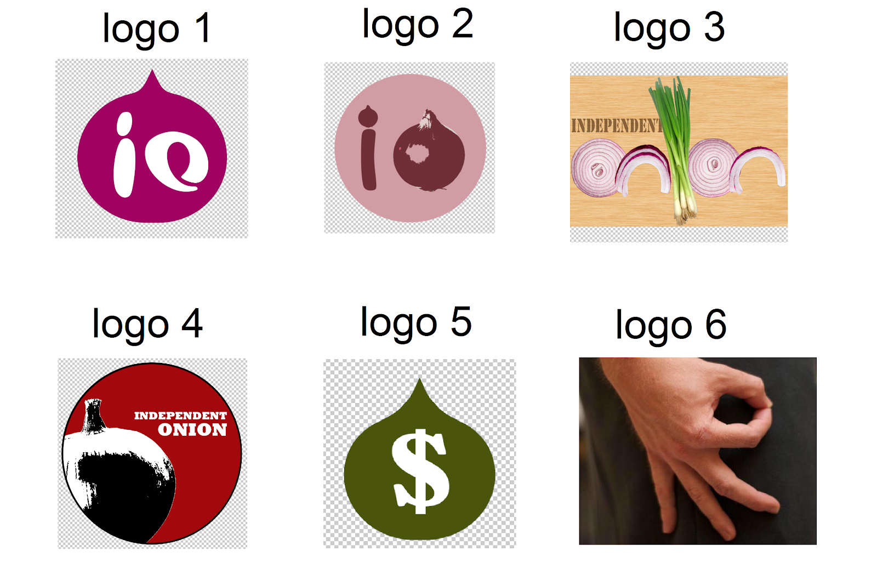

A fairly simple logo inspired by the ‘Beats’ logo. The logo was intended to be simplistic, but we felt that this was too much so.

Then we created this:



Strongly inspired by the ‘Bitcoin’ Logo. We felt that this logo diverted from the website’s purpose due to the dollar sign. The ‘Independent Onion’ brand is more about the passion of the onion rather than money. The use of the dollar sign was also geographically dysfunctional.

Then we began incorparating more imagery into the logo design.



The ‘Pixar’ logo uses a lamp as the letter ‘I’, we mimicked this by using an onion in place of the letter ‘o’. This logo was a step in the right direction. We liked the circular nature of the logo.

This is the logo that we finally settled on:



The colour scheme is taken from the ‘KFC’ logo, though red seems to be commonly used across many brands associated with food. Red has also has cultural connotations that include love, and as the site is aimed at those who love onions we felt that it was appropriate. We especially liked the polarisation of black and white. There was also a layman’s attempt at intertwining photography techniques such as ‘rule of three’ and the Fibonacci spiral.

The logo was then added to the website banner.

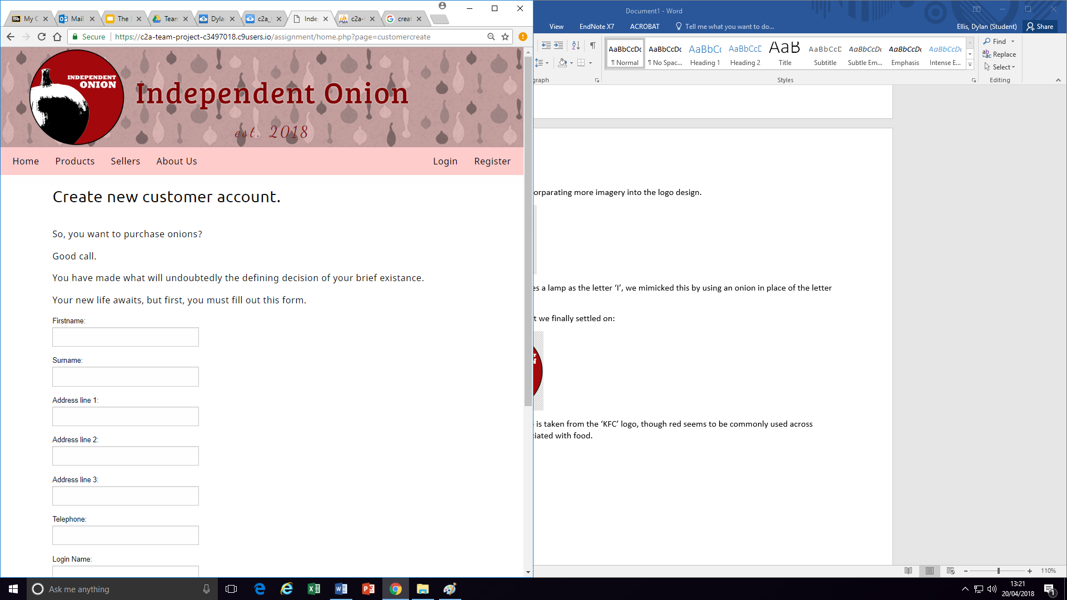

Convention dictates that the logo can be clicked and link to the home page, and so we incorporated this feature.