Mock-ups

This document contains every mock-up that we designed. These will be presented alongside the finished page for comparison.

We created mock-ups for the following pages:

* Home page
* Product Page (general design reused in seller page)
* Product Information/Purchase page
* Seller Information Page
* Admin Page

Other pages were simplistic in the way of design, so we didn’t feel that it was necessary.

Some of these mock-ups were derived from our initial wireframes, which are in the ‘Wireframes’ folder of our documentation.

We felt that it was important to create these mock-ups before building the actual site for the following reasons:

* To get a more accurate perception of the site’s aesthetic
* To adjust the website’s appearance if necessary (it’s easier to change a mock-up than to change the live site)
* A continuation of the above point, to save time

Some notes before you commence to read this document:

* The finished page will be displayed on the left, with the mock-up on the right
* The page that is referred to will be written in the top-left of the page
* The mock-ups show colour where we felt that it was necessary to better gauge the aesthetic. These colours are not always representative of the final build.
* This is not always the case, but most images are represented with this icon:



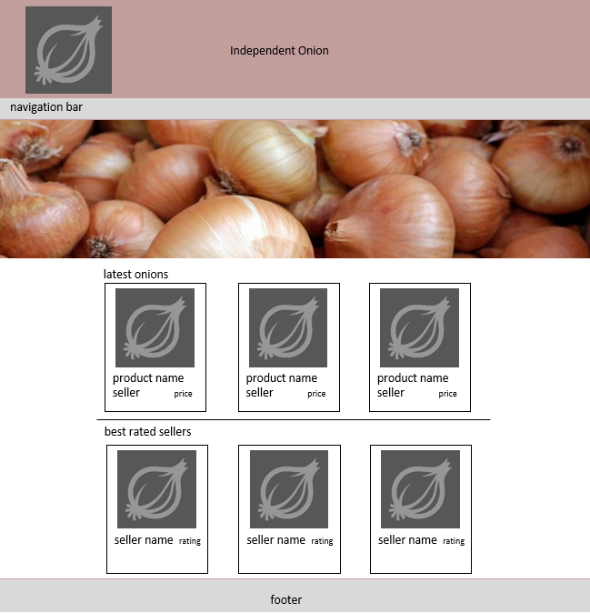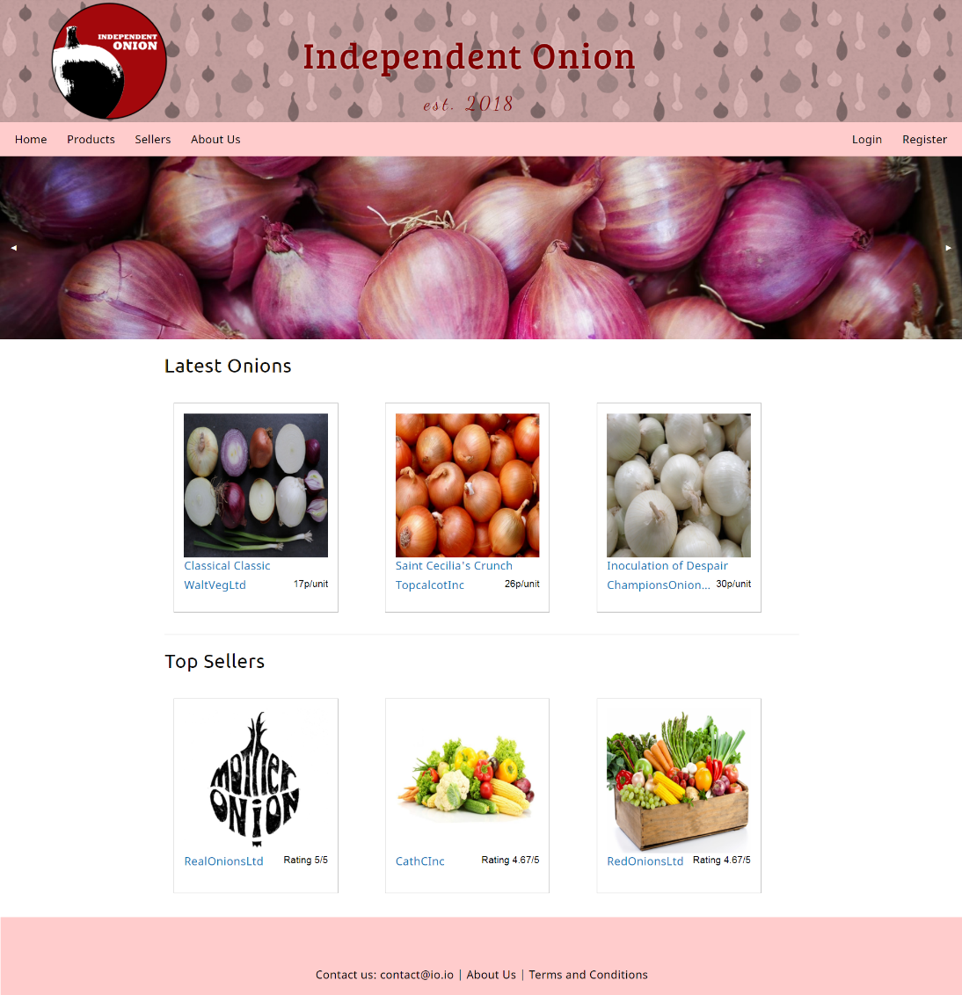Home page

Notes:

Image carousel is slightly smaller in the actual website when compared to the mock-up. When we made it a comparable size to that of the mock-up it was far too large.

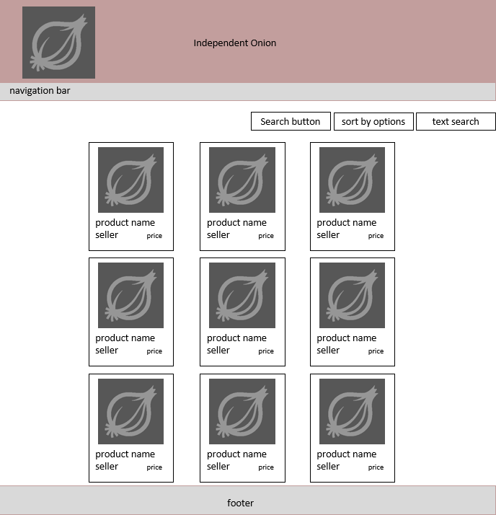Product Page

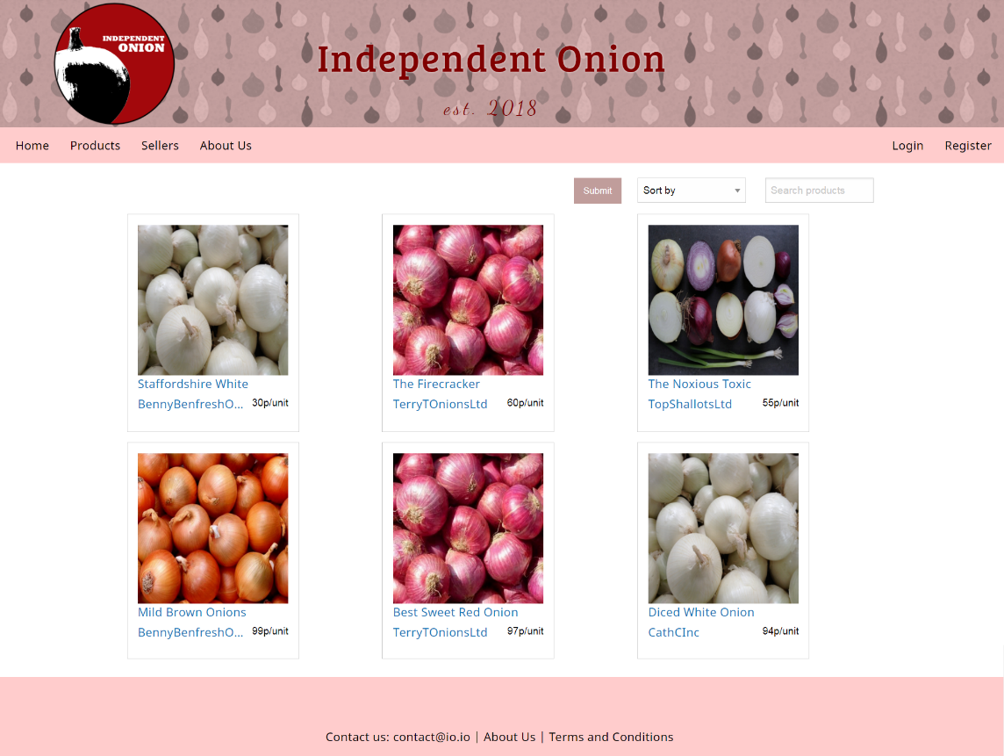

Notes:

Some products were cropped out on the left screenshot to restrict the size. Also, the seller page replicates this look, so this doubles up as a seller page mock-up.

Product Information/Purchase Page

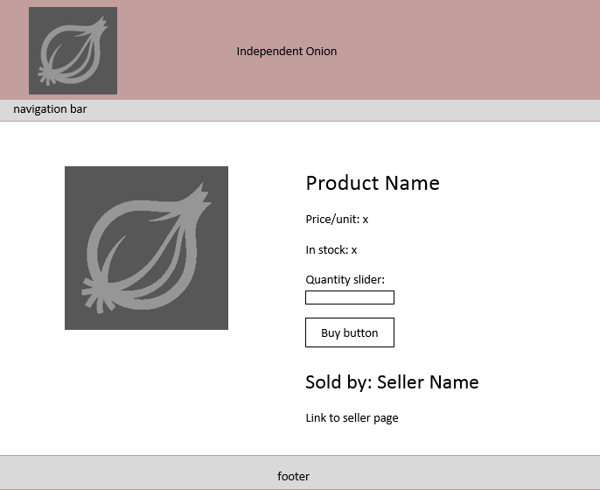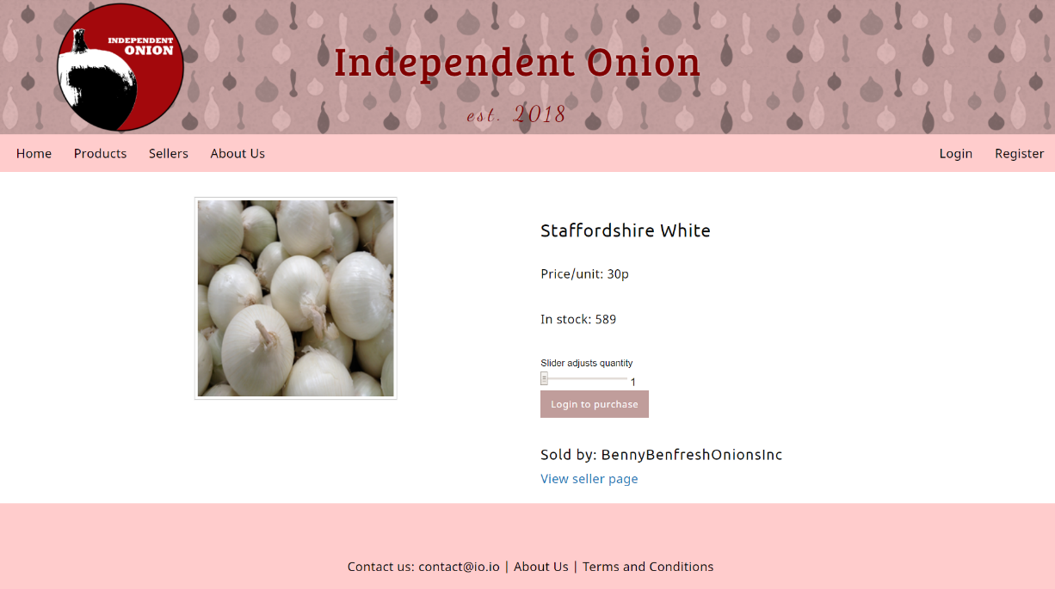

Notes:

The text was scaled down when implementing the mock-up into the actual site.

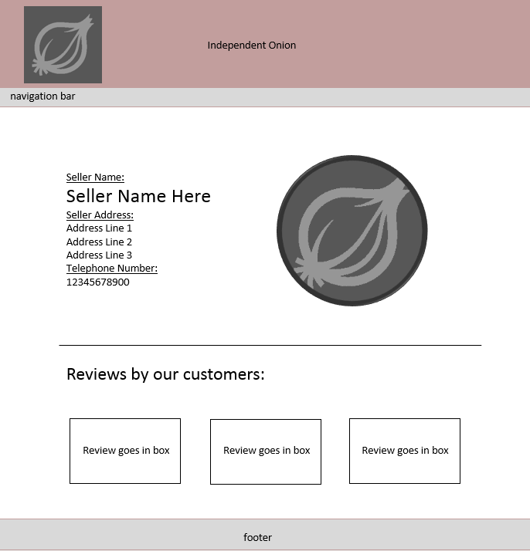Seller Information Page

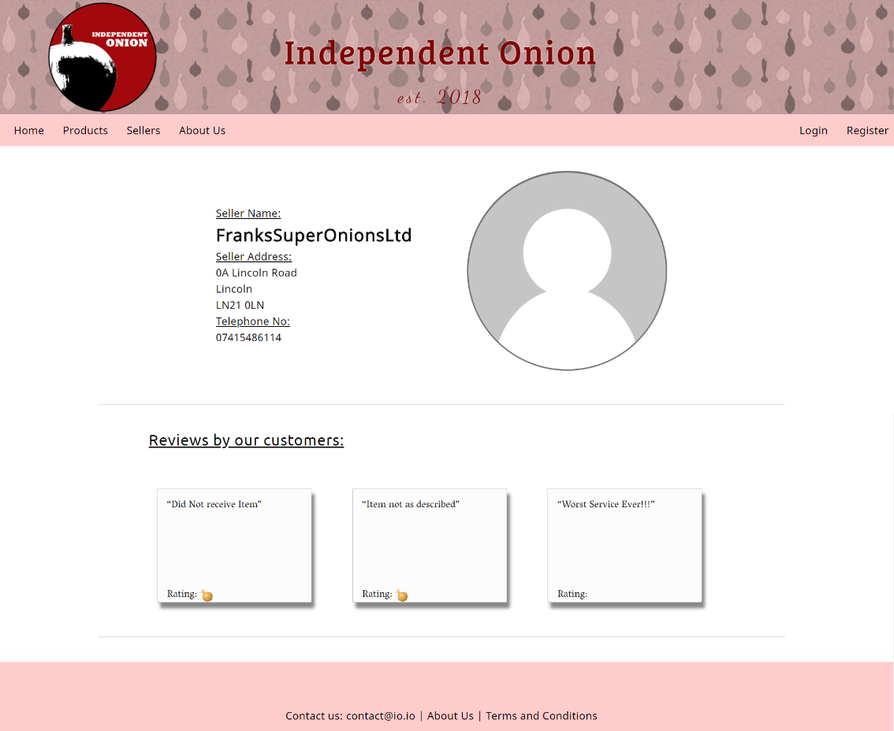

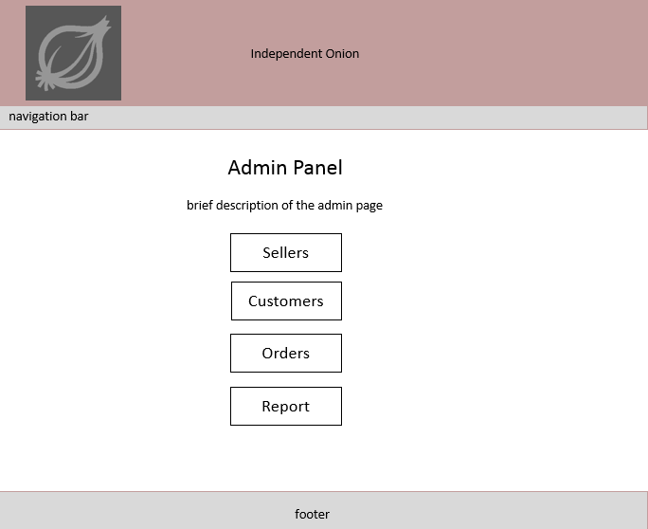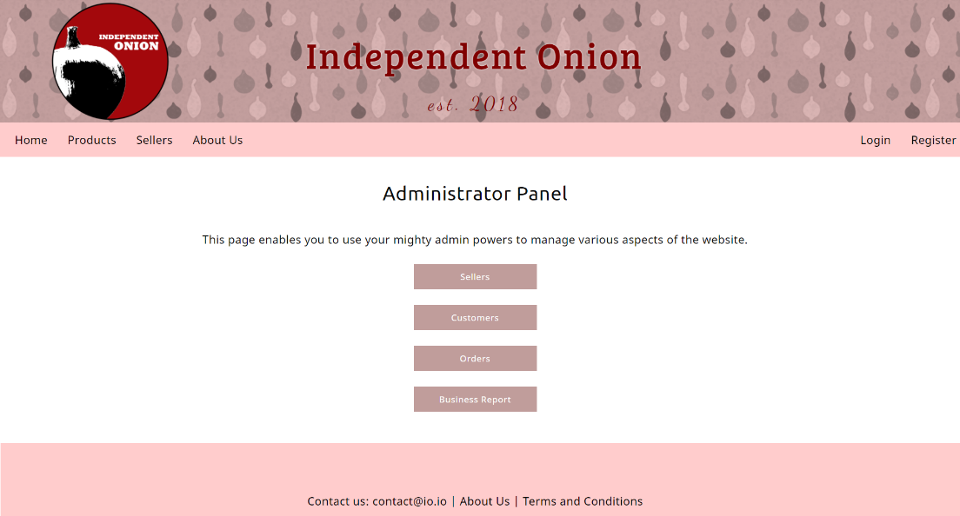Admin Page:

Notes:

The position of the page contents is not in the centre in the mock-up. This was unintentional and was fixed in the site.