**Team C2A – Product Key Features**

**Description**: An ecommerce website titled “Independent Onion” designed to offer an open market place for artisan onion producers to sell their specialised produce directly to their consumers.

This document serves to demonstrate the key features of our website (deployed on the student server using an Oracle database), displaying a screenshot for each feature with a bulleted list below each, offering more detail.

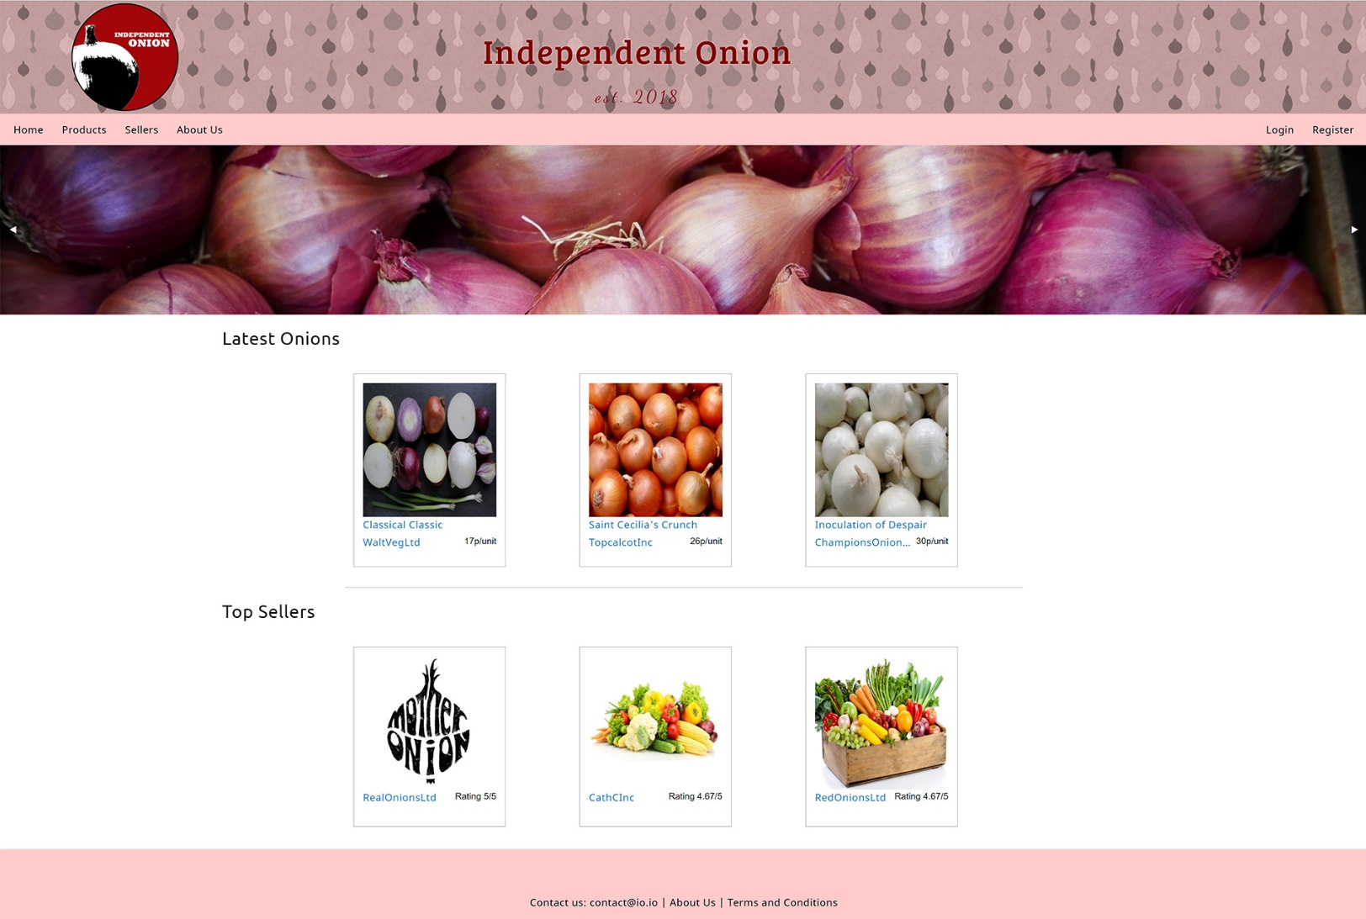

Homepage:

* Website built using the Foundation framework.
* Orbit slider to display onion/agriculture images.
* Foundation Equalizer cards used for layout of “Latest Onions” and “Top Sellers” output.
* Both “Latest Onions” and “Top Sellers” cards pull from the Oracle database dynamically, calculating the three necessary outputs for each section, be it by registration date or a calculation of current three highest average review scores.
* Each card pulls the relevant image from the server and offers links to the product and seller.
* All pages display between the nav bar and footer using the get array and nested if statements to include the relevant content.

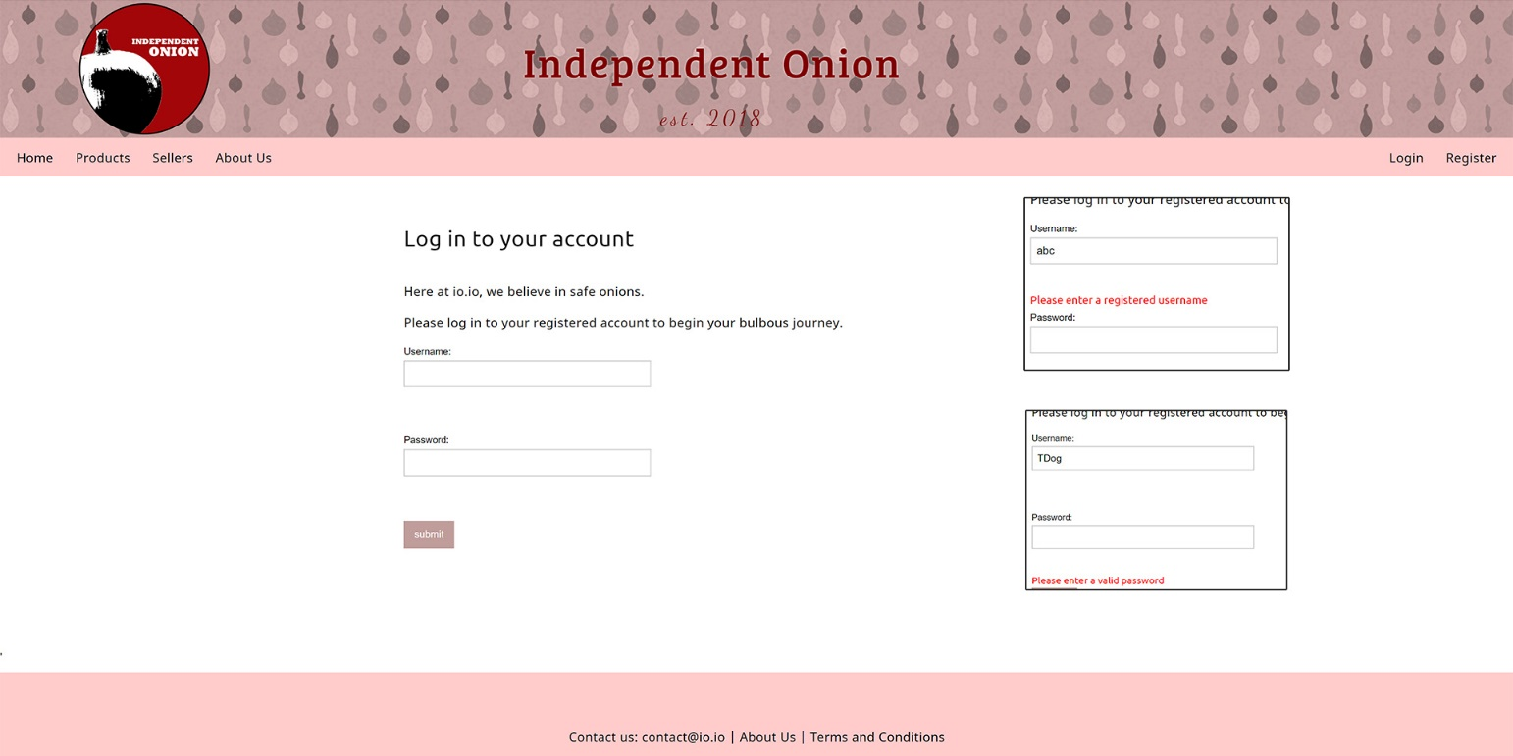

Login page:

* Checks username and password against the database (case sensitive), giving the user feedback on their submission as shown in the inset images on the right.
* Passwords are encrypted using the hash (sha1) and salt method.
* The page logic understands the difference between a customer, seller or admin account and redirects the user to the relevant protected page accordingly.

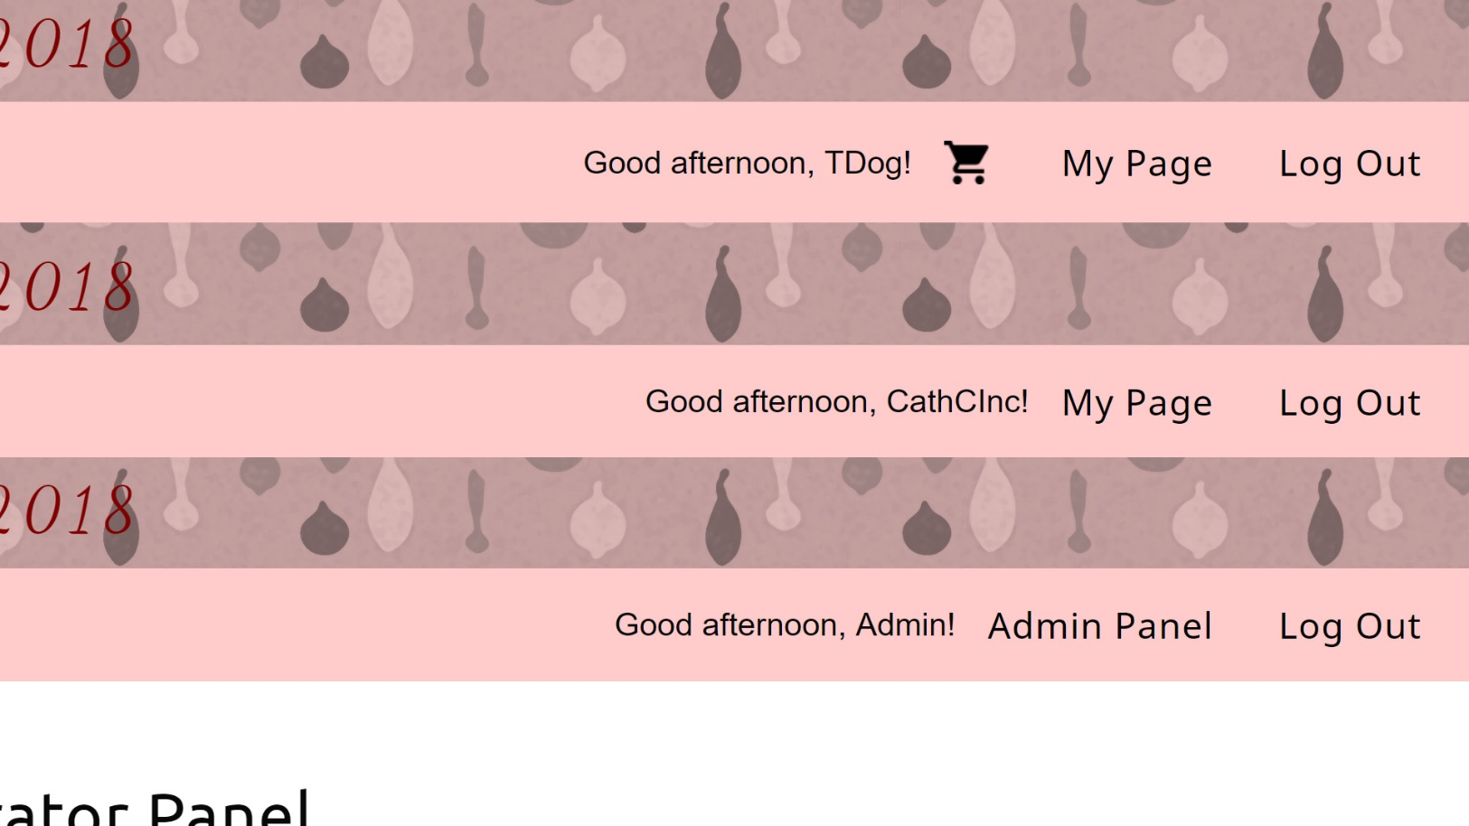

Responsive Nav Bar:

* The above overlaid images show the variations in the nav bar once an account has been successfully logged in.
* The top iteration is a successful customer login with time-sensitive welcome message, user name, shopping basket link, link to their customer home page and a logout link.
* The second iteration is a successful seller login with time-sensitive welcome message, seller company name and a link to their seller home page and a logout link.
* The third iteration is a successful admin account login with time-sensitive welcome message, registered admin name, link to the admin panel and a logout link.

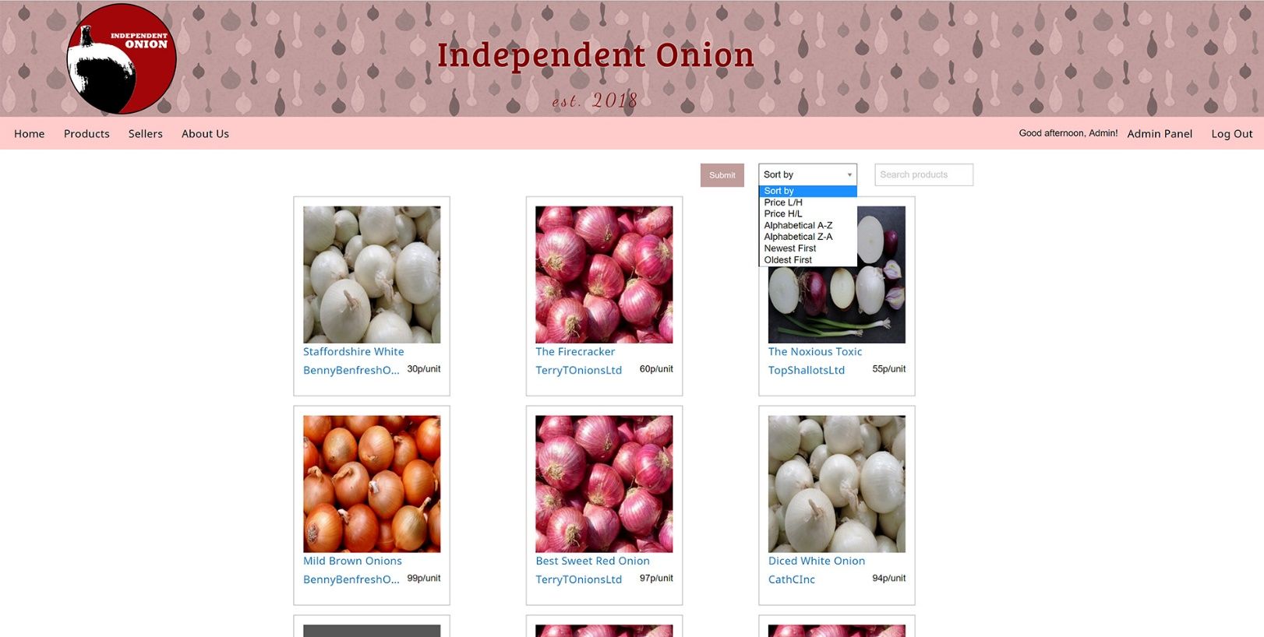

Products Page:

* Product cards generated from database, sql pulls image link, name, seller name and price per unit.
* Each card links to an individual product page and a seller information screen.
* Search functionality searches by category from the dropdown, by text entered into the text box, or by a combination of both.

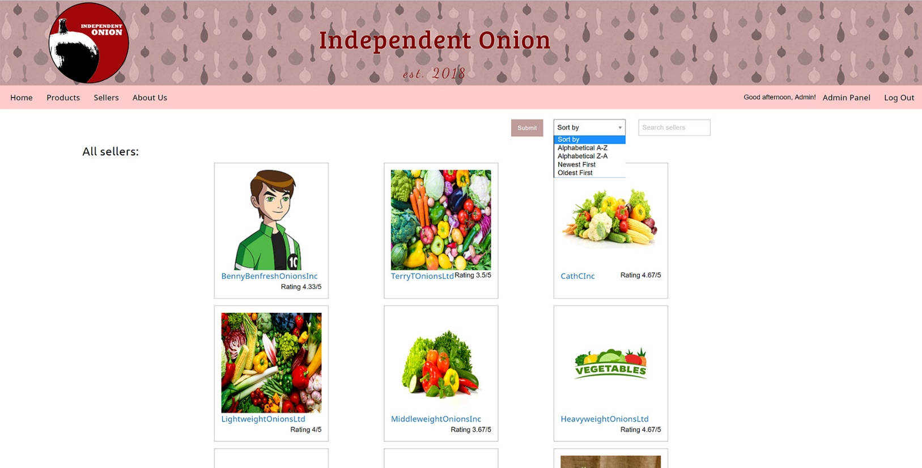

Sellers page:

* Seller cards generated from database, sql pulls image link, company name and calculated average review score.
* Each card links to an individual seller information screen.
* Search functionality searches by category from the dropdown, by text entered into the text box, or by a combination of both.

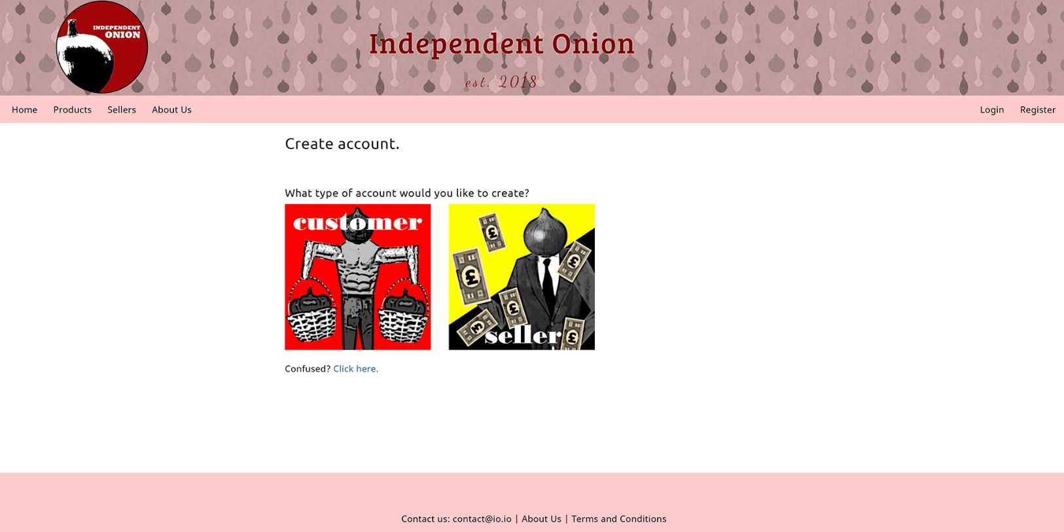

Registration Hub:

* Two types of account are available to users, offering different registration criteria.
* This page also has a pop-up help screen.

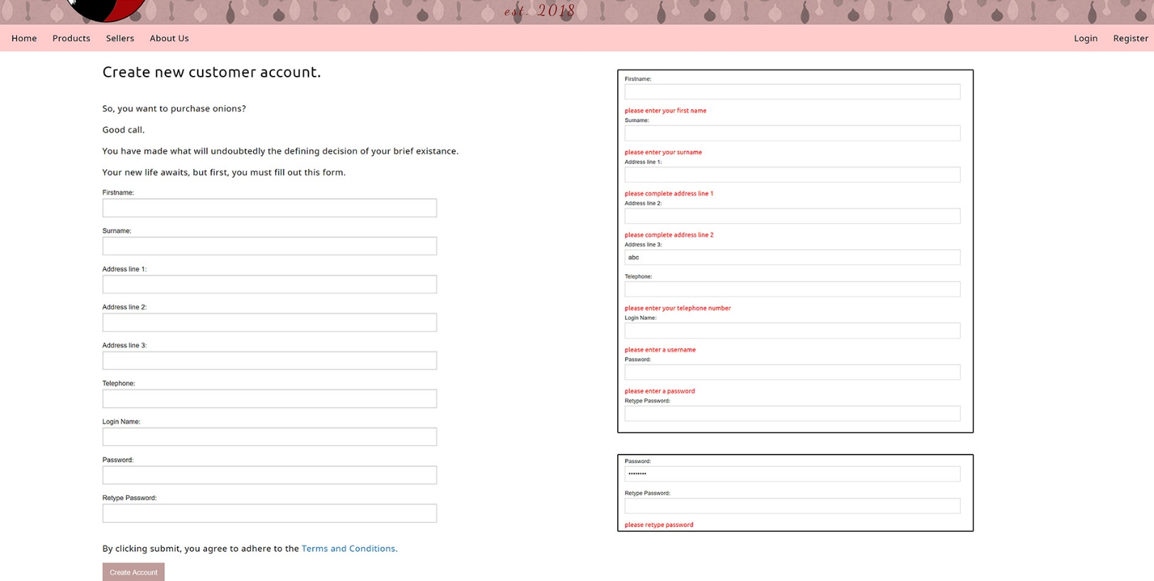

Customer Registration:

* Registration form to create new customer record in the database.
* The form offers user feedback as shown in the top inset image, and requests password to be entered twice and offers feedback, as shown in bottom inset image.
* Passwords are encrypted with hash (sha1) and salt.

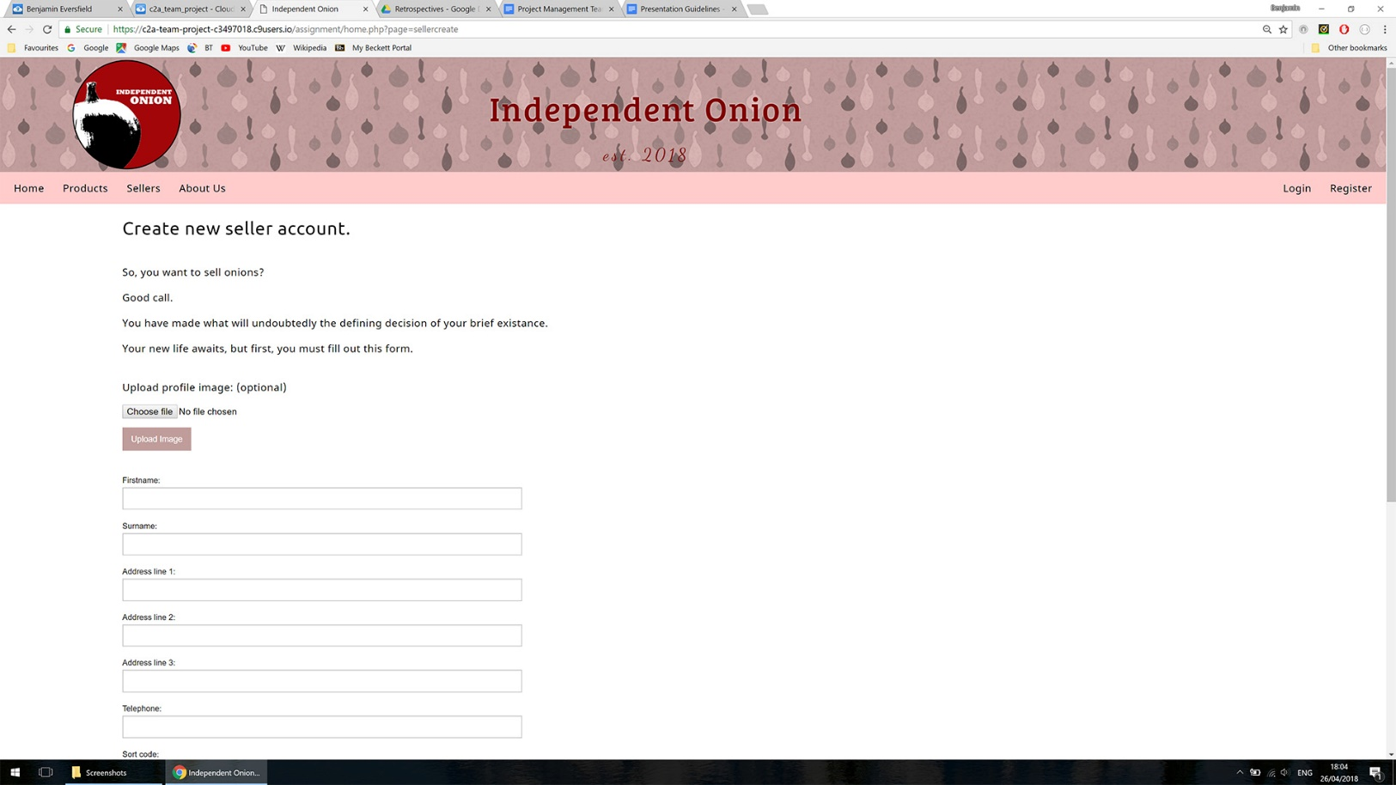

Seller Registration:

* Registration form to create new seller record in the database.
* Functionality is the same as customer registration with an added feature to upload an avatar image to the server. A relative link to the image is stored in the seller record unless no image is uploaded, in which case a link to a default image is added.

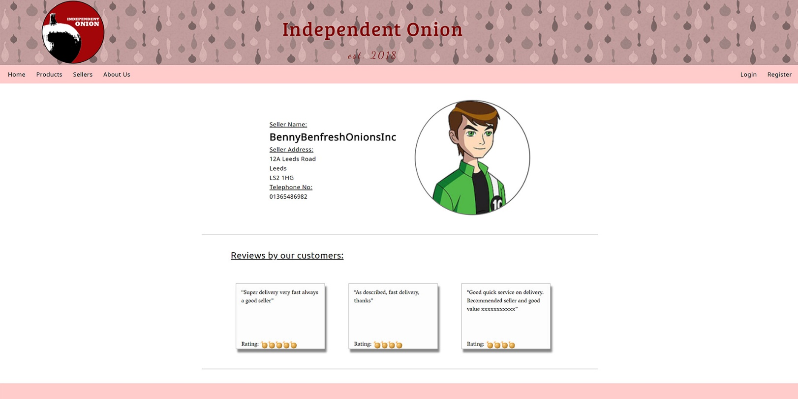

Seller Information Page:

* Image drawn from file system with sql.
* Review cards built with sql query to pull top 3 reviews only.
* Star/onion rating calculated dynamically with for loop from sql query.

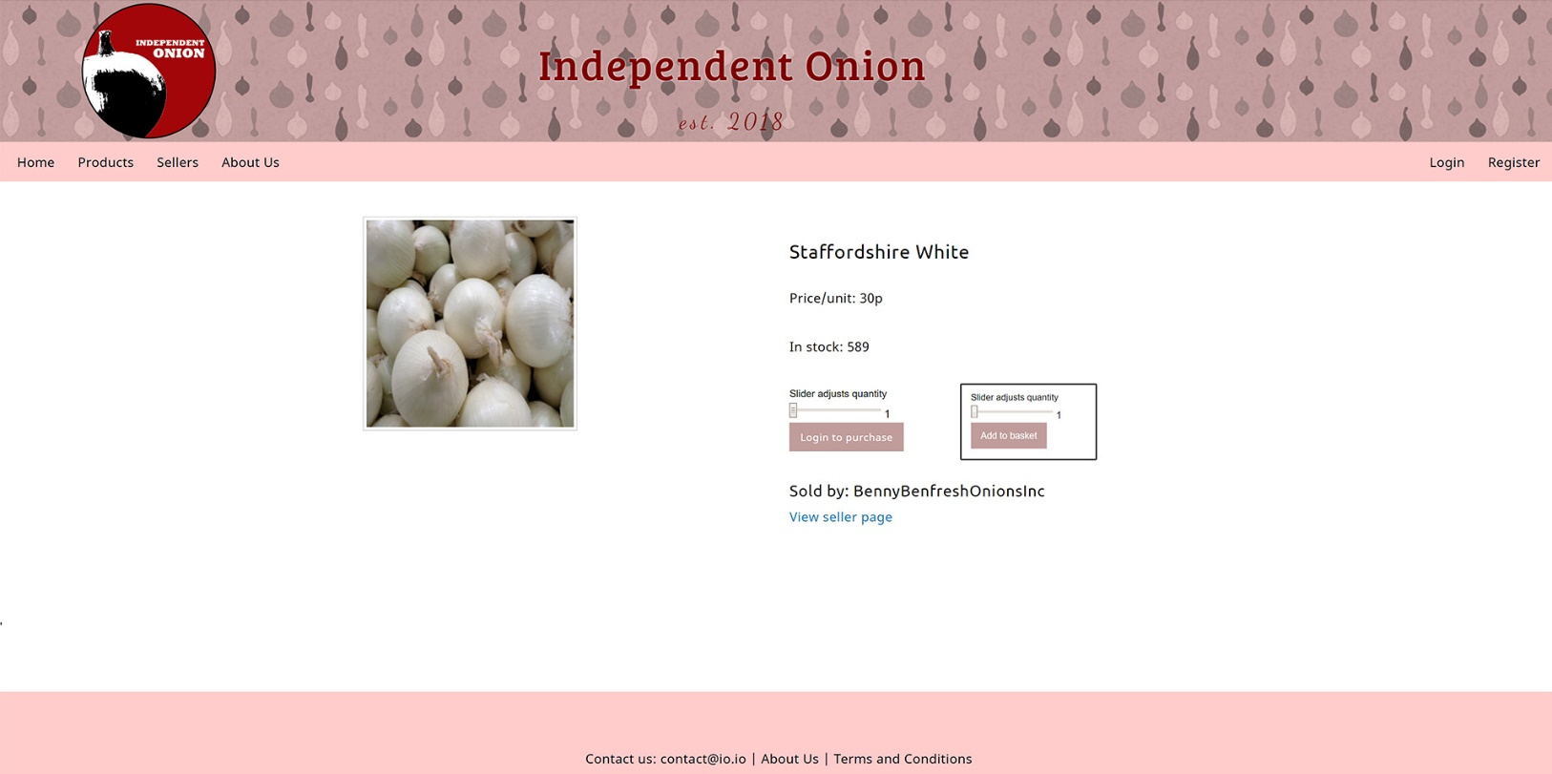

Product Information Screen:

* Image link pulled from database.
* Stock quantity accurate to database.
* Slider max value limited to quantity.
* “Login to purchase” button becomes “Add to basket” only once a customer account has logged in, as shown in the inset image.

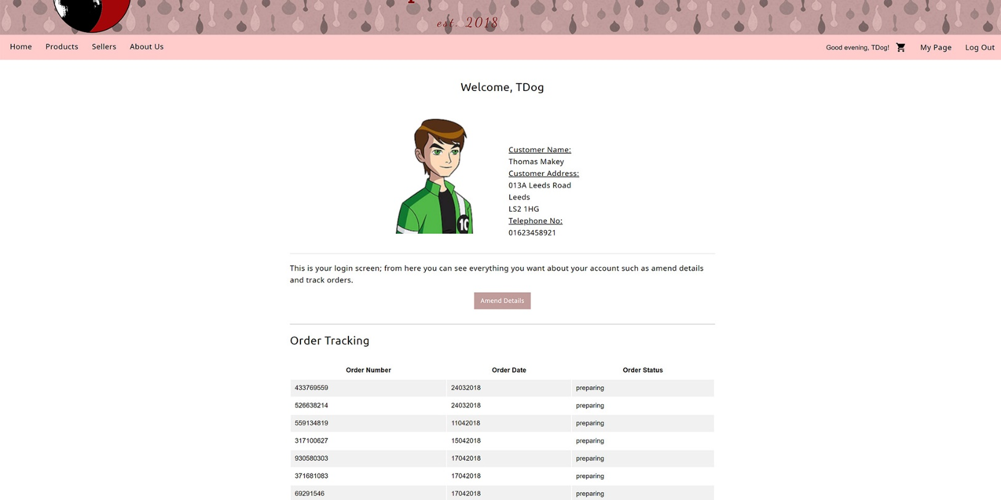

Customer Home Page:

* Account details pulled from database.
* Button linking to an amend details page.
* Order tracking table from database.

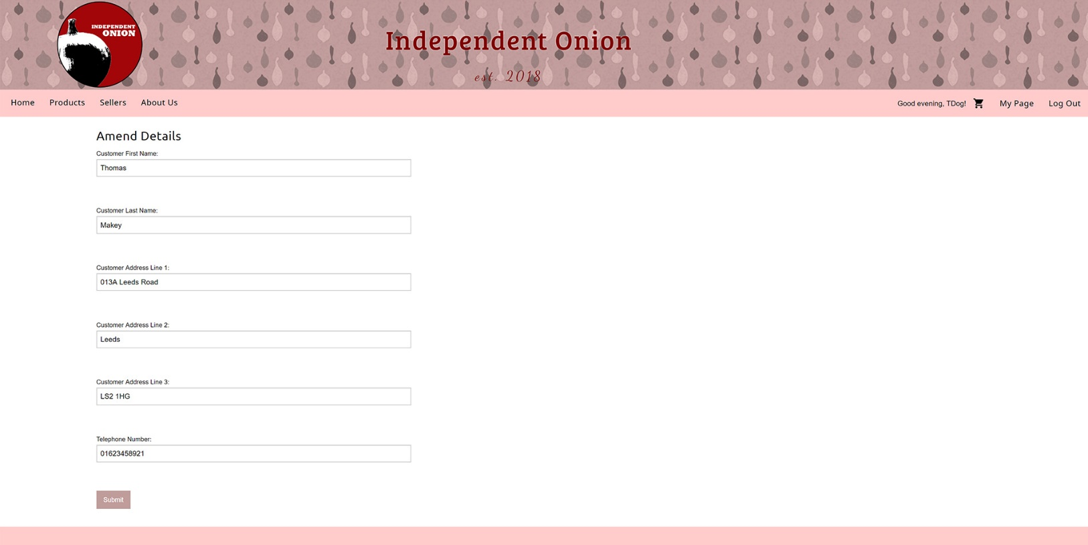

Customer Amend Details Form:

* Form prepopulated from database.
* Updates the database on submission.

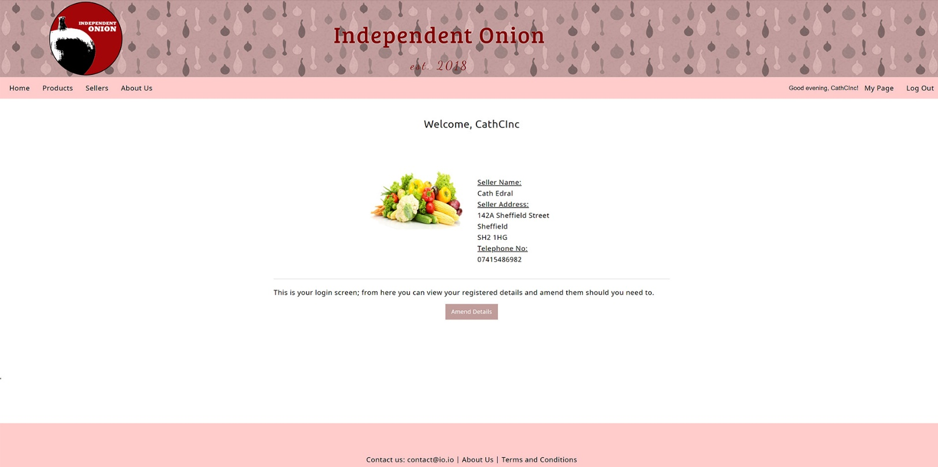

Seller Home Page:

* Displays correct details and image from database query.
* Amend details button redirects to prepopulated amend details form with same design and functionality as the customer amend details form on the previous page of this document.

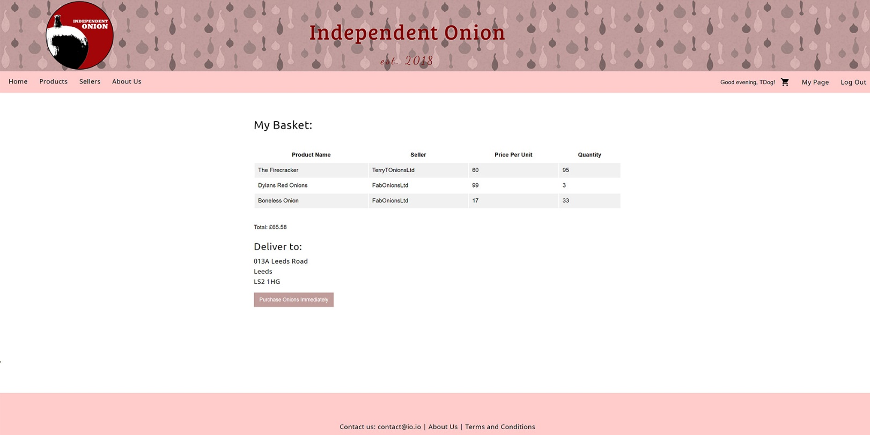

Basket page (with products added):

* Products added from the individual product pages. When “Add to basket” (on the products page) is clicked, data is added to a session associative array of product_id and quantity. The basket page builds the html basket table using sql lookup using data from the session array.
* Total is calculated and the delivery address is pulled from database.
* On purchase button being pressed, an order_table record is created, and the id generated for the new row is used to create an order_item table row for each item in the basket. Then the basket session array is cleared.
* Below is the message shown to the user if their basket is empty.

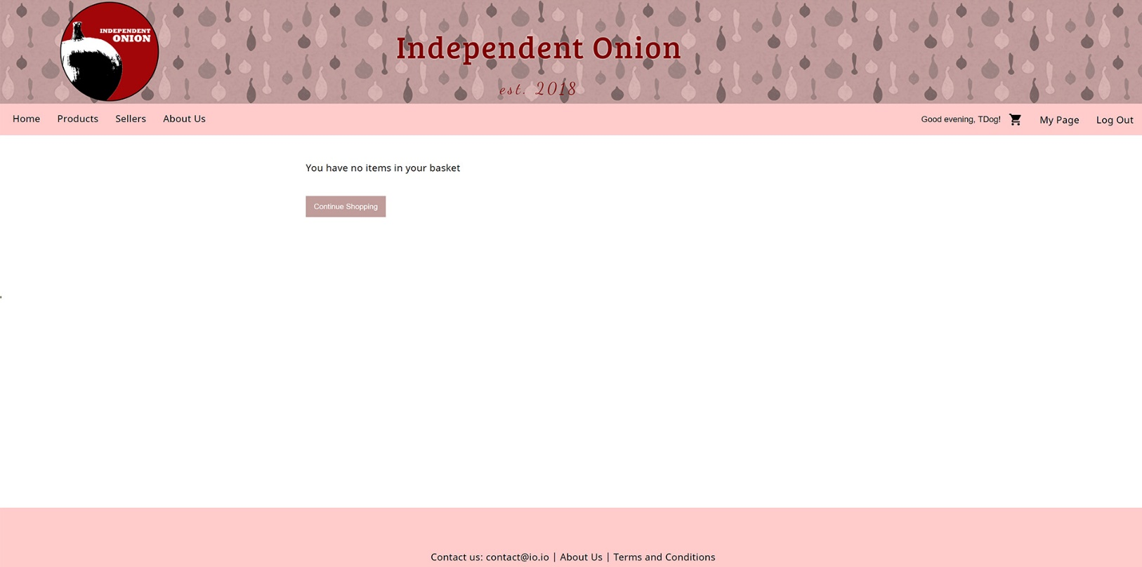

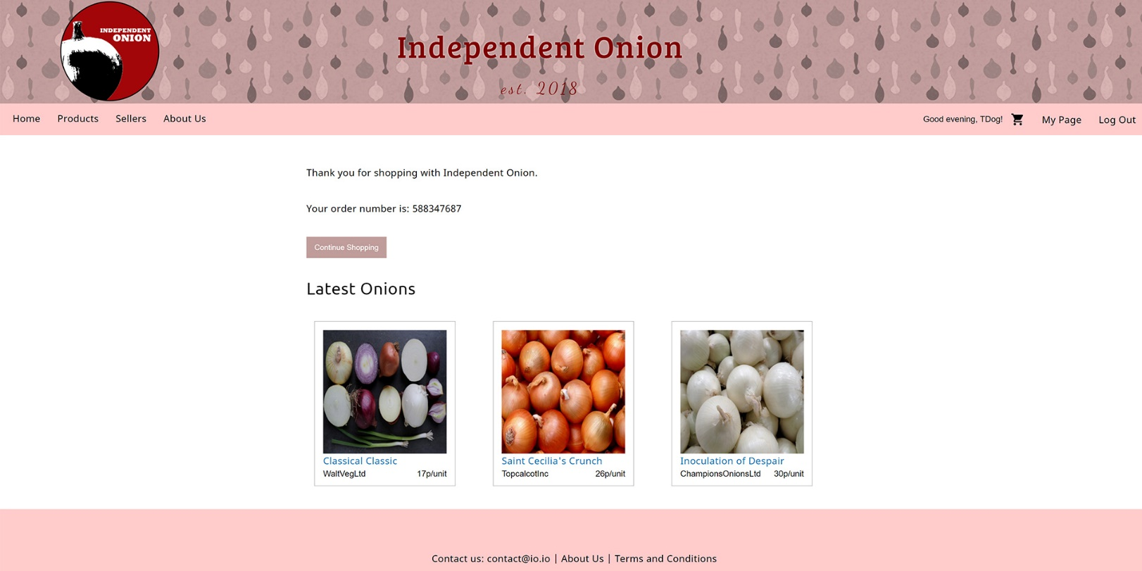

Purchase complete:

* Thank you message and order number.
* Button linking back to the product page to encourage further shopping.
* Latest onion cards operating as on the home screen.

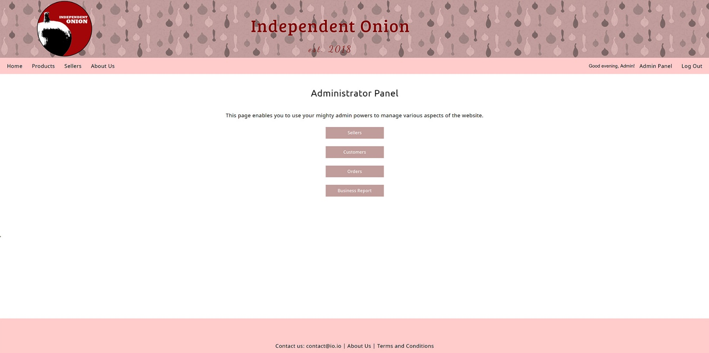

Admin Panel:

* Only accessible from successful login with an admin account.
* Gives access to seller, customer and order tables and the Apex business report.

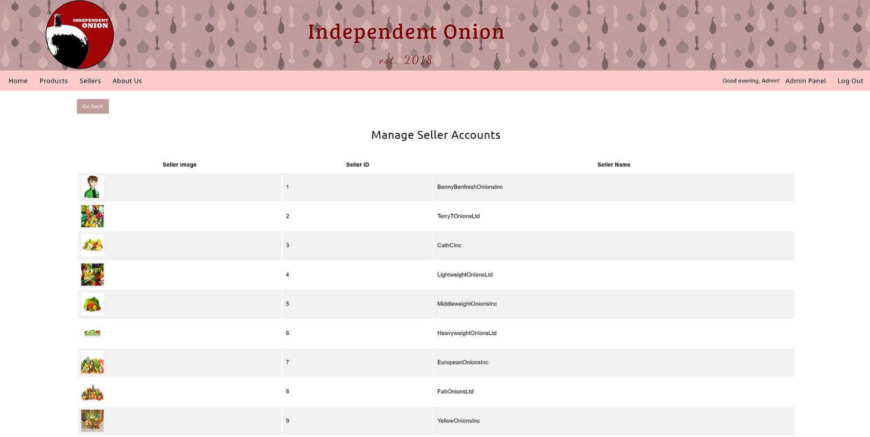

Admin Seller Table:

* Retrieves all seller records in the database.

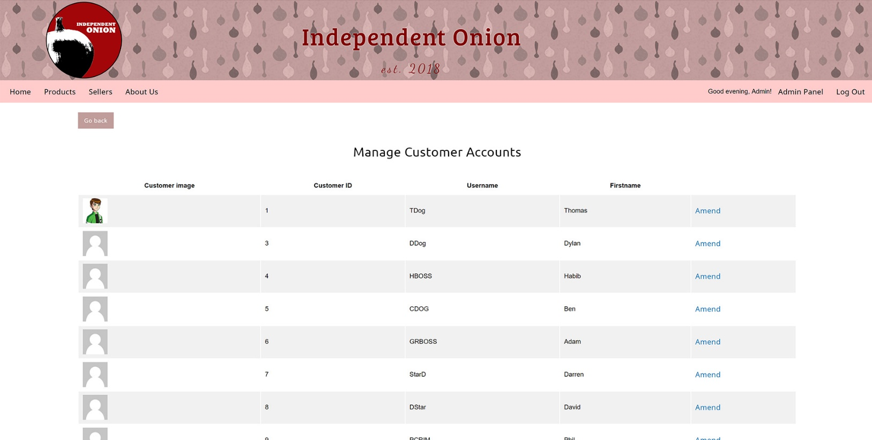

Admin Customer Table:

• Retrieves all customer records in database, has amend link that redirects to a prepopulated amend details form.

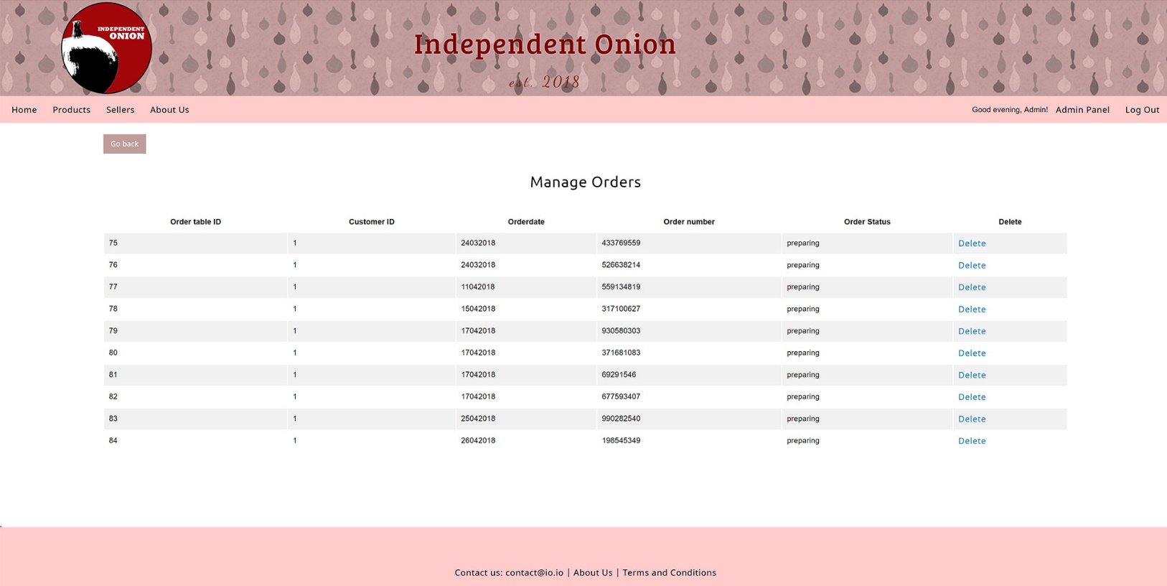

Admin Orders Table:

* Returns all orders in the database.
* The delete link removes the order_table database table entry and related order_item database table entries to prevent integrity constraint violations.

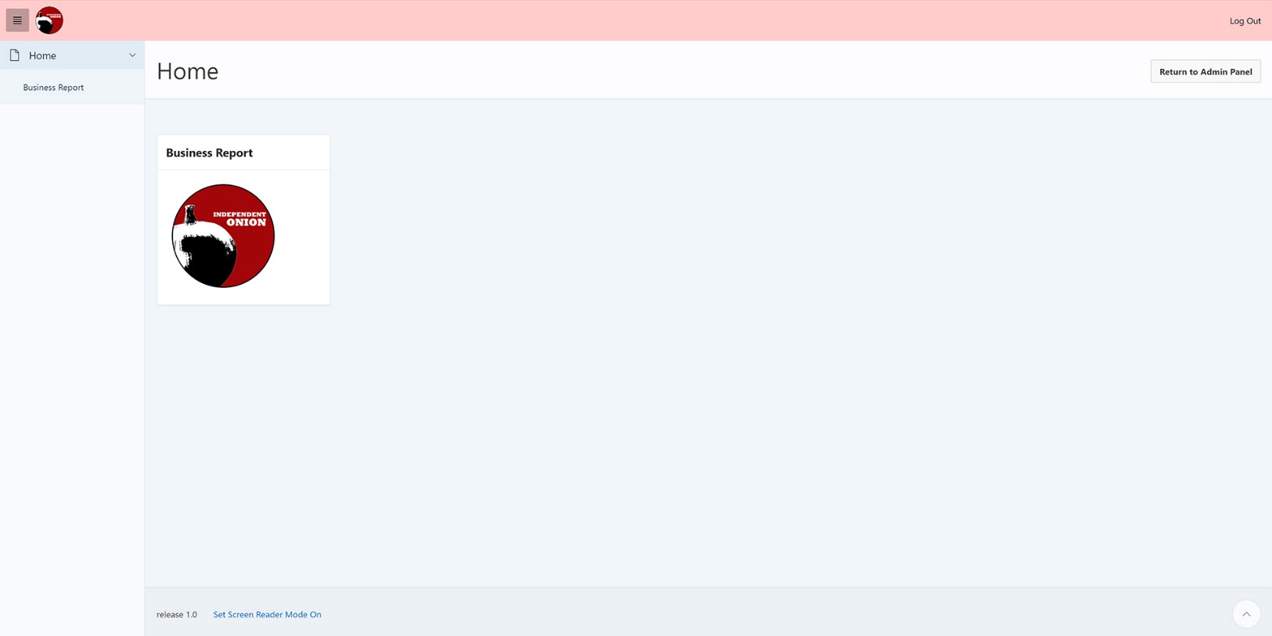

APEX Admin Business Report (home page):

* The “Business Report” button on the admin panel redirects to an APEX report tied to the underlying website database.
* The above image is the home screen with a link to the business report (more icons could be added if more reports were developed).
* The logo and icon image are hosted on the APEX server and linked to using an APEX substitution string.
* The theme roller has been used to match the colour scheme of the website.
* A new authentication scheme was built to allow access from the website.
* Layout built using custom column layout.
* The “Return to Admin Panel” button redirects to the admin panel, which is protected by an if statement containing an isset() method to check that a logged in admin is returning to the admin panel.

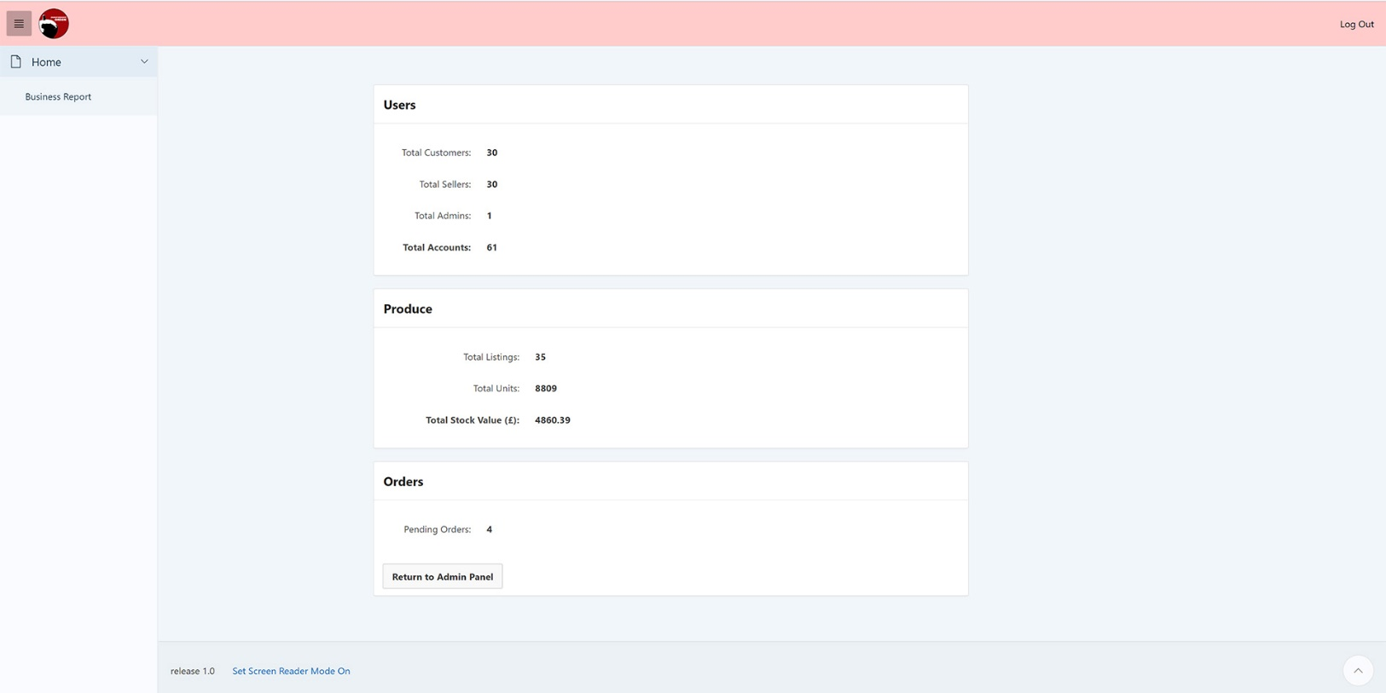

APEX Admin Business Report (main page):

* Pulls data from the database using sql queries.
* Shows number of registered users and their account types.
* Shows the total number of product listings, the total number of units in stock and the total value of the current stock.
* Shows the total number of orders with a “pending” order status value.
* The “Return to Admin Panel” button redirects to the website’s admin panel as discussed above.