PROJECT SYNOPSIS
“Softpro Innovation”
for
Softpro India Computer Technology Pvt Ltd.

SYNOPSIS SUBMITTED FOR THE PARTIAL FULFILMENT OF THE
REQUIREMENT FOR THE BACHLOR OF TECHNOLOGY

SUBMITTED TO
“College Name”
CITY

SUBMITTED BY:
STUDENT NAME

(College Enrolment Number- XXXXXXX )
2023-2027



Under the Guidance of
Er. Brijesh Sir
Senior Consultant
SOFTPRO INDIA COMPUTER TECHNOLOGIES (P) LTD

ABOUT THE ORGANISATION
Softpro India Computer Technologies (P) Ltd. is a leading IT firm and the software development division of Softpro Group of Companies with its headquarter located in the capital city of Uttar Pradesh, Lucknow. Softpro India was established in 2004 by technocrats from IIT-Kanpur and IET Lucknow. Softpro Group of Companies is a cluster of companies working in multiple domains like Software Development, IT Trainings, Research and Designing. The Founder and Managing Director of Softpro Group of Companies is Er. Ajay Chaudhary with over 25 years of experience. Softpro India is the fastest growing IT company with the largest learning center of the region having experienced consultants of 15+ years and industry experts.
Softpro Group of Companies compromises of Softpro Learning Center (Training & Internship division – 2008), Softpro Innovations (R&D division – 2014) and Softpro Foods (Agro Production division – 2018). Softpro India has global presence with its Head Office and Training Center located in Lucknow, International Unit Office located in Malawi, Africa and Virtual Office located in Kuala Lumpur, Malaysia. Softpro India has successfully delivered Government Projects like the visionary project of Government of Uttar Pradesh – URISE. Softpro India also has signed MoU with Department of Technical Education, Government of Uttar Pradesh making it the authorised Training & Development partners to impart and technically upskill all the engineering students of polytechnics (government, private & aided) across Uttar Pradesh.
Softpro India’s recent achievements include the MoU signing with Dr. A. P. J. Abdul Kalam Technical University, Uttar Pradesh. Technologies are transcending boundaries and their volatility is putting stringent demands on the time and mind-space of techno-professionals. At SPG, we update ourselves with technologies even before they become norms and master them long before they become redundant. That's why we are on the roster of clients from across the continents.
Softpro India offers training for all the branches of engineering (Computer Science, Information Technology, Electronics, Electrical, Civil, Mechanical) for updated and trending technologies. Softpro India also has several online and offline trainings like Summer Training, Industrial Training, Vocational Training, Apprenticeship Program, Employment Training Program and Online Courses. The learning material and other resources are available on Softpro India’s Learning Management System (LMS) – “Polyprep – Knowledge @ Your Doorstep” and Come to think of it, we have engineered ourselves to be at the very forefront in Web based technology. Our core competencies span a spectrum of web-intensive services that range from website designing to robust backend management.

TECHNOLOGIES TRAINED ON DURING TRAINING (MERN STACK)

1. HTML (Hypertext Markup Language)
HTML is the standard markup language used to create the structure of web pages. It provides predefined tags to organize content such as headings, paragraphs, images, links, and forms.
In the SOFTPROINNOVATION project, HTML is used to structure product listings, category pages, user dashboards, and checkout interfaces. It forms the backbone of the frontend layout.

2. CSS (Cascading Style Sheets)
CSS is used to style and design web pages. It controls layout, colours, fonts, spacing, and responsiveness across different devices.
In this project, CSS is applied to enhance the visual appearance of the e-commerce platform, ensuring a clean and user-friendly interface for browsing robotics and electronics components.

3. JavaScript
JavaScript is a programming language used to create dynamic and interactive web applications. It enables features like real-time updates, form validation, animations, and API communication.
In SOFTPROINNOVATION, JavaScript is used for handling user interactions such as adding products to cart, filtering items, dynamic pricing updates, and managing asynchronous requests to the backend.

4. Bootstrap
Bootstrap is a front-end framework that helps in building responsive and mobile-friendly websites quickly. It provides pre-designed components like buttons, forms, navigation bars, and modals.
In this project, Bootstrap is used to design responsive layouts for product pages, navigation menus, and admin dashboards, ensuring compatibility across devices.

5. MongoDB (Database)
MongoDB is a NoSQL database used to store data in a flexible, JSON-like format. It is highly scalable and suitable for modern web applications.
In SOFTPROINNOVATION, MongoDB is used to store:
- Product details (robotics kits, sensors, components)
- User information
- Orders and transactions
- Cart and wishlist data
It enables efficient data management and fast retrieval.

6. Express.js
Express.js is a lightweight backend framework for Node.js used to build APIs and handle server-side logic.
In this project, Express.js is used to:
- Create RESTful APIs
- Handle authentication and authorization
- Manage product, user, and order routes
- Connect frontend with the database

7. React.js
React.js is a JavaScript library used to build fast and interactive user interfaces using reusable components.
In SOFTPROINNOVATION, React is used to develop:
- Dynamic product pages
- Shopping cart system
- User authentication UI
- Admin panel for managing products
It improves performance through component-based architecture and virtual DOM.

8. Node.js
Node.js is a runtime environment that allows JavaScript to run on the server side. It is used for building scalable backend services.
In this project, Node.js works with Express.js to:
- Handle server operations
- Process API requests
- Manage business logic
- Integrate with MongoDB

CLIENT INTRODUCTION
Softpro India is a reputed training and development organization that provides technical education across multiple engineering branches including Computer Science, Information Technology, Electronics, Electrical, Civil, and Mechanical. The organization focuses on delivering industry-relevant and up-to-date training programs to students and professionals.

ABOUT SOFTPROINNOVATION
SOFTPROINNOVATION aims to transform the electronics and robotics components market by providing a comprehensive and user-friendly e-commerce platform. The system integrates essential features such as product browsing, detailed specifications, smart search, and secure purchasing, enabling users to easily find and buy required components.
With intelligent product recommendations, users can explore suitable electronics parts, robotics kits, sensors, and modules based on their needs and projects. The platform ensures a smooth and efficient shopping experience for students, hobbyists, and professionals.
Furthermore, SOFTPROINNOVATION promotes innovation and learning by offering high-quality components that support modern technologies such as IoT, automation, and embedded systems. This approach helps users build advanced and cost-effective projects with ease.

CHALLENGES IN TRADITIONAL ELECTRONICS COMPONENT PURCHASING
The current system of purchasing electronics and robotics components faces several challenges, including:
➢ Limited availability of components in local markets
➢ Difficulty in finding accurate product specifications
➢ Lack of proper comparison between similar products
➢ Inefficient inventory and stock management
➢ Delays in procurement and delivery
➢ Lack of trusted platforms for quality components
➢ Difficulty in managing bulk or project-based purchases

PROPOSED DIGITAL SOLUTION: HOW SOFTPROINNOVATION WORKS
⮚ A unified online platform for browsing and purchasing electronics and robotics components
⮚ Advanced search and filtering options for easy product discovery
⮚ Detailed product descriptions, specifications, and images
⮚ Smart recommendation system for selecting suitable components
⮚ Real-time inventory management and stock availability
⮚ Secure user authentication and online payment system
⮚ Order tracking and delivery management
⮚ User-friendly interface for both customers and administrators
⮚ Transparent pricing and easy comparison of products

ENTITIES INVOLVED IN SOFTPROINNOVATION
⮚ Customer: Purchases electronics and robotics components
⮚ Admin: Manages the platform and controls all operations

1. Customer
⮚ Register & login
⮚ Browse electronics and robotics products
⮚ Search and filter products by category, price, and features
⮚ View detailed product descriptions and specifications
⮚ Add products to cart and Wishlist
⮚ Place orders and make secure payments
⮚ Track order status and delivery updates
⮚ Provide feedback and ratings

2. Admin
⮚ Manage customer accounts (view/block/delete)
⮚ Add, update, and delete products
⮚ Manage product categories (robotics, sensors, components, etc.)
⮚ Monitor orders and payment transactions
⮚ Manage inventory and stock levels
⮚ Handle customer complaints and support
⮚ View reports (sales, users, orders)
⮚ Ensure system security and smooth functioning

FEASIBILITY ANALYSIS OF SOFTPROINNOVATION
The project has been evaluated on multiple feasibility aspects:

1. Operational Feasibility
The system provides a user-friendly interface that allows customers to easily browse and purchase products, while admins can efficiently manage the platform.

2. Technical Feasibility
The system is developed using modern MERN stack technologies:
● Frontend: HTML5, CSS3, JavaScript, Bootstrap, React.js
● Backend: Node.js with Express.js
● Database: MongoDB

3. Schedule Feasibility
The project is divided into structured phases such as design, development, testing, and deployment, ensuring timely completion.

4. Economic Feasibility
The platform reduces manual work, improves efficiency, and provides a scalable solution for selling electronics and robotics components online.

PROJECT PLANNING & SOFTWARE DEVELOPMENT LIFE CYCLE (SDLC)

1. Requirement Analysis
Identifying key features like product management, cart system, order processing, and admin controls.

2. System Design
Designing UI/UX, database structure, and overall system architecture.

3. Coding & Development
Developing frontend using React.js and backend APIs using Node.js and Express.js with MongoDB integration.

4. Testing
Performing testing to ensure functionality, performance, and error-free operation.

5. Deployment & Maintenance
Deploying the system and continuously improving performance, fixing bugs, and updating features.

SOFTWARE REQUIREMENT FOR DEVELOPMENT

User Interface Designing
HTML5, CSS3, JavaScript, Bootstrap, React.js

Programming Language
JavaScript (Node.js with Express.js framework)

Database
MongoDB

IDE
VS Code

DATABASE DESIGNING

Collection: Customer
Field Name | Data Type
CustomerID | ObjectId
Name | String
Email | String
Password | String
ContactNumber | String
Address | String
CreatedAt | Date

Collection: Admin
Field Name | Data Type
AdminID | ObjectId
Name | String
Email | String
Password | String
Role | String

Collection: Products
Field Name | Data Type
ProductID | ObjectId
ProductName | String
Category | String
Description | Text
Price | Number
Stock | Number
Image | String (URL)
CreatedAt | Date

Collection: Cart
Field Name | Data Type
CartID | ObjectId
CustomerID | ObjectId
ProductID | ObjectId
Quantity | Number

Collection: Orders
Field Name | Data Type
OrderID | ObjectId
CustomerID | ObjectId
TotalAmount | Number
OrderStatus | String
PaymentStatus | String
OrderDate | Date

Collection: OrderItems
Field Name | Data Type
OrderItemID | ObjectId
OrderID | ObjectId
ProductID | ObjectId
Quantity | Number
Price | Number

Collection: Feedback / Reviews
Field Name | Data Type
ReviewID | ObjectId
CustomerID | ObjectId
ProductID | ObjectId
Rating | Number
Comment | Text
CreatedAt | Date

RELATION OVERVIEW (IMPORTANT FOR VIVA)
- One Customer → can have multiple Orders
- One Order → contains multiple OrderItems
- One Product → can appear in multiple Orders
- One Customer → can give multiple Reviews
- Cart connects Customer and Products

DESCRIPTION OF MODULES

Customer Module
Stores customer-related information such as personal details, login credentials, address, and order history. It also manages cart, wishlist, and product reviews provided by the customer.

Admin Module
Manages all platform activities including user management, product management, order processing, inventory control, and monitoring overall system performance.

Product Module
Stores information about electronics and robotics products, including product name, category, specifications, price, stock, and images. It allows easy browsing and management of products.

Cart Module
Handles the temporary storage of selected products by customers before purchase. It manages product quantity, total price, and updates in real time.

Order Management Module
Manages complete order processing including order placement, payment status, order tracking, and delivery updates.

Payment Module
Handles secure online transactions and payment processing. It ensures safe and reliable payment methods for customers.

Inventory Module
Tracks product availability and stock levels. It updates inventory automatically after each order and helps prevent over-selling.
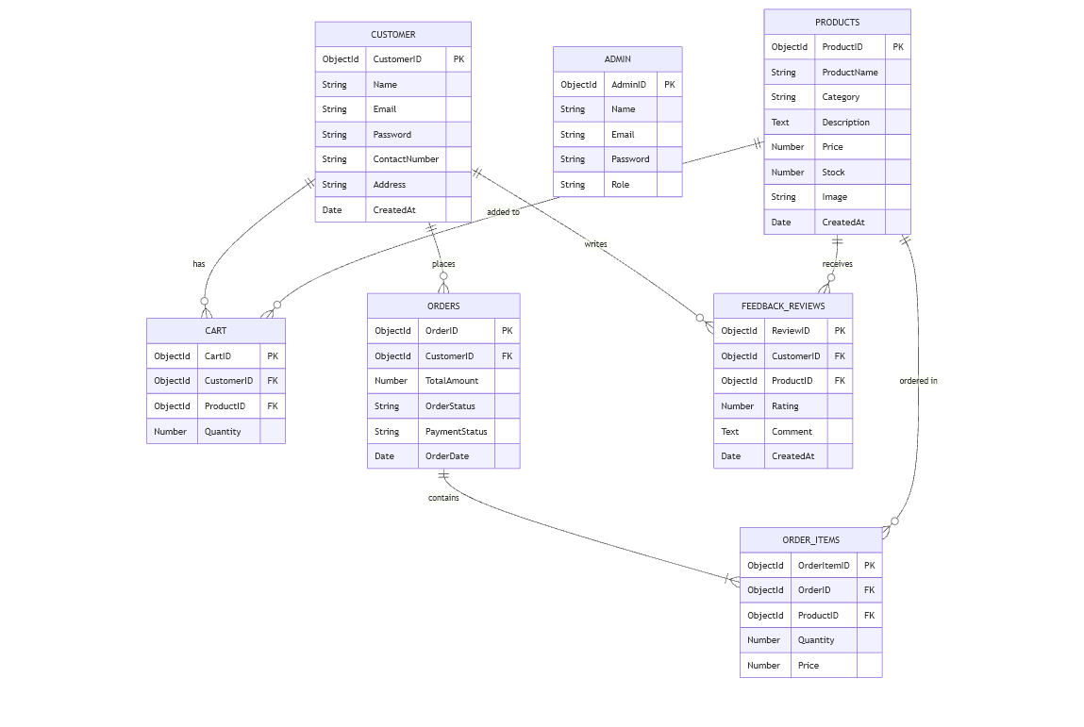

Feedback / Review Module
Stores customer feedback, ratings, and reviews for products, helping improve product quality and customer satisfaction.

FUTURE SCOPE OF PROJECT
Softpo Innovation can be further enhanced by integrating advanced technologies such as:
● AI-based product recommendation system for personalized shopping experience
● Integration with IoT platforms for real-time compatibility of robotics components
● AR-based product visualization for better understanding of components
● Blockchain-based secure payment systems for enhanced transaction security
● Advanced analytics dashboard for sales prediction and inventory optimization
● Mobile application development for better accessibility and user engagement

CONCLUSION
SOFTPROINNOVATION is not just an e-commerce platform—it is a modern solution for simplifying the purchase of electronics and robotics components. By combining efficient system design, user-friendly interface, and scalable MERN stack technologies, the platform provides a seamless and reliable shopping experience.
This project enhances accessibility to high-quality components, supports innovation, and enables users to build advanced technological solutions with ease.

