**Complete Coding Evidence**

package com.example.login_form;  
  
import androidx.annotation.NonNull;  
import androidx.appcompat.app.AppCompatActivity;  
  
import android.content.Intent;  
import android.os.Bundle;  
import android.view.View;  
import android.widget.Button;  
import android.widget.EditText;  
import android.widget.ProgressBar;  
import android.widget.TextView;  
import android.widget.Toast;  
  
import com.google.android.gms.tasks.OnCompleteListener;  
import com.google.android.gms.tasks.Task;  
import com.google.firebase.auth.AuthResult;  
import com.google.firebase.auth.FirebaseAuth;  
import com.google.firebase.auth.FirebaseUser;  
  
import javax.security.auth.login.LoginException;  
  
public class MainActivity extends AppCompatActivity implements View.OnClickListener  
{  
  
 private TextView signUp;  
 private EditText editTextEmail, editTextPassword;  
 private Button logIn;  
 private ProgressBar progressBar;  
  
 private FirebaseAuth mAuth;  
  
  
 @Override  
 protected void onCreate(Bundle savedInstanceState)  
 {  
 super.onCreate(savedInstanceState);  
 setContentView(R.layout.*activity_main*);  
  
 mAuth = FirebaseAuth.*getInstance*();  
  
 signUp = (TextView) findViewById(R.id.*textViewSignUp*);  
 signUp.setOnClickListener(this);  
  
 logIn = (Button) findViewById(R.id.*btnLogin*);  
 logIn.setOnClickListener(this);  
  
  
 editTextEmail = (EditText) findViewById(R.id.*inputEmail*);  
 editTextPassword = (EditText) findViewById(R.id.*inputPassword*);  
  
 // progressBar = (ProgressBar) findViewById(R.id.progressBar);  
  
 }  
  
 @Override  
 public void onClick(View v)  
 {  
 switch (v.getId())  
 {  
 case R.id.*textViewSignUp*:  
 //startActivity(new Intent( this, RegisterActivity.class)); // register page linked here  
 break;  
  
 case R.id.*btnLogin*:  
 userLogin();  
 break;  
 }  
  
 }  
  
 private void userLogin()  
 {  
 String Email = editTextEmail.getText().toString().trim();  
 String Password = editTextPassword.getText().toString().trim();  
  
 if(Email.isEmpty())  
 {  
 editTextEmail.setError("Your email is invalid");  
 editTextEmail.requestFocus();  
 return;  
 }  
  
 if(Password.length() < 6)  
 {  
 editTextPassword.setError("Min password length is 5 characters");  
 editTextPassword.requestFocus();  
 return;  
 }  
  
 mAuth.signInWithEmailAndPassword(Email, Password).addOnCompleteListener(new OnCompleteListener<AuthResult>()  
 {  
 @Override  
 public void onComplete(@NonNull Task<AuthResult> task)  
 {  
 if(task.isSuccessful())  
 {  
 FirebaseUser user = FirebaseAuth.*getInstance*().getCurrentUser();  
 if(user.isEmailVerified())  
 {  
  
 // startActivity(new Intent(LoginActivity.this, FunctionActivity.class)); // function page linked here  
  
 }  
 else  
 {  
 user.sendEmailVerification();  
 Toast.*makeText*(MainActivity.this, "Check your gmail account for verification!", Toast.*LENGTH_LONG*).show();  
 }  
 }  
 else  
 {  
 Toast.*makeText*(MainActivity.this, "Failed to Login! Please check your credentials", Toast.*LENGTH_LONG*).show();  
 }  
  
 }  
 });  
  
  
 }  
}

**User Interface Design**

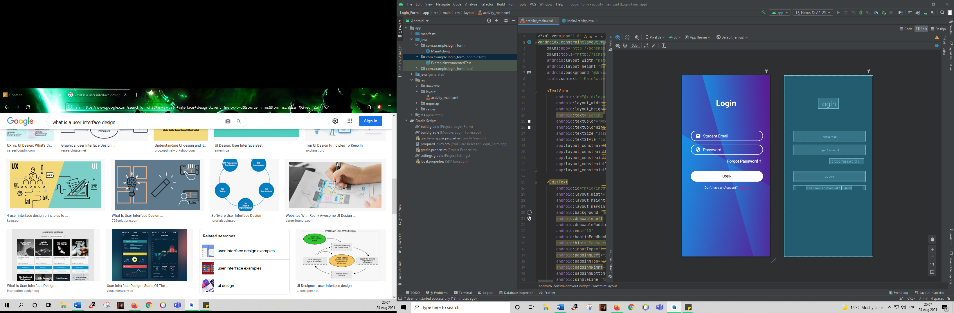

1. I am the creator of the login page. This page takes you to the register page of Warren Jaftha and as well to the forgot Password page.
2. Thereafter, after logging in, it will surely be taking you to the next page regarding the function or the menu page.

**Data Design**

