Assignment TERM3

****Due date:30/08/2021

**PROJECT II**

**PRT2**

**Stream Name:** Application Development

**Course:** Project 2

**Lecturer**: Ayodeji Afolaya

**Student Name:**  Edvalter Jamba

**Student Number**: 220446571

**Student Email:** 20446571@mycput.ac.za

**ASSIGNMENT TERM 3**

**Individual submission of each team member on progress made on their tasks**

**with demonstrable value added to the main project.**

**Contents**

INTRODUCTION 3

FUNCTIONAL REQUIREMENT OF THE ABOUT US PAGE 4

**System Design and Implementation** 4

Construction of the “About us page” 5

DESIGN REQUIREMENTS AND PAGE FUNCTIONALITY 6

WIREFRAMES 7

PROOF OF THAT THE CODE IS/WAS DONE in version 1.3 10

PICTURE OF THE ABOUT US PAGE AFTER RUN THE CODE IN ANDROID STUDIO 11

UPDATES” Version 1.3” 12

FUNCTIONAL REQUIREMENT OF THE ABOUT US PAGE 13

VERSION 1.3 13

SHOWING CODE IN ANDROID STUDIO 14

Git Hub 16

**Link of my GITHUB repository** 16

CONCLUSION 17

# **INTRODUCTION**

In this assignment I was assigned to do the “About us page”

About us page is the page that the visitor or user will be looking for in case they want to know more about who we are or about the app or what we do. About Us Page is not the kind of page where User will need to introduce data, therefore the “About Us” page is used only to display information such Team member’s names, and a brief explanation of the function of the application.

This page will be access for those who wish to know more about of the team and what the application does.

# **FUNCTIONAL REQUIREMENT OF THE ABOUT US PAGE**

**Application Used to edit**

* **Photoshop**

**Application Used to code**

* **Android Studio**

**Application Used for Wireframe**

* **Balsamiq Wireframes**

**Colours Used**

* **Background-blue**
* **TextColor-White**

**Images/icon’s colour**

* **Background-blue**
* **Yellow**

## **System Design and Implementation**

In the System Design, will be made the analysis design of what it will tell us and how the page will be configured and constructed.

There are some points to consider about of what the user or visitor expect to find in the About us page:

* **Who**

Who had the idea, who is in charge, team members?

* **What**

**“What”** We will tell them or what kind of the application we are creating, and what it has to offer to the user.

* **Why**

Why the creation of the application, what the application does.

* **How**

How anyone will be able to contact us.

# **Construction of the “About us page”**

After the Construction of the design, we will be able to go to the implementation of the page, Following the structure bellow as a guide.

For the Construction of the about us page, I divided it as follows:

|  |  |  |  |  |
| --- | --- | --- | --- | --- |
| **Head** | **Menu Button** | | | |
| **Body** | **Load Shedding App.** | | | |
| . Our app that we will be designing will be alert the users based on the area that they are located and at what time load shedding will be taking place so that they can be more prepared. | | | |
| **Sub-Content** | **Team Members** | | | |
| **Member1**  **Name:** | | **Member2**  **Name:** | |
| **Mmeber3**  **Name:** | **Mmber4**  **Name:** | | **Member4**  **Name:** |
| **Footer** | **Some link of our Social media** | | | |

For the design of this page, I wanted to use colours or interface that somehow would not affect the interaction with the user. And as it is a mobile application, and this page requires information, the user will be able to scroll the screen in case the information isn’t showing hundred percent in the screen or in case there is more information to be seeing.

# **DESIGN REQUIREMENTS AND PAGE FUNCTIONALITY**

Here we will be able to see how I could get to the final version of the design for the page.

**Version1.1**

For the first Version I used photoshop to create an image of what I wanted like to code.

Following the diagram above I could get to this version of the About Us page.

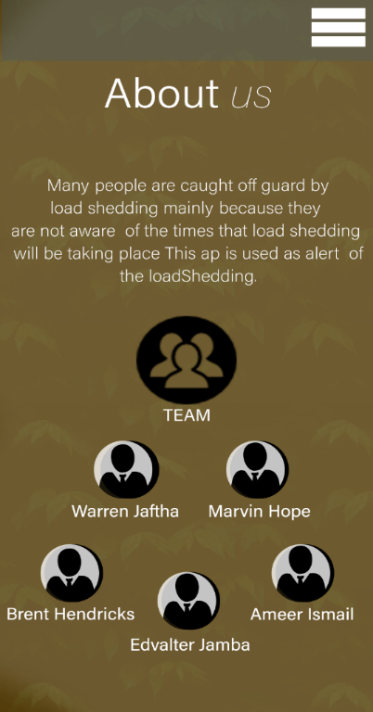

Due some issue of how we could provide the final work in the end of the year, the leader and the secretary advise us use Android Studio instead of java. Therefore, I could get the second version of the about Us page using Android Studio as shows in the picture bellow. Therefore, my version 1.1 of my design could not be executed in the code.

In other was possible to execute the second version of the design I wanted into a code using Android Studio.

# **WIREFRAMES**

These wireframes will show how the about us page will be looking like and how it will work or interact with the other pages.

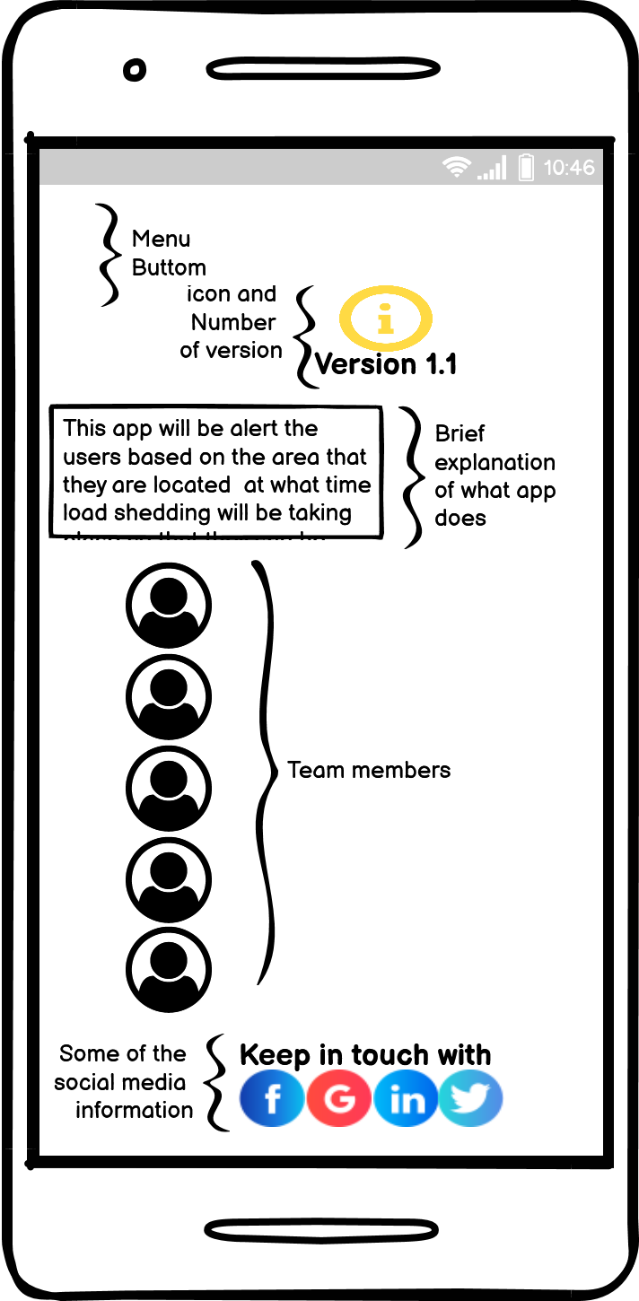

The wireframe above is the illustration of our main page (About Us Page), in this page there will show the Following details:

* An Icon that can be understandable as “Information”,
* Version Details
* Information of what is the application used for
* Team member names and Pictures
* Some social media Links where the user can get more information.

**In other hand in this section is divided by header, body, and footer.**

In the header the user will be able to find a button and this button will allow the use to go to the other pages of the application in case, he/she wants to leave the About Us page.

In the body of the About Us Page the user will be able to see the version Information, the detailed information of what is the application used for, and the members details

And in the footer of the application the user will find some Social media links where can also find more about of each member or the application.

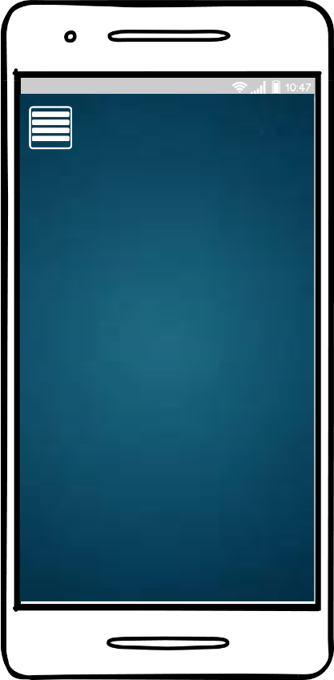**Frame1 Frame2**

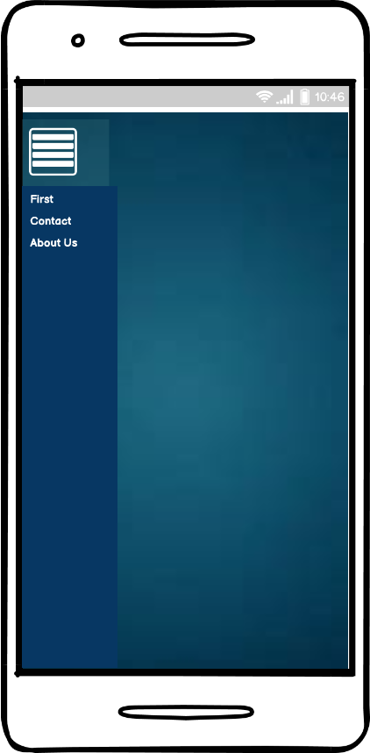

**Frame3 Frame4**

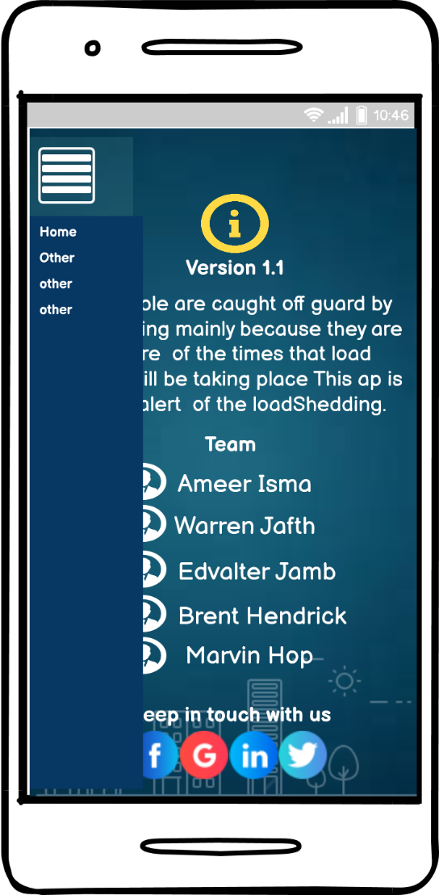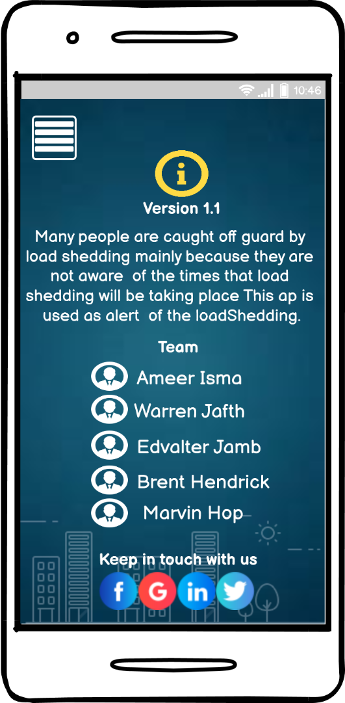

In the **Frame1** it show an example of the main form of the application and once the user click to the button above it will show different option as shows in the **Frame2** and once the user click on the “About Us” the user will be sent to the **Frame3** that is exactly the “About Us Page”, and the user will be able to see all the details mentioned above. If perhaps the user wants to get to the previous page, the user will only need to click again on the button above in the header and will show others option as it shows in the **Frame4**

# **PROOF OF THAT THE CODE IS/WAS DONE in version 1.3**

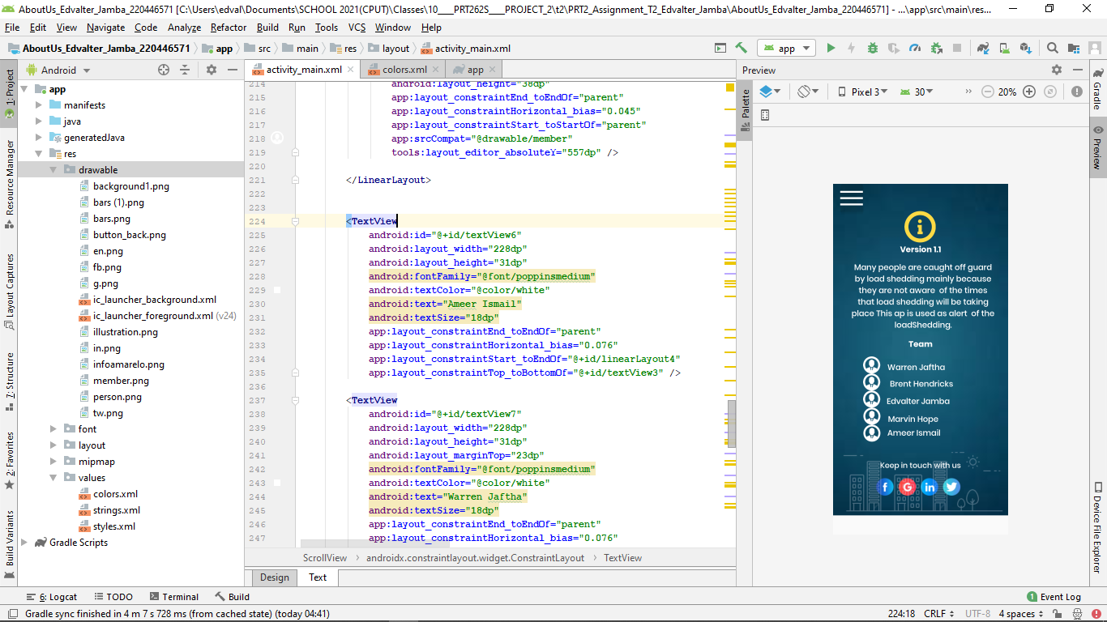

# **PICTURE OF THE ABOUT US PAGE AFTER RUN THE CODE IN ANDROID STUDIO**

**Final Version1.2**

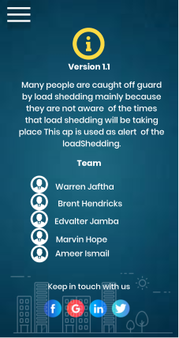

# **UPDATES” Version 1.3”**

After so many attempts was we finally could get to another version of our page, after some analysis was possible to see that we need to turn the page into something more interactive with the users, therefore besides the user be able to see the team members they will also be able to see some instructions of what or how to use the application. In other words, the new version of the “ABOUT US PAGE” will make the user get to know better the application.

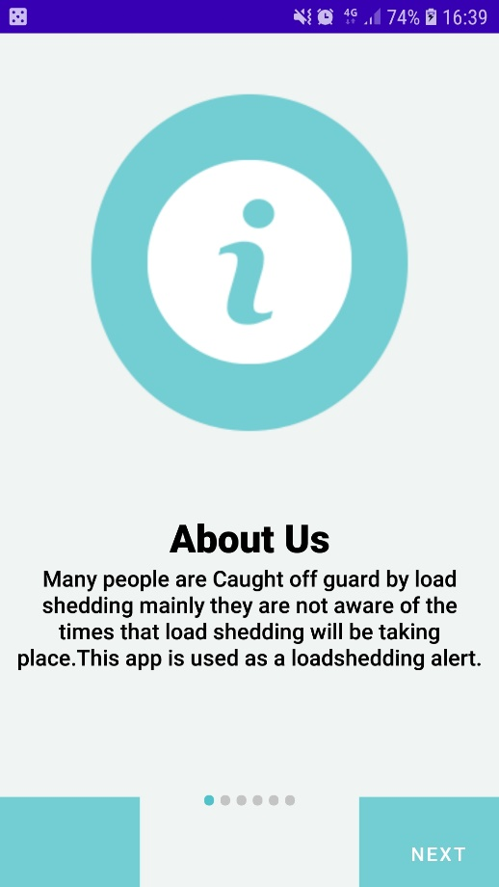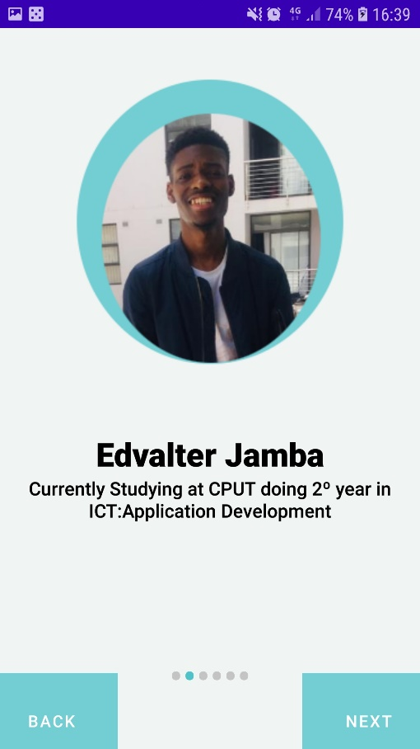

The new version of the About Us page is more friendly as well, once the user click to go to the about Us page he will be able to see two opion:Instructions,informations, if the user click on instruction he will find a slide form of the steps of what to do in case the user forget his password, and as well will be able to see information of how to register in the system and others.

In case the user selects information or info, the user will be able to see a brief explanation of what the system does and as well to see the team member and a brief description about each of them.

Besides of the other versions this new version allows the user to swipe left-right with his finger, which it makes more interesting to the user and easy to interact.

Instead of use one and only form with the whole information there was a necessity to use three differences classes and functions in the program to allow have all the differences data organized in only one form and with some lines of code we could get to this new version.

# **FUNCTIONAL REQUIREMENT OF THE ABOUT US PAGE**

# **VERSION 1.3**

**Application Used to edit**

* **Photoshop**

**Application Used to code**

* **Android Studio**

**Application Used for Wireframe**

* **Balsamiq Wireframes**

**Colours Used**

* **Background-GREEN/TEAL.**
* **TextColor-BLACK**

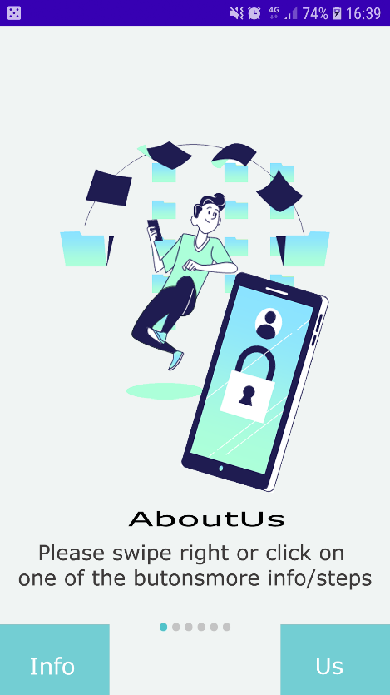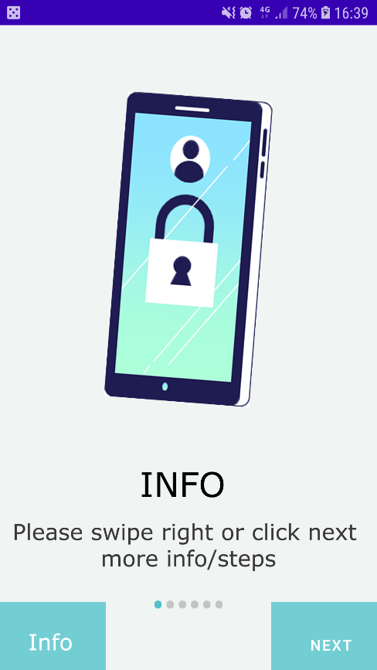

**When the user click on info he will be able to see info such as: steps for the registration in the system and what and how to act when he forget his/hers password and when he click on the button Us he will be able to see information and a brief explanation about the system and the team members.**

# **SHOWING CODE IN ANDROID STUDIO**

Above is the code that allows me to create this new version and the interaction in the screen.

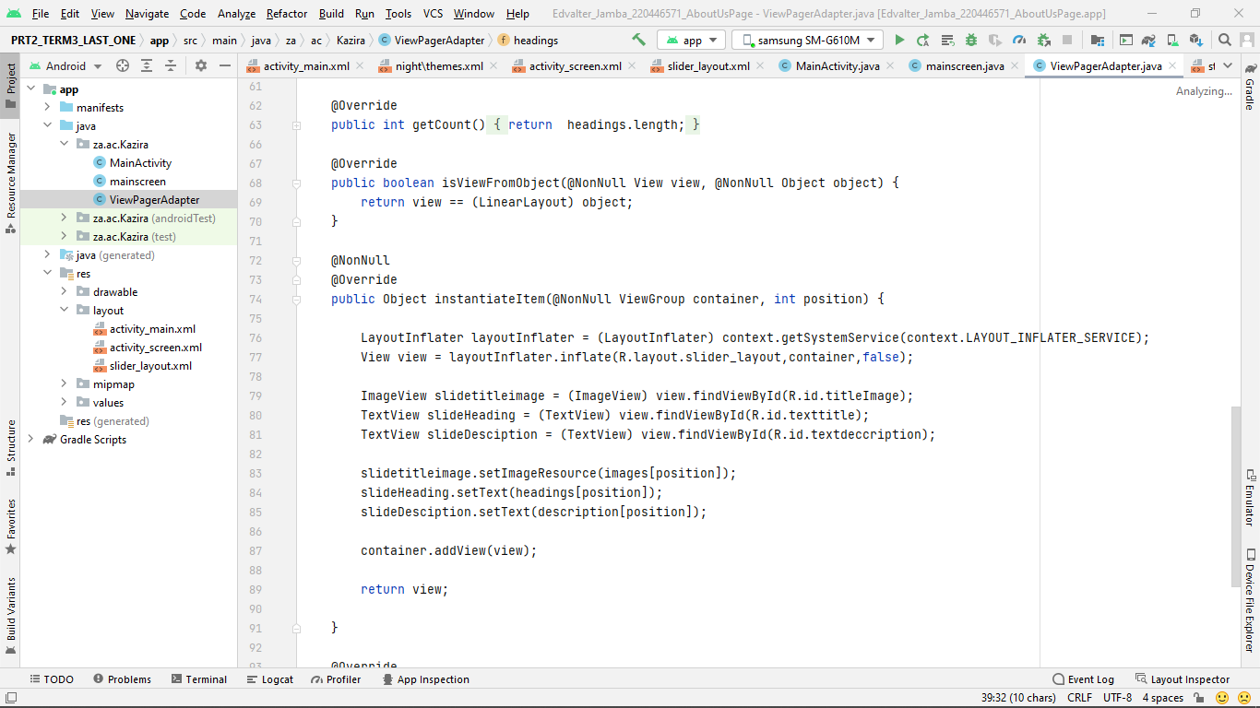

# **Git Hub**

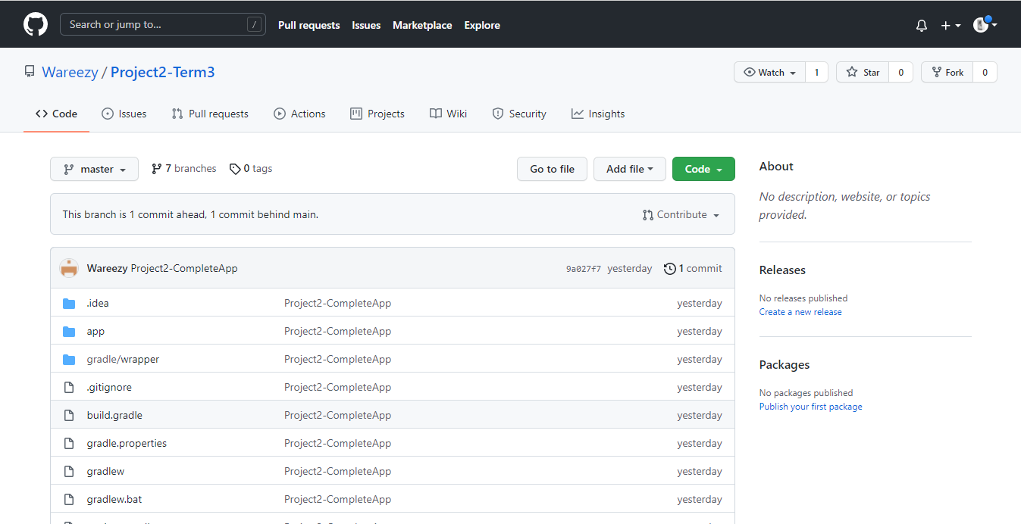I could create my account in GitHub as well I have access to the group Repository as shows in the picture bellow.

As instructed by the Supervisor of the group, for the submission of the link of our GitHub repository the all of us should submit the same link of the repository with the work done in there, So we are able to crate each of us our own branch in the same repository.

## **Link of my GITHUB repository**

https://github.com/Wareezy/Project2-Term3.git

# **CONCLUSION**

In conclusion of this assignment from the steps that I took to get it done am glad to say that I could get a point from this application and that it can be 100% done sooner that I was expecting, in other this application will help a lot many student that has not the possibility or patience to control the time that they are about to get without electricity and I believe as well it will help them to be more organized is this kinds of matters.

**Note:** Hello Sir , am writing this not to explain that I have done a course for **User Experience for Web Design,** the course is for web design, but there is a lot of information that I could get and somehow it helped me a lot for the new version of the “About Us Page”