CSD-310: Database Fundamentals
Module 4.3 Assignment — Movies!

Name: Kristian Wareing
Date: June 29, 2026
Assignment: 4.3 — Entity Relationship Diagram

Entity Relationship Diagram
The following ERD was created based on the business rules provided for the Movies database. The diagram shows three entities — STUDIO, GENRE, and FILM — along with their attributes and relationships.

Business Rules
One STUDIO can produce many FILMs (one-to-many relationship).
One FILM can be described using one GENRE (one-to-one relationship).

ERD Diagram

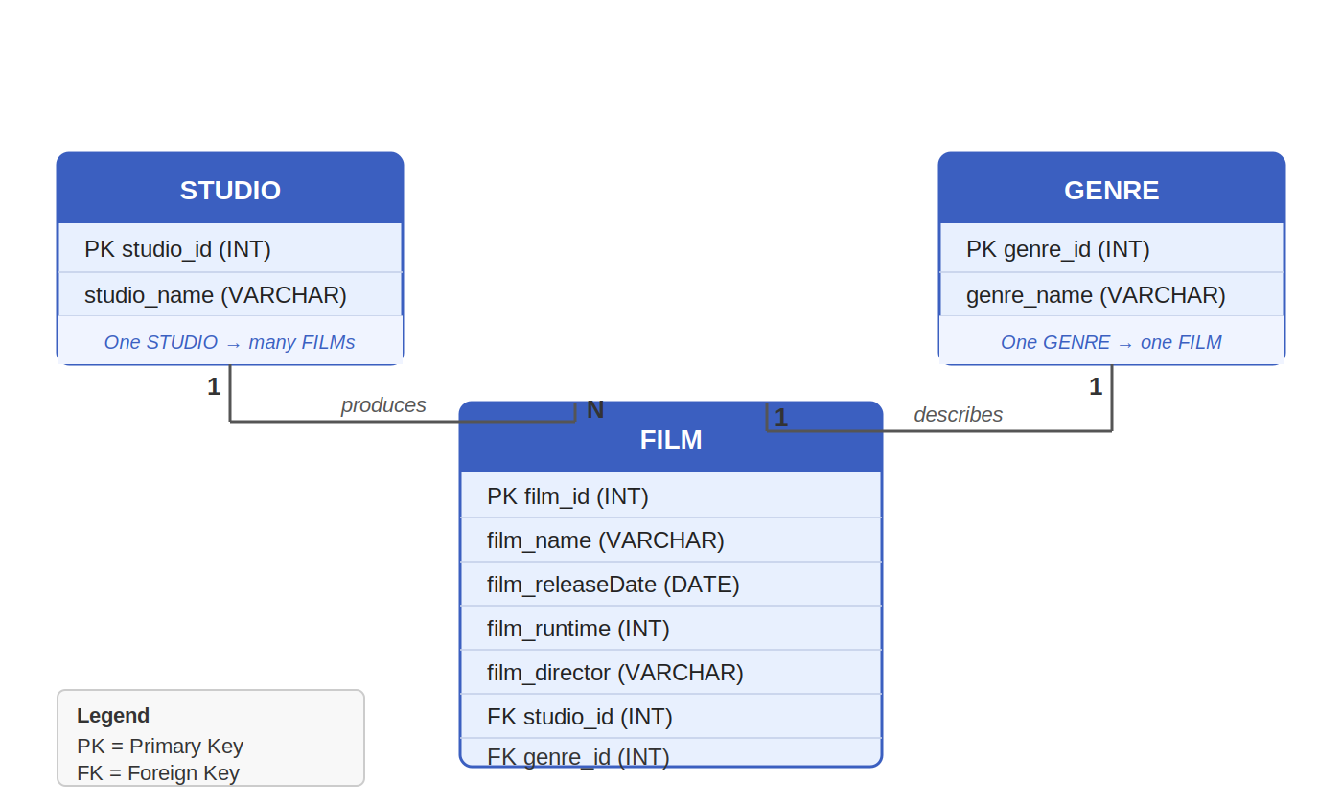

Entity and Attribute Descriptions
STUDIO — Represents the production company. The studio_id serves as the primary key, and studio_name stores the name of the studio. A single studio may be linked to multiple film records through the studio_id foreign key in the FILM table.

GENRE — Represents the category or type of film. The genre_id serves as the primary key, and genre_name stores the genre label (e.g., Action, Drama, Comedy). Each film is associated with exactly one genre.

FILM — The central entity in this diagram. It contains the film_id (primary key), film_name, film_releaseDate, film_runtime, and film_director. The studio_id and genre_id fields are foreign keys that link each film back to its producing studio and its assigned genre respectively.

