CSD-310: Database Fundamentals
Module 4 Assignment

Name: Kristian Wareing
Date: June 29, 2026
Assignment: MySQL Installation and Functions

Section 1: Initial MySQL Database Connection
The screenshot below shows the successful initial connection to the MySQL 8.0 Community Server using the MySQL Command Line Client on Windows. The connection was established using the root account.

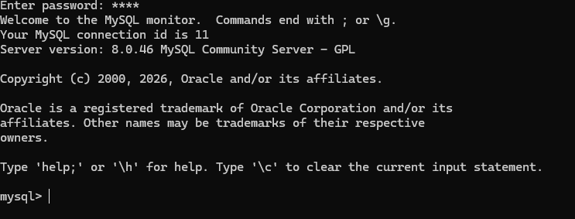

Section 2: Create Database and Show Databases
The following commands were used to create a new database named "movies" and then verify its creation by listing all databases on the MySQL server.

Commands Used:
CREATE DATABASE movies;
SHOW DATABASES;

The screenshot below shows the output of both commands. The "movies" database appears in the list alongside the default system databases (information_schema, mysql, performance_schema, and sys).

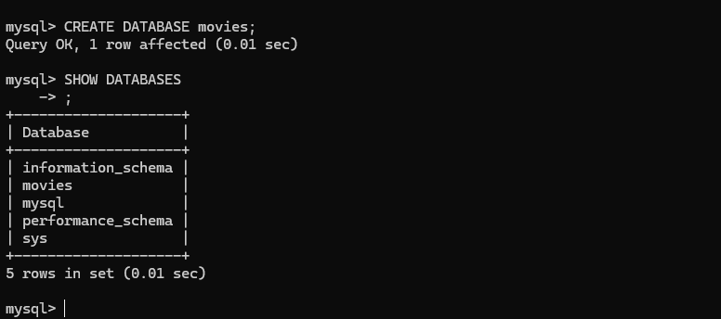

Section 3: MySQL Functions
Three MySQL string and numeric functions were selected from the W3Schools MySQL Function Reference. For each function, an explanation of its use case, an alias for the column header, and the SQL statement with results are provided below.

Function 1: UCASE()
Use Case: The UCASE() function converts all characters in a string to uppercase. This is commonly used when standardizing data for comparisons or display, for example ensuring consistent formatting when searching for user names or storing data that must appear in all caps (such as state abbreviations, country codes, or form labels).

Alias Used: UppercaseName

SQL Statement:
SELECT UCASE("Kristian Wareing") AS UppercaseName;

Function 2: LENGTH()
Use Case: The LENGTH() function returns the number of characters in a string. This is useful for validating input data, such as ensuring a username or password meets a minimum length requirement, or trimming entries that exceed a maximum character limit in a form field or database column.

Alias Used: NameLength

SQL Statement:
SELECT LENGTH("Kristian Wareing") AS NameLength;

Function 3: ROUND()
Use Case: The ROUND() function rounds a numeric value to a specified number of decimal places. This is commonly used in financial and scientific applications, for example rounding prices to two decimal places, calculating averages, or displaying measurements without unnecessary precision.

Alias Used: RoundedPi

SQL Statement:
SELECT ROUND(3.14159, 2) AS RoundedPi;

The screenshot below shows the results of all three functions executed in the MySQL Command Line Client:

