CSD-310: Database Fundamentals
Module 5.2 Assignment — Movies: Setup

Name: Kristian Wareing
Date: June 29, 2026
Assignment: 5.2 — Movies Database Setup
GitHub: https://github.com/l1gw/CSD-310

Section 1: Running the db_init_2022.sql Script
The db_init_2022.sql script was run from the MySQL Command Line Client after switching to the movies database. The script dropped and recreated the studio, genre, and film tables, created the movies_user account, granted privileges, and inserted sample records for studios, genres, and films.

Commands used:
USE movies;
source C:/Users/l1gw/Downloads/db_init_2022.sql

The screenshot below shows the output after running the script. All commands completed with Query OK, confirming successful execution.

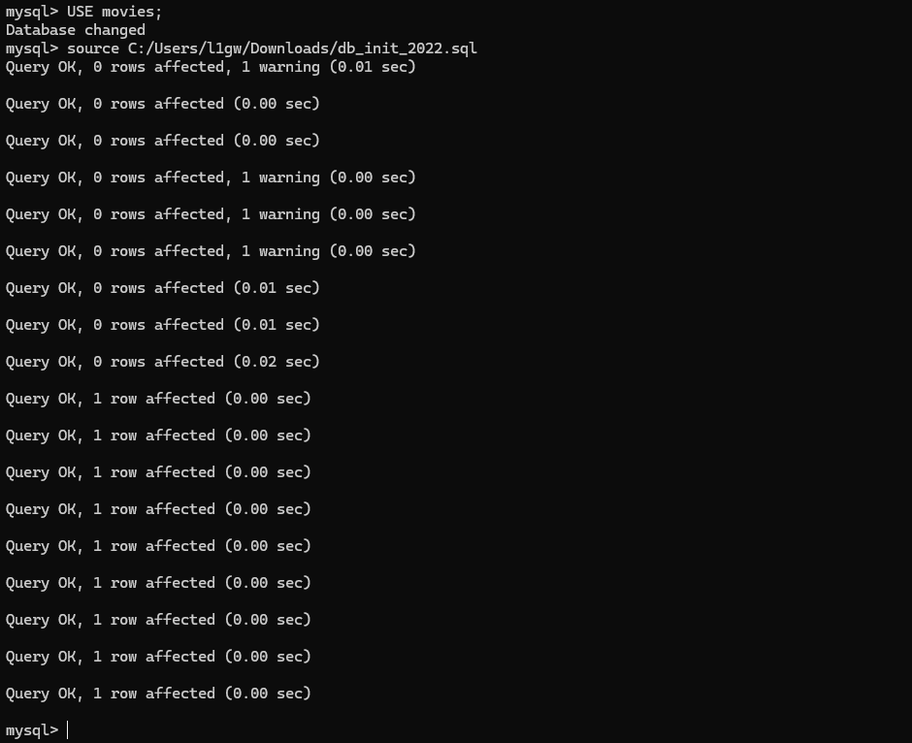

Section 2: SHOW TABLES
After running the initialization script, the SHOW TABLES command was used to verify that all three tables were successfully created in the movies database.

SHOW TABLES;

The screenshot below confirms that the film, genre, and studio tables all exist in the movies database.

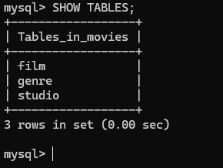

Section 3: Python MySQL Connector Test
The mysql-connector-python and python-dotenv packages were installed using pip. A .env file was created in the module-5 directory containing the database credentials, and a mysql_test.py script was written to test the connection to the movies database using those credentials.

Packages Installed
pip install mysql-connector-python
pip install python-dotenv

.env File Contents
USER=movies_user
PASSWORD=popcorn
HOST=localhost
DATABASE=movies
RAISE_ON_WARNINGS=True

Connection Test Result
The mysql_test.py script was run from the module-5 directory and successfully connected to the movies database as movies_user on localhost, confirming that the Python connector and .env configuration are both working correctly.

