Kristian Wareing
Assignment 2.3 – Data Models

Entity Relationship Diagram (ERD)

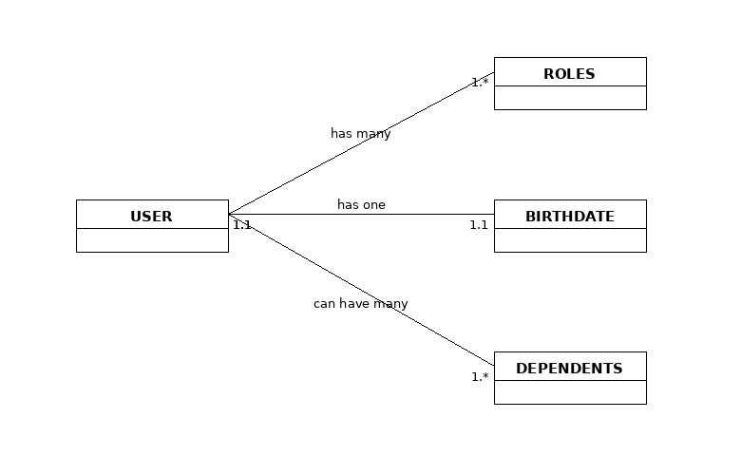

NoSQL Data Structure
