Kristian Wareing
CSD-325 Advanced Python
Module 10 Assignment - Tkinter To-Do List

Part 1: Original Tutorial Program
The code from Listing 2.2 (Our Scrolling To-Do) in Tkinter By Example was entered into a Python file, saved to the module-10 directory, and run with a couple of tasks added.
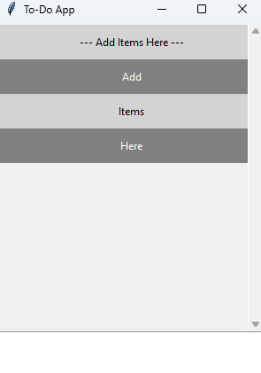
Figure 1: The unmodified program with three tasks added.

Part 2: Modifications
The following changes were made to the tutorial program:
- The window title was changed to Wareing-ToDo.
- Task items alternate between two complementary colors, violet (#9400D3) and gold (#E5C100). The text color flips between white and dark violet so each row stays readable.
- Tasks are now deleted with the right mouse button instead of the left, using a bind to <Button-3>.
- The label at the top of the list reads "Items Added --- ** Right Click Item to Delete **" so the user knows how to remove a task.
- A File menu was added with an Exit item that closes the program.

Screenshot 1: Program Running with Tasks Added
Four tasks have been added to the list. The File menu is open to show the Exit option, and the alternating violet and gold coloring is visible.
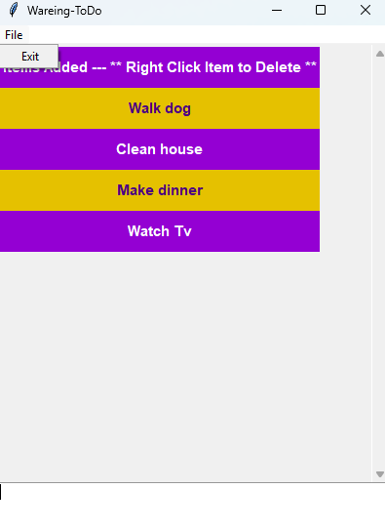
Figure 2: Modified program with tasks added and the File > Exit menu open.

Screenshot 2: After Deleting a Task
The task "Watch Tv" was removed by right clicking it. The remaining tasks shift up and re-color so the alternating pattern is preserved.
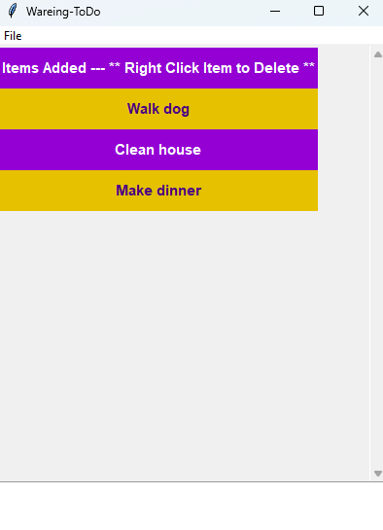
Figure 3: The list after right clicking a task to delete it.

Screenshot 3: All Tasks Removed
With every task deleted, only the instruction label remains. The label cannot be deleted because the right click event is only bound to the task items themselves.
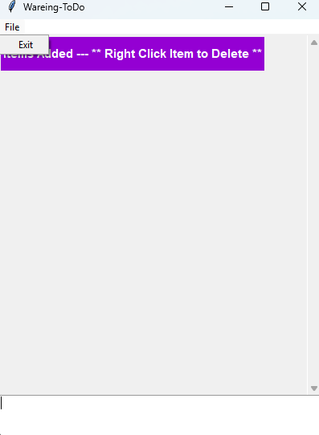
Figure 4: The instruction label remains after all tasks are deleted.

