Kristian Wareing
CSD-325: Advanced Python
Module 7 Assignment: Testing Your Code
July 12, 2026

Screenshot 1: city_country() with City and Country
The function accepts a city and a country and returns a string of the form "City, Country". It is called three times in city_functions.py.
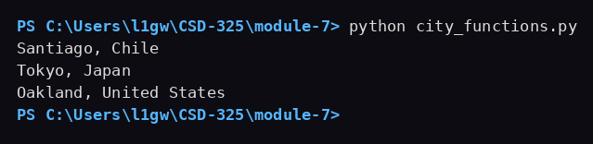

Screenshot 2: test_cities.py passes
test_city_country() calls the function with Santiago and Chile and asserts the result equals "Santiago, Chile". The test passes.
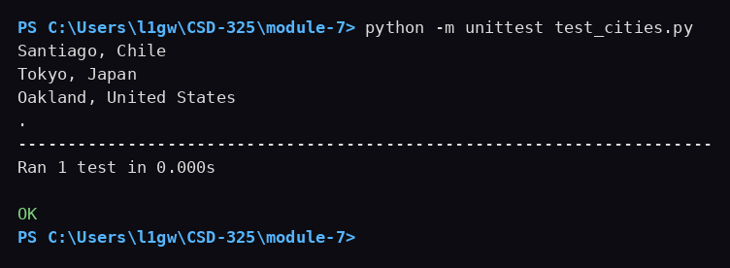

Screenshot 3: Test fails after population becomes required
Adding a required population parameter breaks the existing test. The test calls city_country() with only two arguments, so Python raises a TypeError for the missing positional argument.
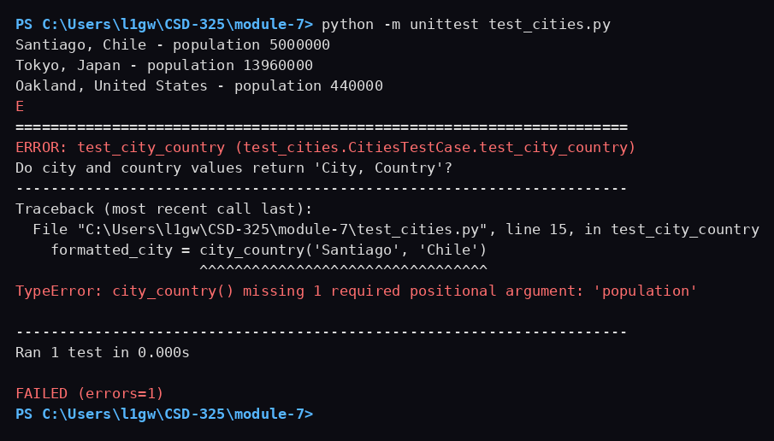

Screenshot 4: Test passes after population becomes optional
Giving population a default value of an empty string makes the third argument optional, so the original two-argument call works again and the test passes.
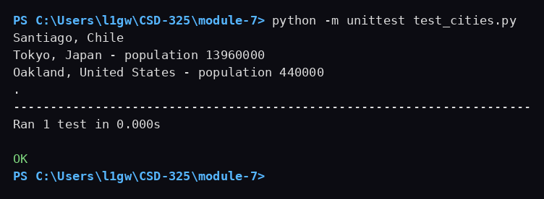

Screenshot 5: Test fails after language becomes required
Adding a required language parameter breaks the test again, this time with two missing positional arguments.
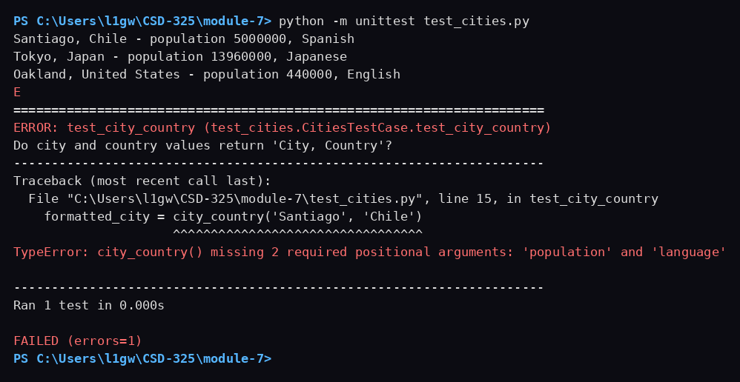

Screenshot 6: Test passes after language becomes optional
Giving language a default value of an empty string makes the fourth argument optional, and the test passes again.
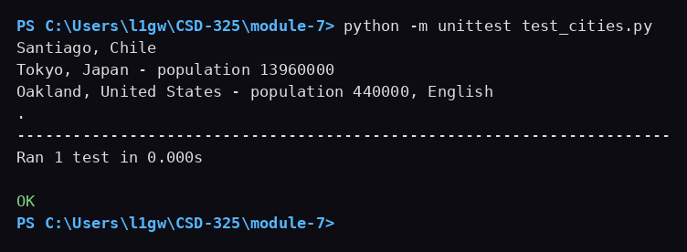

Screenshot 7: Final run of city_functions.py
The final version is called three times: once with city and country, once with city, country, and population, and once with city, country, population, and language.
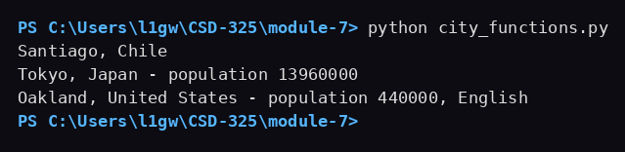

Source Code: city_functions.py
# Kristian Wareing
# 07/12/2026
# CSD-325 Module 7 Assignment
# Purpose: Build a formatted city string with optional population and language.

def city_country(city, country, population='', language=''):
"""Return 'City, Country' plus population and language when provided."""
formatted_city = f"{city.title()}, {country.title()}"

# Only append the population when the caller supplies one.
if population:
formatted_city += f" - population {population}"

# Only append the language when the caller supplies one.
if language:
formatted_city += f", {language.title()}"

return formatted_city

# Call the function with two, three, and four arguments.
print(city_country('santiago', 'chile'))
print(city_country('tokyo', 'japan', 13960000))
print(city_country('oakland', 'united states', 440000, 'english'))

Source Code: test_cities.py
# Kristian Wareing
# 07/12/2026
# CSD-325 Module 7 Assignment
# Purpose: Unit test for the city_country() function in city_functions.py.

import unittest
from city_functions import city_country

class CitiesTestCase(unittest.TestCase):
"""Tests for city_functions.py."""

def test_city_country(self):
"""Do city and country values return 'City, Country'?"""
formatted_city = city_country('Santiago', 'Chile')
self.assertEqual(formatted_city, 'Santiago, Chile')

if __name__ == '__main__':
unittest.main()

