Kristian Wareing
Assignment 2.2 – Documented Debugging

Program Overview
The program selected is a Grade Calculator written in Python. It contains two functions: calculate_average(), which loops through a list of scores and returns the numeric average, and get_letter_grade(), which maps that average to a letter grade. The main() function initializes the scores, calls both functions, and prints the results.

Screenshot 1 – Breakpoint Set
A breakpoint was placed on line 31 inside main(), where the scores list is initialized. The debugger is paused at the breakpoint before execution continues. The Call Stack panel on the right confirms the program is paused on the breakpoint.
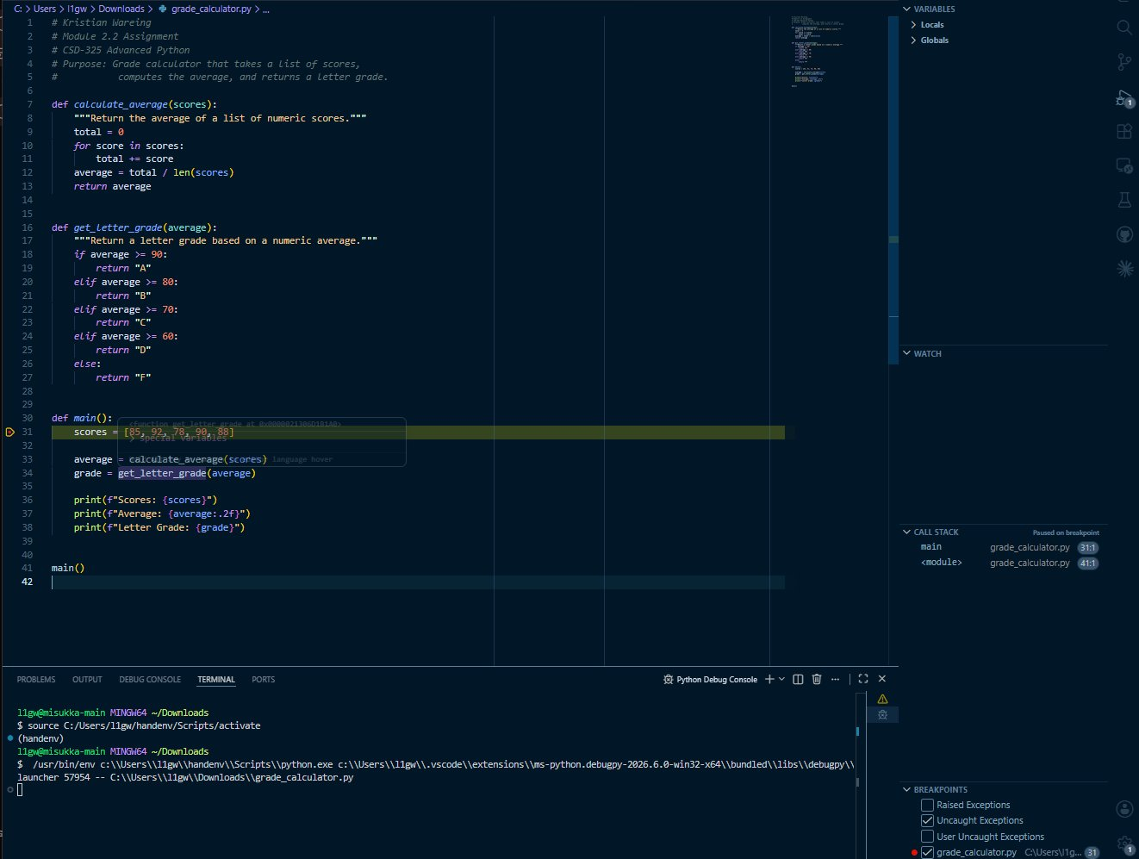
Screenshot 2 – Step Into: Variables Panel
After stepping forward, the debugger has moved to line 33 where calculate_average(scores) is called. The Variables panel on the right now shows the scores list [85, 92, 78, 90, 88] loaded into memory. The Call Stack confirms the debugger is paused on a step inside main().
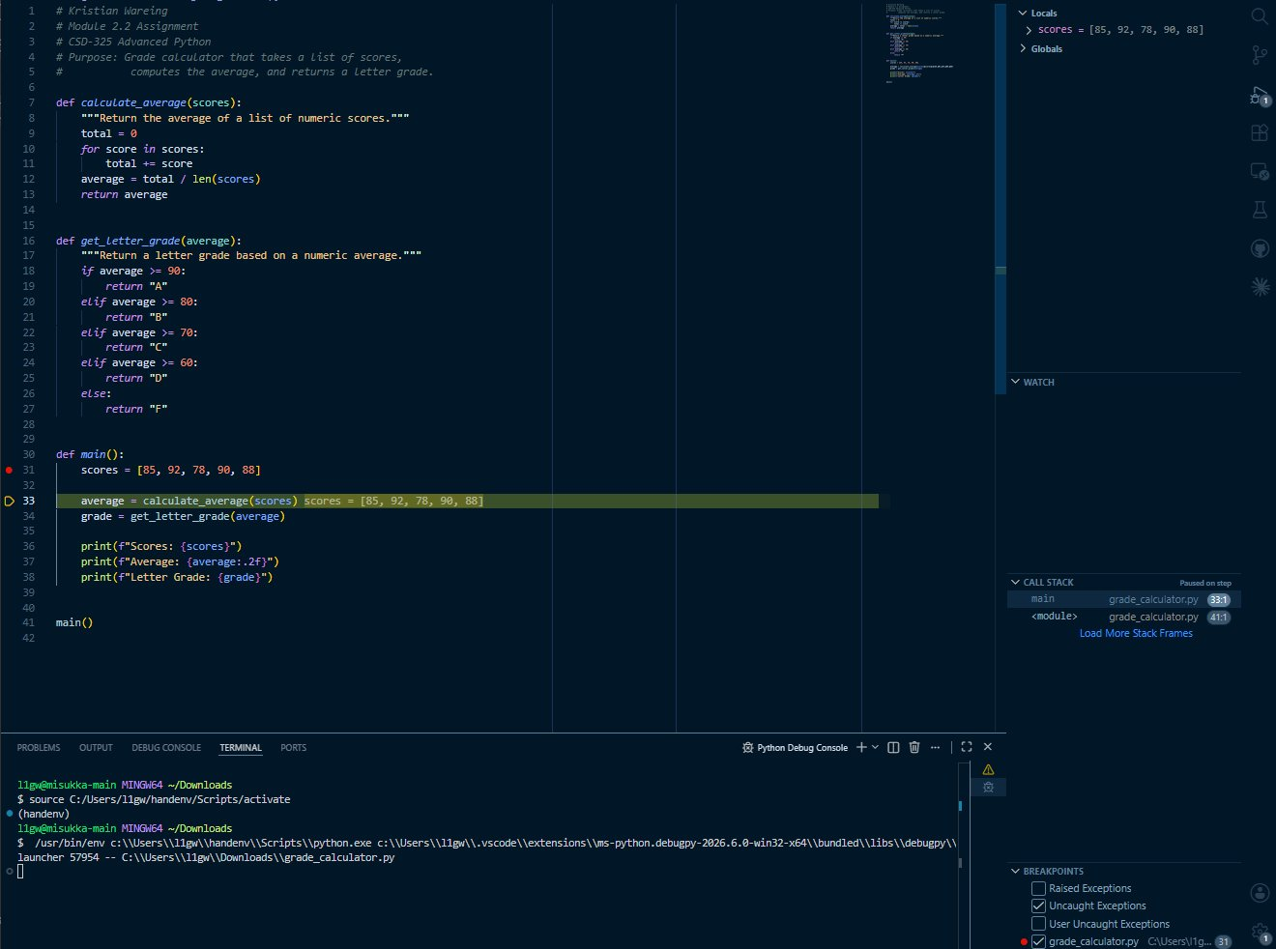
Screenshot 3 – Return Value and Program Output
After stepping through calculate_average(), the Variables panel shows average = 86.6 and the return value of 86.6 confirmed. The debugger has advanced to line 34 where get_letter_grade() is called next. The terminal at the bottom shows the full program output: Scores, Average: 86.60, and Letter Grade: B.
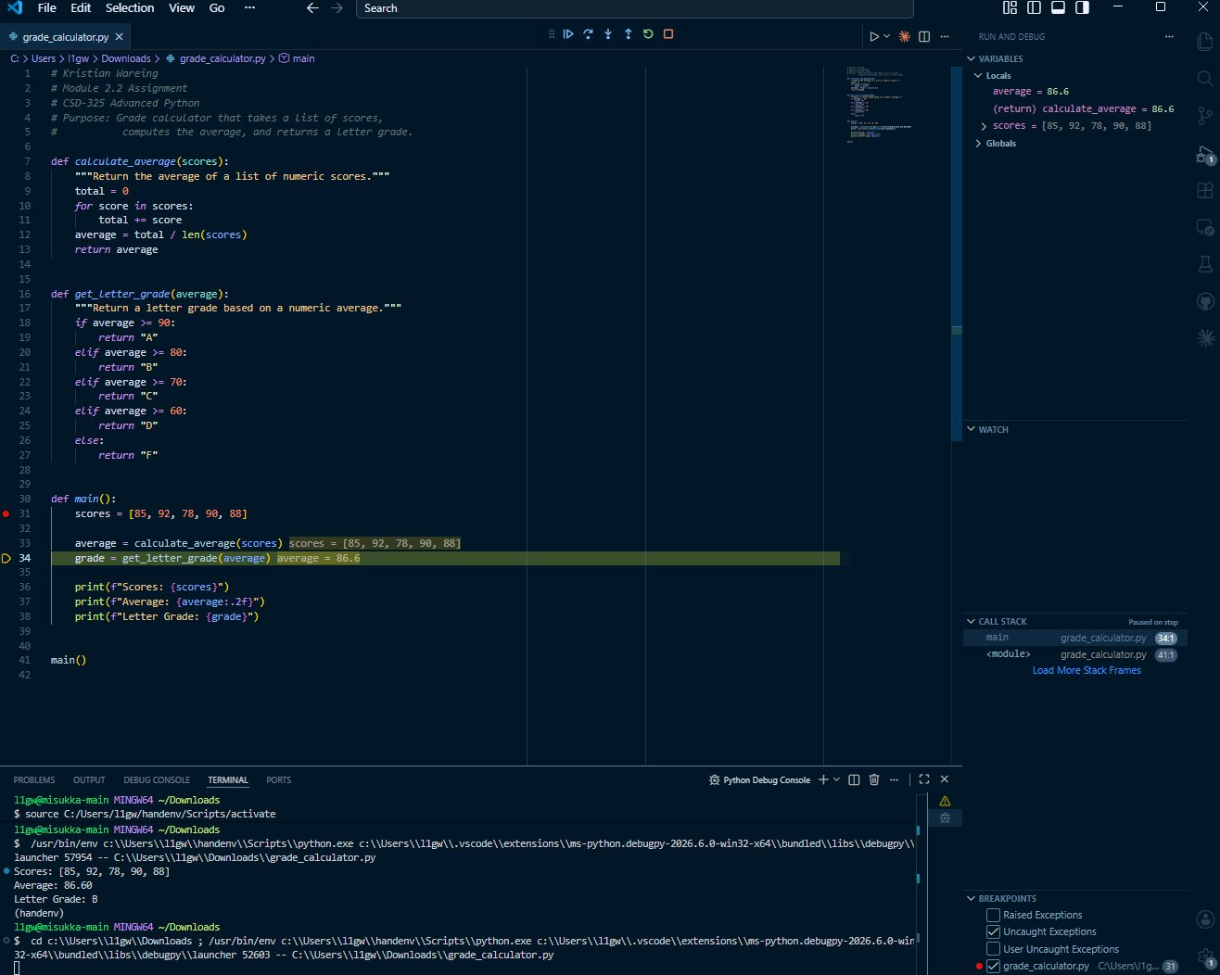

References
Abiola, G. (2017). Debugging in Python. Codementor. https://www.codementor.io/@gbozee/debugging-in-python-9ia7lof32

