Kristian Wareing
CSD-325 - Assignment 9: APIs
Module 9

Part 1: Tutorial - Connection Test
The first part of the tutorial tests the connection to a URL and prints the status code the server returns. A status code of 200 means the request was successful. This was done in tutorial_api.py using the requests library against google.com and the Open Notify astronaut API.



Part 2: Tutorial - Current Astronauts
The second part of the tutorial retrieves the list of people currently in space from http://api.open-notify.org/astros.json. The response comes back as JSON, gets converted to a Python dictionary with .json(), and is then printed twice: once with no formatting, and once formatted with each person's name and spacecraft on their own lines.

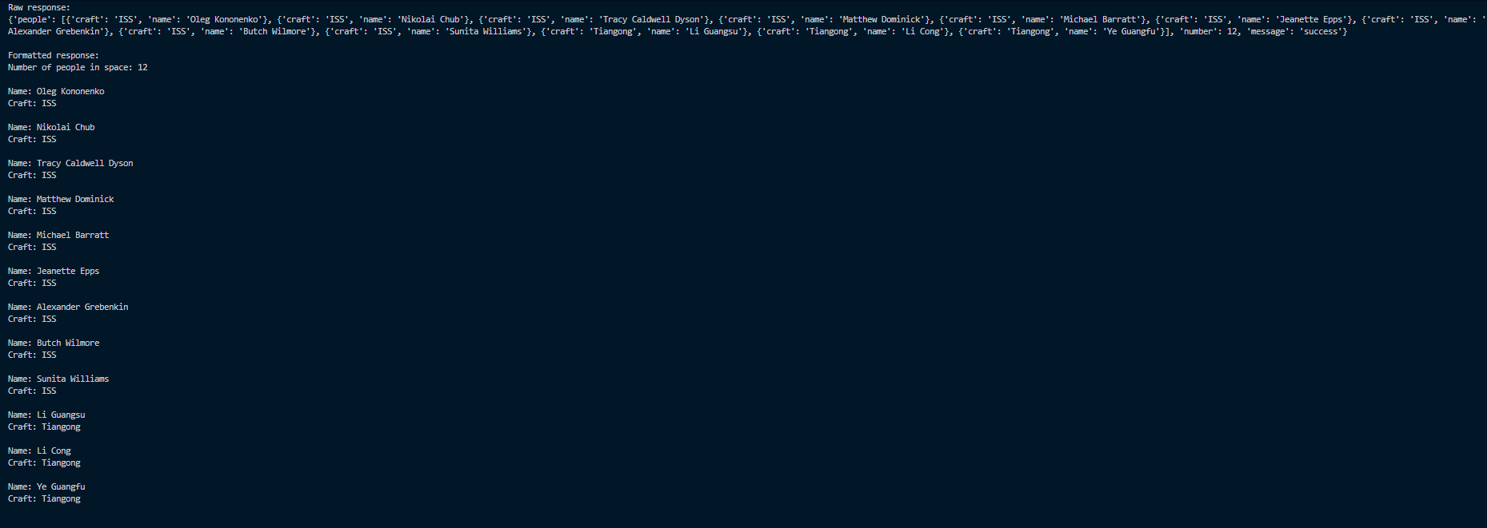Part 3: API of My Choice - PokeAPI
For the second program I used PokeAPI, a free public REST API for Pokemon data. It was listed in the Stoplight article of simple APIs. It requires no API key and no account, so the request is just a plain GET to the endpoint.
Base URL: https://pokeapi.co/api/v2
Endpoint used: https://pokeapi.co/api/v2/pokemon/{name}
The program (pokemonAPI.py) does three things:
1. Tests the connection by requesting one Pokemon and printing the status code.
2. Prints that same response raw, with no formatting, which shows how dense the unformatted JSON dictionary is.
3. Prints the response formatted the same way as the tutorial program, pulling out the name, Pokedex number, height, weight, and base experience, then looping through the nested 'types' and 'abilities' lists to print each one on its own line. This repeats for three Pokemon.

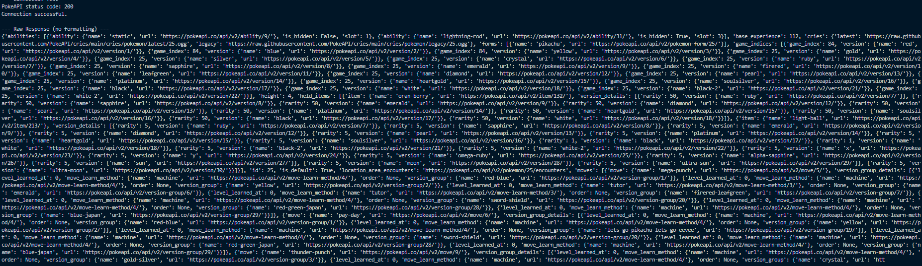

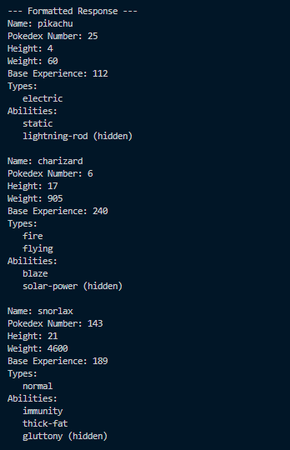

Summary
Both programs follow the same pattern the tutorial demonstrates: send a GET request with the requests library, check the status code before doing anything with the data, convert the JSON response into a Python dictionary, and then loop through the results to print them in a readable format. The main difference with PokeAPI is that some of the values are nested lists of dictionaries rather than plain strings, so getting to a value like an ability name means indexing down two levels instead of one.

