Kristian Wareing
CSD-325: Advanced Python
Module 8 Assignment: JSON and Flowcharts
July 12, 2026

Flowchart
The flowchart models the main program on the left and the print_students() function on the right. It is also saved separately as Wareing_Module8_Flowchart.pdf in the module-8 directory.
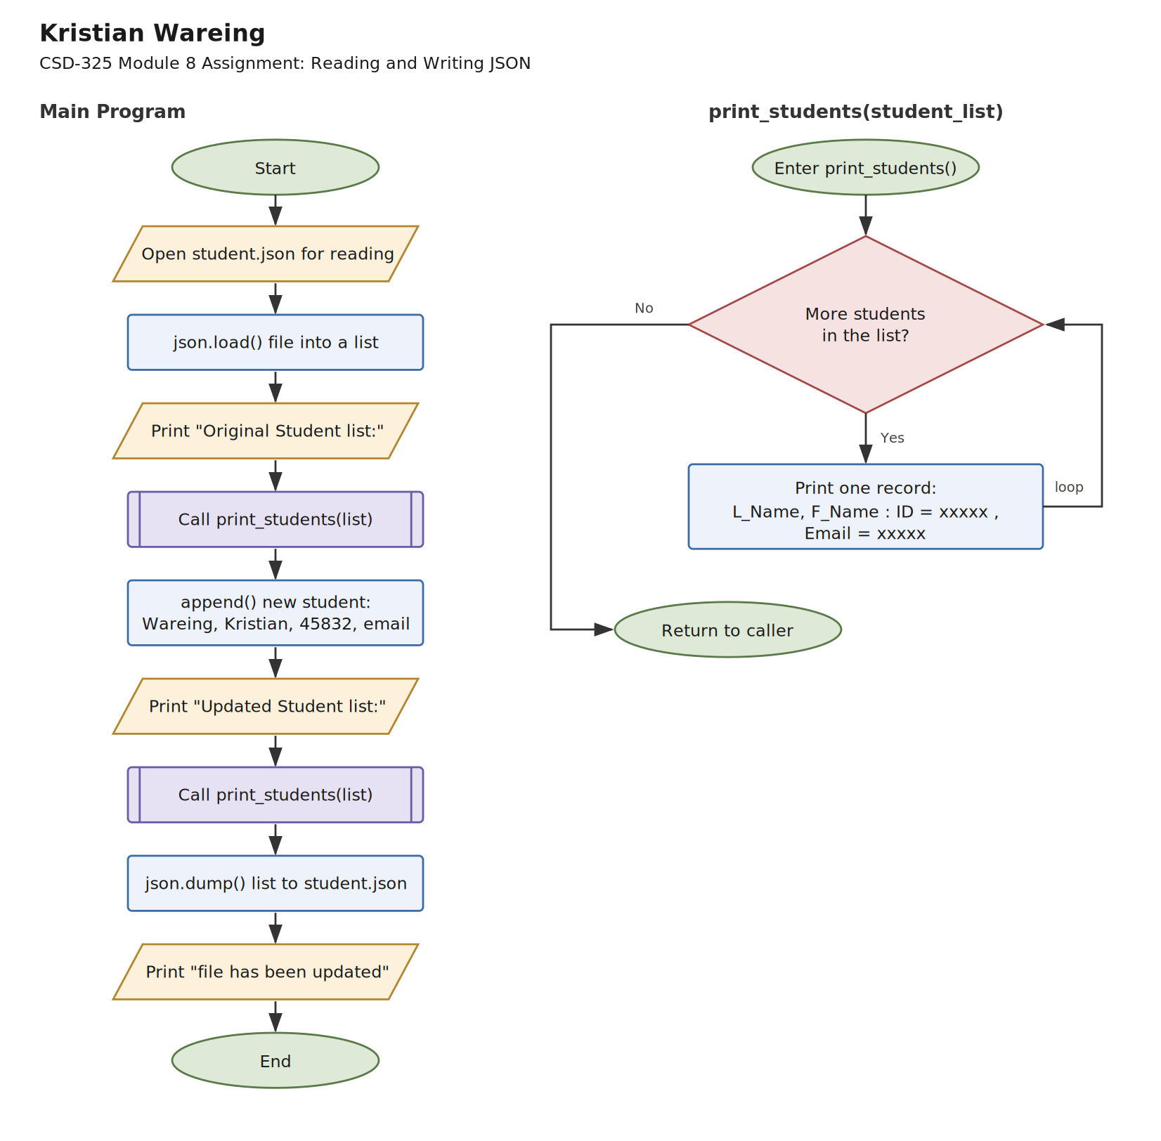

Screenshot 1: Program output
The program loads student.json, prints the original list, appends a new student record, prints the updated list, writes the list back to the file, and confirms the update.
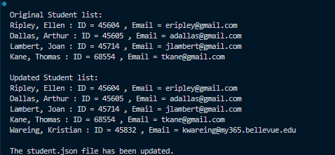

Screenshot 2: student.json modified outside notification
After the program ran, student.json was changed on disk while it was still open in the editor. VS Code reloads changed files automatically instead of showing a reload prompt, so the notification below is the equivalent warning it raises: the copy on disk is newer than the copy in the editor.
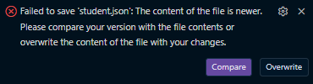

Contents of student.json after running the program
[
{
"F_Name": "Ellen",
"L_Name": "Ripley",
"Student_ID": 45604,
"Email": "eripley@gmail.com"
},
{
"F_Name": "Arthur",
"L_Name": "Dallas",
"Student_ID": 45605,
"Email": "adallas@gmail.com"
},
{
"F_Name": "Joan",
"L_Name": "Lambert",
"Student_ID": 45714,
"Email": "jlambert@gmail.com"
},
{
"F_Name": "Thomas",
"L_Name": "Kane",
"Student_ID": 68554,
"Email": "tkane@gmail.com"
},
{
"F_Name": "Kristian",
"L_Name": "Wareing",
"Student_ID": 45832,
"Email": "kwareing@my365.bellevue.edu"
}
]

Source Code: student_json.py
# Kristian Wareing
# 07/12/2026
# CSD-325 Module 8 Assignment
# Purpose: Load student records from a JSON file, print them, append a new
# student to the list, and write the updated list back to the file.

import json
import os

# Build the path to student.json based on where this script lives, so the
# program works no matter which directory it is launched from.
SCRIPT_DIR = os.path.dirname(os.path.abspath(__file__))
FILE_NAME = os.path.join(SCRIPT_DIR, 'student.json')

def print_students(student_list):
"""Loop through the student list and print each record on one line."""
for student in student_list:
print(f"{student['L_Name']}, {student['F_Name']} : "
f"ID = {student['Student_ID']} , "
f"Email = {student['Email']}")

def main():
"""Read the file, show the original list, append a student, save the file."""

# Load the JSON file into a Python list of dictionaries.
with open(FILE_NAME, 'r') as input_file:
students = json.load(input_file)

# Show the list exactly as it was loaded from the file.
print('\nOriginal Student list:')
print_students(students)

# Add a new student record to the end of the list.
new_student = {
'F_Name': 'Kristian',
'L_Name': 'Wareing',
'Student_ID': 45832,
'Email': 'kwareing@my365.bellevue.edu'
}
students.append(new_student)

# Show the list again now that the new record has been added.
print('\nUpdated Student list:')
print_students(students)

# Write the updated list back out to the JSON file.
with open(FILE_NAME, 'w') as output_file:
json.dump(students, output_file, indent=4)

print("\nThe student.json file has been updated.")

if __name__ == '__main__':
main()

