Kristian Wareing
CSD-325 Advanced Python
Module 11 Assignment: Django Basics
Screenshot 1: Django development server running at 127.0.0.1:8000
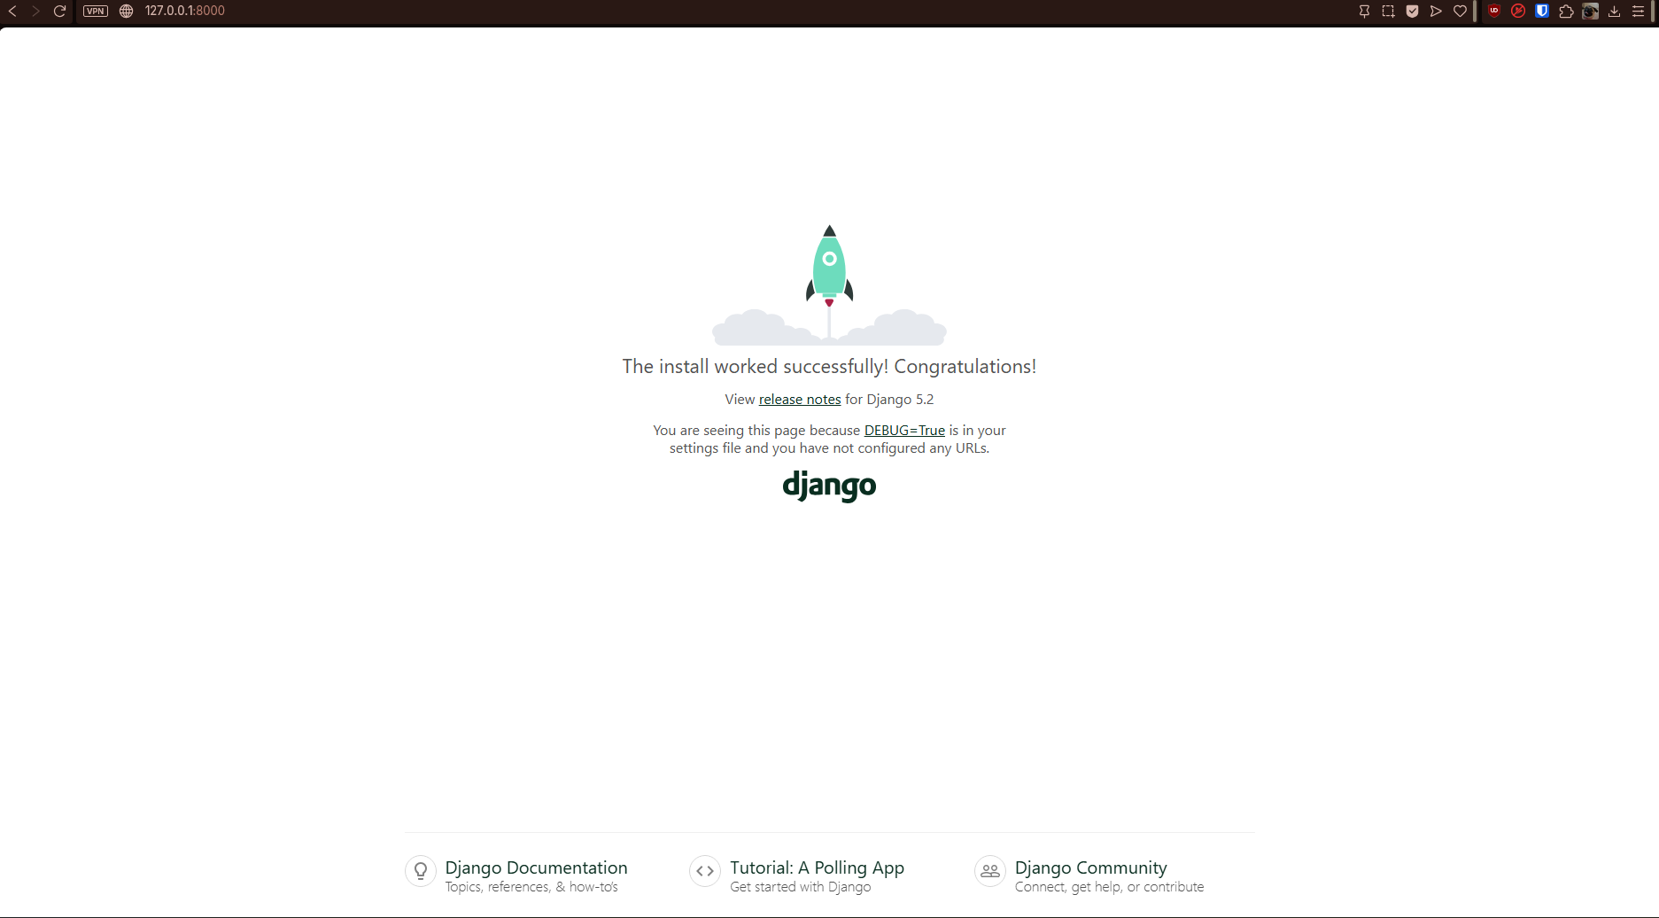
Screenshot 2: HttpResponse modified to display "Wareing says Hello!"
