CSD-325: Advanced Python
Module 4.2 Assignment — High/Low Temperatures

Name: Kristian Wareing
Date: June 29, 2026
Assignment: 4.2 — Sitka High/Low Temperatures

Part 1: Original Flowchart — sitka_highs.py
The flowchart below models the flow of execution of the original sitka_highs.py program. The program opens the CSV file, reads each row to collect dates and high temperatures, then plots the data as a red line chart and displays it.

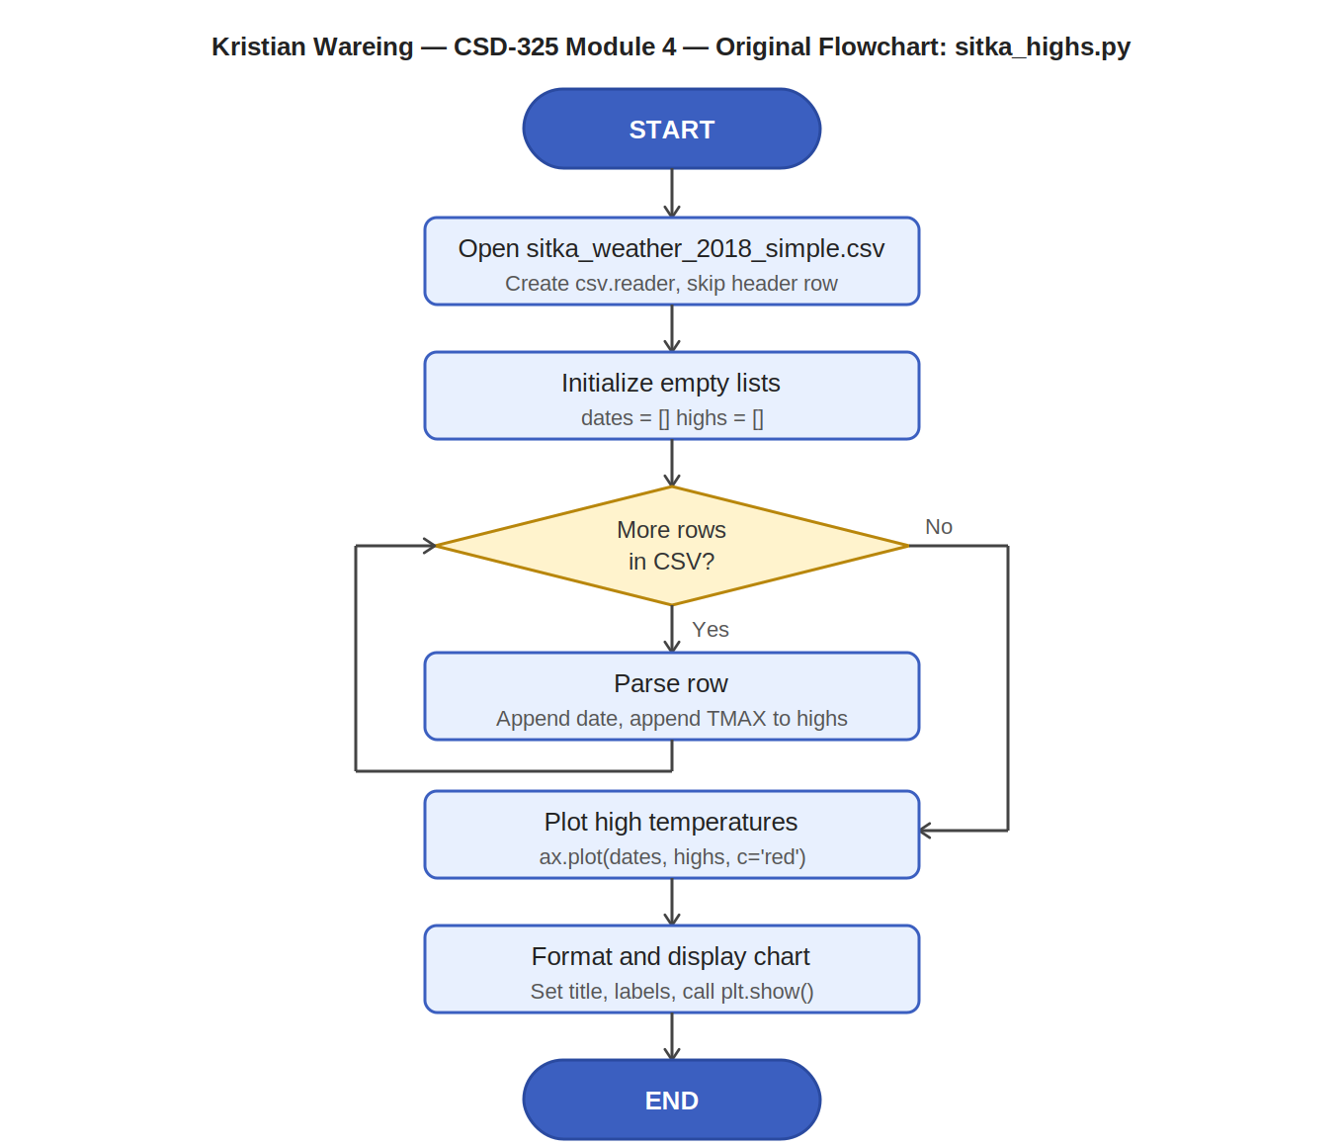

Part 2: Modified Program — sitka_high_low_kw.py
The original sitka_highs.py was modified with the following changes:

Changes Made
1. Added a menu system that displays on program start with three options: H (Highs), L (Lows), and E (Exit).
2. Added low temperature support by reading the TMIN column (index 6) from the CSV in addition to TMAX (index 5).
3. When the user selects Lows, a blue line chart of daily low temperatures is displayed.
4. The menu loops continuously until the user selects Exit.
5. On Exit, a goodbye message is printed and sys.exit(0) terminates the program.
6. Invalid inputs print an error message and re-display the menu.
7. Data is loaded once before the loop begins to avoid re-reading the file on each iteration.
8. Full documentation header added per documentation requirements.

Part 3: Revised Flowchart — sitka_high_low_kw.py
The revised flowchart below reflects all changes made to the program, including the menu loop, the high/low branch logic, the invalid input path, the exit condition, and the goodbye message before sys.exit().

