GitHub Repository Setup
Kristian Wareing
CSD 340 Web Development with HTML and CSS
Instructor: Sue Sampson

1. GitHub Repository Link
https://github.com/WareingK/csd-340

2. Local Directory
Output of dir run inside the cloned repository at C:\Users\l1gw\csd\csd-340, showing the module-01 through module-11 folders along with the cloned LICENSE and README.md files.
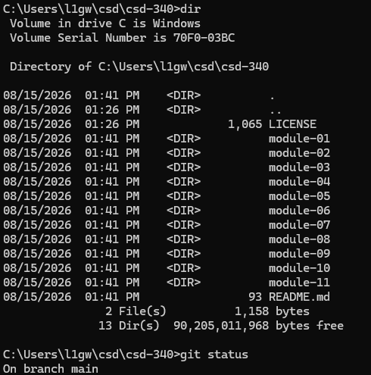

3. GitHub Repository
Repository landing page showing the module folder structure and the updated README.md with the h1 title, h2 Contributors header, and contributor list.
