Assignment 1.3 – Building a Web Page Exercise, Part 1
Kristian Wareing
CSD 340 Web Development with HTML and CSS
August 15, 2026

GitHub Repository Link
https://github.com/WareingK/csd-340

1. Initial Validation Results
W3C Markup Validation Service results for the starter code, showing three errors: an empty title element, an end tag appearing after body had been closed, and a stray thml end tag.
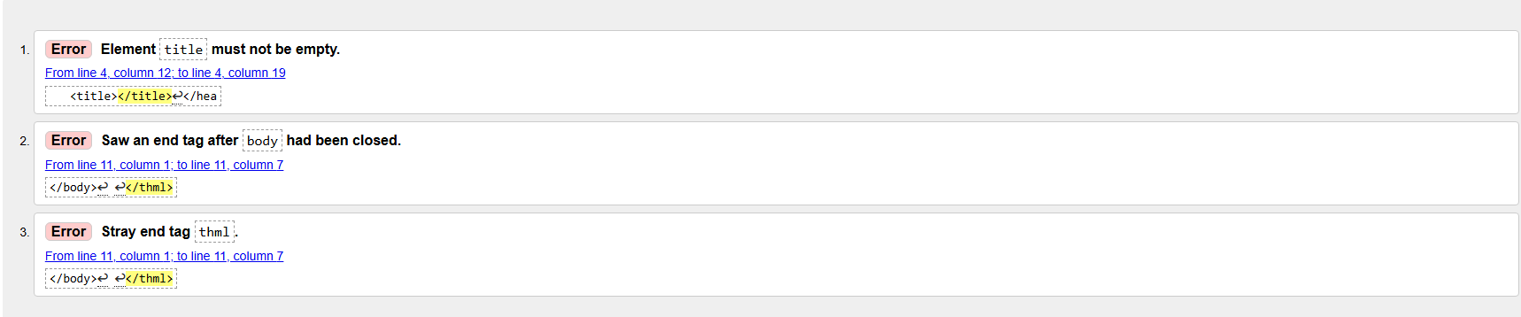

2. Validation After Correcting the Errors
The title element was given content and the misspelled closing thml tag was corrected to html. Re-validating the markup returned no errors or warnings.
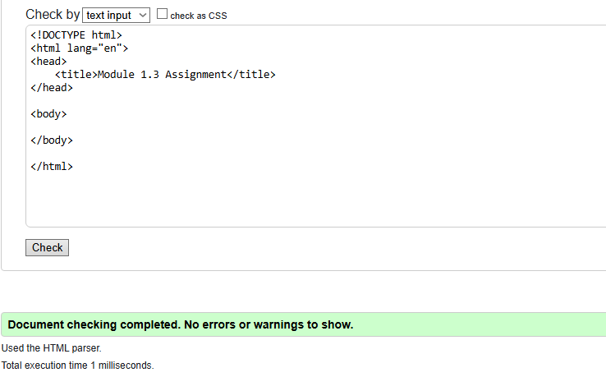

3. Validation After Adding Page Content
The h1 heading and the location and weather sentence were added to the body, and the title was updated to "CSD 340 Web Development with HTML and CSS". Re-validating returned no errors or warnings.
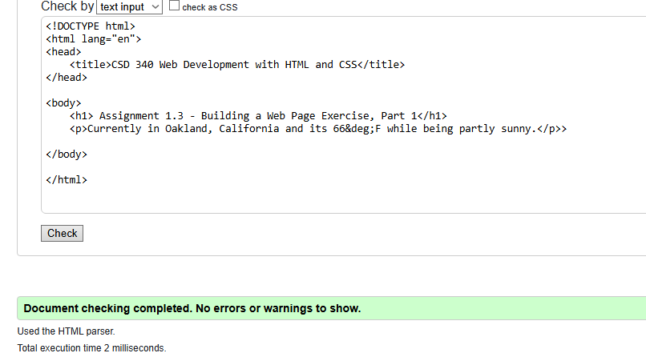

4. Browser Output
The finished page rendered in the browser, showing the h1 heading and the sentence with the degree symbol produced by the &deg; character entity.
