Kristian Wareing
August 23, 2026
CSD 340 – Assignment 3.3 – GitHub Pages Landing Page
Repository: https://github.com/WareingK/csd-340
GitHub Pages URL: https://wareingk.github.io/csd-340/
Figure 1 – W3C HTML Validator results for index.html (0 errors)
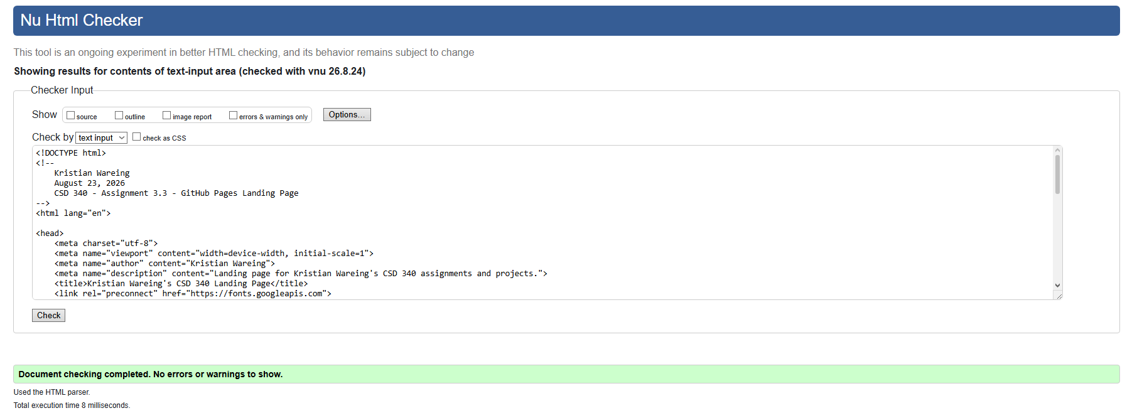
Figure 2 – W3C CSS Validator results for site.css (0 errors)
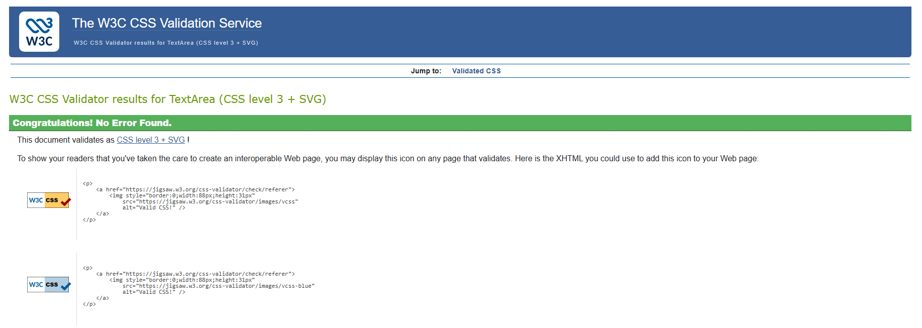
Figure 3 – index.html rendered in a browser from GitHub Pages
