JavaFX HBox and VBox Layout Panes

Kristian Wareing
Bellevue University
CSD-402: Java for Programmers
October 11, 2026
JavaFX HBox and VBox Layout Panes
When you build a JavaFX app, everything on screen lives in a scene graph, which is a tree of nodes the runtime draws for you. You could place every button and label yourself using exact coordinates, but that becomes hard to manage quickly, and the layout breaks as soon as someone resizes the window. That is the problem layout panes solve. They are containers that figure out where their children should go and rearrange them on their own whenever the available space changes (Oracle, 2014). I picked HBox and VBox, two of the simplest panes, and I will go over how each one works, which properties matter, and how I combined them in a small 2010s-style music player program submitted with this paper.
HBox
An HBox lines its children up side by side, left to right, in the same order you add them (OpenJFX, n.d.-a). Each resizable child starts out at its preferred width, and the HBox itself wants to be as wide as all of those children combined, plus any spacing and padding. Spacing is the gap between neighboring children, and padding is the space between the children and the edge of the box. Alignment decides where the whole group sits inside the HBox. One thing that caught me off guard is that alignment defaults to the top-left corner, so if you want a row centered, you have to set that yourself (Jenkov, 2020).
The most important thing to understand about HBox is what happens with extra space. If the window is wider than the row needs, the children stay at their preferred widths and the leftover space is left empty. A child only gets that extra room if you give it a horizontal grow priority with the static setHgrow method, and if more than one child has the same priority, they split the space evenly (OpenJFX, n.d.-a). There is also a property called fillHeight, which is on by default and stretches each resizable child vertically so it matches the height of the row. In Oracle's layout tutorial, the HBox is used as a toolbar along the top of the window, which is one of its most common uses (Oracle, 2014).
VBox
A VBox is the same idea turned on its side. It stacks its children one above another, from top to bottom, and its API is almost identical to HBox (OpenJFX, n.d.-b). Spacing becomes the vertical gap between items, padding works the same way, and alignment once again defaults to the top-left. Instead of setHgrow, VBox uses setVgrow to let a child take up extra vertical space, and instead of fillHeight it has fillWidth, which stretches children across the column's width by default (Jenkov, 2021). VBox makes the most sense for things that naturally read top to bottom, like forms, settings screens, and side menus.
Combining HBox and VBox
These panes really get useful when you put one inside the other. Every pane counts as a node, so you can place an HBox inside a VBox as a single row, and the VBox treats that whole row as one item (Oracle, 2014).
That is exactly how my program, MusicPlayer.java, is built. The root is a VBox that stacks five things: the song title, a square album cover that I drew in code, the artist name, and two HBox rows. I gave the root top-center alignment and 14 pixels of spacing, so everything stays centered no matter how wide the window is. The first HBox holds the previous, play, and next buttons, centered, and styled like the glossy buttons from early 2010s music players. The second HBox has Share, Like, and Add buttons, with an empty Region sitting between Share and Like. I set that Region's grow priority to ALWAYS, so when you stretch the window, it takes up all of the new width. That keeps Share pinned to the left edge while the other two buttons stay on the right. Without the spacer, all three buttons would stay grouped on the left side of the row, which is the default behavior (OpenJFX, n.d.-a). Figure 1 shows the program running.
Figure 1
MusicPlayer.java Running With the Window Widened
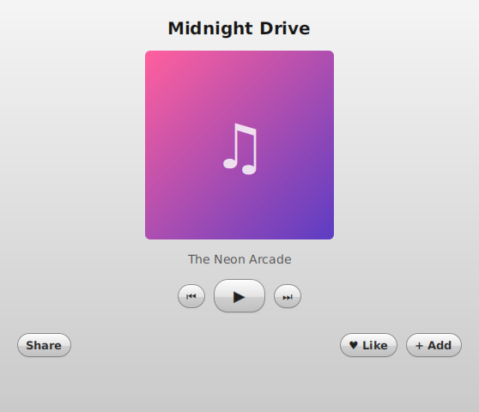
Note. The empty Region between Share and Like absorbs the added width, while the centered rows above it stay centered.
Conclusion
HBox and VBox each only handle one direction, but between the two of them you can build a lot of the layouts you see in everyday apps. Once you understand spacing, padding, alignment, and especially grow priorities, most of their behavior makes sense. Nesting them like I did in the music player gives you a clean screen that resizes properly without positioning anything by hand, which is good practice before moving on to panes like BorderPane and GridPane.
References
Jenkov, J. (2020, February 5). JavaFX HBox. Jenkov.com. https://jenkov.com/tutorials/javafx/hbox.html
Jenkov, J. (2021, March 9). JavaFX VBox. Jenkov.com. https://jenkov.com/tutorials/javafx/vbox.html
OpenJFX. (n.d.-a). Class HBox (JavaFX 27 API documentation). https://openjfx.io/javadoc/27/javafx.graphics/javafx/scene/layout/HBox.html
OpenJFX. (n.d.-b). Class VBox (JavaFX 27 API documentation). https://openjfx.io/javadoc/27/javafx.graphics/javafx/scene/layout/VBox.html
Oracle. (2014). Using built-in layout panes. In JavaFX: Working with layouts in JavaFX (Release 8). https://docs.oracle.com/javase/8/javafx/layout-tutorial/builtin_layouts.htm

