Assignment 1.2 – GitHub Repository Setup
Kristian Wareing
CSD 402
August 15, 2026

GitHub Repository Link
https://github.com/WareingK/csd-402

Local Directory
Directory listing of the local csd-402 repository at C:\Users\l1gw\csd\csd-402, showing the module directories alongside the .gitignore, LICENSE, and README.md files created with the repository.
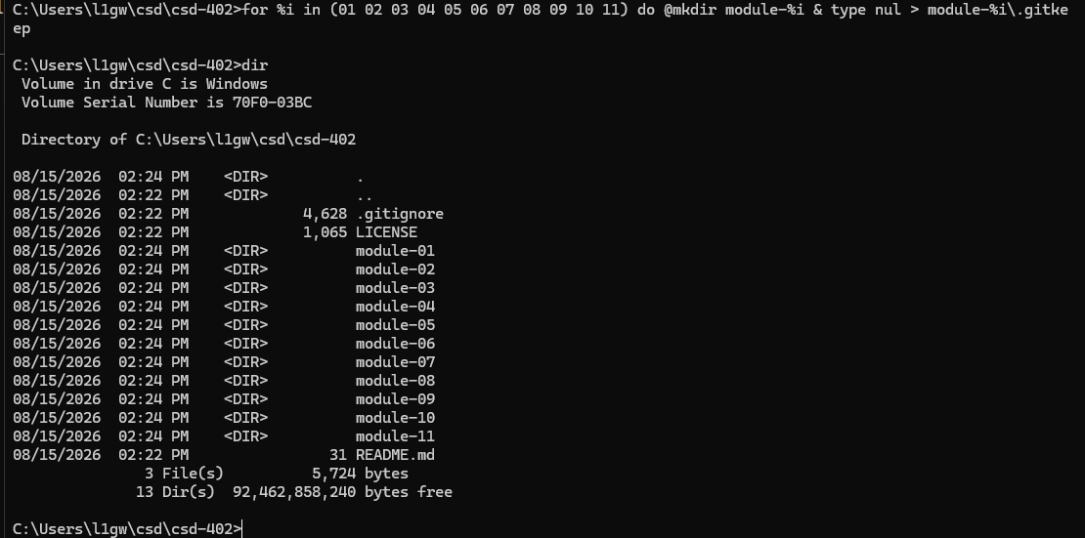

GitHub Repository
[Paste the screenshot of the pushed module folder here, then save and push again.]

