Assignment 1 – Java and JavaFX Setup
Kristian Wareing
CSD 402
August 15, 2026

1. Java Installation and JavaFX Configuration
The Java runtime and compiler both report version 20.0.2. The window in the foreground is a JavaFX application compiled and launched against the installed JavaFX SDK, confirming that JavaFX is configured and working.
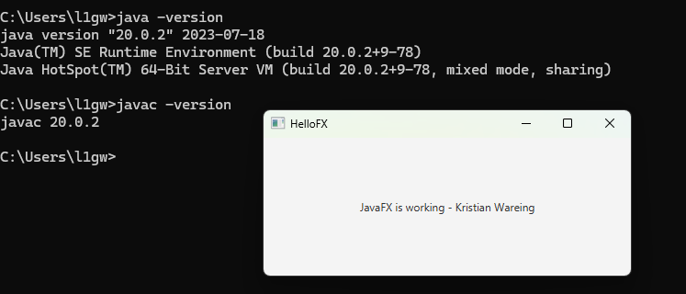

2. JavaFX SDK Contents
Directory listing of the JavaFX SDK library folder at C:\javafx-sdk-21.0.12\lib, showing the JavaFX module JAR files referenced by the module path.
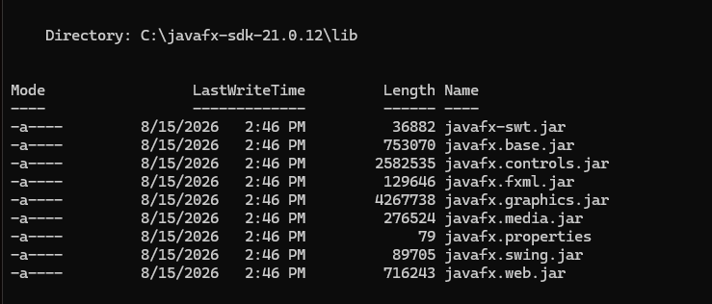

3. Program Output
The completed program running from the command line. Heating 25 kilograms of water from 4 degrees Celsius to 100 degrees Celsius requires 10,041,600 joules.
