# SaaS architecture examples

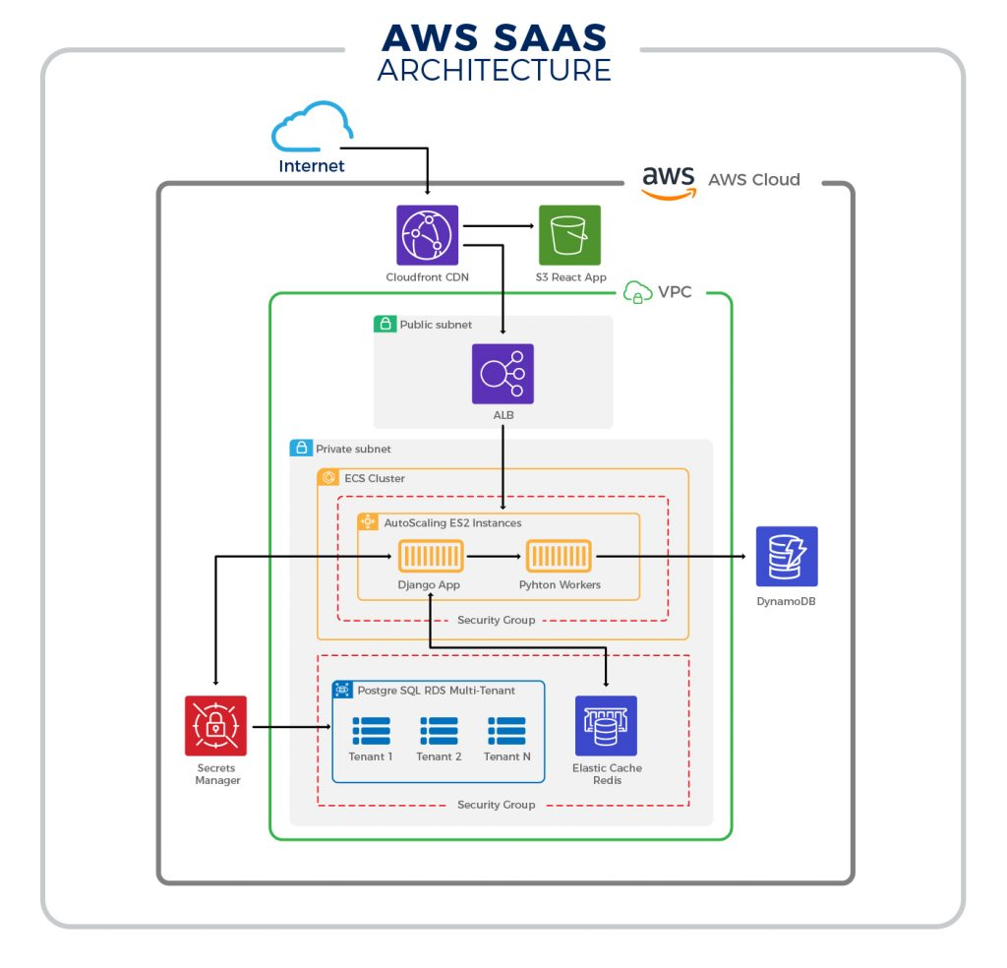

# Components proposal for Agnicio

Multi-tenant architecture inside the SaaS application

Front-end (Drag & Drop Visual Interface)

* **Angular**(<https://material.angular.io/cdk/drag-drop/overview>) **or React**

Back-end

* **Python language**
* **Django (novite Python devs) or Flask (More experienced devs)**

Database

* **Postgresql** or **Snowflake** **Cloud-Based Data Warehousing service** (Depends on data volume and structure).

Sources:

<https://acropolium.com/blog/build-scale-a-multi-tenant-saas/>

<https://acropolium.com/blog/how-to-choose-the-right-technology-stack-for-saas-development/>