

**Lovely Professional University**

**Academic Task No. 03**

**(Artificial Intelligence)**

School of computer Sciences and Engineering

Online ChatBot using Python

Name of Faculty in-charge: - Mrs. Ankhita

Course Code: - INT 404

Course Title: - ARTIFICIAL INTELLIGENCE

Student Name: Waris Ali Avdhesh kuma Himanshu Raj Ashish Singh

Roll number: - 07 18 20 02

Student ID: 11804212 11805118 11805106 11805076

Github link:

* **INDEX OF CONTENTS:**

1. What is ChatBot? ……………………………………
2. Retrievel Based ChatBots……………………………
3. Generative Based ChatBots…………………………..
4. About the Python Project ChatBot……………………
5. The Dataset……………………………………………
6. Prerequisites…………………………………………..
7. How to make ChatBot in python ??..............................

**What is ChatBot ?**

A chatbot is an intelligent piece of software that is capable of communicating and performing actions similar to a human. Chatbots are used a lot in customer interaction, marketing on social network sites and instantly messaging the client. There are two basic types of chatbot models based on how they are built; Retrieval based and Generative based models.

#### 1. Retrieval based Chatbots

A retrieval-based chatbot uses predefined input patterns and responses. It then uses some type of heuristic approach to select the appropriate response. It is widely used in the industry to make goal-oriented chatbots where we can customize the tone and flow of the chatbot to drive our customers with the best experience.

#### 2. Generative based Chatbots

Generative models are not based on some predefined responses.

They are based on seq 2 seq neural networks. It is the same idea as machine translation. In machine translation, we translate the source code from one language to another language but here, we are going to transform input into an output. It needs a large amount of data and it is based on Deep Neural networks.

### About the Python Project – Chatbot

In this Python project with source code, we are going to build a chatbot using deep learning techniques. The chatbot will be trained on the dataset which contains categories (intents), pattern and responses. We use a special recurrent neural network (LSTM) to classify which category the user’s message belongs to and then we will give a random response from the list of responses.

Let’s create a retrieval based chatbot using NLTK, Keras, Python, etc.

### The Dataset

The dataset we will be using is ‘intents.json’. This is a JSON file that contains the patterns we need to find and the responses we want to return to the user. The link to the project is available below:

[**Python Chatbot Project Dataset**](https://drive.google.com/open?id=1763Y5zy7HmRYsOoBLQgUxQRGY6xCgQiN)

### Prerequisites

The project requires you to have good knowledge of Python, Keras, and [***Natural language processing (NLTK)***](https://data-flair.training/blogs/nltk-python-tutorial/). Along with them, we will use some helping modules which you can download using the python-pip command.

How to Make Chatbot in Python?

Now we are going to build the chatbot using Python but first, let us see the file structure and the type of files we will be creating:

[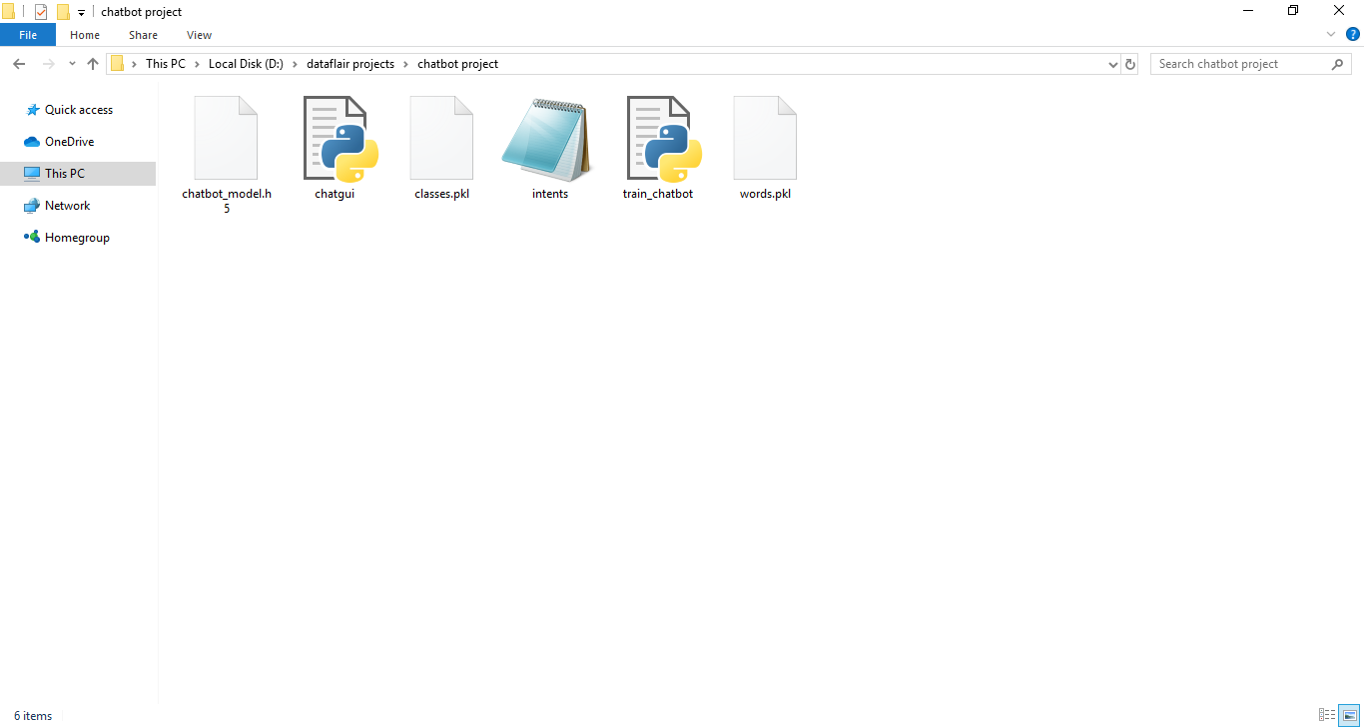](https://d2h0cx97tjks2p.cloudfront.net/blogs/wp-content/uploads/sites/2/2019/12/Types-of-files-1.png)

* **Intents.json –** The data file which has predefined patterns and responses.
* **train_chatbot.py –** In this Python file, we wrote a script to build the model and train our chatbot.
* **Words.pkl –** This is a pickle file in which we store the words Python object that contains a list of our vocabulary.
* **Classes.pkl –** The classes pickle file contains the list of categories.
* **Chatbot_model.h5 –** This is the trained model that contains information about the model and has weights of the neurons.
* **Chatgui.py –** This is the Python script in which we implemented GUI for our chatbot. Users can easily interact with the bot.

Here are the 5 steps to create a chatbot in Python from scratch:

1. Import and load the data file
2. Preprocess data
3. Create training and testing data
4. Build the model
5. Predict the response