**IoT-based Driver Drowsiness Detection Using AI**



**Waris Hayat**

**Mubashir Janjua**

**Asim Riaz**

*Supervised By*

**Mr. Muhammad Irtaza**

*Submitted for the partial fulfillment of BS Software Engineering/ Information Technology degree to the Faculty of Engineering and Computing*

**NATIONAL UNIVERSITY OF MODERN LANGUAGES ISLAMABAD**

**November, 2024**

**ABSTRACT**

Driver fatigue is a leading cause of traffic accidents globally, with severe consequences for both drivers and other road users. As the number of vehicles on the road continues to increase, the need for effective safety mechanisms to minimize fatigue-related accidents becomes more critical. Drowsy driving impairs decision-making, reaction times, and overall vehicle control, posing a significant concern for road safety authorities. To address this issue, the proposed project aims to develop a reliable driver drowsiness detection system that leverages computer vision, machine learning, and IoT technologies to monitor the driver's alertness in real time and provide timely warnings to prevent accidents caused by fatigue.

While existing driver drowsiness detection systems often use eye tracking or more invasive techniques like physiological sensors and steering wheel sensors, these methods can be costly, uncomfortable, or inaccurate in real-world scenarios. This project aims to overcome these limitations by creating a non-intrusive, precise, and affordable system using computer vision algorithms and pre-trained deep learning models. The system tracks subtle signs of fatigue, such as eye closure, sluggish blinking, and changes in facial expressions, by analyzing real-time video feeds of the driver. Once the system detects signs of drowsiness, it triggers an alarm and activates a seat vibrator to alert the driver and prompt corrective action.

The scope of this project includes designing, developing, and testing an IoT-based driver drowsiness detection system that can be easily integrated into various vehicle models. This technology is primarily targeted at two application areas: commercial fleet management, where monitoring driver alertness is essential for safety, and Advanced Driver Assistance Systems (ADAS), which can incorporate this technology to enhance vehicle safety. The proposed system offers a novel, real-time approach to drowsiness detection and is a significant step toward reducing fatigue-related accidents, improving road safety, and contributing to the development of intelligent transportation systems.

**CERTIFICATE**

Date: __________

**Final Approval**

It is certified that project report titled **IoT-based Driver Drowsiness Detection Using AI, Alarm, and Vibration** submitted by **Waris Hayat**, **Mubashir Janjua**, **Asim Riaz** for the partial fulfillment of the requirement of “Bachelor’s Degree in Software Engineering” is approved.

**COMMITTEE**

Dr. Muhammad Noman Malik

DEAN FEC Signature: ___________________

Dr. Sumaira Nazir

HOD Software Engineering Signature: ___________________

Dr. Naveed Ahmed/

Ms. Maryam Imtiaz Malik

Head Project Committee Signature: ___________________

Mr. Muhammad Irtaza

Supervisor Signature: ____________________

**DECLARATION**

We hereby declare that our dissertation is entirely our work and genuine / original. We understand that in case of discovery of any PLAGIARISM at any stage, our group will be assigned an F (FAIL) grade and it may result in withdrawal of our Bachelor’s degree.

**Group Members Signature**

1.Waris Hayat ___________________

2.Mubashir Janjua ___________________

3.Asim Riaz ___________________

# **Table of Content**

**Chapter Pages**

**1. Introduction** 7

**1.1. Background of the Study** 7

**1.2. Current Issues** 7

**1.3. Problem Statements** 7

**1.4. Proposed Solution** 7

**2. Existing System** 8

**3. Problem Description** 8

**4. Project Objectives** 9

**5. Proposed System** 9

**5.1. Scope** 9

**5.2. Proposed System Module** 9

**5.2.1 Real-Time Camera Module** 9

**5.2.2 Preprocessing and Image Enhancement Module** 10

**5.2.3 Drowsiness Detection Module** 10

**5.2.4 Alarm and Vibrator Module** 10

**5.2.5 Raspberry Pi Control Module** 10

**5.3.** **Advantages of the Proposed System** 10

**5.4. Limitations/Disadvantages** 11

**5.5. Applications** 11

**5.6. SDG Goals** 11

**6. Modules** 11

**6.1. Real-Time Camera** 11

**6.2. Preprocessing and Image Enhancement** 12

**6.2.1. Flowchart for Preprocessing and Image Enhancement Module** 12

**6.3 Drowsiness Detection** 13

**6.3.1 Flowchart for Drowsiness Detection** 13

**6.4 Alarm and Vibrator** 14

**6.4.1 Flowchart for Alarm and Vibrator** 14

**6.5 Raspberry Pi Control Module** 14

**6.5.1 Flowchart for Raspberry Pi Control** 14

**7. Methodology** 15

**7.1. Waterfall Model** 15

**7.1.1. Requirement Analysis** 15

**7.1.2. System Design** 15

**7.1.3. Implementation** 15

**7.1.4. Testing** 15

**7.1.5. Deployment** 15

**7.1.6.** **Maintenance** 16

**7.1.7.** **Predictability and Milestones:** 16

**8. Project Scope** 16

**9. Feasibility Study** 17

**10. Applications** 17

**10.1. Solutions** 17

**10.2 Application Areas** 17

**11. Tools & Technologies** 17

**12. Expertise of Team Members** 17

**13. Milestone** 17

**Referance** 17

# **LIST OF FIGURES**

Figure 1: Real-Time Camera Detection [13](#_Toc183005564)

[Figure 2: Flow Chart on Preprocessing and Image Enhancement 14](#_Toc183005564)

[Figure 3: Flow Chart on Drowsiness Detection 15](#_Toc183005564)

[Figure 4: Flow Chart on Alert & Vibrator 16](#_Toc183005564)

[Figure 5: Flow Chart on Raspberry pi control 17](#_Toc183005564)

#### **LIST OF TABLES**

Table 1: Existing system comparison with proposed ………………………………………………..... 8

Table 2: Expertise …………………………………………………………………………………….... 18

# **1. Introduction**

## 

## **1.1. Background of the Study**

Driver drowsiness is a major cause of traffic accidents, impairing reaction times and decision-making. Traditional methods, like eye-tracking and physiological monitoring, are often costly or intrusive. Recent advancements in computer vision and machine learning offer non-invasive, cost-effective solutions for detecting drowsiness by analyzing facial cues such as eye closure and yawning. Additionally, integrating IoT technologies like cameras, alarms, and seat vibrators can provide real-time alerts. This project aims to combine these technologies to create an efficient, affordable, and reliable driver drowsiness detection system.

# **1.2. Current Issues**

Current driver drowsiness detection systems face several challenges that impact their effectiveness. Many systems, particularly those relying on eye-tracking or physiological sensors, struggle with accuracy and reliability, especially under varying real-world conditions, leading to false alarms or missed detections. Additionally, invasive methods and costly sensors make these solutions impractical for widespread use. Environmental factors, such as poor lighting or vehicle vibrations, further reduce the accuracy of detection. Moreover, many existing systems do not provide real-time feedback, which is critical for preventing accidents. This project aims to address these limitations by developing a more reliable, non-intrusive, and cost-effective solution that provides timely alerts to enhance road safety.

## **1.3. Problem Statements**

Driver drowsiness is a leading cause of road accidents, yet existing detection systems often suffer from accuracy issues, high costs, and invasiveness. Current solutions, such as eye-tracking or physiological monitoring, are not always reliable or practical for widespread use. There is a need for a more efficient, non-intrusive, and affordable system that can detect signs of drowsiness in real-time and alert the driver to prevent accidents.

## **1.4. Proposed Solution**

The proposed solution is an IoT-based Driver Drowsiness Detection System that uses computer vision and machine learning to monitor real-time signs of driver fatigue, such as eye closure, yawning, and facial expressions. A camera will capture video footage of the driver, which will be processed for signs of drowsiness. If detected, an alarm and a seat vibrator will activate to alert the driver. This system will be non-intrusive, cost-effective, and provide immediate feedback, offering a reliable solution to enhance road safety and reduce fatigue-related accidents.

# **2. Existing System**

A review of existing systems reveals that while many driver drowsiness detection platforms use eye-tracking, physiological monitoring, or steering behavior analysis, few offer a comprehensive, real-time, and non-intrusive solution. The table below summarizes the key features and limitations of some of these existing systems

**Table 1:** Existing system comparision with proposed.

| **Feature** | **Smart Eye Monitoring System (SEMS)** | **Mercedes-Benz Attention Assist** | **Toyota Driver Monitoring System** | **Volvo Driver Alert Control** | **Proposed Model (Raspberry Pi Alarm & Vibrator)** |
| --- | --- | --- | --- | --- | --- |
| **Eye Blink Rate Detection** | ✔ | ✖ | ✔ | ✖ | ✔ |
| **Eye Closure Pattern Detection** | ✔ | ✖ | ✔ | ✖ | ✔ |
| **Yawning Detection** | ✖ | ✖ | ✔ | ✖ | ✔ |
| **Steering Behavior Analysis** | ✖ | ✔ | ✖ | ✔ | ✖ |
| **Vehicle Dynamics Monitoring** | ✖ | ✔ | ✖ | ✖ | ✖ |
| **Facial Expression Detection** | ✖ | ✖ | ✔ | ✖ | ✔ |
| **Head Movement Detection** | ✖ | ✖ | ✖ | ✔ | ✔ |
| **Low-Cost Solution** | ✖ | ✖ | ✖ | ✖ | ✔ |
| **Cost-effective Hardware (Raspberry Pi)** | ✖ | ✖ | ✖ | ✖ | ✔ |
| **Real-time Alerts (Alarm & Vibrator)** | ✖ | ✖ | ✖ | ✖ | ✔ |
| **Works in Low Light/Obstructed Faces** | ✖ | ✖ | ✖ | ✖ | ✔ |
| **Handles Multiple Drowsiness Indicators** | ✖ | ✖ | ✖ | ✖ | ✔ |
| **Low Power Consumption** | ✖ | ✖ | ✖ | ✖ | ✔ |

# **3. Problem Description**

Driver fatigue is a major cause of road accidents, leading to significant fatalities and injuries. Existing systems often fail to detect early signs of drowsiness, relying on steering behavior or vehicle movement, which miss subtle indicators like eye closure and yawning. Additionally, many systems are costly, ineffective in low-light conditions, or dependent on specialized equipment, making them unreliable and inaccessible. A more affordable, non-intrusive solution is needed to accurately detect drowsiness in real-time and improve road safety.

# **4. Project Objectives**

The primary objective of this project is to develop a real-time driver drowsiness detection system that continuously monitors key indicators of fatigue, such as eye closure, blinking rate, and yawning. The system aims to use advanced machine learning algorithms to ensure high accuracy in detecting drowsiness while minimizing false positives and negatives. It is designed to be non-intrusive, utilizing a standard camera for facial feature analysis, making it accessible and cost-effective. The system will trigger immediate alerts, including an audible alarm and seat vibrator, when signs of drowsiness are detected, ensuring timely intervention. Additionally, the project aims to create a low-cost and energy-efficient solution that can be easily integrated into existing vehicle infrastructure without requiring complex modifications or expensive hardware, thereby enhancing overall road safety.

# **5. Proposed System**

The proposed system is an IoT-based Driver Drowsiness Detection System that uses a camera to monitor facial features like eye movement and yawning to detect signs of drowsiness. It employs machine learning algorithms to analyze these indicators and triggers alerts via an audible alarm and seat vibrator when fatigue is detected. The system is powered by a Raspberry Pi, making it cost-effective and easy to integrate into vehicles. The solution aims to enhance road safety by providing real-time alerts, preventing accidents caused by drowsy driving.

## **5.1. Scope**

The scope of this project is to develop an IoT-based Driver Drowsiness Detection System that monitors the driver’s alertness in real time using a camera, machine learning algorithms, and a Raspberry Pi. It will detect signs of fatigue, such as prolonged eye closure, slow blinking, or yawning, and activate an alarm and seat vibrator to alert the driver. The system will be implemented for both commercial and personal vehicles, enhancing road safety by providing a non-intrusive, cost-effective solution to prevent accidents caused by drowsy driving. The project will focus on real-time detection, accurate alerts, and easy integration into existing vehicles.

## **5.2. Proposed System Module**

### **5.2.1 Real-Time Camera Module**

• Captures real-time video feed of the driver's face.

• Monitor facial features like eye movements, blinking, and yawning.

• Essential for identifying potential signs of drowsiness.

### **5.2.2 Preprocessing and Image Enhancement Module**

• Processes raw video frames by resizing, converting to grayscale, and normalizing them.

• Ensures consistent input quality and enhances detection accuracy.

• Improves performance by reducing computational load.

### **5.2.3 Drowsiness Detection Module**

• Analyzes preprocessed images to detect signs of drowsiness.

• Focuses on indicators like prolonged eye closure, slow blinking, or yawning.

• Utilizes computer vision and machine learning models for real-time detection.

### **5.2.4 Alarm and Vibrator Module**

• Triggers an audible alarm to alert the driver when drowsiness is detected.

• Activate a seat vibrator to physically alert the driver if they show signs of fatigue.

• Provides immediate, effective feedback to prevent accidents

### **5.2.5 Raspberry Pi Control Module**

• Acts as the central processing unit for the system.

• Manages communication between the camera, detection algorithms, and alert system.

• Processes inputs from the camera and activates the alarm/vibrator upon detecting drowsiness

## **5.3.** **Advantages of the Proposed System**

* **Real-Time Detection**: Provides instant alerts upon detecting signs of drowsiness, ensuring timely intervention to prevent accidents.
* **Non-Intrusive**: Uses a camera-based system and seat vibrator, making it comfortable for the driver without the need for invasive sensors.
* **Cost-Effective**: Utilizes a Raspberry Pi for central control, making the system affordable and easy to implement in a variety of vehicles.
* **Improved Safety**: Monitors multiple drowsiness indicators (eye closure, yawning, and blinking), offering a more comprehensive detection approach compared to existing systems.

## **5.4. Limitations/Disadvantages**

* **Camera Sensitivity**: The system's performance may be affected in low-light environments or when the driver is wearing face coverings such as glasses or hats.
* **False Alarms**: There is a possibility of false positives or false negatives, where the system may fail to detect drowsiness or may alert unnecessarily due to variations in facial expressions.

## **5.5. Applications**

The system can be integrated into commercial fleet management to monitor driver alertness and prevent accidents, as well as incorporated into personal vehicles as part of ADAS to enhance road safety and reduce fatigue-related risks.

## **5.6. SDG Goals**

• **Goal 3: Good Health and Well-Being** by reducing fatigue-related accidents and promoting road safety.

• **Goal 9: Industry, Innovation, and Infrastructure** through the integration of advanced IoT, machine learning, and computer vision technologies in automotive systems.

• **Goal 11: Sustainable Cities and Communities** by enhancing transportation safety and contributing to safer urban environments.

# **6. Modules**

## **6.1. Real-Time Camera**

The Real-Time Camera Module captures a continuous video feed of the driver's face, allowing for the monitoring of facial features such as eye movements, blinking, and yawning. This module is crucial in detecting potential signs of drowsiness, as it provides real-time data for further analysis. By constantly observing these features, the system can identify early indicators of fatigue, such as prolonged eye closure or frequent yawning, and trigger appropriate alerts.

**6.1.1 Flowchart of Real-Time Camera**

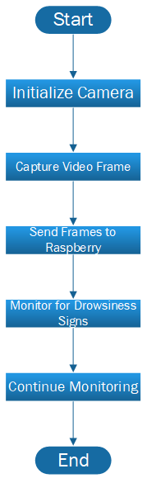

Figure 1: Real-Time Camera Detection

## **6.2. Preprocessing and Image Enhancement**

The preprocessing and image enhancement module processes raw video frames by resizing them, converting them to grayscale, and normalizing the images. This ensures consistent input quality, which improves the accuracy of drowsiness detection. Additionally, these steps reduce the computational load, enhancing the system's overall performance and efficiency.

## **6.2.1. Flowchart for Preprocessing and Image Enhancement Module**

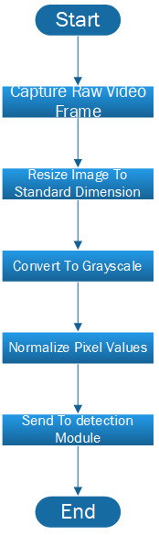

Figure 2: Flow Chart on Preprocessing and Image Enhancement

## **6.3 Drowsiness Detection**

The drowsiness detection module analyzes the preprocessed images to identify signs of fatigue, such as prolonged eye closure, slow blinking, or yawning. It leverages advanced computer vision techniques and machine learning models to perform real-time detection of these indicators. The system continuously monitors the driver’s facial features, ensuring prompt detection of drowsiness to enhance road safety.

## **6.3.1 Flowchart for Drowsiness Detection**

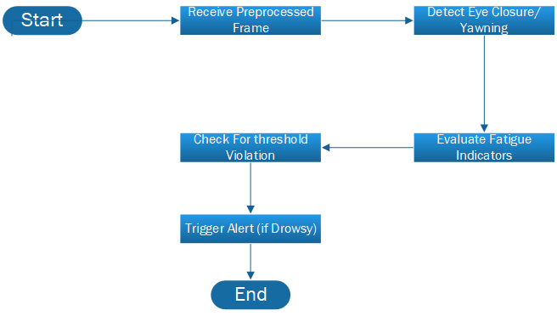

Figure 3: Flow Chart on Drowsiness Detection

## **6.4 Alarm and Vibrator**

The alarm and vibrator module is activated when signs of drowsiness are detected, ensuring the driver receives immediate feedback. The system triggers an audible alarm to alert the driver, while the seat vibrator provides a physical nudge to prevent fatigue-related accidents. This dual approach enhances driver awareness and responsiveness, offering an effective solution for real-time fatigue management.

## **6.4.1 Flowchart for Alarm and Vibrator**

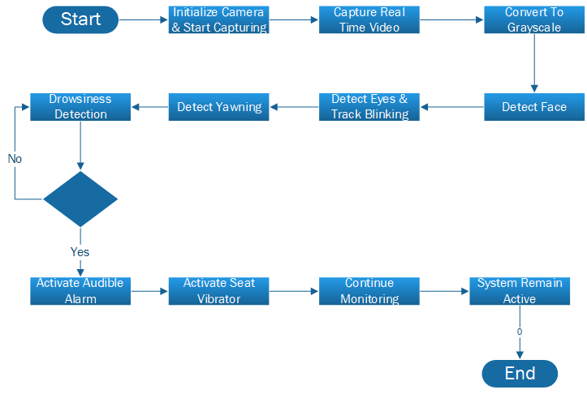

Figure 4: Flow Chart on Alarm and Vibrator

## **6.5 Raspberry Pi Control Module**

The Raspberry Pi Control Module acts as the central unit, managing communication between the camera, detection algorithms, and the alert system. It processes the video input from the camera and analyzes it for signs of drowsiness. Upon detecting fatigue, it triggers the alarm and vibrator to alert the driver, ensuring prompt action to prevent accidents.

## **6.5.1 Flowchart for Raspberry Pi Control**

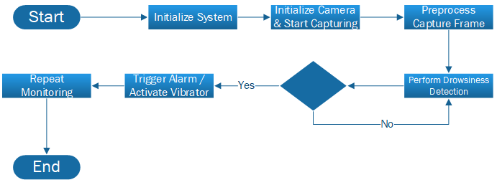

Figure 5: Flow Chart on **Raspberry Pi Control**

# **7. Methodology**

## **7.1. Waterfall Model**

### **7.1.1. Requirement Analysis**

In this phase, the system’s requirements, including hardware and software specifications (camera, sensors, alarm, etc.), are gathered. This includes determining the project’s objectives and constraints

### **7.1.2. System Design**

The system's architecture is designed, including the detailed design of each module (camera module, preprocessing, drowsiness detection, etc.), defining how each module will function and interact.

### **7.1.3. Implementation**

The actual coding and setup of the hardware components (e.g., Raspberry Pi, camera, seat vibrator) are done. Algorithms for drowsiness detection and real-time processing are implemented using appropriate machine learning models.

### **7.1.4. Testing**

After the system is built, it undergoes rigorous testing to ensure it functions as expected, such as checking if the drowsiness detection algorithm accurately detects fatigue and triggers the alarm and vibrator.

### **7.1.5. Deployment**

Once tested, the system is deployed for real-world use in a car. In this phase, the system is installed in a vehicle, and the sensors and software are configured to work in the vehicle's environment.

### **7.1.6.** **Maintenance**

The system is monitored and maintained to ensure proper functioning over time. Bugs or issues are addressed, and any necessary updates to the system’s software or hardware are made.

### 

### **7.1.7.** **Predictability and Milestones:**

**Waterfall Model Flow Diagram**

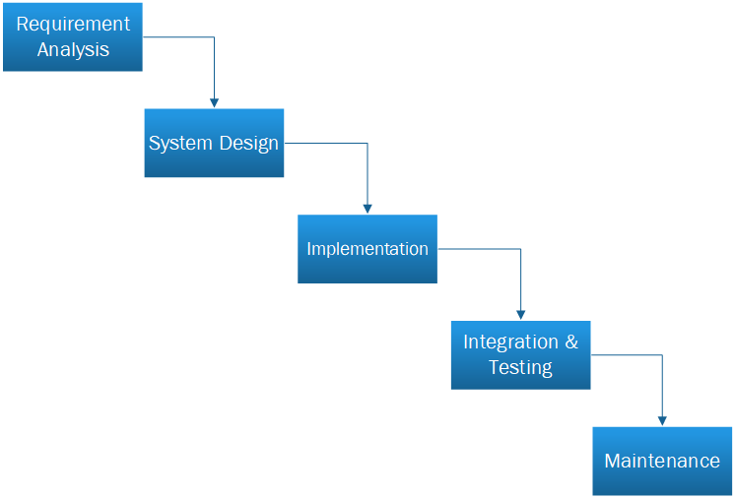

Figure 6: Flow Chart on Waterfall Model

# **8. Project Scope**

The project scope for the IoT-based Driver Drowsiness Detection System defines the boundaries and goals of the project, focusing on developing a real-time system to detect drowsiness in drivers. The primary objective is to create a system that uses a camera to monitor facial features such as eye movements, blinking, and yawning, with an alert mechanism consisting of an audible alarm and seat vibrator to prevent accidents caused by driver fatigue. The system will be built using a Raspberry Pi, a camera, and basic alert systems, integrated with computer vision and machine learning models to detect key drowsiness indicators. Target users for this system include commercial fleet managers, vehicle manufacturers for integration into Advanced Driver Assistance Systems (ADAS), and individual vehicle owners who are focused on enhancing road safety. The system's functionality will focus on real-time detection of eye closure, slow blinking, and yawning, providing immediate alerts to the driver. The system will not be integrated with existing vehicle software but will be designed as a retrofit solution. The project will follow a waterfall development model, with a timeline of approximately 4 months to complete the design, implementation, and testing phases.

# **9. Feasibility Study**

The feasibility study for the IoT-based Driver Drowsiness Detection System evaluates its technical, operational, and financial viability. Technically, the system leverages existing technologies like Raspberry Pi, camera modules, and machine learning algorithms to detect drowsiness, making it feasible to develop with current tools and frameworks. Operationally, the system is easy to use with minimal user interaction, but it will require stable power for continuous operation. Economically, the system is cost-effective compared to existing solutions, with the potential for significant returns by improving road safety and reducing accident-related costs. Legal and ethical considerations, such as data privacy and driver safety, will also be addressed to ensure compliance with relevant standards. Overall, the system is technically and economically viable, with room for optimization.

# **10. Applications**

## **10.1. Solutions**

The proposed IoT-based Driver Drowsiness Detection System can be applied in commercial vehicles, passenger cars, and public transport to monitor driver alertness in real time. It provides immediate feedback through alarms and seat vibration, alerting drivers when drowsiness is detected. This system can enhance road safety, reduce fatigue-related accidents, and be integrated into Advanced Driver Assistance Systems (ADAS) for further driving assistance.

## **10.2 Application Areas**

* **Commercial Vehicles**: Ensuring the safety of long-haul drivers by monitoring their alertness during extended driving periods.
* **Passenger Cars**: Enhancing driver safety in everyday vehicles by providing real-time alerts for drowsiness
* **Public Transport**: Safeguarding bus and train operators to prevent fatigue-related accidents.
* **Fleet Management**: Assisting companies in managing driver health and safety, ensuring better performance and reduced accident risk.

# **11. Tools & Technologies**

• **Raspberry Pi**: The central processing unit for managing inputs from sensors and controlling the alert system.

• **Camera Module**: A real-time video capture device used to monitor facial features such as eye movement and blinking.

• **OpenCV**: A powerful computer vision library used for processing images and detecting drowsiness indicators like eye closure and slow blinking.

• **TensorFlow/Keras**: Machine learning libraries used for training models to detect drowsiness based on facial landmarks and eye movements.

• **Python**: The primary programming language used for system development, including image processing, algorithm implementation, and system control.

• **Vibrator and Alarm Module**: Hardware components used to alert the driver when drowsiness is detected.

• **Jupyter Notebook/Colab/VS-Code**: Tools used for data analysis, model training, and testing during the development phase.

# **12. Expertise of Team Members**

Our Team Member have prior knowledge and their domain of expertise

Table 2: Expertise

|  |  |
| --- | --- |
| **Name** | **Expertise** |
| ***Waris Hayat*** | ***Artificial Intelligence, python ,Backend, Iot*** |
| ***Mubashir Janjua*** | ***Front-end Web Developer ,System Designing*** |
| ***Asim Riaz*** | ***Content Writing &******Design and Architecture Documentation*** |

# **13. Milestone**

15-Oct-24 15-Nov-24 09-Jan-25 28-Feb-25 19-Apr-25 08-Jun-25 28-Jul-25 16-Sep-25

Problem Identification Requirement Gathering

System Analysis Proposal Report

Design Coding Implementation

Testing

Final Documentation

# **Referance**

**Books**:

Patel, V. (2020). *Introduction to Machine Learning and Computer Vision*. Springer.

**Websites**:

Raspberry Pi Foundation. (2024). *Official Raspberry Pi Documentation*. https://www.raspberrypi.org/documentation/. Accessed on November 18, 2024.

OpenCV. (2024). *OpenCV Documentation*. https://docs.opencv.org. Accessed on November 19, 2024.

**Datasets**:

Kaggle. (2024). *Driver Drowsiness Detection Dataset*. https://www.kaggle.com/datasets/xyz/driver-drowsiness-detection. Accessed on November 20, 2024.

**Technology Documentation**:

TensorFlow. (2024). *TensorFlow for Machine Learning*. <https://www.tensorflow.org/>. Accessed on November 15, 2024.