**GENERATE TABLE OF CONTENTS**

**OF PDF FILE FROM FEDERAL REGISTER**

THIS DOCUMENT IS A GUIDE TO INSTALL AND USE THE SOFTWARE

(WRITING IN PYTHON) TO DOWNLOAD, CONVERT AND MERGE THE PDF FILES FROM IRS WITH THE ACTUAL FILES OF FEDERAL REGISTERS.

# Table of Contents

Contents **Error! Bookmark not defined.**

How To 3

Install 3

Use 3

Tutorial for general purpose 4

BUGS 6

JSON loads 6

Description 6

Solution 6

# How To

## Install

To install the software you must have this Python libraries in the OS you use:

* **JSON**
* **REQUEST**
* **WEASYPRINT**
* **PyPDF2**
* **XML.DOM**
* **ElementTree**
* **URLLIB**

If you want to install this libraries in your system, type **“pip install *name of the package*”** where the name of the package is specified upside. Then you have to create a root folder in your system to allocate the package.

Name the folder as what you want but inside it must have be a folder called **“pdfs_irs”** where the PDF of IRS allocated.

## Use

To use the software you have to run the Python interpreter in any OS and run the actual **__init__.py** code. Then follow the instructions inside the terminal.

ATTENTION: For good performance of the software ensure you have a PDF file of the IRS archive.

# Tutorial for general purpose

A guide step by step

1. Install all dependencies to ensure the correctly function of the software.
2. Run the software within make **__init__.py** code.
3. In the main menu, select one of two options show up:
   1. **Option** 1 (Search by text)
   2. **Option** 2 (Search by year-document number)
4. If you select the **Option 1,** you have to provide a name to search the document in Federal Register Database.
5. If you select the **Option 2,** you have to provide a document number (if you have it) and the year of emission.

You have to see something like that depends of what option you choose:

Option 1

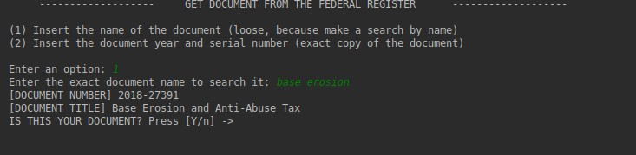

Option 2

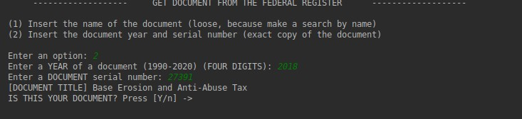

1. Then, you have to PRESS ENTER to continue and provide the PATH of the PDF IRS, according with the DOCUMENT TITLE of the last steps.

***Example:***

If a document search by Option 1 have the title **BASE EROSION AND ANTIABUSE TAX**, you should have a file (downloaded from IRS) according with that title.

1. The file named **FINAL_PREAM** and **FINAL_PROPOSED** will be saved in the root folder. The same of the __init__.py

# Bugs and Error

## JSON loads

### Description

Estrange bug in the **json.loads(str, encoding)** parameter make an exception when BYTES pass by parameter.

### Solution

Use request.json() instead in get_document variables.

*Ex: get_document_json() = get_document.json()*