

Space Club,
CIIED
(Center for Innovation, Incubation and Entrepreneurship Development),
Rajarambapu Institute of Technology, Islampur.

PROJECT NAME Experimental Payload Launch Vehicle 1.1

REPORT BY Space Club, RIT

Nomenclature

Cg – the center of gravity
Cp – the center of pressure
E-bay – electronic bay

OBC: On-Board Computer System
BMP: Barometric pressure sensor
RPI: raspberry pi

Abstract

As rocket launches, it is important to recover it. The recovered rocket can be used for the next upcoming mission which will save money and give safety to electronic components and humans too. In upcoming missions aim is to reach 3km it is important to test different systems like recovery mechanisms, electronic components, etc.
This rocket was designed with the help of software named Open Rocket. The software provides all the necessary components to design a rocket. The motor is made up of solid fuel which contains a mixture of sugar and KNO3 (potassium nitrate). And Arduino UNO, BMP280, MPU 6050 sensors were used to collect the data.
After launch rocket recovered successfully with a single parachute mechanism. Data from sensors were stored on the SD card. As a result, all systems worked properly and the rocket reached its desired height which was nearer to the estimated height i.e. 1km.

Index

Sr. |  |  | Name | Page Number
1 |  |  | Introduction | 7
2 |  |  | Mission | 8
3 |  |  | Theory | 8
 | 3.1 |  | Structure | 9
 |  | 3.1.1 | Material Used | 9
 |  | 3.1.2 | Material selection | 9
 |  | 3.1.3 | Design | 14
 |  | 3.1.4 | Calculations and simulations | 15
 | 3.2 |  | Motor | 16
 |  | 3.2.1 | Material used | 18
 |  | 3.2.2 | Casing | 19
 |  | 3.3.3 | Methodology | 20
 |  | 3.3.4 | Impulse Calculation | 21
 |  | 3.3.5 | Advancement | 21
 | 3.3 |  | OBC | 22
 |  | 3.3.1 | Hardware Description | 22
 |  | 3.3.2 | Testing | 25
 |  | 3.3.3 | Advancement | 26
 | 3.4 |  | Ignition | 27
 |  | 3.4.1 | Material Used | 27
 |  | 3.4.2 | Methodology | 27
 |  | 3.4.3 | Testing | 30
 |  | 3.4.4 | Advancement | 30
 | 3.5 |  | Deployment | 31
 |  | 3.5.1 | Hardware | 31
 |  | 3.5.2 | Methodology | 34
 |  | 3.5.3 | Experimental Testing | 35
 |  | 3.5.4 | Advancement | 37
 | 3.6 |  | Recovery | 38
 |  | 3.6.1 | Material Used | 38
 |  | 3.6.2 | Methodology | 38
 |  | 3.6.3 | Experimental testing | 42
 |  | 3.6.4 | Advancement | 42
4 |  |  | Mission Concept of Operation | 43
5 |  |  | Result & discussion | 44
6 |  |  | Conclusion | 45
7 |  |  | Appendix | 46
 |  | 1 | Code for Arduino UNO and sensors | 46
 |  | 2 | Code for Ignition System | 49
 |  | 3 | Embedded C for PIC18f4520 | 52
8 |  |  | Reference | 57

List of figures

Sr  No | Name | Page  No.
1 | Structure Parts | 10
2 | Nosecone | 10
3 | Bulkhead | 12
4 | Electronic system mounted on the bulkhead | 13
5 | Design of rocket by Open Rocket | 15
6 | Simulated Graph of motion vs time | 17
7 | Simulated graph of Stability vs time | 17
8 | Motor Design | 19
9 | The graph obtained through loadcell | 20
10 | Meteor data | 21
11 | Arduino UNO | 22
12 | Sensors | 23
13 | Connection of Arduino and MicroSD card Adaptor | 24
14 | The connection between relay and nodemcu | 28
15 | Application of Ignition | 29
16 | Button configuration on application | 29
17 | Pin Structure of PIC | 31
18 | Rating of PIC | 32
19 | Interrupt Pin | 33
20 | Mosfet Switch Circuit Diagram | 34
21 | Testing of the system | 36
22 | Practical implementation of the system on the rocket | 38
23 | Ejection charge with E-bey | 40
24 | Eyebolt was present between two ejection charges | 41
25 | shock cord connected to the bulkhead | 41
26 | Piston present between parachute and ejection charge | 42
27 | Testing of Parachute Opening | 43

- INTRODUCTION

The present report has been prepared by Space Club RIT on Experimental Payload launch Vehicle – 1.1 (EPLV-1.1) based on research and experiment between November And December 2021. The purpose of the report is to review EPLV-1.1 and for further improvements for EPLV-2. The report summaries the whole working principle of Experimental Payload Launching Vehicle-1.1, when the rocket reaches its apogee, it begins to accelerate rapidly towards the ground. As a result, to manage the rocket's speed, we employ a parachute recovery system to slow down the rocket's speed and lessen the rocket's impact after colliding with the ground. The difficulty now is how to open the parachute at the precise moment. As a result, we're utilizing a deployment system to precisely time the parachute's opening. The main purpose of EPLV -1.1 is to reach a height of 800m-1000m, successful deployment, and recover flight data.

- “EPLV 1.1” Mission:

EPLV1.1 mission is all about reaching the height of 1000m (1km), testing the recovery mechanism, and collecting data from different sensors at particular height. This data will help to build the algorithm for a modern type recovery system(Controlled by the electronic controller ). This data is going to use in future missions like Cloud Seeding.

- Theory:

3.1 Structure:

The structure subsystem plays a crucial role in maintaining stable flight, which helps to achieve maximum altitude. Some software is used like Catia, AutoCAD, open rocket, rocks, and tools like 3D printing, laser cutting is used for reply 1.1. Open rocket software and rocks are the software on which simulations can be performed for complete flight. It gives all data related to motor grades and their specifications, apogee time, apogee, max velocity and acceleration, static margin, flight time, and various graphs which give all results from which flight can be predicted. After the manufacturing and testing, all the parts of the rocket are assembled at a proper position.

3.1.1 Material Used:
Nose cone:
It is the forwardmost part of the rocket. Tangent ogive shape is selected to reduce aerodynamics drag.
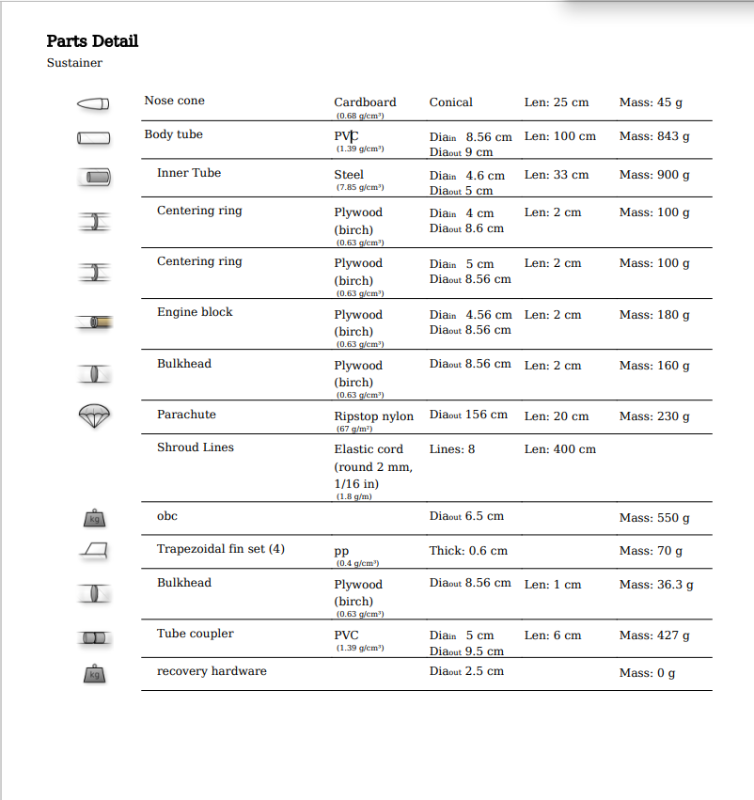

Fig. 1 Structure Parts

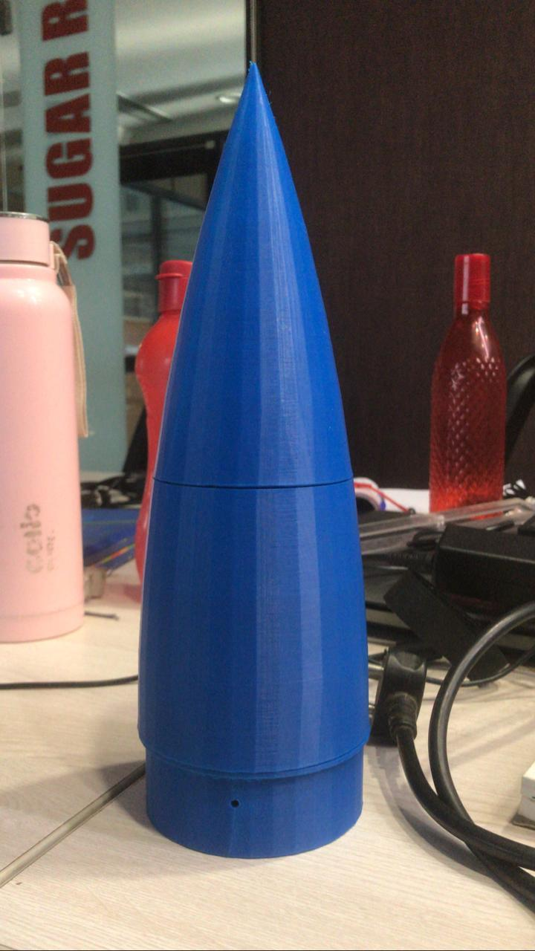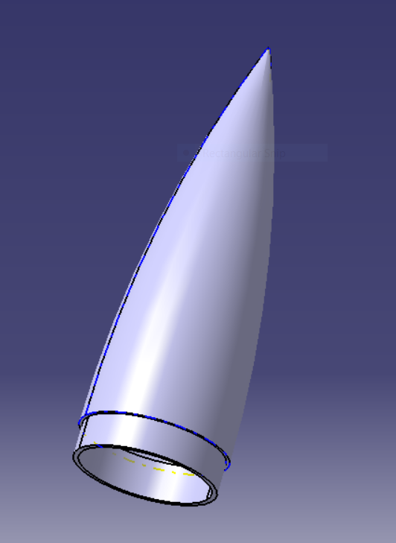

Fig. 2 Nosecone

Body Tube:

Body tube dimensions:
- Length – 1310 mm
- Outer diameter – 90 mm
- Inner diameter – 85.6 mm
- Thickness – 2.2 mm

Body tube selected having inbuilt coupler hence no need of any coupler to made. As recovery is done using body separation, the body tube consists of two parts.
Fins:
The objective of putting fins to a rocket is to achieve flight stability. The differential between the Centre of gravity and the Centre of pressure is maintained by fins. four fins were attached to the body tube for stability and of a clipped delta shape for manufacturing ease. Another reason is that height is perpendicular to the root chord as less possibility of getting damaged and not being recycled. The density of the substance is 1.25 gm/cm 3.

Motor mounting assembly:

Engine block –

- Transfer motor thrust to rocket.
- Prevent the upper part of a rocket from flame.

Specification of Centred ring :
The material used – wood
The manufacturing process used – laser cutting
Fixing material used – m-seal

Bulkhead:

It is a composite of wood and Aluminium to give sufficient strength which is attached to the eye bolt. Eyebolt has a nut at the center which is welded with the ring.

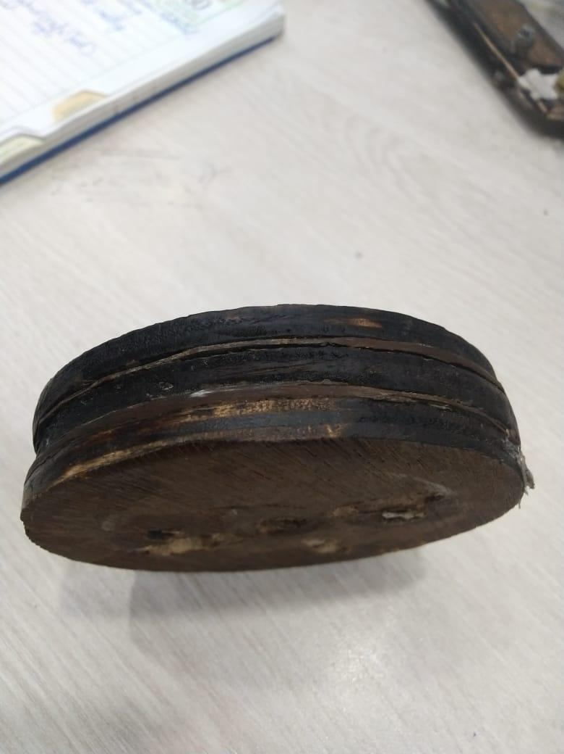
Fig. 3 Bulkhead
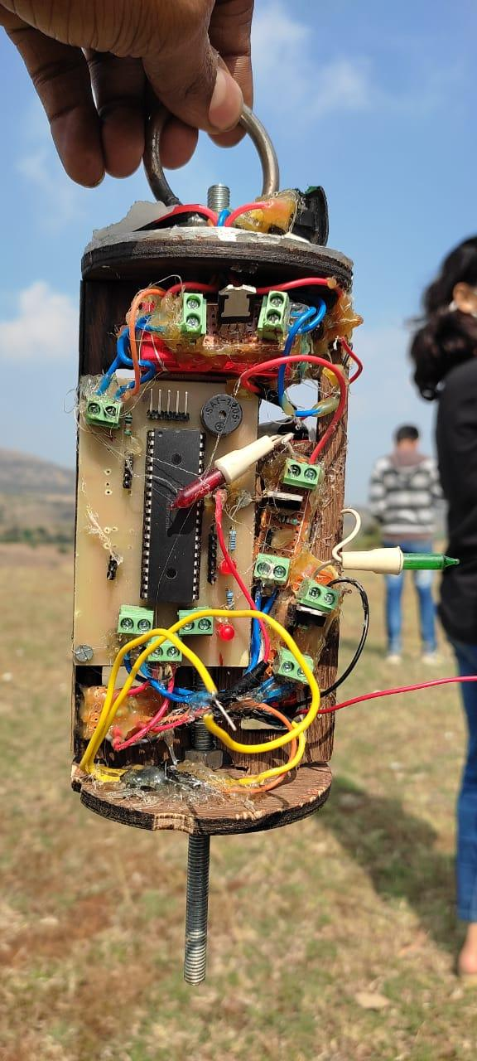

Eye bolt
Composite bulkhead
Electronic module
Threaded screw
Fig. 4 Electronic system mounted on the bulkhead

E-bay:
The purpose of making E- the bay is to provide sufficient strength to electronic components and add some part of weight to the upper side so that stability is achieved. Design is done on AutoCAD. For manufacturing simplicity and to obtain high accuracy we decided to go with laser cutting. Wood is selected as it is easily available, has low cost, is lightweight, good machinability. The slot is made on the wall for connecting wire with Arduino. The threaded screw which is connected with the U bolt and both the bulkhead provides extra strength to E- bay.

Advantage:
- Reusable.
- Increase the safety factor of the electronic module.
- Simple design.

3.1.3 Design:
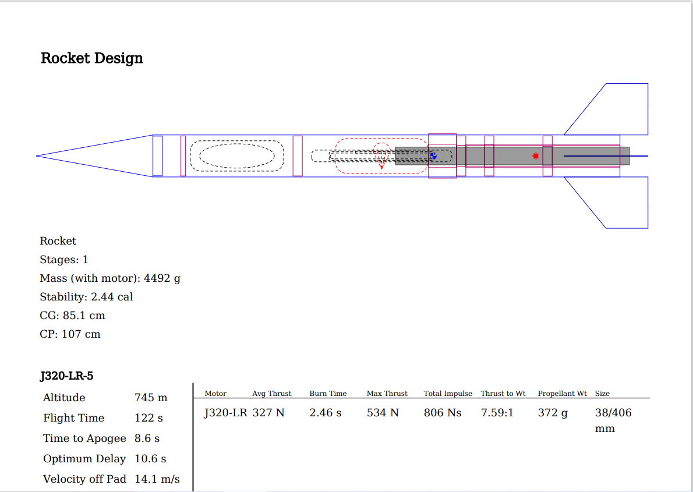

Fig. 5 Design of rocket by Open Rocket

3.1.4 Calculations and simulations:

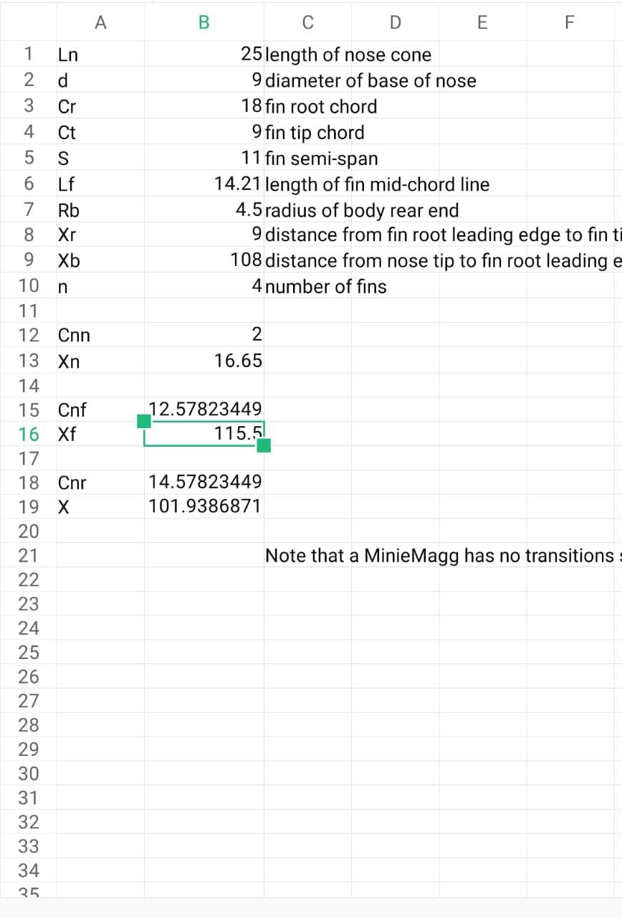

Simulations:

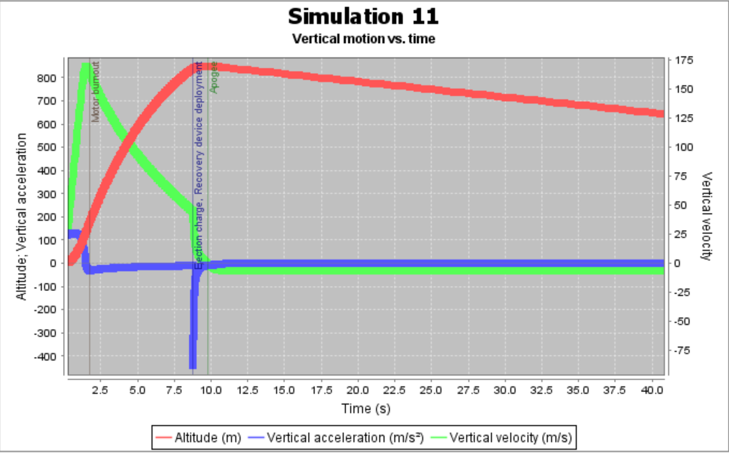
Fig 6 Simulated Graph of motion vs time

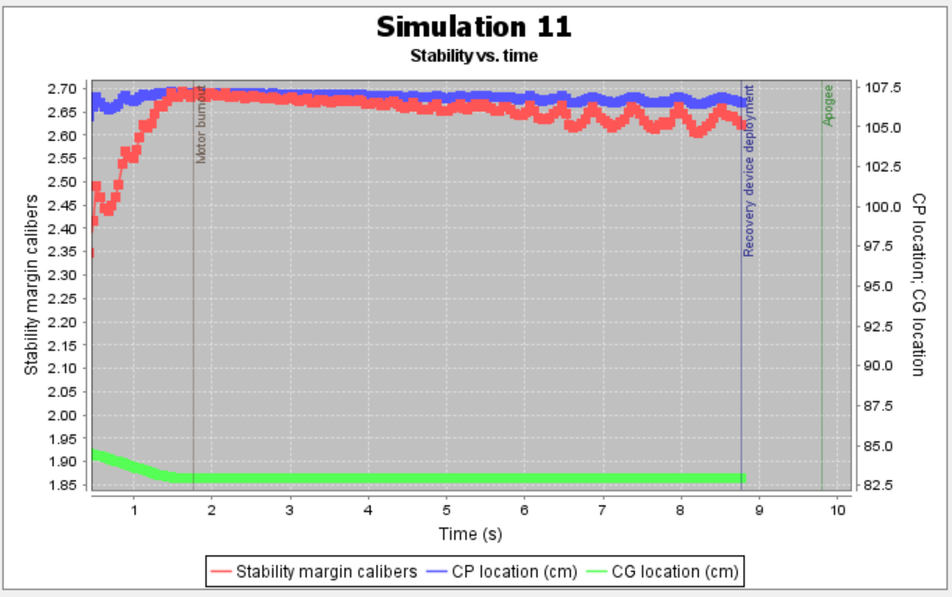
Fig.7 Simulated graph of Stability vs time
3.2 Motor:

The propulsion system aims for the propulsion of vehicles with the required amount of thrust, to reach the desired destination up in the sky. There are different types of propulsion systems used to propel rockets and satellites, but for model rockets, usually solid and hybrid propulsion is used. Model rocketry consists of developing, building, and launching small rockets to understand the basic mechanics of rockets. In space club Propulsion system (which is also called a motor system) mainly works with solid propulsion type. Solid propulsion is quite simple and safe for use in model rocketry. Solid propulsion consists of fuel and an oxidizer in the solid state. There are various aspects on which the flight of rockets depends and the motor (or propulsion system) is one of the important aspects. There are multiple design criteria on which motor design depends. In space club, the motor subsystem ensures the rocket reaches its predicted apogee successfully. It is important to prioritize safety first while developing and constructing rocket motors.

3.2.1 Material Used:

Motor Specification:

Fuel | Sugar (35%)
Oxidizer | KNO3(65%)
Propellant mass | 600 gm
chamber length | 245 mm
Chamber dia. | 47.9 mm
Nozzle throat dia. | 13 mm
Nozzle exit dia. | 31.05 mm
Grain dia. | 47 mm
Grain length | 68 mm
Grain core dia. | 13.25 mm
No of segments | 3

3.2.2 Casing
The material used for the casing was stainless steel because of its high strength-to-weight ratio.
As motor casing faces high chamber pressure during the motor combustion so it’s important to have high strength material as casing as a safety factor also weight is an important factor that affects overall rocket performance, so it’s important to select casing material considering both safety and efficiency.
Casing stress calculations :

HOOP STRESS
Total fuel grain length= 204 mm
Hoop stresses generated= (Pi-Po) D/2t
P₁ = 29.52 bar =2.952 N/mm², Po = 1.013 bar =2 0.1013 N/mm² 2,t = 0.8 mm .

σ = (2.8507 * 50)/2*0.8
σ= 89 N/mm²
. Considering the factor of safety 2
allowable stress
σa=syt/2
σa=275.7/2 = 137.85 N/mm². ..........(syt of steel=275.7N/mm²)
as the stress generated in the motor is at the limit, we could use this design as our motor.

3.2.3 Methodology:

- Used meteor software for the theoretical calculation of motor
- Used combustion Chambers dimensions, nozzle dimensions, propellant grain dimensions, and fuel- oxidizer as input.
- Through this software we get propellant mass and theoretical values of impulse, chamber pressure, thrust, burn time, etc.
- Made grains of propellant with fuel to oxidizer ratio as 35:65 using caramelization process.
- Made 3 segments of grain.
- Then kept grains in a combustion chamber then we attached the nozzle at the exit of the combustion chamber.
- Took two static tests of this motor.
- After measuring the performance of the motor and doing various calculations of flight data using open rocket software.
- Then finally mounted the motor on EPLV-I

Fig.10 Meteor data

3.2.4 Impulse Calculation:

Calculated total impulse provided by a motor using the graph obtained from the static tests.
to do so, just calculated the total area under the trust and time curve(loadcell provides spring displacement vs time curve but after multiplying the spring displacement with spring stiffness we could get thrust vs time curve). the area provides total impulse and from total impulse, we calculated sp. impulse (sp. impulse is a parameter of efficiency of the motor, higher the sp. impulse better the motor).
sp.impulse = total impulse / weight of fuel .
Max thrust can be calculated by finding the maximum spike in thrust vs time curve.

3.3 On-Board Computer System:

An OBC primarily consists of a microprocessor, memory banks, and interfacing chip to connect the computer to other sub-systems. OBC plays a vital role in rocketry, the basic function of OBC is to collect, handle and synthesize the data coming from various sensors. Under the OBC different types of modules can be used as Arduino UNO, RPI, Arduino-nano, Arduino-mega, Node MCU, etc. by using these modules data can be handled.

For Experimental Launch Vehicle -1, Arduino-Uno was used as a controller with MPU6050 and BMP280 sensors.
MPU6050 gives gyro data, accelerometer data and BMP280 gives altitude, pressure, and temperature. And storing the data coming from sensors SD card was used.

3.3.1 Hardware Description:

Arduino UNO
The Arduino Uno is an open-source microcontroller board based on the Microchip A Tmega328P microcontroller and developed by Arduino. cc. The board is equipped with sets of digital and analog input/output (I/O) pins that may be interfaced to various
(shields) and other circuits.

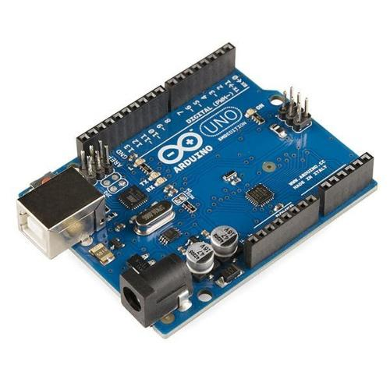
Fig 11 Arduino UNO

Sensors:

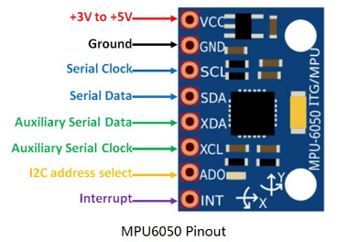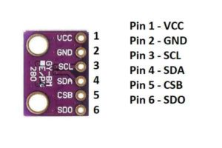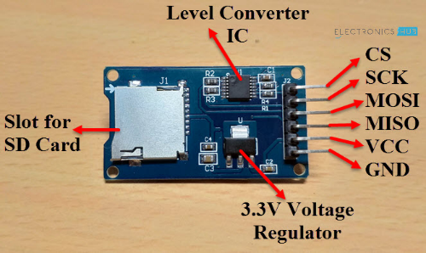
MPU6050 BMP280 Micro SD card Adaptor

Fig.12Sensors
MPU6050: The MPU-6050 is the world’s first and only 6-axis motion tracking device designed for the low power, low cost, and high-performance requirements of smartphones, tablets, and wearable sensors.
- Supply voltage: 2.3–3.4 V
- Consumption: 3.9 mA max
- I2C interface
- Accelerometer:
  - Measuring ranges: ±2 g ±4 g ±8 g ±16 g
  - Calibration tolerance: ±3%
- Gyroscope:
  - Measuring ranges: ±250/500/1000/2000 °/sar
  - Calibration tolerance: ±3%
BMP280:
The BMP280 is an absolute barometric pressure sensor, which is especially feasible for mobile applications. Its small dimensions and its low power consumption allow for the implementation in battery-powered devices such as mobile phones, GPS modules, or watches.

- Chip: BMP280
- Power supply: 3V/3.3V DC
- Peak current: 1.12mA
- Air pressure range: 300-1100hPa (equi. to +9000…-500m above sea level)
- Temperature range: -40 … +85 °C
- Digital interfaces: I²C (up to 3.4 MHz) and SPI (3 and 4 wire, up to 10 MHz)
- Current consumption of sensor BMP280: 2.7µA @ 1 Hz sampling rate.
Micro SD card Adaptor:
The module (MicroSD Card Adapter) is a Micro SD card reader module and the SPI interface via the file system driver, microcontroller system to complete the Micro SD card read and write files. Users can directly use the Arduino IDE that comes with an SD card to complete the library card initialization and read-write.

- Power supply: 4.5V – 5.5V, 3.3V voltage regulator circuit board
- Positioning holes: 4 M2 screws positioning hole diameter of 2.2mm
- Control Interface: GND, VCC, MISO, MOSI, SCK, CS
- Size: 45 x 28mm
- Net weight: 6g

Circuit Diagram for MPU6050, BMP280 sensor, an SD card adapter with Arduino:

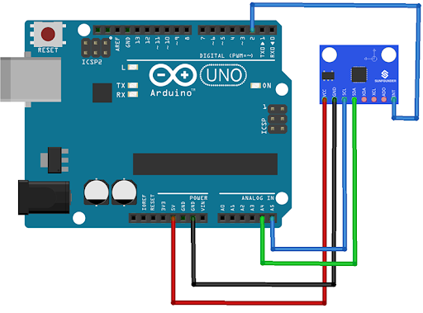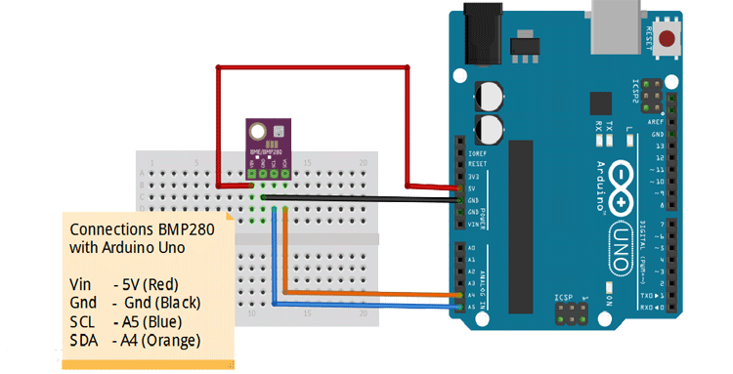
Arduino and MPU6050 Arduino and BMP280

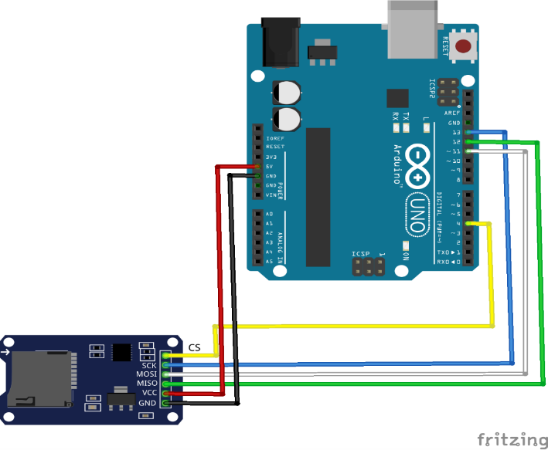
Fig 13 Connection of Arduino and MicroSD card Adaptor

Flowchart code:
Power to Arduino UNO

Sensors sensing the data in analog

Sensor’s data stored
in SD as in digital from

The reason behind choosing Arduino Uno was as it is cost-effective as other modules are expensive and the availability of modules was also a concern.
MPU6050 and BMP280 was also available sensors but different sensors were available for coast cutting MPU6050 and BMP280 was used

3.3.2 Testing:

- Testing Arduino and sensors using plastic can:
This test was taken for checking how MPU6050 and BMP280 give data from the packed environment. The can was thrown up using an elastic cord.
In this whole process, it was expected MPU6050 will give near to accurate data and BMP280 will give precise values of altitude, pressure, and temperature.
After trial, it was observed both MPU6050 & BMP280 gives data with some error(as BMP280 gives data of pressure and altitude by using temperature so, by a change in temperature value of pressure and altitude also changes )

- Testing SD card:
In can, SD card was mounted for checking how data get stored and to check whether it stores data properly or not.
At end of the test, it was found that the SD card works properly.

    - Advancement:
- For storing the data given by MPU6050 and BMP280 sensors SD card was used but in the future, it can be replaced by firebase. By using firebase it will be possible to check live data and firebase will decrease the data loss issue.
- For this rocket, an ejection charge was used for recovery but in future rocket recovery, it can be replaced by checking conditions.

3.4 Ignition:

The ignition system in model rocketry is a system used to ignite the rocket motor to uplift the rocket. It comes under the power subsystem. Power subsystem plays a vital role in providing the power assist to communication and on-board computer subsystem. It includes power management and its calculation. The battery and battery arrangement system is part of the power subsystem. The following report includes two methods for ignition mentioned as method 1(MOSFET as a switch) and method 2(Relay and transistor)

3.4.1 Material Used:
Method 1:

COMPONENT | RATING | QUANTITY
NODE MCU | - | 1
LEAD-ACID BATTERY | 12V,5v | 1,1
NICHROME WIRE | 0.292mm | 2cm
JUMPER WIRE | - | 20
WIRE | - | 1 m
DIODE | - | 1
CORCODILE CLIPS | - | 2
RELAY MODULE | 5V | 1

3.4.2 Methodology

WORKING:
- A button on the firebase app is used to trigger the nodemcu by Wi-Fi mode.
- The Nodemcu transmits a signal to relay module via pin D1.
- The relay module is an electrically operated switch that can be turned on or off deciding to let current flow through or not. They are designed to be controlled with low voltages like 3.3V like the ESP32, ESP8266, etc, or 5V like your Arduino
- Relay module is then connected to the nichrome wire ignitor.
CONNECTION:
- A battery is used to power the nodemcu.
- The gnd and vcc of the relay are connected to gnd and 3.3v of nodemcu respectively. As it has low operating voltage i.e 3.3 V.
- The IN of the relay module is connected to the D1 of nodemcu which a switching signal for the relay.
- The battery and ignitor(Nichrome wire) is connected in series and in between COM(common) and NO(normally open) of the relay.
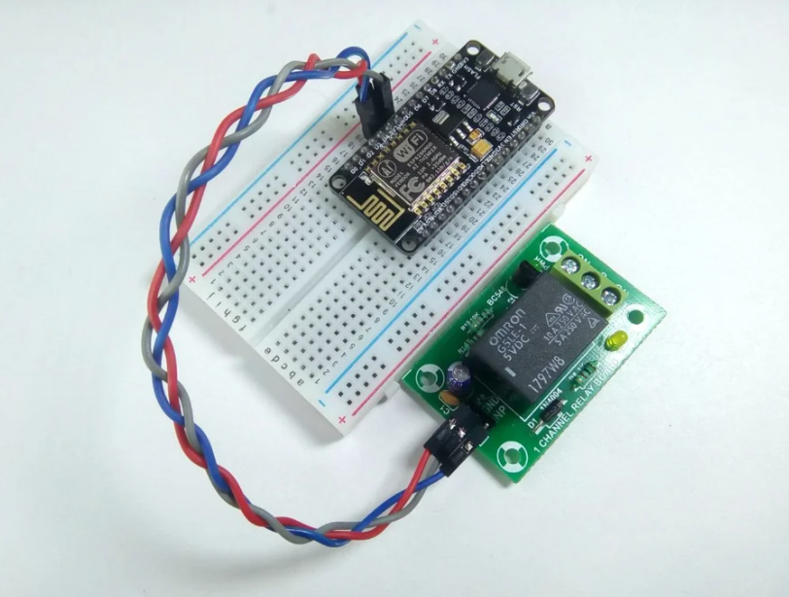
Fig 14 Connection between relay and nodemcu
Power requirement:

1. 12V, 6.5 A connected in series with nichrome wire.
2. 9V 400-600mAh for powering Arduino in OBC.
3. Two 9Vfor ejection charge ignition connected in parallel for each bulb.
4. 9V 400-600mAh for powering a PIC microcontroller in a recovery system connected through a 5V voltage regulator.
3.4.3 Experimental Testing
The main purpose of testing is to check each individual module and component is in perfect condition for working.
For this following steps were carried:-
1, To test the relay, a simple blinking code was dumped and executed to ensure the module's good operation.
2, jumper wires were tested through a multimeter.3.the whole system was tested twice and once for a static test of the motor
3.5 Deployment:
When the rocket reaches its apogee, it begins to accelerate rapidly towards the ground. As a result, to manage the rocket's speed, we employ a parachute recovery system to slow down the rocket's speed and lessen the rocket's impact after colliding with the ground.
The difficulty now is how to open the parachute at the precise moment. As a result, we're utilizing a deployment system to precisely time the parachute's opening.
This subsystem plays a major role in checking the rocket is ignited and opening the parachute by switching ON the MOSFET switch for ejection charges at a predefined time.

3.5.1 Hardware:

Hardware is the most visible part of any system while selecting any component we have to take care of many things such as power consumption, temperature, operating voltage to avoid issues.

PIC18F4520:
PIC18f4520 is an industry-grade microcontroller used for developing electronics products. As this microcontroller is based on RISC architecture it is easy to program for different applications.
- Program Memory Type – flash
- Program Memory Size (KB) – 32
- CPU Speed (MIPS/DMIPS) – 10
- SRAM (B) – 1536
- Temperature Range (°C) - -40 to 125
- Operating Voltage Range (V) – 2 to 5.5
- Pin Count – 40
- Timers - 1x 8-bit, 3 x 16-bit
- ADC Input - 13 ch, 10-bit

- Capture/Compare/PWM Peripherals - 1 CCP, 1 ECCP
- Digital Communication Peripherals - 1-UART, 1-SPI, 1-I2C
- Data EEPROM/HEF (bytes) – 256
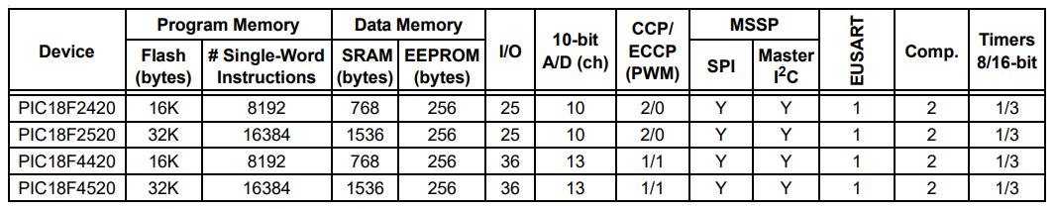

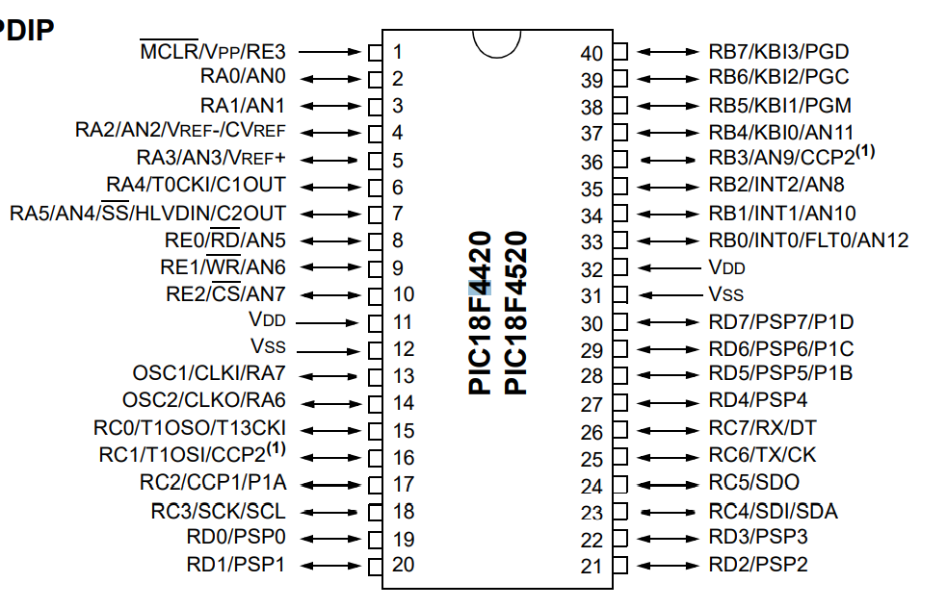
Fig 17 Pin Structure of PIC
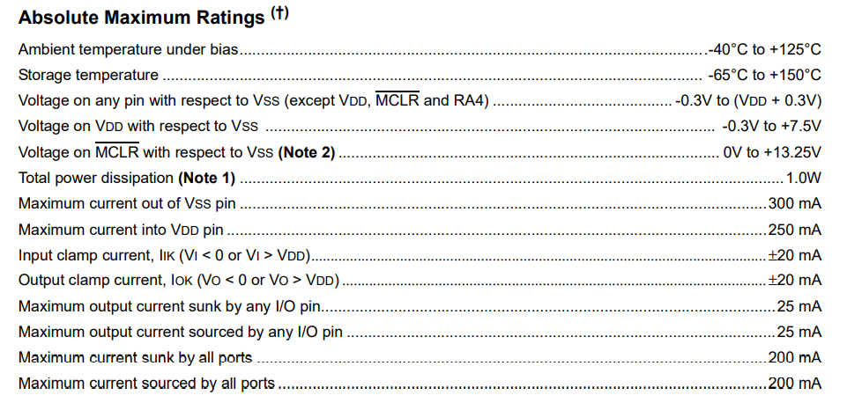
Fig 18 Rating of PIC

Hardware Interrupt:
Interrupts are the signals which alter the flow of an executing program by causing the microcontroller to jump to the Interrupt Service Routine to serve to interrupt.
These interrupts are given to the microcontroller unit through external pins of the microcontroller. In this project, the external interrupt act as a triggering system for Timer operation. For EPLV-1, it is used for the microcontroller to know that ignition started and the rocket is ascending upwards. This leads the controller to start the timer routine for the opening of the parachute.
Initially, the pin is made logic HIGH by using a pull-down resistor circuit. When the rocket gets ignited after the rocket ascends the short-circuited jumper wire is pulled down and the interrupt pin goes to logic LOW and the interrupt routine is called by the microcontroller.
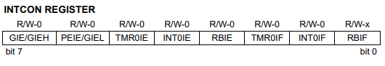
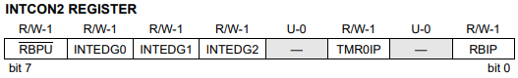
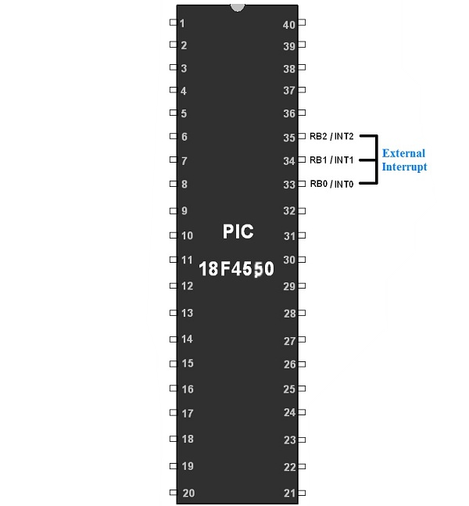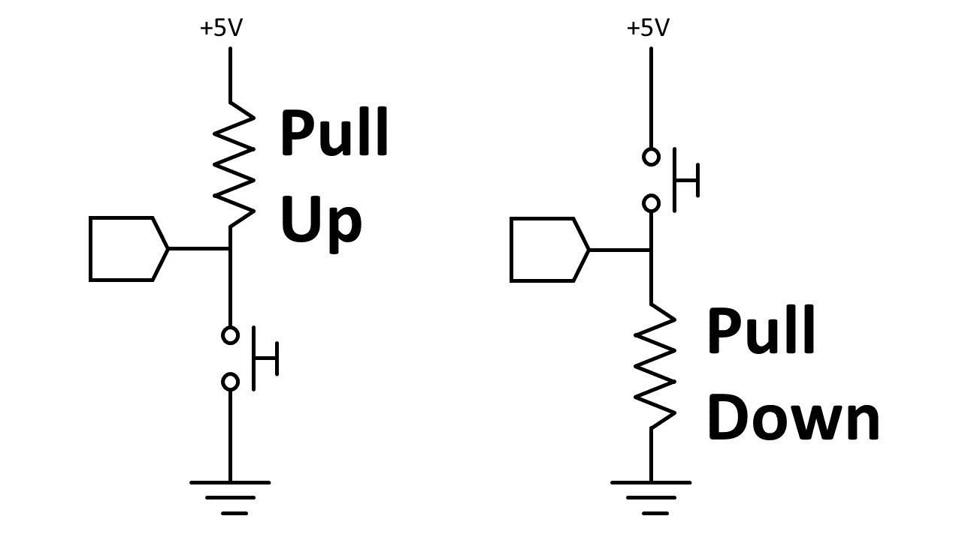
Fig.19 Interrupt Pin

MOSFET Switch:
MOSFETs exhibit three regions of operation viz., Cut-off, Linear or Ohmic, and Saturation. Among these, when MOSFETs are to be used as amplifiers, they are required to be operated in their ohmic region wherein the current through the device increases with an increase in the applied voltage.
On the other hand, when the MOSFETs are required to function as switches, they should be biased in such a way that they alter between cut-off and saturation states. This is because, in the cut-off region, there is no current flow through the device while in the saturation region there will be a constant amount of current flowing through the device, just mimicking the behavior of an open and closed switch, respectively.
This functionality of MOSFETs is exploited in many electronic circuits as they offer higher switching rates when compared to BJTs (bipolar junction transistors).

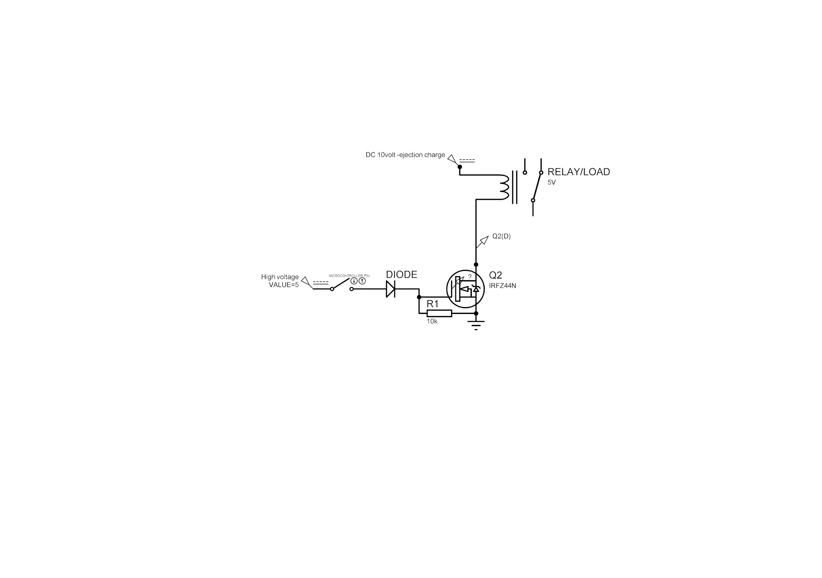
Fig.20 Mosfet Switch Circuit Diagram

3.5.2 Methodology:
- Proper selection of microcontrollers that will be reliable and efficient. As the microcontroller must be able to outstand the different difficulties it will face while flight example – vibration, air pressure, external mechanical forces, etc.
- A interrupt routine for enabling the timers in the microcontroller.
- When the apogee is reached, the MOSFET switch will be ON after the predefined time for triggering ejection charges.

3.5.3 Experimental Testing:
Before implementing the circuit in the rocket various testing were done. Initially, the MOSFET switching code was uploaded for testing them. After that interrupt routine code with pull-down resistor interrupt circuit was implemented with timer code. Finally, taking the combination of interrupt, MOSFET switch, timer code then uploading it in PIC18f4520 using PICkit.

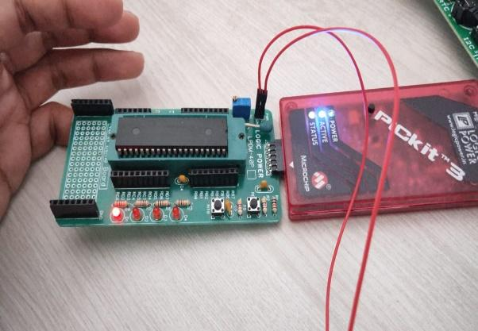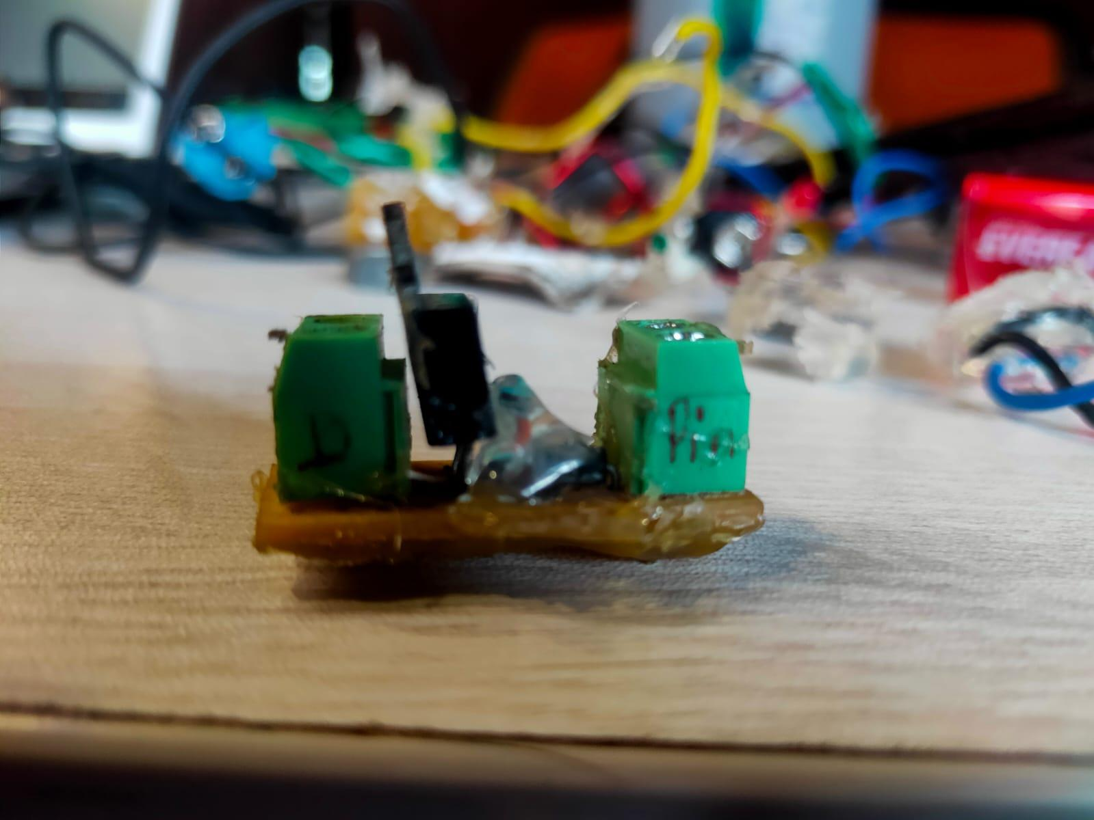

Fig.21 Testing of the system

    - Advancement:
For the next launch, there will be a sensor-based data acquisition for calculating the altitude with acceleration and orientation of the rocket. Using this data the parachutes will be deployed.

3.6 Recovery:
A major goal in model rocketry is to safely retrieve a rocket after it has been launched.
A recovery system is defined as “any device that is incorporated into the model rocket to return it safely to the ground”. Recovery systems work by inducing an upward drag force to overcome the force of gravity and subsequently cause the rocket to slowly descend. Aside from improving safety, integrating a recovery system into model rockets allows the rocket to be re-used if undamaged upon landing.
For this launch, we especially used the body separation method using an ejection charge.
One of the biggest challenges of flying model rockets is trying to successfully recover the rocket.

3.6.1 Material used:
- Parachute: it is made up of nylon material having an octagon shape and having a diameter
- Strings: strings connected to the parachute and shock cord are made up of fully worked cotton having way more strength than the raw cotton strings. there were 8 strings connected to the parachute.
- Shock chord: there were two types of shock chords in EPLV 1.1, one is made up of rubber and another one was fully worked cotton string. There were one rubber shock chord and 2 strings
- Piston: piston was made up of cardboard pipe and foam material
- Chamber for ejection charge: chamber was made up of PVC pipe, it was used to displace the created exhaust
- Heat resistance tape: it was wounded to the shock chord of the upper part of the rocket
- Hair conditioner: it was applied over the heat resistance tape to reduce the tier that caused to shock chord.
- Eye-Bolt: it is used to knot the shock cord to the upper part of the rocket
- U-Bolt: it is used to knot the lower part of the rocket which contains the motor of the rocket

3.6.2 Methodology:
The method used for EPLV-1.1 was body separation using an ejection charge for the deployment of the single parachute.
The main focus was on the ejection charge.
- Process contains checking of a blub by connecting it to a 9V battery to verify its condition whether it was good or bad, then broke the glass of bulb which was in good condition.
- cut the electrical sleeve of length 5.5cm.
- inserted the bulb in the sleeve and shrink it by using a hot gun
- after that insert gun powder of weight 3gm in sleeve
- then cover the upper head of the sleeve by using a glue gun and shrink it by using a hot gun
- connect external extended wire to the bulb wire

- Connect an external extended wire to E-bey.
- Fit the ejection charge with E-bey by using a glue gun.
- Eye bolt was present between two ejection charges as shown in fig and shock cord was connected to the eye bolt using a knot.
- Another shock cord was connected to the bulkhead which was present above the motor.
- Both shock chords were connected to the parachute string by using a knot.
- There was a piston present between parachute and ejection charge to push the parachute downward whenever bursting an ejection charge
- Heat resistance tape was wounded around the shock chord of the upper part of the rocket and the conditioner was applied to it. (To reduce the tear of shock chord caused due to ejection charge bursting).

- Mission Concept of Operation

On December 13 2021 EPLV 1.1 mission was executed. At 10 am team departs from the college. The launch was taken at ‘Retre Dam which is near Islampur. The team arrived at the launch site by 10:30 am. Two groups were working one on rocket assembly and another on setup the Launchpad. The Assembly team assembled the whole rocket within an hour in this assembly they assembled motors, body tubes, electronic components, nosecones, etc.

After 2-hours whole rocket and Launchpad were ready to launch. And at exactly 12:15 pm
the countdown started and within 10-sec the rocket got launched. The flight time of the rocket was 60 sec.
Mission successful. The rocket was recovered successfully & within 100m of area. The team celebrated this victory and came to college at 4 pm.

5 Result & discussion

The rocket contains a payload Arduino UNO as a microcontroller, BMP 280, and MPU 6050 sensors.
BMP 280 and MPU 6050 give altitude and acceleration, gyroscopic angle respectively.
After successful launch and recovery of the rocket, data is retrieved and sent to analysis.
In analysis, it was found that all data of both sensors were correctly stored on SD card modules.
And this received data will help to develop an algorithm for rocket recovery using the sensors as in this rocket timer-based system was used.

- Conclusion

Studying various subsystems of rocket and implementing the knowledge to make a working model EPLV1.1(experimental payload launch vehicle1.1). Standardizing the rocket for 1Km is the first step towards the 3Km cloud seeding project. Successfully launching and recovering the rocket resulted in giving the boast to the team in the forward direction to accomplish more.

- References

https://www.nakka-rocketry.net/
https://www.apogeerockets.com/
https://www.nasa.gov/
https://www.youtube.com/watch?v=_eFW_4HKhys
https://youtu.be/3PkpOeHTnfo
https://www.nakka-rocketry.net/
http://www.jacobsrocketry.com/ https://ww1.microchip.com/downloads/en/DeviceDoc/39631E.pdf
https://www.electronics-tutorials.ws/transistor/tran_7.html

Embedded Systems: Using Assembly and C for PIC18 https://g.co/kgs/AYhpHx

