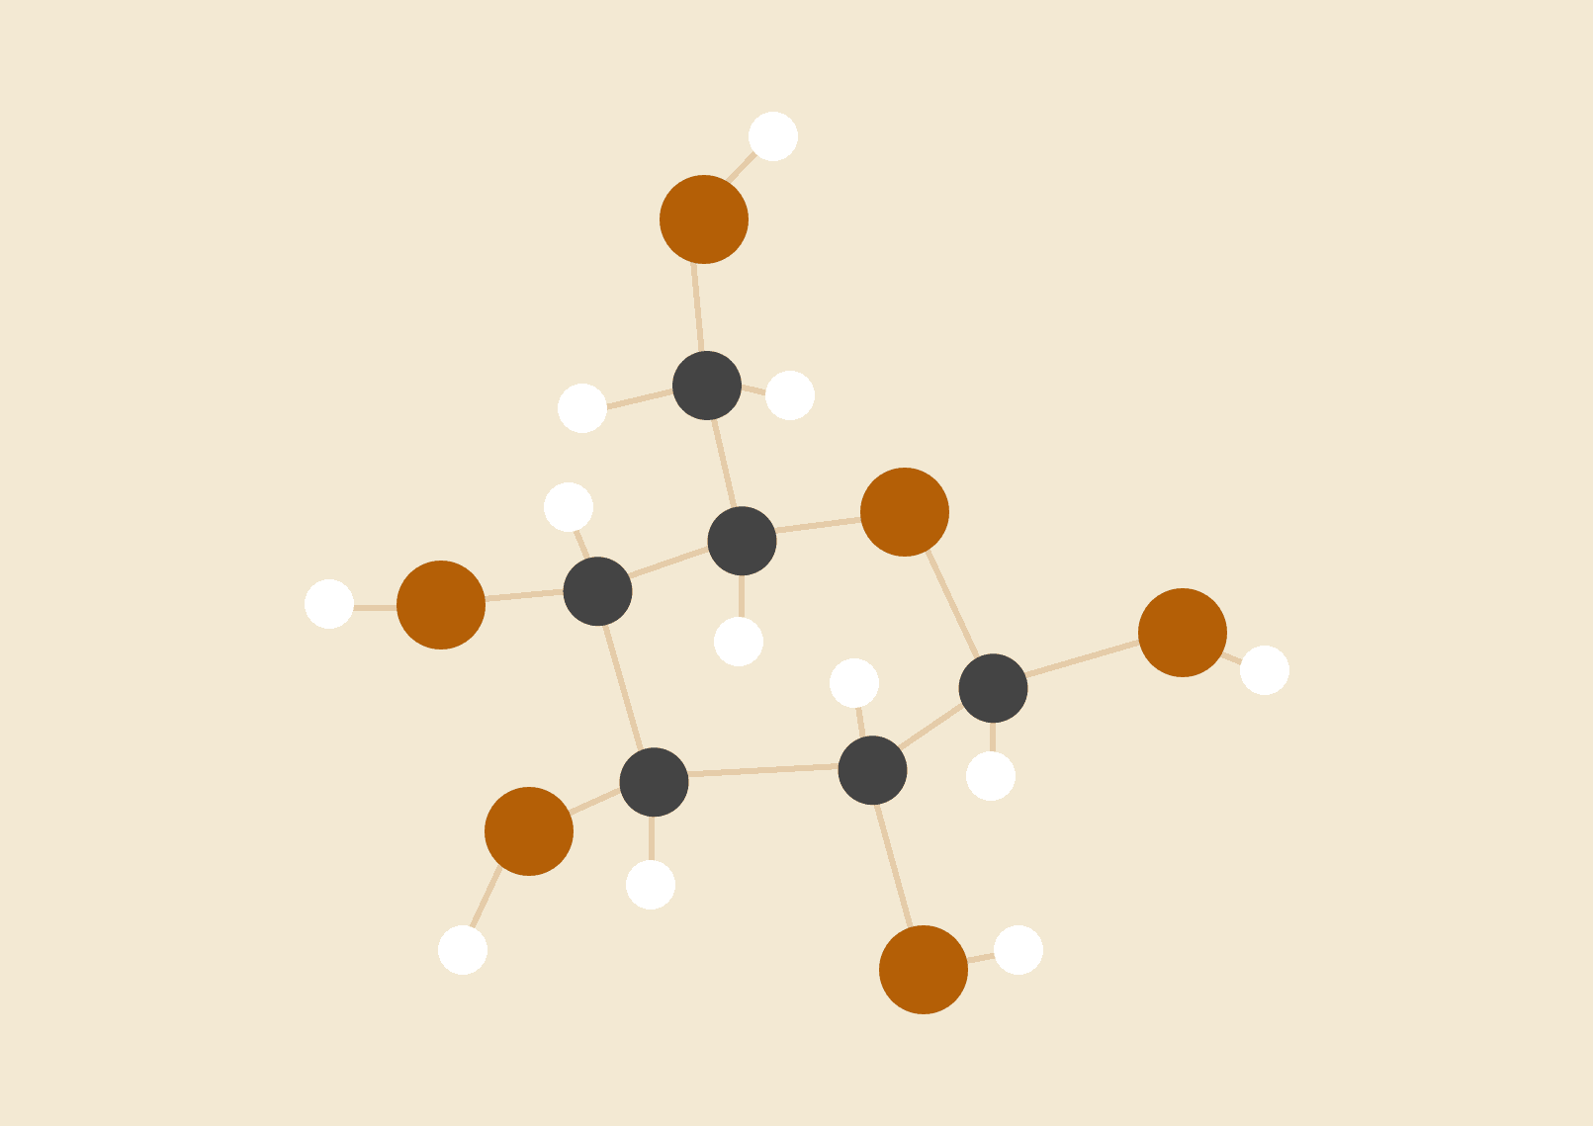

**CS-UY 4523**

**Fall 2016**

**Professor Strauss**

**Sharit**

**Kenneth Liang (kl1792), Allen Zheng (az1010),**

**Warlon Zeng (wz634), Hui Huang (hh1128)**

**Project Motivation**

File sharing has become an integral part of the online community, no matter what the person is doing. It is quite easy to email documents or share a file through Facebook, but the process is very disorganized. Our idea stems from the need to share files/documents in an organized, coherent manner that is also accessible to many others who you want to share with. There are services out there that do this job but is disorganized and does not provide any kind of feedback system.

Students can use this service to post notes for the underclassmen and receive feedback on their work. Students will be able to collaborate and create notebooks that can be shared with other students in the class. This will benefit those who may not have been able to attend school for that day or those who want to use this platform to study for an upcoming exam. The key to our platform is organization of uploaded files; we want people to be able to look up the file they want and quickly access it or ask the owner of the file to grant permission to access.

Our client has expressed the desire to be able to distribute documents among individuals within the company as well as other companies. By trying to be create both an android app and a web app, this project will allow our client to distribute documents online seamlessly as well as use modern security to ensure privacy of documents. As well as distribute documents, users with the right permissions can comment as well as modify the document.

**Proposed Project**

The project is to establish software that can be used as a means of communication in an organization. The structure will be similar to that of the social site “reddit.” An organization will have its own domain on the server. User will belong to an organization and can only access their organization’s **domain**. Users may belong to several organizations. In each domain there will be several **subdomains** that usually correspond to different parts of the organization. Users can create topics in each section and comment on topics. Files can be attached to and downloaded from topics or comments. Some users will be given special privileges in a subdomain, allowing them to delete invalid threads or comments. These users will be known as **moderators**. A user can be the moderator of many subdomains. The domain itself will have moderators, allowing those users to create and delete subdomains. By being a domain moderator, that user will also be a moderator of all subdomains.

A website will be created to allow users access to their domains. The website will feature a simple and clean interface. For this project, the website will feature logging in, logging out, and access for authenticated domains, subdomains, and topics. There will also be a user account page in case the user wishes to change his information.

An Android version will be created that parallels the functionality of the web version. The Android version will allow mobile access for cases when computers are inaccessible.

**Deliverables**

Project proposal: Due date - 9/20/16

Software Project Management Plan (SPMP): Due date - 9/27/16

Requirements and Analysis Document (RAS): Due date – 10/4/16

Software Design Document (SDD) - initial: Due date - 10/25/16

Design Document Final (w/ code): Due date – 11/22/16

Implementation/Demonstration: Starts – 11/30/16