

**Computer Science and Engineering**

**Sharit**

**Requirements/Analysis Specification**

**Version 1.0**

Document Number: RAS-001

Team B6

Allen Zheng (az1010)

Hui Huang (hh1128)

Kenneth Liang (kl1792)

Warlon Zeng (wz634)

**REVIEW AND APPROVALS**

|  |  |  |  |
| --- | --- | --- | --- |
| **Printed Name and Title** | **Function (Author, Reviewer, Approval)** | **Date** | **Signature** |
| Allen Zheng | Author | October 4, 2016 | Allen Zheng |
| Hui Huang | Author | October 4, 2016 | Hui Huang |
| Kenneth Liang | Author | October 4, 2016 | Kenneth Liang |
| Warlon Zeng | Author | October 4, 2016 | Warlon Zeng |
|  |  |  |  |
|  |  |  |  |

**REVISION LEVEL**

|  |  |  |
| --- | --- | --- |
| **Date** | **Revision Number** | **Purpose** |
| October 4, 2016 | Version 1.0 | Initial Release |
|  |  |  |
|  |  |  |
|  |  |  |

**Table of Contents**

1. INTRODUCTION 5

1.1 Purpose

2. SCOPE 5

2.1 Identification

2.2 Bounds

2.3 Objectives

2.4 System Overview

2.5 Document Overview

3. REFERENCE DOCUMENTS 7

4. BUSINESS REQUIREMENTS 7

4.1 Technology

4.2 Economics

4.3 Regulatory and Legal

4.4 Market Considerations

4.5 Risks and Alternatives

4.6 Human Resources and Training

5. CONTEXT DIAGRAM 9

5.1 High Level (Level 0)

6. FUNCTIONAL REQUIREMENTS ANALYSIS SPECIFICATION 9

6.1 Functional Descriptive Detailed Requirements

6.2 System Capability Requirements

6.2.1 Capabilities

6.3 User Interface Requirements

6.4 Component Architecture

6.4.1 Component Descriptions

6.4.2 Component Architecture Diagram

6.5 Class Diagrams

6.6 Class Relationship/Interaction Diagrams

6.7 Event Section

6.7.1 Event Dictionary

6.7.2 Event Diagrams

6.8 Activity/State (Scenario) Section

6.8.1 Activity (Scenario) Diagrams

6.8.2 Activity (Scenario) Specification

6.9 Sequence Diagrams

6.10 Collaboration Diagrams

6.11 Dictionaries

7. NON-FUNCTIONAL/OPERATIONAL REQUIREMENTS 19

7.1 System External Interface Requirements

7.2 Safety Requirements

7.3 Security and Privacy Requirements

7.4 System Environment Requirements

7.5 Computer Resource Requirements

7.5.1 Computer Hardware Requirements

7.5.2 Computer Hardware Resource Requirements

7.5.3 Computer Software Requirements

7.5.4 Computer Communications Requirements

7.6 System Quality Factors

7.7 Design and Construction Constraints

7.8 Personnel-Related Requirements

7.9 Training-Related Requirements

7.10 Logistics-Related Requirements

7.11 Packaging Requirements

7.12 Precedence and Criticality Requirements

7.13 Other Requirements

8. SYSTEM TEST PLAN REQUIREMENTS 22

9. QUALIFICATION PROVISIONS 24

10. REQUIREMENTS TRACEABILITY 24

11. RATIONALE 25

12. NOTES 25

13. APPENDICES 25

13.1 Dictionaries

13.2 UML Diagrams

13.3 Schedule Tracking

13.4 Defect Tracking

13.5 Gantt Chart/Microsoft Project Schedule

# **1. INTRODUCTION**

## **1.1 Purpose**

The purpose of this document is detail all requirements for the project Sharit. Business requirements and software requirements will be presented here. This includes the component architecture, functional requirements, non-functional requirements, and personnel-related requirements.

# **2. SCOPE**

## **2.1 Identification**

This document is the Requirements/Analysis Specification for Sharit. This document is revision 1.0, number 1.

## **2.2 Bounds**

The client’s idea stems from the need to share files/documents in an organized, coherent manner that is also accessible to many others who you want to share with. There are services out there that do this job but is disorganized and does not provide any kind of feedback system.

Students can use this service to post notes for the underclassmen and receive feedback on their work. Students will be able to collaborate and create notebooks that can be shared with other students in the class. This will benefit those who may not have been able to attend school for that day or those who want to use this platform to study for an upcoming exam. The key to our platform is organization of uploaded files; we want people to be able to look up the file they want and quickly access it or ask the owner of the file to grant permission to access.

The project is a website that facilitates conversations and file sharing between people from a common organization. The layout will be a clean and simple format for easy intuitive understanding. Organizations will have a domain that will be split into smaller pieces, such as the subdomain and topics. Users will will have permissions regarding which organization domain and subsequent subdomains they may access.

## **2.3 Objectives**

The objective is to release the final product on December 20, 2016. The next priority is the Software Design Document. The project will be utilizing an incremental life cycle with the deliverables listed below:

|  |  |
| --- | --- |
| Software Project Management Plan | September 27, 2016 |
| Requirements and Analysis Specifications | October 4, 2016 |
| Software Design Document | October 25, 2016 |
| Implementation and Demonstration | November 30, 2016 |
| Presentation | Last Two Weeks of Semester |

## **2.4 System Overview**

The project is to establish software that can be used as a means of communication in an organization. The structure will be similar to that of the social site “reddit.” An organization will have its own domain on the server. User will belong to an organization and can only access their organization’s domain. Users may belong to several organizations. In each domain there will be several subdomains that usually correspond to different parts of the organization. Users can create topics in each section and comment on topics. Files can be attached to and downloaded from topics or comments. Some users will be given special privileges in a subdomain, allowing them to delete invalid threads or comments. These users will be known as moderators. A user can be the moderator of many subdomains. The domain itself will have moderators, allowing those users to create and delete subdomains. By being a domain moderator, that user will also be a moderator of all subdomains.  
 A website will be created to allow users access to their domains. The website will feature a simple and clean interface. For this project, the website will feature logging in, logging out, and access for authenticated domains, subdomains, and topics. There will also be a user account page in case the user wishes to change his information

## **2.5 Document Overview**

The document is split into 4 main parts. Sections 1, 2, 3, 11, and 12 describe the purpose and intentions of Sharit and this document in general terms. Section 4 is entirely related to the business aspect of the Sharit project. Sections 5, 6, 7, 8, & 9 describe the bounds and requirements of Sharit along with testing procedures during the development of Sharit. The last part, section 13, is simply the scheduling for the project thus far and diagrams.

# **3. REFERENCE DOCUMENTS**

Team A6 System Requirements Specification, Version 2.0, March 23, 2016

Team A6 System Analysis Specification, Version 1.0, April 18, 2016

Team B6 Software Project Management Plan, Version 2.0, September 27, 2016

# **4. BUSINESS REQUIREMENTS**

## **4.1 Technology**

To deliver fast, reliable, and high quality website service, recent dated versions of software in servers, databases, and programming languages should be used. These softwares, in combination with development tools, such as git, google cloud, or any other preference tool, will help build a website to meet users’ expectations.

## **4.2 Economics**

1. Domains will be sold to organizations.
2. Revenue comes from selling disk space to organizations

## **4.3 Regulatory and Legal**

There are no regulatory and legal requirements.

## **4.4 Market Considerations**

Since registration is entirely dependent on having an NYU email address (@nyu.edu), the targeted group of consumers will be NYU students and faculty. The project will proceed to follow a subscription model in which the school will pay for users’ subscriptions.

## **4.5 Risks and Alternatives**

1. Not enough users signing up
   1. Can potentially expand to more schools outside of NYU
2. Not enough content being produced
   1. Can offer monetary incentives for students to contribute as a start-up and later retract offers after a self-sufficient number of contributions generated
3. Work that are not acceptable to be shared
   1. Can be removed by moderators

## **4.6 Human Resources and Training**

1. Student programmers
2. PEAN Stack training
   1. PEAN Stack: PostgreSQL, Express, AngularJS, Node
   2. Windows - operating system
   3. Git - version control

# **5. CONTEXT DIAGRAM**

## **5.1 High Level (Level 0)**

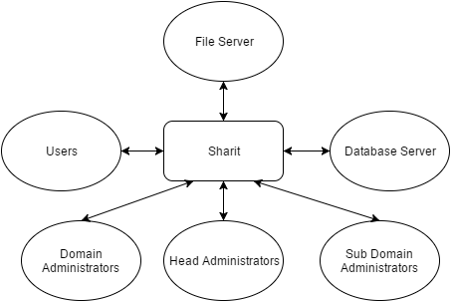

# **6. FUNCTIONAL REQUIREMENTS ANALYSIS SPECIFICATION**

## **6.1 Functional Descriptive Detailed Requirements**

1. The website will provide functions for the user to login and register as well as a profile
   1. A user will be able to register using their student or company email
   2. Existing users will be able to log in using the credentials they registered with
   3. Each user will have a profile with information such as name and school/company
   4. Options will be provided to change basic information
2. Each organization will be allowed to create a domain on the server
   1. Domains are only accessible to users in the organization or with permission
   2. Domains will have administrators or moderators
   3. Admins can modify aspects of the domain as well as grant permissions
   4. Each domain can have subdomains that correspond to different parts of the organization
3. Users will be able to upload and download files
   1. A user will be able to create a thread where the file will be uploaded
   2. Threads will be part of a subdomain
   3. A user that is part of the subdomain may choose to view or download the file
4. Each thread will support feedback/comments
   1. A thread can be upvoted/downvoted to show popularity within a domain
   2. Users can leave comments on the thread
   3. Other users can respond to a previous user’s comment
   4. Users will be able to upvote/downvote other user’s comments
5. A search will be provided to look up specific information in the system
   1. Users can look up specific files/threads in the domain
   2. Users can search for other users and view their profile
   3. Users can search for domains or subdomains to join

## **6.2 System Capability Requirements**

### **6.2.1 Capabilities**

Each of the use cases correspond to each bubble (or combination of bubbles) in the use case diagram in section 5.1.

|  |  |
| --- | --- |
| **Use Case** | **Description** |
| Register | A new user can register for Sharit |
| Login | A registered user can login by providing a valid username and password |
| Edit Information | A user can edit basic account information such as password, school, company, and profile. |
| View other user’s profile | A user can view the basic information of another user such as comments, thread posts, and upvotes. |
| Access domain and subdomain | An authorized user can access a domain or subdomain, they can create threads, leave comments, and upvote. |
| Create thread | An authorized user of a domain can create threads within the domain. |
| Upload/Download | Users can upload/download files from a thread. |
| Feedback | The user can leave a comment or upvote/downvote in a thread. |
| Search for threads, subdomains, users | Head and domain administrators, as well as users, can search for existing threads, subdomains, and/or users |
| Grant/revoke domains, subdomains access/privilege | Administrators will be able to grant or revoke permission/access to users or other administrators |
| Create domains, sub-domains | Administrators can create domains and subdomains. |
| Delete domains, subdomains, threads | Administrators can delete domains, subdomains, and threads. |

## **6.3 User Interface Requirements**

The user interface will be simple but effective. On the top navigation bar will be all the domains that the user is in. Entering a domain will have the top navigation bar show the subdomains of that domain and so on and so forth for each level. To the left side of the page and below the navigation bar will be the menu, allowing access to the login, account settings, site options, etc. To the right of the menu and below the top navigation bar is the main page content. This is where the thread postings will be. Each posting will have a title, creator, date of creation, rating, the number of comments, and the number of attachments shown. There will also be upvote and downvote buttons next to the postings. Accessing a post will result in the thread post appearing the top portion of the main content view with all comments below.

The main content page will be mainly white with black text. The top navigation bar will be a blue color and the menu will be a black color. These colors will be changeable in the settings.

## **6.4 Component Architecture**

### **6.4.1 Component Descriptions**

|  |  |
| --- | --- |
| Component | Description |
| Account Manager | Handles user login and various other account activities, such as change password and update email address. |
| Domain Manager | Handles user access in domains, rejecting them if the user has insufficient privilege. |
| Thread Manager | Handles viewing threads, comments, and posting comments. |
| File Manager | Handles uploading files to the file server and downloading files from the server. |
| Database Manager | Handles access to the database server for information. |

### **6.4.2 Component Architecture Diagram**

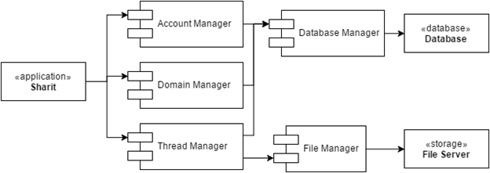

## **6.5 Class Diagrams**

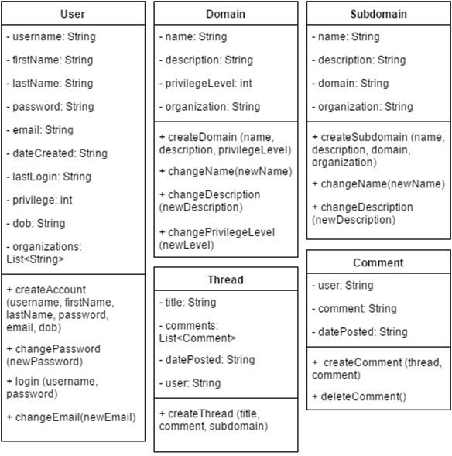

## **6.6 Class Relationship/Interaction Diagrams**

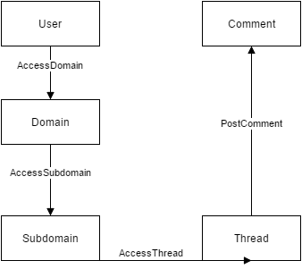

## **6.7 Event Section**

### **6.7.1 Event Dictionary**

|  |  |  |
| --- | --- | --- |
| **Motive** | **Description** | **Objective** |
| Register | Allow user to create account | Grant access to Sharit |
| Upload file | User uploads a file | Share files so others in domain can view |
| Download file | User downloads a file | Gain resource that was shared by others |
| Create thread | User creates a thread in a domain | A thread allows users to interact with others |
| Create domain/sub- domain | Authorized user can create a subdomain | Compartmentalize domains into more specific groups |
| Feedback | User can comment, upvote/downvote | This allows users to engage with each other |

### **6.7.2 Event Diagrams**

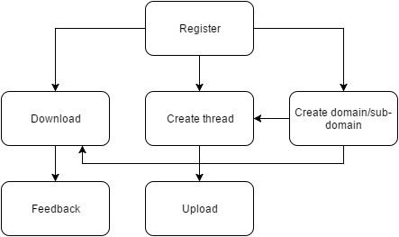

## **6.8 Activity/State (Scenario) Section**

### **6.8.1 Activity (Scenario) Diagrams**

The user tries to login or register into Sharit.

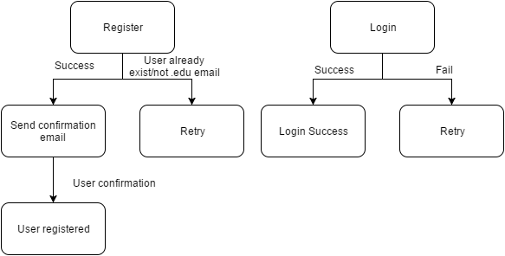

The user tries to access or create a domain or a subdomain.

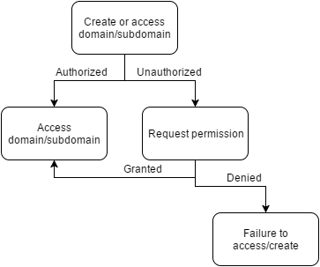

The user tries to create a thread after gaining access to a domain or subdomain.

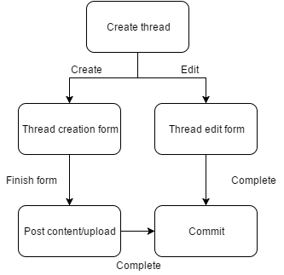

The user wants to download content from a thread or leave feedback

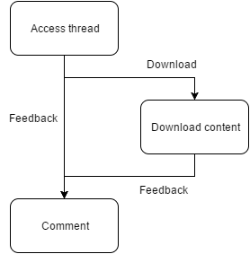

### **6.8.2 Activity (Scenario) Specification**

## **6.9 Sequence Diagrams**

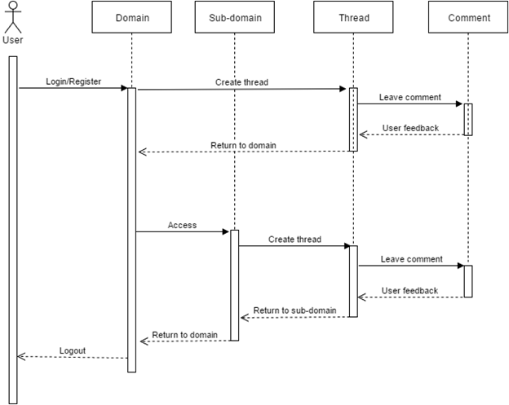

## **6.10 Collaboration Diagrams**

This is a very simplified collaboration diagram as there would be too many actions to fit everything on one clean diagram.

Collaboration Diagram.png

## **6.11 Dictionaries**

See appendix 13.1 for the relevant dictionary information

# **7. NON-FUNCTIONAL/OPERATIONAL REQUIREMENTS**

## **7.1 System External Interface Requirements**

Sharit will use an external server for our data files. The backend interface will communicate with this server to request file reads and writes. A separate server for files will lessen the load on the other servers. The requirement will therefore be the capability to connect to the external server.

## **7.2 Safety Requirements**

Access to the system is maintained by login. Files are also managed by the user who uploaded it. This permission can be changed only by the user and may provide difficulties in sharing to a large group of people.

## **7.3 Security and Privacy Requirements**

The credentials maintained by users is a simple username and password verification system. The system maintains that each new user has a unique username that is not in the system already. Privacy is equivalent to access in our system. Files can only be downloaded and uploaded by a logged in a user. Domains given to groups will be monitored monthly, but contents will not be released. Files uploaded will likewise be checked for legitimacy, but not released. Files deemed to be dangerous will be made inaccessible to users.

## **7.4 System Environment Requirements**

The product runs in every environment with a mouse, keyboard, and a working internet connection. A hard drive is optional if the user needs to store files offline. The user can access their account assuming they do not forget their login information.

## **7.5 Computer Resource Requirements**

### **7.5.1 Computer Hardware Requirements**

|  |  |
| --- | --- |
|  | Minimum requirements |
| Processor | Intel Pentium® D 2.8 GHz or AMD Athlon™ 64 X2 4400+ |
| Video | [Intel Q35 Express](http://www.videocardbenchmark.net/gpu.php?gpu=Intel+Q35+Express&id=968) or Radeon HD 2400 PCI |
| Memory | 512 MB RAM |
| Resolution | 1280 × 720 |
| Internet | 1 Mbps |

### **7.5.2 Computer Hardware Resource Requirements**

|  |  |
| --- | --- |
| I/O Devices | QWERTY keyboard  Mouse  Hard drive with sufficient free space |

### **7.5.3 Computer Software Requirements**

|  |  |
| --- | --- |
| Operating System | Windows® XP/Vista/7/8/8.1/10  OS X  Chrome OS  Linux |
| Browser | Google Chrome, Firefox, Safari, Opera, Internet Explorer  (Latest version recommended) |

### **7.5.4 Computer Communications Requirements**

Communication between users will occur through comments on a specific thread. The only communications requirement will therefore be the minimum computer requirements to access the website and a keyboard.

## **7.6 System Quality Factors**

In order to have a high quality system, the goal is have the lowest possible number of faults and defects. To achieve this, programmers will partake in peer code reviews, walkthroughs, and inspections. This will greatly reduce the number of faults found in a system, thus increasing quality.

## **7.7 Design and Construction Constraints**

The life cycle model used will be the Iteration and Incremental Life Cycle Model. This model is flexible and adaptable. During the design of the website, there will be many changes in its appearance and feel. Increments will be used to handle these changes, while the inherent Waterfall Model will provide a structured basis for development.

Coding will be done primarily using the MEAN stack: MongoDB, Node, Express, and AngularJS. These technologies will be used to create the front-end, the website.

Git will be used for source-control during the development.

## **7.8 Personnel-Related Requirements**

The head administrator will periodically check the content and files uploaded for all the domains and subdomains. This check will be quick and cursory. It is up to the domain administrator and subdomain administrators to conduct more thorough checks on the content in their assigned domain.

## **7.9 Training-Related Requirements**

The accessibility of the website is very simple. Users will register for an account that is aided by a step-by-step form process. Functionality of website will be self-explanatory by a friendly interface.

## **7.10 Logistics-Related Requirements**

All crashes and errors will be logged in the database. Data usage rates will be noted to determine the rate at which space will need to be added to the servers. Git will log code history.

## **7.11 Packaging Requirements**

There are no packaging requirements for Sharit.

## **7.12 Precedence and Criticality Requirements**

The main requirement is to ensure that Sharit does not turn into a site where illegal files (copyrighted material) are shared. File security is also very important; users who do not have access to a domain should not have access to the files inside.

## **7.13 Other Requirements**

The Sharit system will be made scalable so that if the user base gets large, the system can adjust accordingly to accommodate.

# **8. SYSTEM TEST PLAN REQUIREMENTS**

This test plan will assess the requirements as specific in section 7.1 of the SRS.The following test scenario will demonstrate how a user might use Sharit.

|  |  |  |  |
| --- | --- | --- | --- |
| Spec. # | Action | Input | Expected Output |
| 7.1.1.1 | Sign up for account | smith@nyu.edu | Account created |
| 7.1.1.1 | Sign up for account | jane@gmail.com | Fail |
| 7.1.1.2 | Login to account | smith@nyu.edu | Login Successful |
| 7.1.1.2 | Login to account | foo@nyu.edu | Fail |
| 7.1.1.3 | View profile | Smith’s profile | Smith’s information(name, company/school) |
| 7.1.1.4 | Change information | John | Smith’s name is now John |
| 7.1.2.1 | Access domain | Smith’s domain | Success |
| 7.1.2.1 | Access domain | Jane’s domain | Fail |
| 7.1.2.2 | Check administrator | Smith | True |
| 7.1.2.3 | Delete thread | Ice skating | Thread deleted |
| 7.1.2.3 | Grant permission | Jane | Permission granted |
| 7.1.2.4 | Create subdomain | Tests | Subdomain successfully created |
| 7.1.3.1 | Create thread | Prof. Bob’s Fall 2015 midterm | Thread successfully created |
| 7.1.3.3 | Upload file | fall_2015_midterm.pdf | File upload success |
| 7.1.3.3 | Download file | fall_2015_midterm.pdf | Download success |
| 7.1.4.1 | Upvote/downvote thread | -1 | Vote success |
| 7.1.4.2 | Comment on thread | “Useful sample” | Comment posted |
| 7.1.4.3 | Comment on comment | “Incorrect info” | Comment replied |
| 7.1.4.4 | Upvote/downvote comment | +1 | Comment upvoted/downvoted |
| 7.1.5.1 | Search file/thread | fall_2015_midterm | File/thread found |
| 7.1.5.2 | Search user | John | User profile found |
| 7.1.5.3 | Search subdomain | CS2214 | CS2214: Computer Architecture course found |

# **9. QUALIFICATION PROVISIONS**

The primary method used to review documentation and code for quality is inspection. The inspection will be performed by the SQA group, a group formed by all the members of the team. For document-related corrections, copies of the completed document will be distributed to members of the team. Initially, an overview of the document will be inspected. This document will be carefully read to understand the document in detail. Each member will review the document to identify faults, but not correct them. The faults identified will be documented and the one responsible for the document will then resolve those faults. In the follow-up, the document will be inspected again to see if the faults were not satisfactorily resolved.

For code-related corrections, we will use a version-control system using Git. To synchronize the project with all other programmers, the project will be frozen by the programmer making the bug fix to the code. After that programmer is done fixing the fault, the programmer will push the new version of the project using Git version control. The other programmers will work on this newer version with the bug fix implemented.

# **10. REQUIREMENTS TRACEABILITY**

The functional and non-functional requirements will be thoroughly traced throughout the life of the software engineering process. Each specification will be corresponded with an artifact in each of the workflows and be traced. Requirements tracing is done to avoid litigation and also mitigates liabilities. Keeping track of requirements will make sure everything is implemented and meets the specifications.

# **11. RATIONALE**

Finding information relevant to coursework can drastically improve one’s grades. NYU-Poly has historically incurred an usually low graduation rate (50~60%). Information, pertaining previous semester student notes, tests, and possibly homeworks, should be upheld as samples for students currently taking the course to help them review. In the requirements, we aim to answer general questions posted by students that not even google.com, NYUClasses, and instructors could not provide. This is most often phrased “what’s the format” or “is there a sample midterm?”. To uphold integrity of information, we provide and limit information and registration to students with a nyu.edu email address.

In the future, if the project expands outside the NYU community, Sharit can be a creative solution for an easier file sharing system while also fostering a sense of community within a group. It intentions are to be simplistic in nature while boasting required functionalities to fulfill its purpose. Clear organization will allow intuitive understanding to allow the user to quickly execute their actions.

# **12. NOTES**

Currently, Sharit is developed to be accessible only by those with an NYU email address. In the future access may be expanded to allow all email addresses.

# **13. APPENDICES**

## **13.1 Dictionaries**

**CLASSES**

|  |  |  |
| --- | --- | --- |
| User - represents a user in the system | | |
| username | The user’s username | String |
| firstName | The user’s first name | String |
| lastName | The user’s last name | String |
| password | The user’s password | String |
| email | The user’s email address | String |
| dateCreated | The timestamp the user was created | String |
| lastLogin | The last timestamp when the user logged in | String |
| privilege | The user’s privilege | int |
| dob | The user’s date of birth | String |
| organizations | A collection of the organizations the user is part in | Collection<String> |
| createAccount(username, fristname, lastName, password, email, dob) | Creates a new user | Boolean - returns true if successful |
| changePassword(newPassword) | Changes the user’s password | void |
| login(username, password) | Logs in the user | Boolean - returns true if successful |
| changeEmail(newEmail) | Changes the user’s email address | Void |

|  |  |  |
| --- | --- | --- |
| Domain - represents an organization’s domain | | |
| name | The domain’s name | String |
| description | A description of the domain | String |
| privilegeLevel | The user privilege required to access the domain | int |
| organization | The organization this domain belongs to | String |
| createDomain(name, description, privilegeLevel) | Creates a new domain with the passed in parameters | Boolean - returns true if successful |
| changeName(newName) | Changes the domain’s name | void |
| changeDescription(newDescription) | Changes the domain’s description | void |
| changePrivilegeLevel(newPrivilegeLevel) | Changes the domain’s access privilege level | void |

|  |  |  |
| --- | --- | --- |
| Subdomain - represents a subdomain, a mini-domain part of a domain | | |
| name | The subdomain’s name | String |
| description | A description of the subdomain | String |
| domain | The domain name this subdomain is part of | String |
| organization | The organization this subdomain belongs to | String |
| createSubdomain(name, description, domain, organization) | Creates a new subdomain with the passed in parameters | Boolean - returns true if successful |
| changeName(newName) | Changes the subdomain’s name | void |
| changeDescription (newDescription) | Changes the subdomain’s description | void |

|  |  |  |
| --- | --- | --- |
| Thread - represents a topic of discussion | | |
| title | The thread’s name | String |
| comments | A collection of all the Comments in the thread where the first comment is original post | Collection<Comment> |
| datePosted | The timestamp the thread was created | String |
| user | The user who created the thread | String |
| createThread(title, comment, subdomain) | Creates a new thread in the specified subdomain | Boolean - returns true if successful |

|  |  |  |
| --- | --- | --- |
| Comment - represents a user’s comment | | |
| user | The user who posted this comment | String |
| comment | The user’s comment | String |
| datePosted | The timestamp the thread was created | String |
| createComment(thread, comment) | Creates a new comment in the specified thread) | Boolean - returns true if successful |
| deleteComment() | Deletes the comment from the thread | void |

**RELATIONSHIPS**

|  |  |  |  |
| --- | --- | --- | --- |
| Class 1 | Class 2 | Description | Cardinality |
| User | Domain | A user can access a domain | Many-to-many |
| Domain | Subdomain | A subdomain is part of domain | One-to-many |
| Subdomain | Thread | A thread is part of a subdomain | One-to-many |
| Thread | Comment | A comment is part of a thread | One-to-many |

## **13.2 UML Diagrams**

UML diagrams can be found in section 6.

## **13.3 Schedule Tracking**

|  |  |  |  |  |
| --- | --- | --- | --- | --- |
| **Artifact or Deliverable** | **Whom** | **Estimated** | **Actual** | **Difference** |
| Initial SRS | Allen Zheng | 3 hr | 4 hr | 1 hr |
|  | Hui Huang | 3 hr | 5 hr | 2 hr |
|  | Kenneth Liang | 3 hr | 7 hr | 4 hr |
|  | Warlon Zeng | 3 hr | 5 hr | 2 hr |
|  | Summary | 12 hr | 21 hr | 9 hr |
| SRS 2.0 | Allen Zheng | 2 hr | 2 hr | 0 hr |
|  | Hui Huang | 2 hr | 4 hr | 2 hr |
|  | Kenneth Liang | 2 hr | 3 hr | 1 hr |
|  | Warlon Zeng | 2 hr | 4 hr | 2 hr |
|  | Summary | 8 hr | 13 hr | 5 hr |
| Initial SPMP | Allen Zheng | 3 hr | 3 hr | 0 hr |
|  | Hui Huang | 3 hr | 5 hr | 2 hr |
|  | Kenneth Liang | 3 hr | 4 hr | 1 hr |
|  | Warlon Zeng | 3 hr | 4 hr | 1 hr |
|  | Summary | 12 hr | 16 hr | 4 hr |
| SPMP 2.0 | Allen Zheng | 2 hr | 1 hr | 1 hr |
|  | Hui Huang | 2 hr | 2 hr | 0 hr |
|  | Kenneth Liang | 2 hr | 1 hr | 1 hr |
|  | Warlon Zeng | 2 hr | 2 hr | 0 hr |
|  | Summary | 8 hr | 6 hr | 2 hr |
| Initial SAS | Allen Zheng | 3 hr | 4 hr | 1 hr |
|  | Hui Huang | 3 hr | 5 hr | 2 hr |
|  | Kenneth Liang | 3 hr | 3 hr | 0 hr |
|  | Warlon Zeng | 3 hr | 2 hr | 1 hr |
|  | Summary | 12 hr | 14 hr | 2 hr |
| Initial RAS | Allen Zheng | 3 hr | 3 hr | 0 hr |
|  | Hui Huang | 3 hr | 4 hr | 1 hr |
|  | Kenneth Liang | 3 hr | 5 hr | 2 hr |
|  | Warlon Zeng | 3 hr | 3 hr | 0 hr |
|  | Summary | 12 hr | 15 hr | 3 hr |

**Cumulative**

|  |  |  |  |
| --- | --- | --- | --- |
| **Whom** | **Estimated** | **Actual** | **Difference** |
| Allen Zheng | 16 hr | 17 hr | 1 hr |
| Hui Huang | 16 hr | 25 hr | 9 hr |
| Kenneth Liang | 16 hr | 23 hr | 7 hr |
| Warlon Zeng | 16 hr | 20 hr | 4 hr |
| Summary | 64 hr | 85 hr | 21 hr |

## 

## **13.4 Defect Tracking**

|  |  |  |  |  |
| --- | --- | --- | --- | --- |
| **Artifact or Deliverable** | **Whom** | **Estimated** | **Actual** | **Difference** |
| Initial SRS | Allen Zheng | 5 | 3 | 2 |
|  | Hui Huang | 5 | 2 | 3 |
|  | Kenneth Liang | 5 | 4 | 1 |
|  | Warlon Zeng | 5 | 2 | 3 |
|  | Summary | 20 | 11 | 9 |
| SRS 2.0 | Allen Zheng | 4 | 2 | 2 |
|  | Hui Huang | 4 | 5 | 1 |
|  | Kenneth Liang | 4 | 3 | 1 |
|  | Warlon Zeng | 4 | 2 | 2 |
|  | Summary | 16 | 12 | 6 |
| Initial SPMP | Allen Zheng | 5 | 4 | 1 |
|  | Hui Huang | 5 | 5 | 0 |
|  | Kenneth Liang | 5 | 6 | 1 |
|  | Warlon Zeng | 5 | 3 | 2 |
|  | Summary | 20 | 18 | 4 |
| SPMP 2.0 | Allen Zheng | 3 | 4 | 1 |
|  | Hui Huang | 3 | 3 | 0 |
|  | Kenneth Liang | 3 | 4 | 1 |
|  | Warlon Zeng | 3 | 2 | 1 |
|  | Summary | 12 | 13 | 3 |
| Initial SAS | Allen Zheng | 7 | 3 | 4 |
|  | Hui Huang | 7 | 8 | 1 |
|  | Kenneth Liang | 7 | 5 | 2 |
|  | Warlon Zeng | 7 | 4 | 3 |
|  | Summary | 28 | 20 | 10 |
| Initial RAS | Allen Zheng | 6 | 5 | 1 |
|  | Hui Huang | 6 | 7 | 1 |
|  | Kenneth Liang | 6 | 9 | 3 |
|  | Warlon Zeng | 6 | 4 | 2 |
|  | Summary | 24 | 25 | 7 |

**Cumulative**

|  |  |  |  |
| --- | --- | --- | --- |
| **Whom** | **Estimated** | **Actual** | **Difference** |
| Allen Zheng | 30 | 21 | 9 |
| Hui Huang | 30 | 30 | 0 |
| Kenneth Liang | 30 | 31 | 1 |
| Warlon Zeng | 30 | 17 | 13 |
| Summary | 120 | 99 | 23 |

## **13.5 Gantt Chart/Microsoft Project Schedule**

