CS-UY 4513 Software Engineering (DP I)

Warlon Zeng, N11183332, wz634

Chapter 5 - 1, 9, 12, 14

1. A

|  |  |  |
| --- | --- | --- |
|  | Input | Output |
| Insert | Bob | Metrotech 2 center |
| Modify | Bob | Metrotech 6 center |
| Delete | Bob |  |

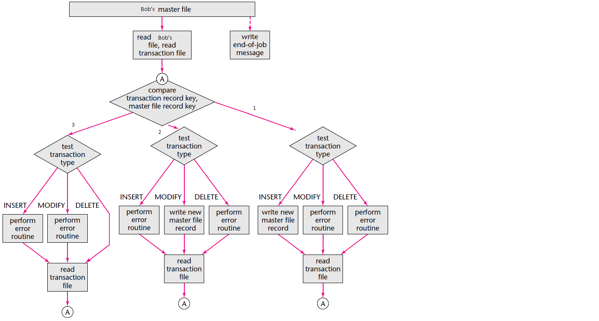

1. If the rate of fault detecting during design inspection doubles, we can say that testing and implementation doubles, as well as reliability and quality, but there will be more expenses.
2. Yes, a version-control tool is essential for revisions and maintenance. In the part for operating systems consideration, different versions are needed to ship out to different types of operating systems.
3. Each of the four artifacts will be locally copied and assigned to Paul, Quentin, and Rachel. Each of them makes changes to the artifacts and push the changes to SQA group to have it methodical testing. After it has passed, it is ready to be integrated into the product, and copies are so forwarded to the post-delivery maintenance programmers. The whole process should be directly supervised by the manager in the case the configuration-control tool is inoperative.