UnityEditorScript(UES) Document

UnityEditorScript(UES) is so easy to creat EditorWindow.It’s looks like ActionScript3.You can find help in “Tools/UnityEditorScript”.
UnityEditorScript(UES)是灵活简便实现EditorWindow界面的插件。它的实现与ActionScript3比较相似。你可以在顶部菜单Tools/UnityEditorScript查看相关内容。

Window

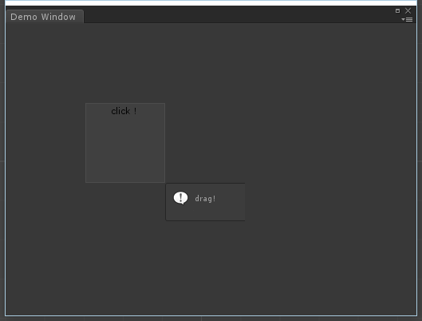
DisplayObject
Stage

- Creat Window
Your custom EditorWindow need inherited USEWindow.
创建窗体
自定义窗口需要继承自UESWindow

public class UESDemoWindow : UESWindow
{
//Open window
[MenuItem("Tools/UnityEditorScript/Demo")]
static void Init()
{
var window = EditorWindow.GetWindow<UESDemoWindow>();
window.titleContent = new GUIContent("Demo Window");
window.Show();
}

- Creat DisplayObject
创建显示对象
一般情况在Awake()中创建显示对象，使用AddChild添加对象。

protected override void Awake()
{
base.Awake(); //Important!Window initialize(初始化)

var box = UESTool.Create<UESBox>(this); //Create display object(创建对象)
box.Rect = new Rect(100,100,100,100); //Set size and position(设置尺寸位置)
box.Mask = new Rect(-20, -20, 220, 300); //Support mask(支持遮罩)
stage.AddChild(box); //Important!Add to stage for rendering(添加到舞台才能显示)
}

- Add Listener
It’s different between Target and CurrentTarget.
添加事件监听
注意Target与CurrentTarget的区别！

...
stage.AddEventListener(UESMouseEvent.MOUSE_CLICK, OnMouseClick); //舞台添加鼠标点击监听
void OnMouseClick(UESEvent obj)
{
var display = obj.Target as UESDisplayObject;
Debug.Log(display.Name);
}

4.DisplayObject List
显示对象列表
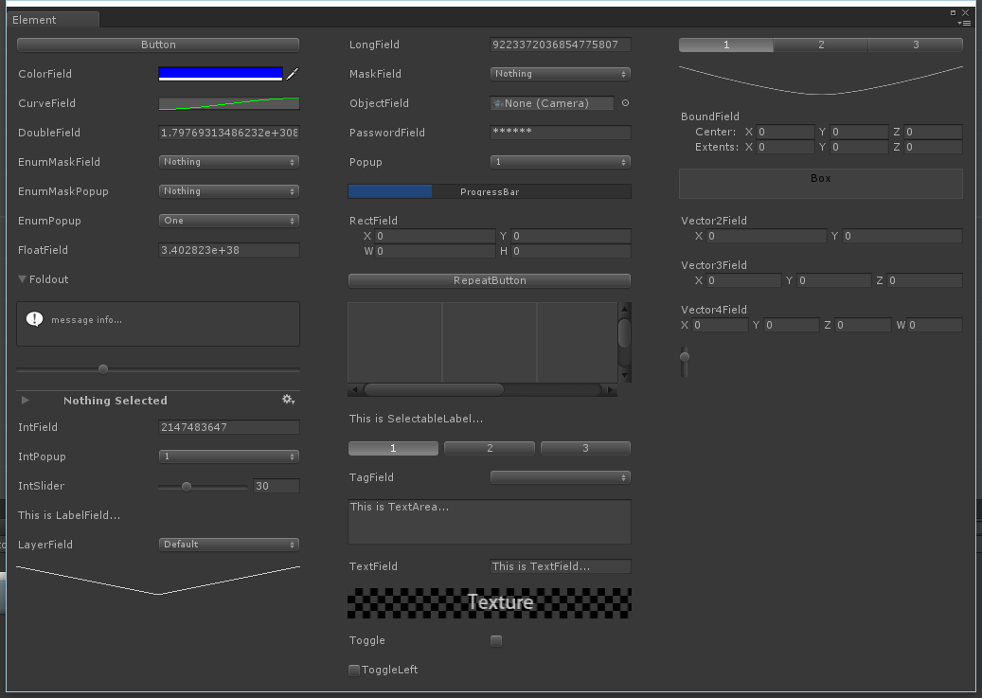

V1.0
1.Easy to creat EditorWindow.
2.You can add ui element on stage;

