ROS

ROSNODE

rosnode list
// only runs when roscore is running

rosnode info /rosout
// rosnode list tells about no. of nodes that are currently active

rosnode ping /filename
//basic ping command that will ping the rosrun that’s running

ROSRUN

rosrun “name” “filename”
//rosrun turtlesim turtlesim_node

rosrun rqt_graph rqt_graph
//tells which node is publishing and subscribing

ROSTOPIC

//The turtlesim_node and the turtle_teleop_key node are communicating with each other over a ROS Topic. turtle_teleop_key is publishing the key strokes on a topic, while turtlesim subscribes to the same topic to receive the key strokes.

rostopic echo xyz
//print all the messages

//It acts as a subscriber to the publisher turtle_teleop_key

rostopic list -v
//tells about all the Publishers an Subscribers that are running

rostopic type [topicname]
rosmsg show [output of above]
//print the type of arguments that are passing

rostopic pub //publish data to the running node

$ rostopic pub -1 /turtle1/cmd_vel geometry_msgs/Twist -- '[2.0, 0.0, 0.0]' '[0.0, 0.0, 1.8]'
// -1 => publish one message
// turtle1/cmd_vel => name of the topic
// geometry_msgs/Twist => the datatype
// [] [] => linear and angular
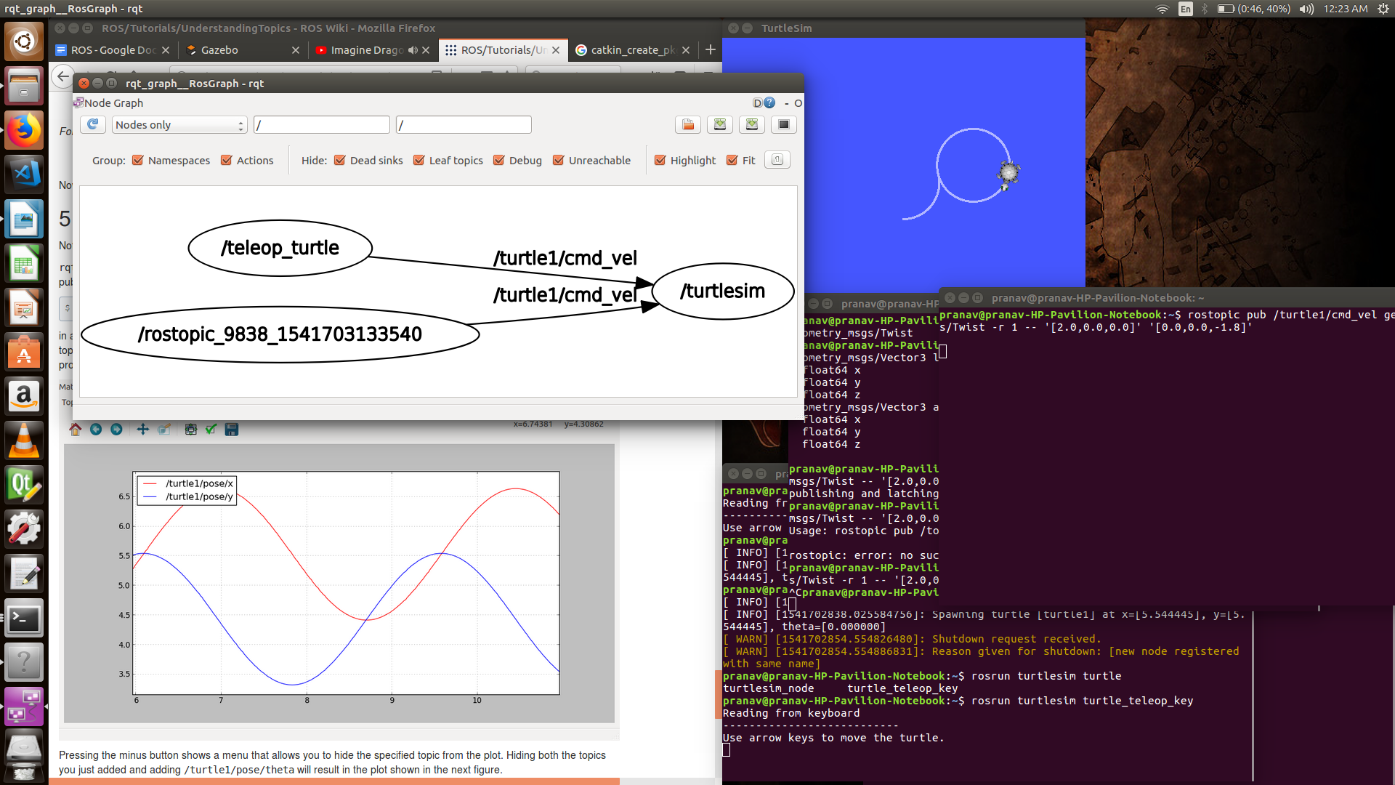
rosservice list
//Tells about the services provided by the rosrun

call => apply to the program

rosparam
//sets and gets parameters

set
get

msg and srv

Imp-
http://wiki.ros.org/ROS/Tutorials/CreatingMsgAndSrv

rospack = ros+pack(age) : provides information related to ROS packages
- roscd = ros+cd : changes directory to a ROS package or stack
- rosls = ros+ls : lists files in a ROS package
- roscp = ros+cp : copies files from/to a ROS package
- rosmsg = ros+msg : provides information related to ROS message definitions
- rossrv = ros+srv : provides information related to ROS service definitions
- catkin_make : makes (compiles) a ROS package
- rosmake = ros+make : makes (compiles) a ROS package (if you're not using a catkin workspace)

ROS publisher and subscriber
Publisher code >>
#include "ros/ros.h"
#include "std_msgs/String.h"
#include <sstream>
int main(int argc,char **argv)
{
ros::init(argc,argv,"talker"); //initializing ros
ros::NodeHandle n; //creating a handle for this process node
ros::Publisher chatter_pub = n.advertise<std_msgs::String>("chatter",1000);
//publishing a msg of type String which tells master that node is listening on 'chatter' with 1000 max msgs
//advertise serves - publish method and - unadvertise automatically if it goes out of scope
ros::Rate loop_rate(10); //loop freq.

int count = 0;
while (ros::ok())
//returns False when - CTrL+C is pressed or
// - kicked out of the network
// - ros::shutdown() is called by another application
// - all ros NodeHandles have been destroyed
{
std_msgs::String msg;
std::stringstream ss;
ss<<"Hello World"<<count;
msg.data = ss.str();

ROS_INFO("%s",msg.data.c_str());

chatter_pub.publish(msg); // msg is being broadcast
ros::spinOnce();
loop_rate.sleep();
++count;
}
return 0;
}

//Init. ROS
//Advertise the published msg
//Loop while publishing msg to loop time, i.e., here - 10

Subscriber Code >>

#include "ros/ros.h"
#include "std_msgs/String.h"
void chatterCallback(const std_msgs::String::ConstPtr& msg)
{
ROS_INFO("I heard: [%s]",msg->data.c_str());
}
//callback function will called when a new message has arrived on the chatter topic
//used a boost shared_ptr

int main(int argc,char **argv)
{
ros::init(argc,argv,"listener");
ros::NodeHandle n;
ros::Subscriber sub = n.subscribe("chatter",1000,chatterCallback);//Subscribe to the required topic, i.e., here - chatter
ros::spin();//loop that calls the message in Callback fn.
//will exit when ros::ok() returns False

return 0;
}

//Init ROS
//Subscribe to chatter topic
//Spin, waiting for msg to arrive
//When msg arrives, 'chatterCallback()' fn. is called

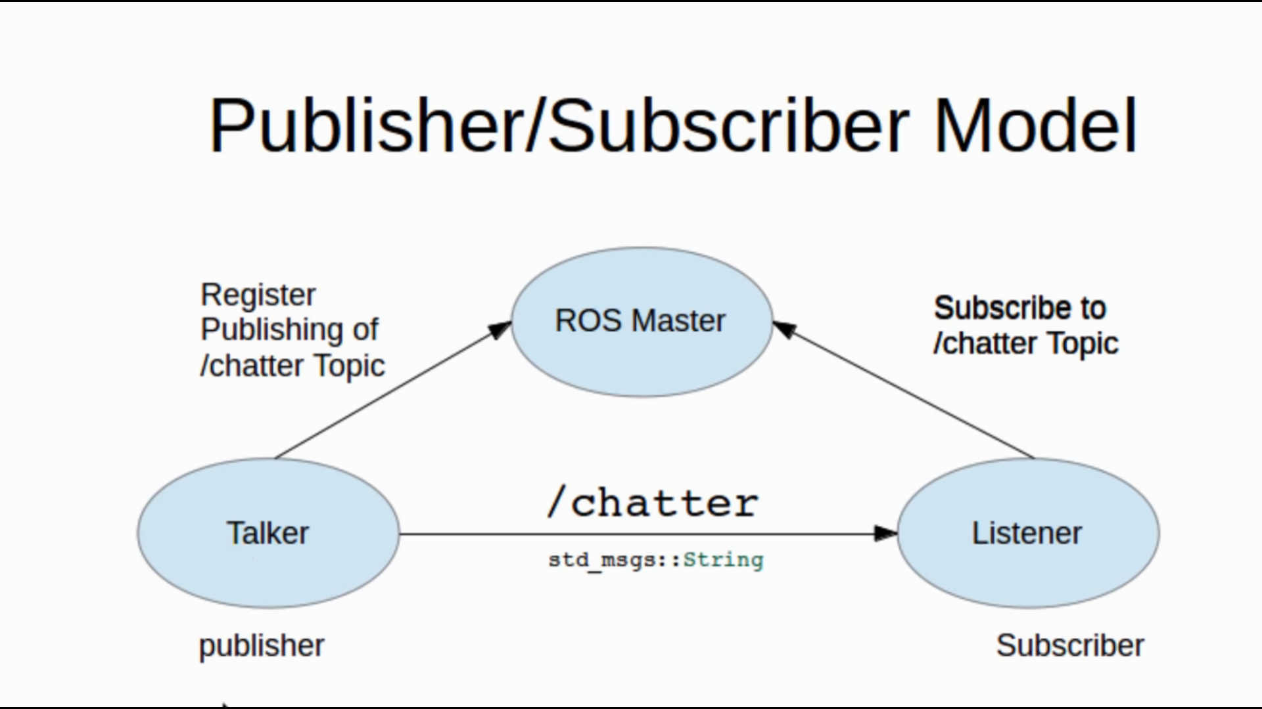

NOTE:

Problem when opening new terminal for Talker and Listener
- First run command in catkin_ws as – source ./devel/setup.bash
- Then catkin_make

ROS Service and Client
ROS Recording data in Bagfile

ps -ef | grep -i rosmaster

For checking if ROSCORE is running or not

ROSWTF
roscd rosmaster
roswtf

//Checks for errors on the whole ROS Kinetic Project

