A
PROJECT REPORT
ON
ClassPlus: Class Management System
Submitted for the fulfillment of the Degree of Bachelor of Engineering in Computer awarded by Pokhara University


SUBMITTED BY
Nikit Pandey [21070562]
Ranjan Paudel [21070565]
Suman Sharma [21070579]
Shiva Kumar Bhandari [21070575]

SUPERVISOR
Er. Shiva Kunwar

SUBMITTED TO:
DEPARTMENT OF COMPUTER ENGINEERING
POKHARA ENGINEERING COLLEGE
PHIRKE, POKHARA-8
2025

CERTIFICATE
Date:2025/07/20

This is to certify that the project entitled “ClassPlus: Class Management System” has been carried out by Nikit Pandey (21070562), Ranjan Paudel (21070565), Suman Sharma (21070579) and Shiva Kumar Bhandari (21070575) in fulfillment of the degree of Bachelor of Engineering in Computer of Pokhara University, during the academic year 2025. To the best of our knowledge and belief, this work has not been submitted elsewhere for the award of any other degree and thus has been accepted.
--------------------------------
External Examiner
Er. Tara Bahadur Thapa

----------------------------
Er. Shiva Kunwar
Project Supervisor

----------------------------
Er. Suraj Basant Tulachan
HOD, Computer & Electronics

----------------------------
Er. Krishna Ghimire
Research & Development Chief

ACKNOWLEDGEMENT
We would like to express our heartfelt gratitude to our respected Supervisor, Er. Shiva Kunwar, whose valuable guidance, constant encouragement, and insightful feedback played a vital role throughout the development of this project. His expertise and motivation pushed us to perform better and think critically at every stage.
We are equally thankful to our Head of Department, Er. Suraj Basant Tulachan, for his continuous support, timely suggestions, and for fostering an academic environment that nurtures innovation and research. We would also like to extend our sincere appreciation to all the faculty members and staff of the Department of Computer Engineering, Pokhara Engineering College, for providing the necessary resources and academic support.
We are grateful to our friends, families and classmates who offered their assistance, feedback, and moral support during the challenges we faced throughout the course of this project. Their involvement was invaluable.
This project stands as a collective effort of everyone who contributed directly or indirectly, and to all of them, we offer our sincere thanks.

Nikit Pandey [21070562]
Ranjan Paudel [21070565]
Suman Sharma [21070579]
Shiva Kumar Bhandari [21070575]

ABSTRACT
ClassPlus is an intelligent and comprehensive web-based solution designed to assist schools and colleges in managing classroom activities in both online and offline modes. The system offers attendance marking through QR code with fallback mechanisms such as OTP verification to minimize proxy attendance. For online learning, the system integrates Jitsi Meet to facilitate live video classes with features including chat, screen sharing, and whiteboard support.
Instructors can manage course delivery by posting notes, uploading assignments and tracking student submissions through a unified dashboard. Students can access all course content, submit assignments, and receive timely notifications via email or SMS regarding upcoming classes, approaching deadlines, and new learning materials.
Additionally, ClassPlus includes tools for routine management and notice circulation, enabling both students and teachers to stay informed about daily schedules and academic or extracurricular announcements.
The platform ensures a secure, user-friendly, and systematic learning environment, enhancing the overall effectiveness and accessibility of classroom engagement.
Keywords: Class management system, QR attendance, Jitsi Meet, web-based LMS, online learning, virtual classroom, routine management, OTP verification

साराांश

ClassPlus एउटा स्माटट र बहुआयामिक वेब-आधाररत प्रणाली हो जसले मवद्यालय तथा कलेजहरूलाई अनलाइन र अफलाइन दुवै िाध्यििा कक्षा गमतमवमधहरू व्यवस्थापन गनट सहयोग पुर्य‍ ाउँछ। यस प्रणालीिा QR code िाफट त उपस्थस्थमत मिन्ह लगाउने सुमवधा छ, जसिा OTP verification जस्ता मवकल्पहरू प्रयोग गररन्छ जसले proxy attendance रोक्न िद्दत पुर्य‍ ाउँछ। अनलाइन कक्षाका लामग, यो प्रणालीले Jitsi Meet को िाध्यिबाट लाइभ मभमियो कक्षा सञ्चालन गदटछ, जसिा chat, screen sharing, र whiteboard जस्ता सुमवधाहरू सिावेश छन्।
मशक्षकहरूले‍एउटै‍ड्यासबोिट‍बाट‍नोट्स‍पोस्ट‍गनट, असाइनिेन्टस्‍अपलोि‍गनट‍र‍मवद्याथीहरूको‍ सबमिसनस्‍अनुगिन‍गनट‍सक्छन्।‍मवद्याथीहरूले‍कोसट‍कन्टेन्ट‍हेनट, असाइनिेन्टस्‍बुझाउन‍र‍ आगािी‍क्लासहरू, नमजमकँ दै‍गरेका‍िेिलाइनहरू‍र‍नयाँ‍लमनटङ‍िटेररयल्स‍को‍बारेिा‍इिेल‍वा‍ एसएिएस‍िाफट त‍सूिनाहरू‍प्राप्त‍गनट‍सक्छन्। यसका‍साथै, ClassPlus िा‍क्लास‍रुमटन‍व्यवस्थापन‍तथा‍मवशेष‍सूिना‍प्रसारण‍गने‍सुमवधा‍पमन‍ छ, जसले‍मवद्याथी‍र‍मशक्षक‍दुवैलाई‍दैमनक‍तामलका‍तथा‍शैमक्षक‍वा‍अमतररक्त‍गमतमवमधहरूको‍ जानकारीिा‍राख्छ। यो‍प्लाटफिट‍सुरमक्षत, प्रयोगिैत्री‍र‍व्यवस्थस्थत‍मशक्षण‍वातावरण‍प्रदान‍गदै‍कक्षा‍सहभामगताको‍सिग्र‍ प्रभावकाररता‍र‍पहुँिलाई‍बढाउँछ।

ABBREVIATIONS

- AJAX: Asynchronous JavaScript and XML
- API: Application Programming Interface
- CSS: Cascading Style Sheets
- HTML: Hyper Text Markup Language
- JS: JavaScript
- LMS: Learning Management System
- OTP: One-Time Password
- PHP: Hypertext Preprocessor
- QR: Quick Response
- SMS: Short Message Service
- SQL: Structured Query Language
- UI: User Interface
- XML: eXtensible Markup Language

TABLE OF CONTENTS
CERTIFICATE ............................................................................................................... i
ACKNOWLEDGEMENT ............................................................................................. ii ABSTRACT ..................................................................................................................iii साराशां ............................................................................................................................... iv
ABBREVIATIONS ....................................................................................................... v
CHAPTER 1: INTRODUCTION .................................................................................. 1
1.1 Background ................................................................................................ 1
1.2 Statement of Problem ................................................................................. 2
1.3 Objectives .................................................................................................. 3
1.4 Scope of Project ......................................................................................... 3
1.5 Limitation ................................................................................................... 3
CHAPTER 2: LITERATURE REVIEW ....................................................................... 4
2.1 Preliminary Study ...................................................................................... 4
2.2 Similar Tasks ............................................................................................. 4
CHAPTER 3: METHODOLOGY ................................................................................. 4
3.1 Jitsi Meet Integration ................................................................................. 7
3.2 Chillerlan/php-qrcode Integration .............................................................. 8
3.3 html5-qrcode Integration ........................................................................... 9
3.4 PHPMailer Integration ............................................................................. 10
CHAPTER 4: SYSTEM MODELLING ...................................................................... 11
4.1 E-R Diagram ........................................................................................... 11
4.2 Class Diagram .......................................................................................... 12
4.3 Use-Case Diagram ................................................................................... 13
4.3.1 Use-Case Description…………..…………………………….14
4.4 Flowchart Diagram .................................................................................. 19
4.5 Sequence Diagram ................................................................................... 20
4.5.1 System, Student and Admin Sequence Diagram….………….20
4.5.2 System, Student and Teacher Sequence Diagram ………..….21
4.5.3 Admin, System and Teacher Sequence Diagram ……...…….22
4.6 Database Design....................................................................................... 23
CHAPTER 5: PROJECT SCHEDULE ....................................................................... 29
CHAPTER 6: CONCLUSION .................................................................................... 30
REFERENCE…………………………………………………………………………31
APPENDIX………………………………………………………………...……........32

LIST OF FIGURES
3.1 Agile Model …………………………………..…………………………………….…5
3.2 Jitsi Meet WorkFlow ………………………………………………………………….7
3.3 Chillerlan/php-qrcode WorkFlow …………………………………………………......8 3.4 html5-qrcode WorkFlow……………………….……………………………………...9 3.5 PHPMailer WorkfFlow ………………………………………………………………10
4.1 E-R Diagram ………………….……………………………………………………...11
4.2 Class Diagram ………………….…..………………………………………………...12
4.3 Use-Case Diagram …………………………………………………………………...13
4.4 Flowchart Diagram ……………………………………..……………………………19
4.5.1 System, Student and Admin Sequence Diagram ……………..……………………20
4.5.2 System, Student and Teacher Sequence Diagram …….…………………………...21
4.5.3 Admin, System and Teacher Sequence Diagram …….………..…………………...22

LIST OF TABLES
4.6.1. Database Table for Admin……………………………………………….…………23
4.6.2. Database Table for Teacher…………………………...………………….…..………23
4.6.3. Database Table for Class…………………….……….………….....………..….……24 4.6.4. Database Table for Student…………………………………..……….……..……….24
4.6.5. Database Table for Course………………………..………………………..…..…….25
4.6.6 Database Table for Attendance Session…………………………………………..25
4.6.7. Database Table for Temporary Attendance………………………..…….…………26
4.6.8. Database Table for Attendance…………………………......………………..………26
4.6.9. Database Table for Chatroom…………………….……….……….………..….……27
4.6.10. Database Table for Virtual Class...………………………………..……….……….27
4.6.11. Database Table for Notes………………………………..…………..………..…….28
4.6.12 Database Table for Assignment………………………………....……..………..28
4.6.13. Database Table for Assignment Submission……………………..………………29
4.6.14. Database Table for Routine…………………………..……………………..………29

CHAPTER 1 INTRODUCTION
These days, schools and colleges are embracing technology to enhance the teaching and learning experience. However, keeping track of attendance, online classes, assignments, and notes can still be a challenge when relying on paper or judging multiple apps. That’s where ClassPlus comes in, a smart online platform that brings everything together in one convenient place. With ClassPlus, student can easily mark their attendance using QR codes, join live online classes, submit assignments, and access notes shared by their teachers. The system sends out automatic email ensuring that students never miss out on anything important. For teachers, managing classes is a breeze. They can upload learning materials, check assignments, and even share the daily class routine and notices for special events to keep students updated. ClassPlus is designed to be simple, secure, and beneficial for both online and in-person learning.

1.1 Background

• Social Aspect
Education is becoming more digital with teachers and learners using technology in routine learning processes. However, most of the institutions continue to experience challenges because different tools are used to handle attendance, online lectures, assignments, and notes. It is cumbersome and time-demanding. ClassPlus resolves this by bringing all the classroom activities in one system. It ensures improved communication between teachers and learners, increases student engagement, and allows the learning process to be organized and productive.

• Economic Aspect
Manual class management in paper-based form of leaving notes and distribution of printed assignments is costly and time-consuming. Schools need to spend money on paper, printing, and staff hires. Manual errors in records are time-consuming as well. ClassPlus reduces these expenses by providing an online solution. It does everything online-online attendance, assignments, notes, even class schedules. It is cost-saving, eliminates human error, and allows teachers to focus on teaching.
• Geographical Aspect
The majority of the students live in distant areas or far from school, so it is hard to reach school on a daily basis. In lockdowns or emergency situations, it is even harder. It is totally online in the case of ClassPlus and allows the student to participate in live classes, read notes, and work on assignments from any internet-enabled location. It ensures learning is never disrupted wherever the student is located. It provides education to all in an equal manner.

1.2 Statement of Problem
- Attendance and online classes are managed using different tools, which causes confusion.
- Manual attendance can be faked, like proxy marking or sharing logins.
- Online platforms like Google Classroom don’t have secure attendance features.
- Schools can’t easily track student academic performance because data is stored in different places.
- There is no integrated solution to share class routines and provide notifications for special events.

1.3 Objectives
- To make one system that handles attendance, online classes, assignments, and notes.
- To take secure attendance using QR codes and OTP login.
- To send reminders to students about classes, assignments, and shared notes.
- To provide daily routine of classes and issue notices about special events in a single platform.

1.4 Scope of Project
- Students can mark attendance using QR codes login.
- Teachers can take classes online and share notes, assignments, and recordings.
- Students can submit assignments and view study materials in one place.
- The system sends automatic reminders for classes, attendance, and assignments.
- It displays daily class routines and issues notices for any special academic or extra events.

1.5 Limitation
- Internet connection is required for most features to work properly.
- QR login may not be supported on all devices or browsers.
- Some users may need training to use the system effectively.
- Routine updates and special event notices need to be manually updated by the admin.
- The number of students that can join Virtual class can be limited due to lack of paid version of Jitsi Meet.

CHAPTER 2 LITERATURE REVIEW

2.1 Preliminary Study
Before starting this project, we studied how schools manage attendance, online classes, assignments, and student performance. We found that most schools use different apps or manual systems for each task. This causes confusion, more work for teachers, and poor communication with students. There was no single system that could do everything in one place.

2.2 Similar Tasks
- We looked at some popular systems that offer similar features:
- Google Classroom – Used for sharing assignments and notes but lacks secure attendance tracking.
- Moodle – A learning platform with many features but complex to use and not focused on QR attendance.
- Zoom with Manual Attendance – Used for online classes, but attendance must be taken separately.
- Edmodo and Schoology – Focus on learning content, but don’t offer full integration with secure attendance or performance tracking.
These systems helped us understand what is missing in current tools and what we can improve. ClassPlus brings all the needed features into one system—secure attendance (QR), online classes (Jitsi Meet), assignment and note sharing.

CHAPTER 3 METHODOLOGY
The development of ClassPlus follows the Agile methodology, which means the project was built step-by-step with regular feedback. This method allows the team to make improvements quickly and adjust the system based on user needs. Each phase of development was tested carefully before moving to the next step to make sure the system works well and is easy to use.

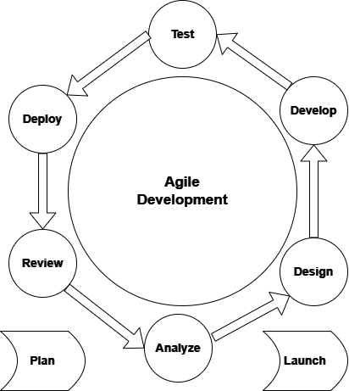

Figure 3.1: Agile Model

- Requirement Gathering: We collected ideas and needs from teachers, students, and administrators to understand what features the system should include—like attendance, virtual classes, reminders, and routine/event management. This phase helped us identify the core problems users were facing with existing systems and define a clear list of essential features for the project.
- System Design: The layout of the system was planned, including the user interface (UI), database structure, and how each feature will work together. We also decided how to integrate external tools like Jitsi Meet for video conferencing, PHPMailer for email OTP, and QR code libraries for attendance. The design ensured that all modules were well-connected, scalable, and easy to maintain.
- Implementation (Development): The backend was developed using PHP, which handles security, data storage, and system operations. The frontend was created using JavaScript, Bootstrap, and jQuery to make the system responsive and interactive. Jitsi Meet API was embedded to enable live online classes within the dashboard. QR code attendance was implemented using chillerlan/php-qrcode for generation and html5qrcode for scanning. Routine management, event notifications, and OTP-based login were also developed during this phase.
- Testing: After each development cycle, we tested the system for errors, bugs, and performance issues. Unit tests were done for individual modules like OTP verification and QR scanning, while integration testing ensured that all features worked smoothly together. User feedback was collected and used to make necessary fixes and improvements in each iteration.
- Deployment: Once all features were tested and finalized, the system was uploaded to a live server where real users could access it online. SMTP settings were configured for live email delivery, and final checks were made to ensure all modules (attendance, LMS, notifications, etc.) functioned as expected. The system was then ready for use in real classroom scenarios.

3.1 JitsiMeet Integration
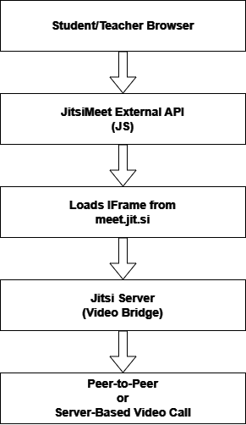
Figure 3.2: Jitsi Meet API WorkFlow

Jitsi Meet is an open-source video conferencing platform, and in ClassPlus, it is embedded using the JitsiMeetExternalAPI JavaScript class. When a teacher starts a virtual class, the system generates a unique room name and embeds the live video session in an <iframe> on the dashboard. This iframe loads https://meet.jit.si/ROOM_NAME, connecting participants to Jitsi’s video bridge servers. Students click “Join Class,” and their browsers load the same room, enabling peer-to-peer or server-based conferencing. Features like screen sharing, chat, whiteboard are available within this embedded environment. Since it’s API-based, developers can control room settings, mute participants, or customize UI controls using JavaScript. No installation or signup is required by users. The integration provides a seamless virtual class experience directly within ClassPlus, making it highly accessible and efficient, especially for blended or online learning models.

3.2 Chillerlan/php-qrcode Integration
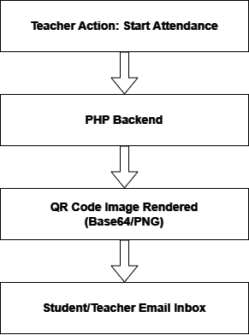
Figure 3.3: chillerlan/php-qrcode WorkFlow

The chillerlan/php-qrcode library is a lightweight and flexible PHP library used for generating QR codes. In ClassPlus, this library is used to generate a QR code each time a teacher starts a new attendance session. When the teacher clicks the “Start Attendance” button, a unique session ID or attendance token is generated by the backend. This token is passed to the QR code generator, which then encodes it into a scannable QR image. The QR is rendered in PNG format or embedded directly in HTML using base64 encoding, allowing it to be displayed instantly without saving a file. The generated QR contains just the session identifier, which links the student’s scan to a specific attendance instance. This QR is shown on the teacher’s dashboard, ready for scanning by students. The whole process is done in real-time using PHP, without any external API calls. The QR is not reused and becomes invalid once the attendance session ends or expires. This ensures each session is secure and tamper-proof.

3.3 html5-qrcode Integration
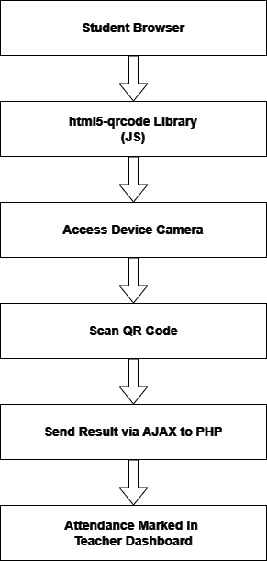

Figure 3.4: html5-qrcode WorkFlow
The html5-qrcode library is a JavaScript-based solution for scanning QR codes directly from a user's device camera using the browser. In ClassPlus, this library is integrated into the student dashboard to allow real-time scanning of the QR code generated by the teacher. When the student opens the attendance page, the library requests camera permission. Once granted, it activates the device's rear or front camera, detects the QR code in the camera frame, and decodes its content. The decoded value is sent via an AJAX request to the backend PHP script. This script verifies the session ID, checks the student's identity, and temporarily logs their attendance in a table like tblattendance_temp. If the code is invalid or expired, an error message is shown. The scanner works across mobile and desktop browsers without needing an app. This makes the attendance process fast, secure, and userfriendly. Optional callbacks and event listeners in the library allow the system to give realtime feedback, such as "Attendance marked successfully" or "Invalid session."

3.4 PHPMailer Integration
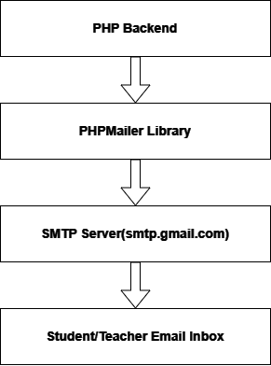
Figure 3.5: PHPMailer WorkFlow
PHPMailer is a popular PHP library used for sending emails securely via SMTP. In ClassPlus, it is used primarily for sending OTPs during login verification and delivering notifications such as assignment updates or attendance alerts. When a user requests an OTP, the PHP backend initializes a new PHPMailer object, sets the SMTP server configuration and includes credentials like email and app password. The system prepares the email content dynamically based on the user and use case. PHPMailer then connects to the SMTP server, authenticates, and sends the message to the recipient's email address. Error handling is built in, so if something fails, the system can alert the user. PHPMailer also supports HTML content, so emails can be formatted cleanly. Since OTPs expire after a few minutes, their generation and expiry timestamp are stored in the database to validate upon user entry. This process ensures reliable, secure communication without relying on
PHP’s native mail() function, which is less configurable and more prone to spam filtering.

CHAPTER 4 SYSTEM MODELLING 4.1 E-R Diagram
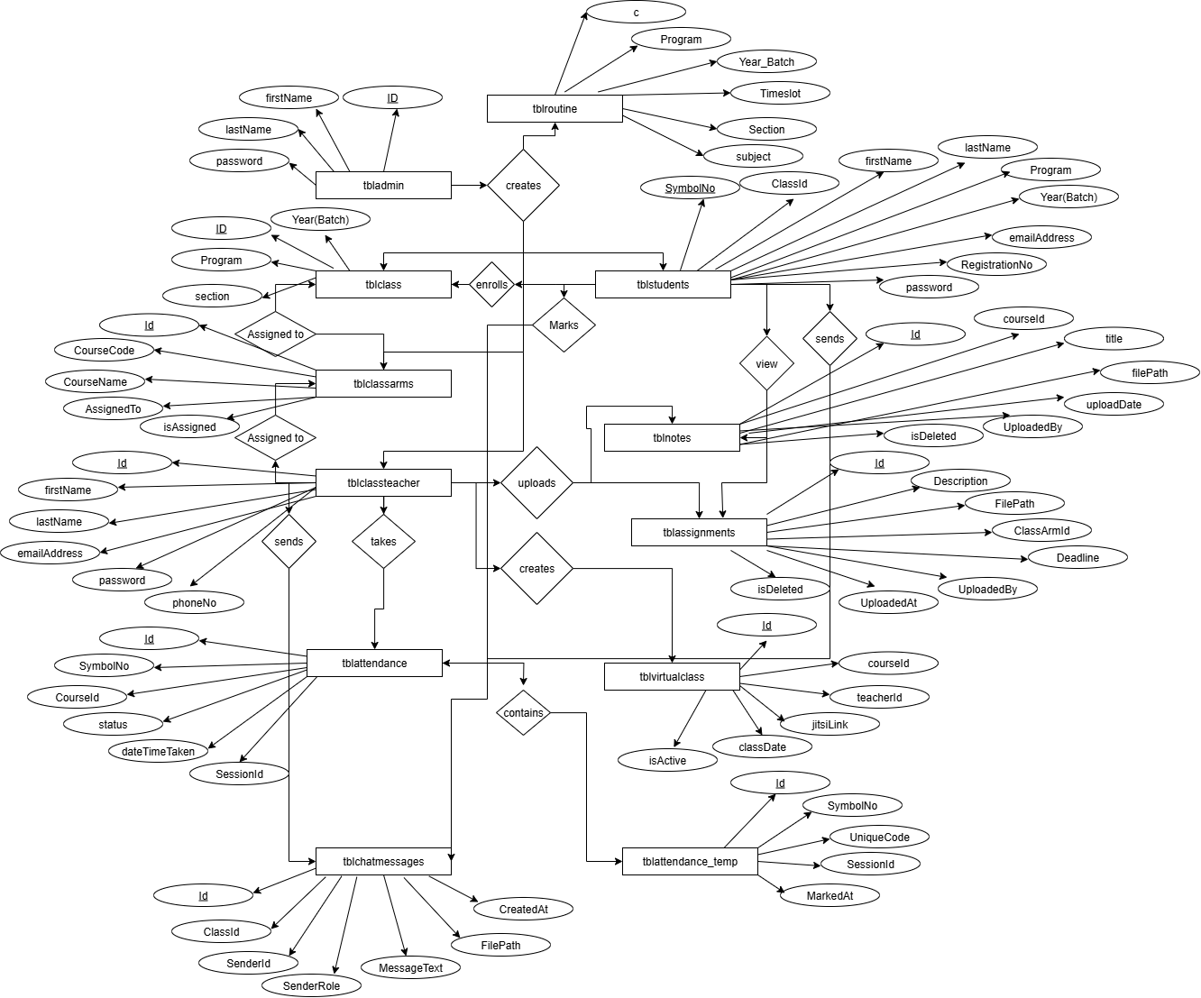

Figure 4.1: E-R Diagram

4.2 Class Diagram
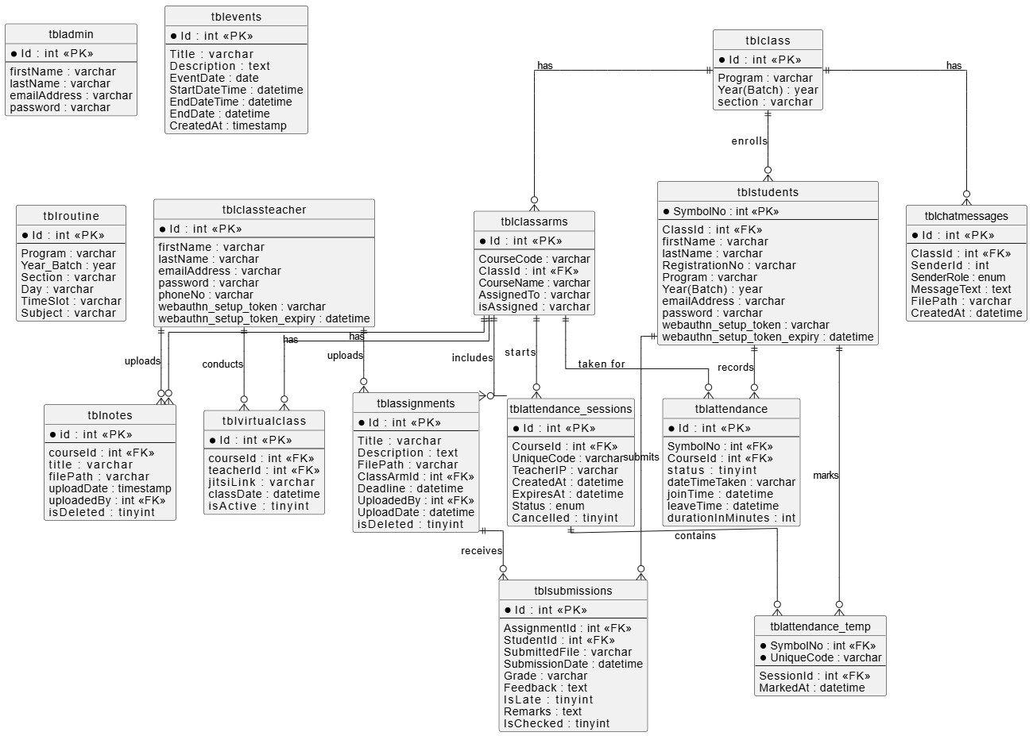

Figure 4.2: Class Diagram

4.3 Use-Case Diagram

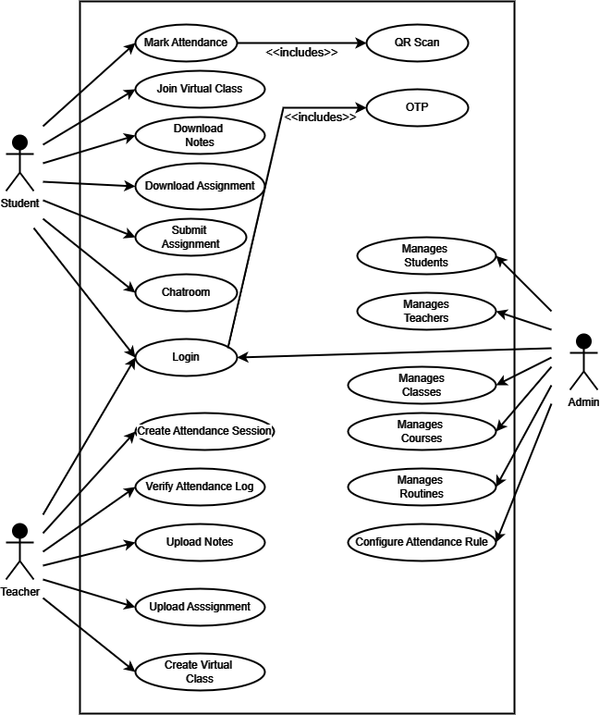

Figure 4.3: Use-Case Diagram

4.3.1 Use Case Description

- Use Case: Login
  - Actors: Student, Teacher, Admin
  - Description: Allows users to securely log into the system based on their role.
  - Includes: OTP (for additional verification)
  - Precondition: Valid credentials must be provided.
  - Postcondition: User is redirected to their respective dashboard.

- Use Case: OTP
  - Actors: Student, Teacher, Admin
  - Description: A One-Time Password is sent to the user's email for secure login.
  - Precondition: Email must be registered in the system.
  - Postcondition: OTP is verified and access is granted.

- Use Case: Mark Attendance
  - Actor: Student
  - Description: Students can mark their attendance by scanning a QR code during class.
  - Includes: QR Scan
  - Precondition: An active attendance session must be running.
  - Postcondition: Attendance is recorded in the system.

- Use Case: QR Scan
  - Actor: Student
  - Description: Scans the QR code displayed by teacher to identify attendance session.
  - Precondition: Student must have a device with camera access.
  - Postcondition: Session code is verified and attendance is marked.

- Use Case: Join Virtual Class
Actor: Student
Description: Allows students to attend live online classes via embedded Jitsi Meet.
Precondition: A valid class link or session must be active.
Postcondition: Student joins the class and may interact via video, chat.

- Use Case: Download Notes
  - Actor: Student
  - Description: Students can download course-related notes uploaded by teachers.
  - Precondition: Notes must be uploaded for the respective subject.
  - Postcondition: Files are downloaded locally to the student's device.

- Use Case: Download Assignment
  - Actor: Student
  - Description: Students can download their course assignments from the dashboard.
  - Precondition: Assignments must be uploaded by the teacher.
  - Postcondition: Assignment file is available for the student to complete.

- Use Case: Submit Assignment
  - Actor: Student
  - Description: Students submit their completed assignments through the system.
  - Precondition: File format and deadline must be valid.
  - Postcondition: Assignment is uploaded and stored for teacher review.

- Use Case: Chatroom
  - Actors: Student, Teacher, Admin
Description: Allows real-time messaging between students and teachers per class.
Precondition: User must be enrolled/assigned to that class.
Postcondition: Messages are delivered and stored in chat logs.
- Use Case: Create Attendance Session
Actor: Teacher
Description: Teacher generates a new attendance session and QR code.
Precondition: Teacher must be logged in and assigned to the class.
Postcondition: QR code is generated and students can scan it.

- Use Case: Verify Attendance Log
  - Actor: Teacher
  - Description: Teacher views and verifies the list of students who marked attendance.
  - Precondition: Attendance session must have been conducted.
  - Postcondition: Verified data is stored in permanent records.

- Use Case: Upload Notes
  - Actor: Teacher
  - Description: Teacher uploads lecture notes to share with students.
  - Precondition: Notes must be in supported format.
  - Postcondition: Notes are stored and accessible to students.

- Use Case: Upload Assignment
  - Actor: Teacher
  - Description: Teacher uploads assignments for students to download and complete.
  - Precondition: Valid assignment file and instructions provided.
  - Postcondition: Assignment is stored and displayed on the student dashboard.

- Use Case: Create Virtual Class
  - Actor: Teacher
Description: Teacher sets up a live online class using embedded Jitsi Meet.
Precondition: Date, time, and subject details must be provided.
Postcondition: Students can join using the system dashboard.
- Use Case: Manage Students
Actor: Admin
Description: Admin adds, edits, or removes student accounts.
Precondition: Admin is authenticated.
Postcondition: Student records are updated.

- Use Case: Manage Teachers
  - Actor: Admin
  - Description: Admin creates and manages teacher accounts.
  - Precondition: Admin has access rights.
  - Postcondition: Teacher data is updated in the system.

- Use Case: Manage Classes • Actor: Admin
  - Description: Admin defines and organizes class batches and sections.
  - Precondition: Class structure must be validated.
  - Postcondition: Classes are linked with subjects, teachers, and students.

- Use Case: Manage Courses • Actor: Admin
  - Description: Admin adds or updates course subjects and their codes.
  - Precondition: Course must be assigned to a class.
  - Postcondition: Course appears in the system for that batch.

- Use Case: Manage Routines • Actor: Admin
Description: Admin uploads or schedules the class routine/timetable.
Precondition: Routines must align with class and teacher availability.
Postcondition: Routines are shown on student/teacher dashboards.

- Use Case: Configure Attendance Rule
Actor: Admin
Description: Admin sets policies such as minimum attendance, proxy prevention rules, etc.
Precondition: Rules must align with institutional policies.
  - Postcondition: Rules are enforced during attendance tracking and reports.

4.4 Flowchart Diagram
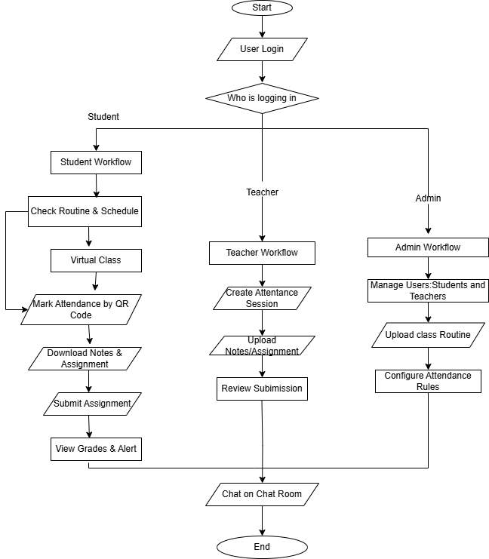

Figure 4.4: Flowchart Diagram

4.5 Sequence Diagram

4.5.1 Student, System and Admin Sequence Diagram
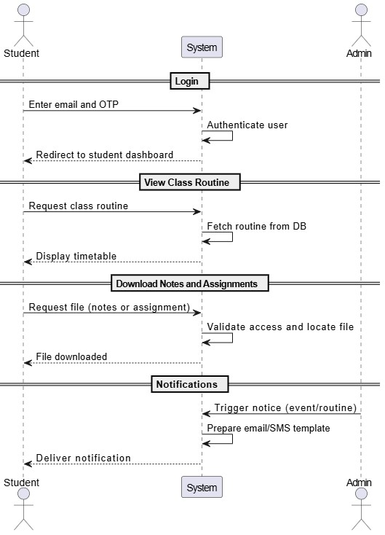

Figure 4.5: Student and Admin Sequence Diagram

4.5.2 Student, System and Teacher Sequence Diagram

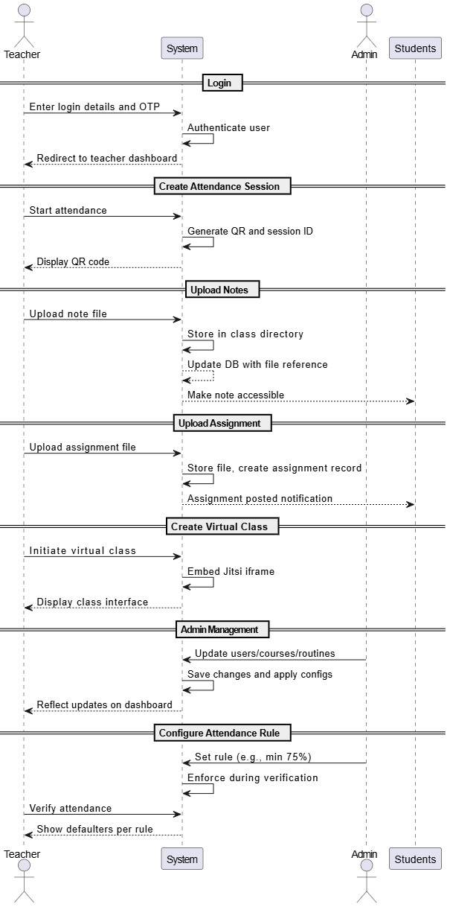

Figure 4.6: Student, System and Teacher Sequence Diagram

4.5.3 Admin, System and Teacher Sequence Diagram


Figure 4.7: Teacher, System and Admin Sequence Diagram

4.6 Database Design

4.6.1 Database Table for admin(tbladmin)
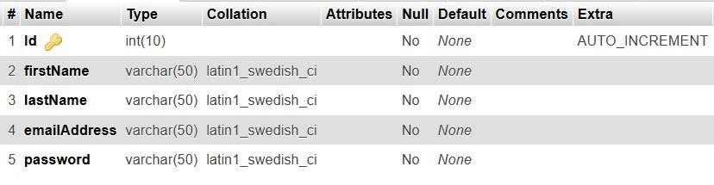

Table 1: Database Table for admin

4.6.2 Database Table for Teacher(tblclassteacher)
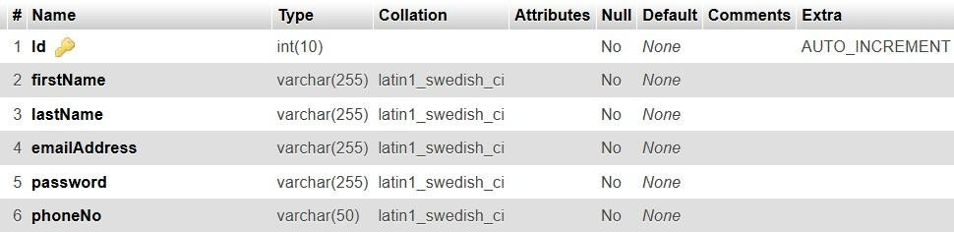

Table 2: Database Table for Teacher

4.6.3 able for Class(tblclass)
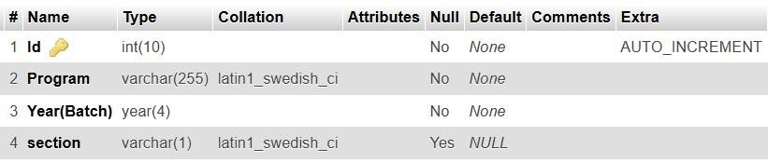

Table 3: Database Table for Class

4.6.4 Database Table for Student (tblstudents)
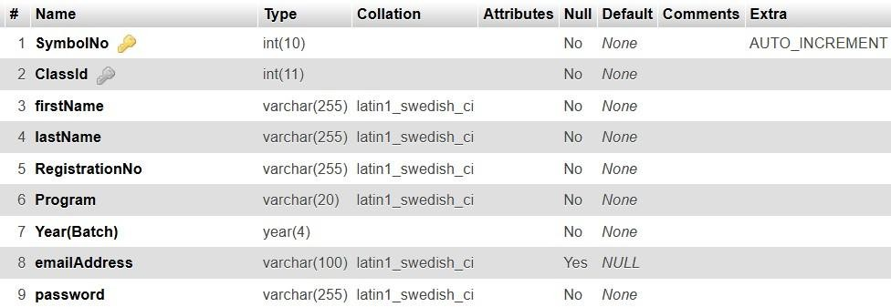

Table 4: Database Table for Student

4.6.5 able for Course(tblclassarms)
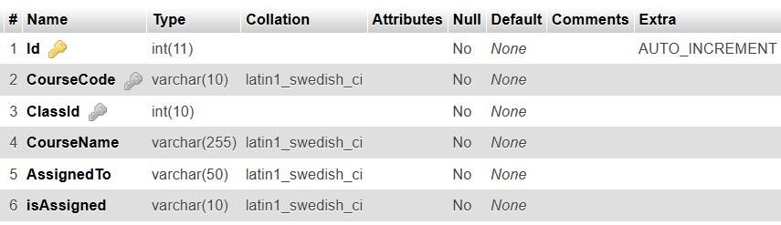

Table 5: Database Table for Course

4.6.6 Database Table for Attendance Session(tblattendance_sessions)

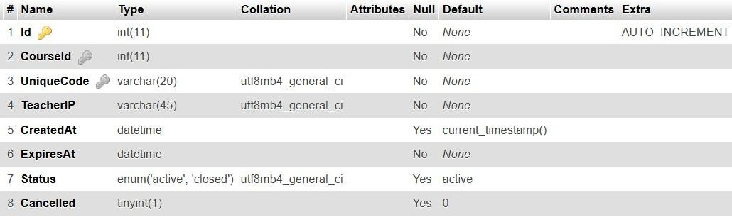

Table 6: Database Table for Attendance Session

4.6.7 able for Temporary Attendance (tblattendance_temp)

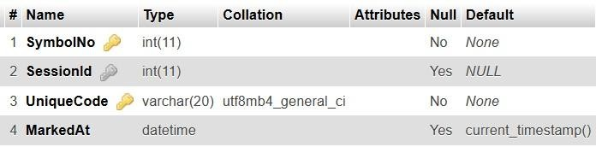

Table 7: Database Table for Temporary Attendance

4.6.8 Database Table for Attendance(tblattendance)

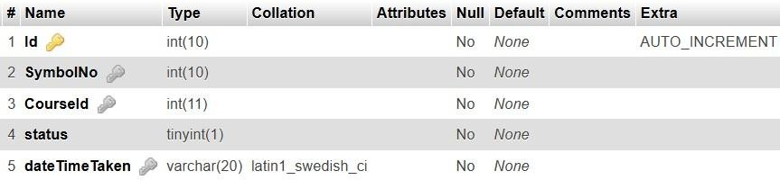

Table 8: Database Table for Attendance

4.6.9 able for Chatroom(tblchatmessages)
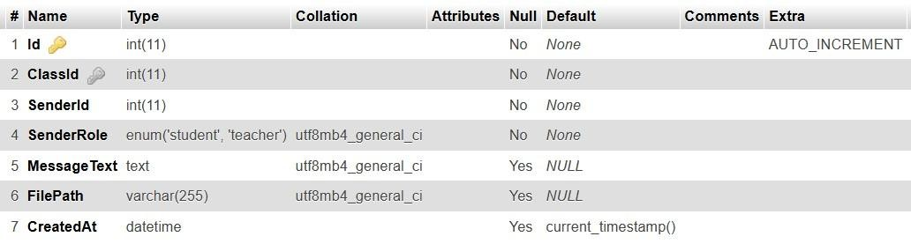

Table 9: Database Table for Chatroom

4.6.10 Database Table for Virtual Class(tblvirtualclass)

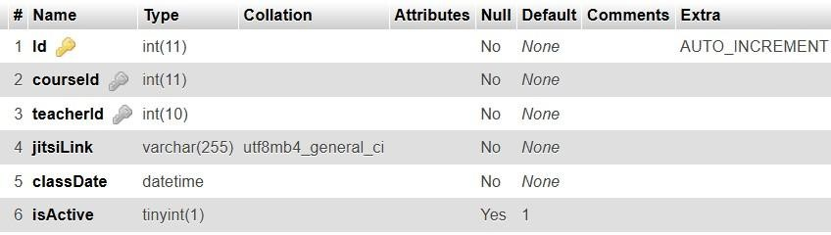

Table 10: Database Table for Virtual Class

4.6.11 Database Table for Notes(tblnotes)

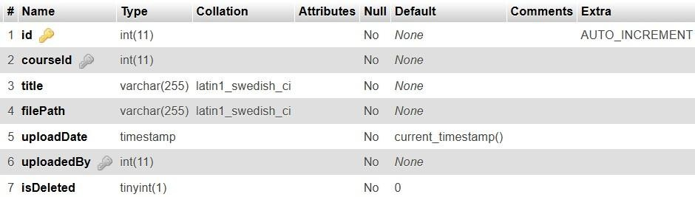

Table 11: Database Table for Notes

4.6.12 Database Table for Assignment(tblassignments)
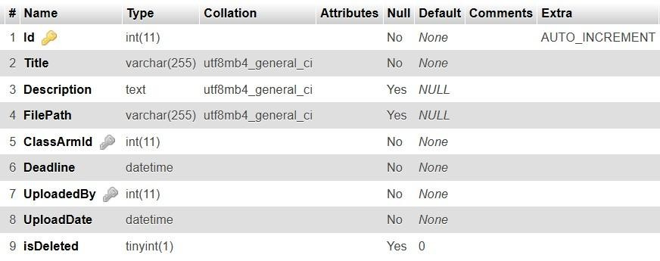

Table 12: Database Table for Assignment

4.6.13 Database Table for Assignment Submissions(tblsubmission)

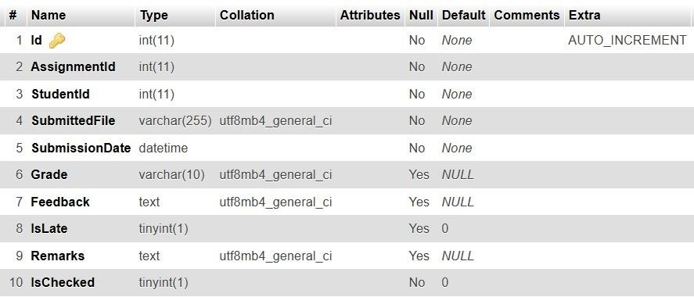

Table 13: Database Table for Assignment Submission

4.6.14 Database Table for Routine(tblroutine)
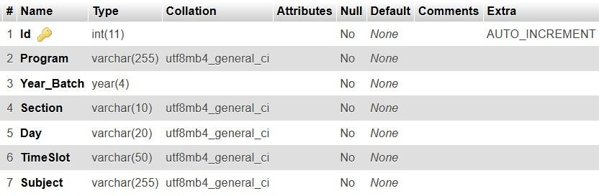

Table 14: Database Table for Routine

CHAPTER 5 PROJECT SCHEDULE

Phases | October  2024-  November  2024 | November  2024- January  2025 | January 2025-  April  2025 | April  2025- June  2025 | June  2025- July  2025
Project planning and preparation
Design and
Prototyping
Development
Phase I
Development
phase II
Testing and debugging
Finalization and
Deployment

CHAPTER 6 CONCLUSION

The following points summarize the overall conclusion of the ClassPlus project:
- The ClassPlus system successfully centralizes classroom management tasks into a single web platform
- Secure attendance mechanisms (QR code) ensure reliable student presence tracking.
- Jitsi integration enables online classes with features like chat, whiteboard, and screen sharing.
- The system allows students to access and submit assignments, receive automated SMS/email notifications, and stay informed.
- A feature for displaying class routines and notifying special events has been implemented, ensuring everyone is informed of daily academic schedules and activities.
- Agile methodology helped us iteratively build and test the system, allowing continuous improvements.

Further Improvement:
- Add fingerprint or Face ID support for more secure and accurate attendance tracking.
- Build Android/iOS apps for easier access and notification.
- Use AI to analyze attendance trends and predict at-risk students.
- Allow guardians to track attendance and academic updates.
- Let teachers record attendance without internet, with auto-sync later.

REFERENCE

- Welling, L. and Thomson, L., 2009. PHP and MySQL Web Development. 4th ed.
Boston: Addison-Wesley Professional.
- PHP Group, n.d. PHP Manual: PHP: Hypertext Preprocessor. [online] Available at: https://www.php.net/manual/en/.
- Bootstrap, n.d. Bootstrap Documentation. [online]
Available at: https://getbootstrap.com/docs/
- jQuery Foundation, n.d. jQuery API Documentation.
Available at: https://api.jquery.com/
- Stack Overflow, n.d. Stack Overflow Community Forum.
Available at: https://stackoverflow.com/
- PHPMailer, n.d. PHPMailer: The Classic Email Sending Library for PHP. [online] Available at: https://github.com/PHPMailer/PHPMailer
- HTML5-QRCode, n.d. html5-qrcode: A Cross-Platform HTML5 QR Code Scanner.
[online]
Available at: https://github.com/mebjas/html5-qrcode
- chillerlan, n.d. PHP QR Code: A QR Code Generator for PHP. [online]
Available at: https://github.com/chillerlan/php-qrcode

APPENDIX

A. Login Page

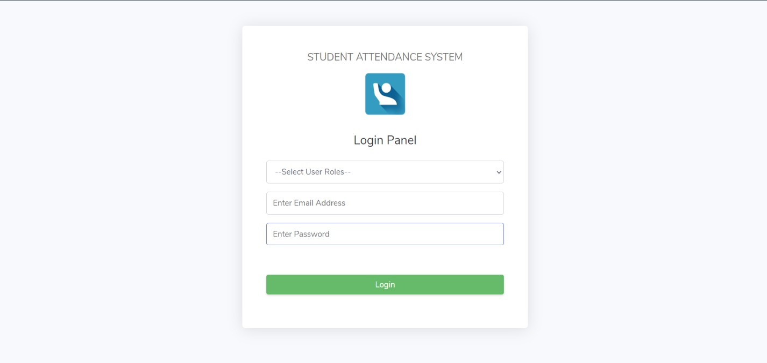

Figure A: Login Page

B. OTP Verification
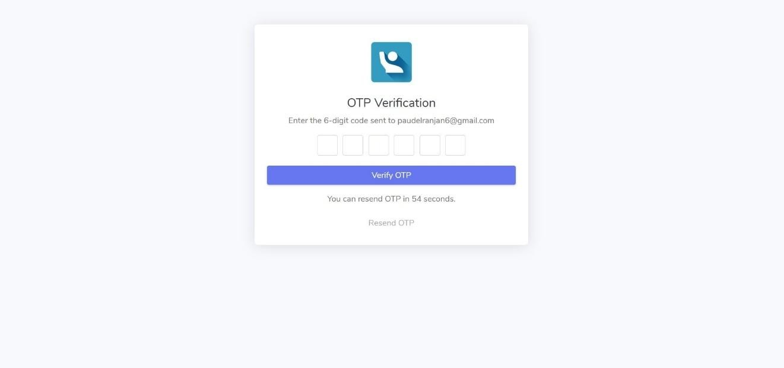

Figure B: OTP Verification

C. Admin Dashboard
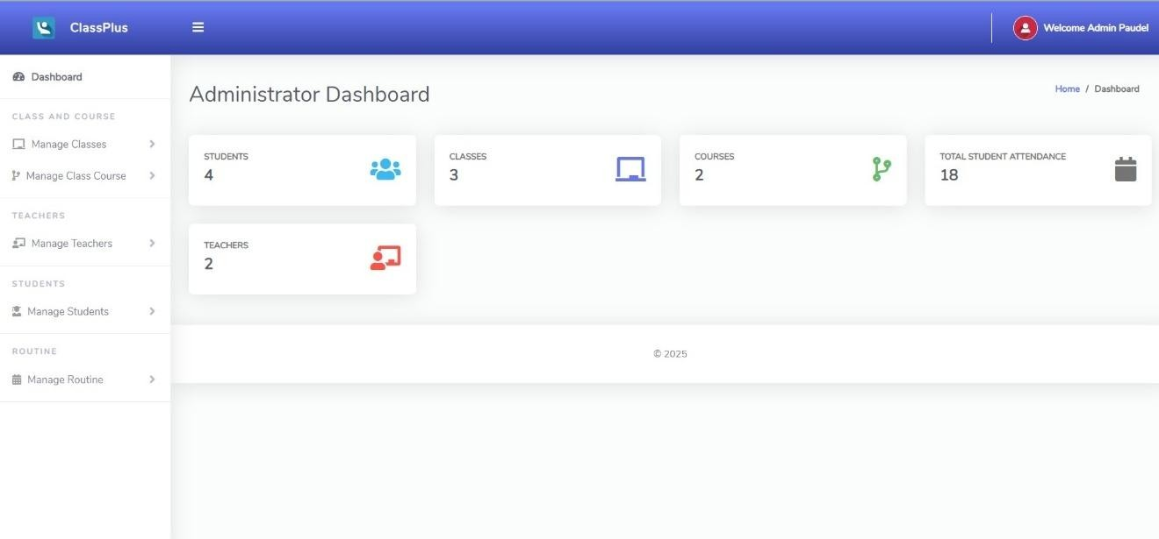

Figure C: Admin Dashboard

D. Admin manage Students
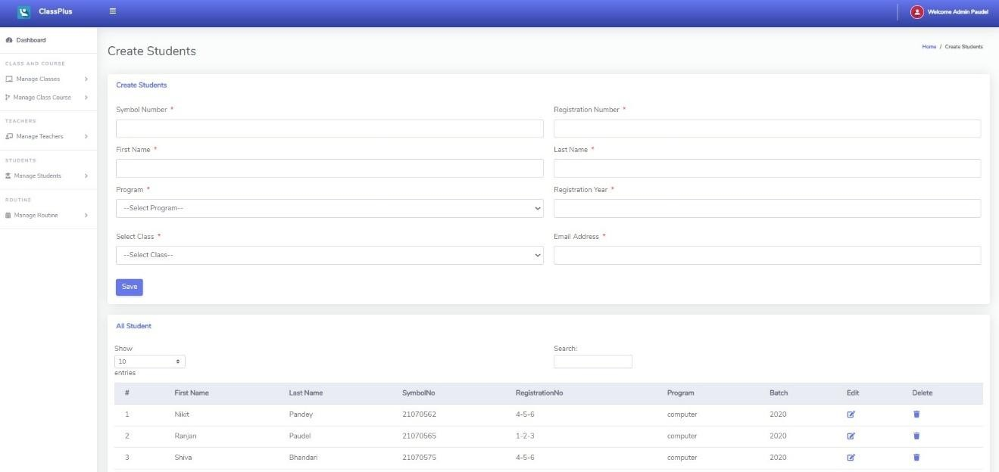

Figure D: Admin manage Students

E. Admin add routine
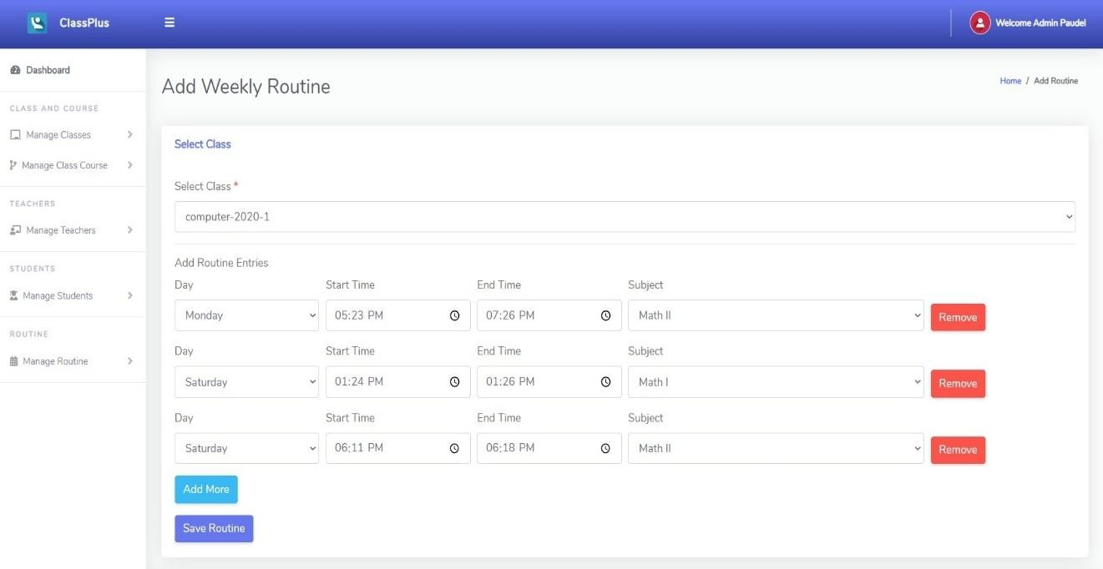

Figure E: Admin add routine

F. Teacher Dashboard
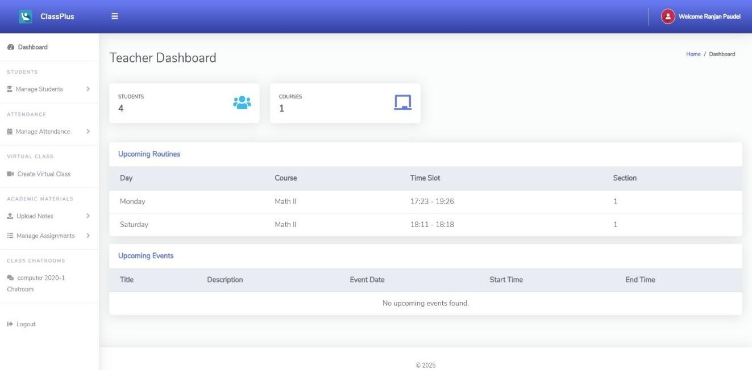

Figure F: Teacher Dashboard

G. Teacher taking Attendance
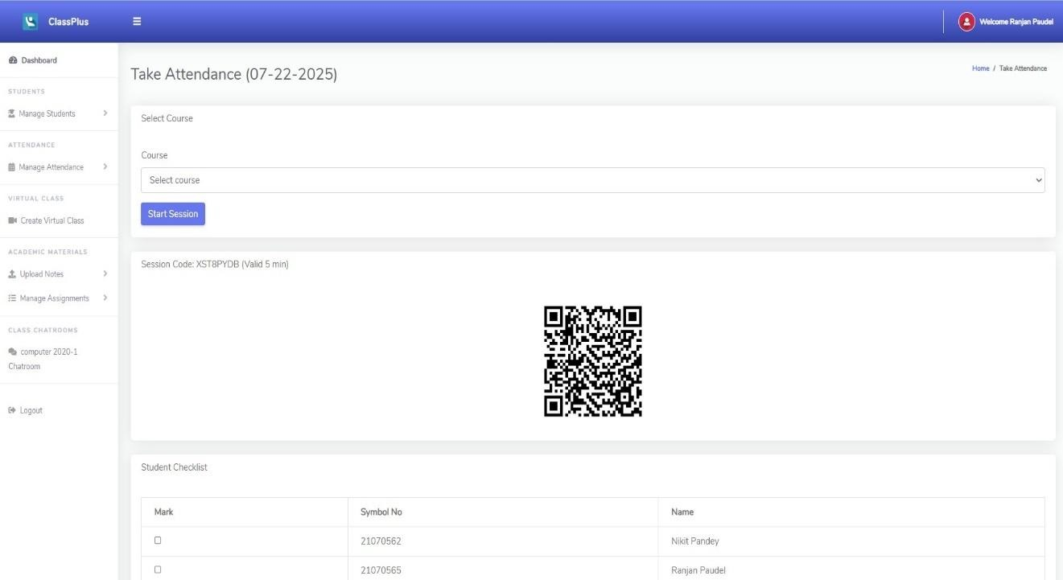

Figure G: Teacher taking Attendance

H. Teacher joins Virtual Class
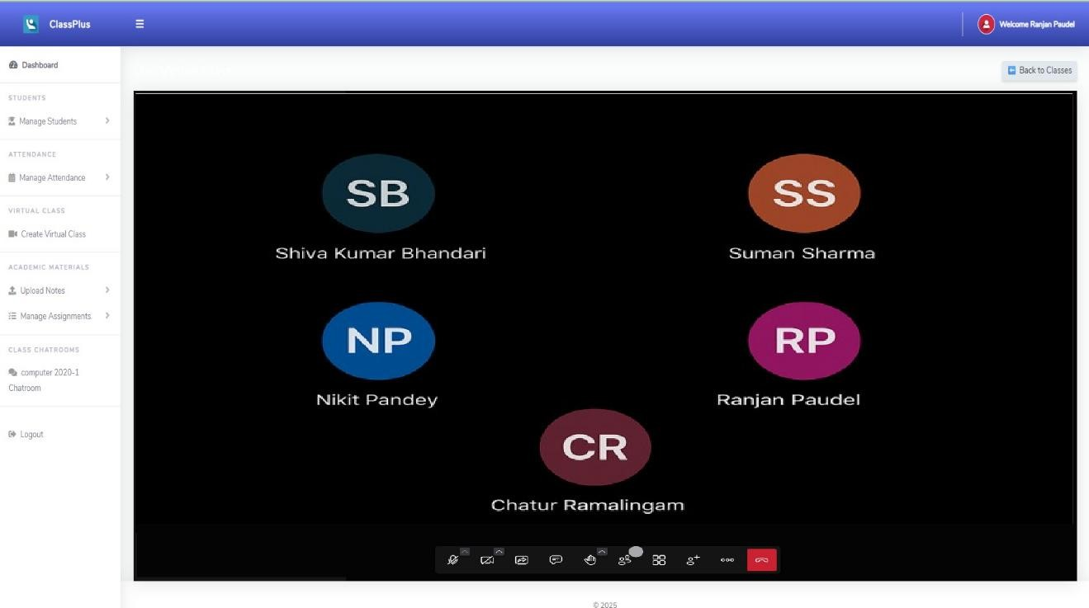
Figure H: Teacher joins Virtual Class

I. Teacher uploads Note
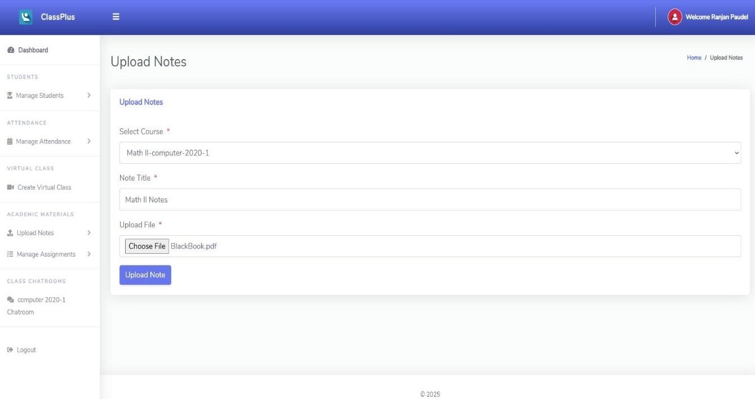
Figure I: Teacher uploads Note
J. Teacher uploads Assignment
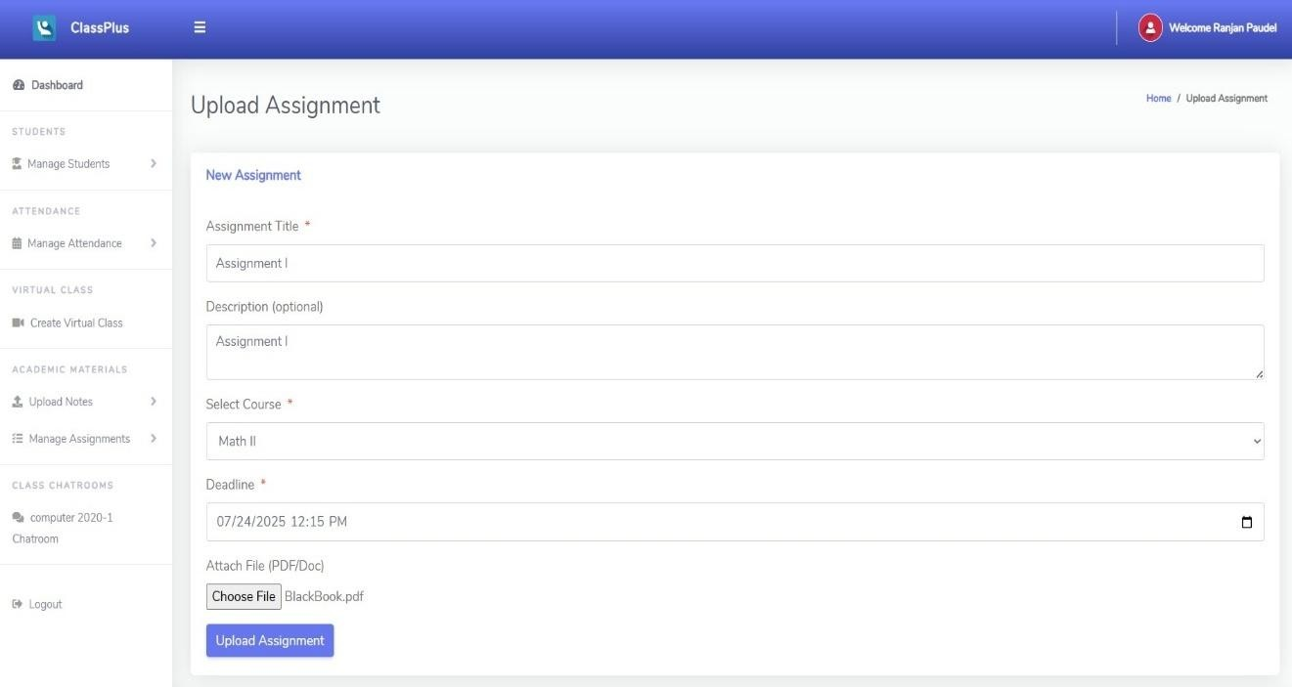

Figure J: Teacher uploads Assignment

K. Teacher reviewing Assignment Submission
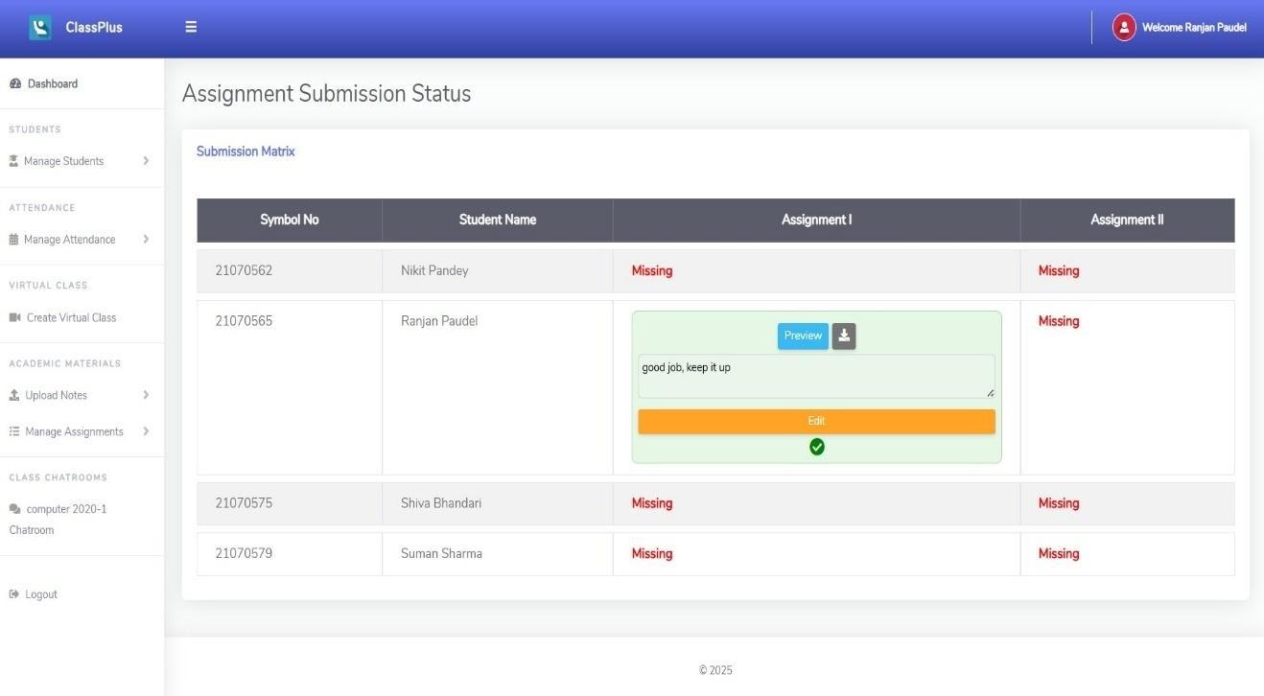

Figure K: Teacher reviewing Assignment Submission L. Chatroom
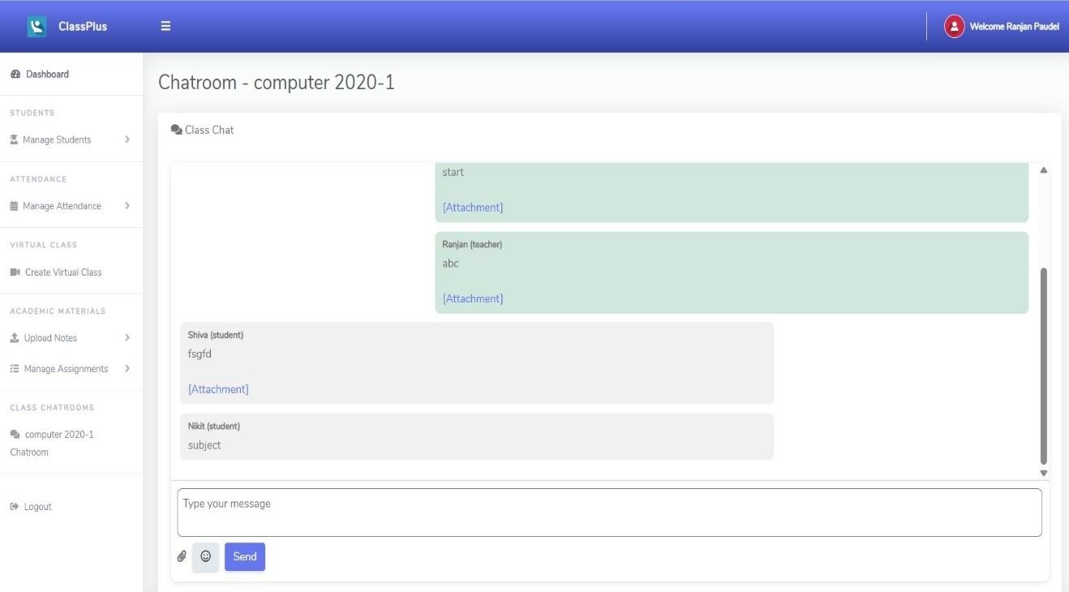
Figure L: Chatroom

M. Student Dashboard
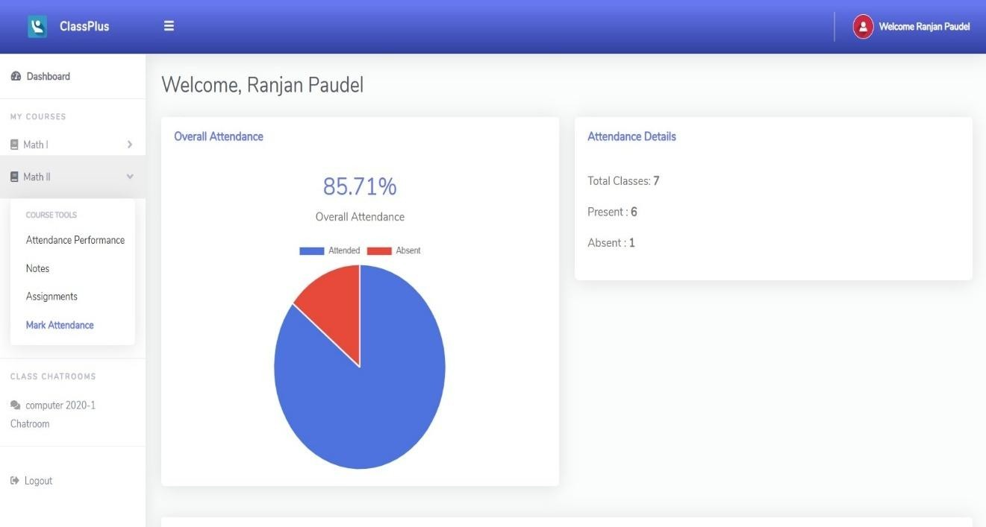
Figure M: Student Dashboard

N. Mark Attendance using QR Scanner
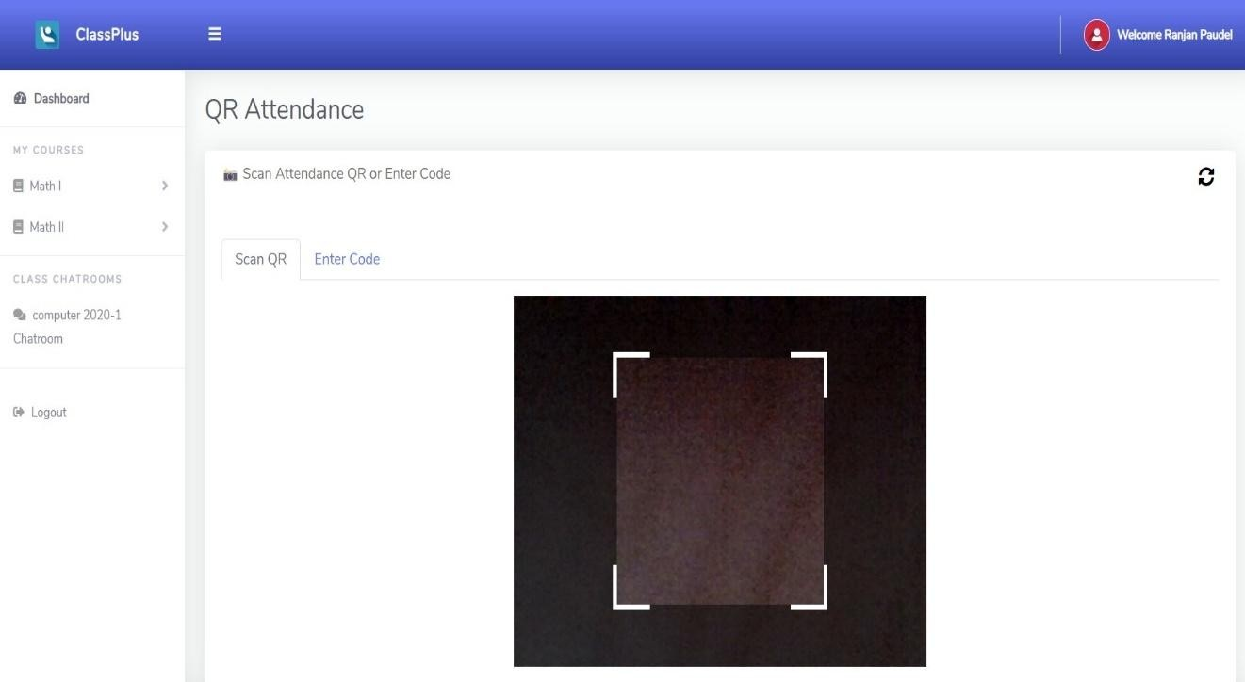
Figure N: Mark Attendance using QR Scanner

O. Student viewing Assignment
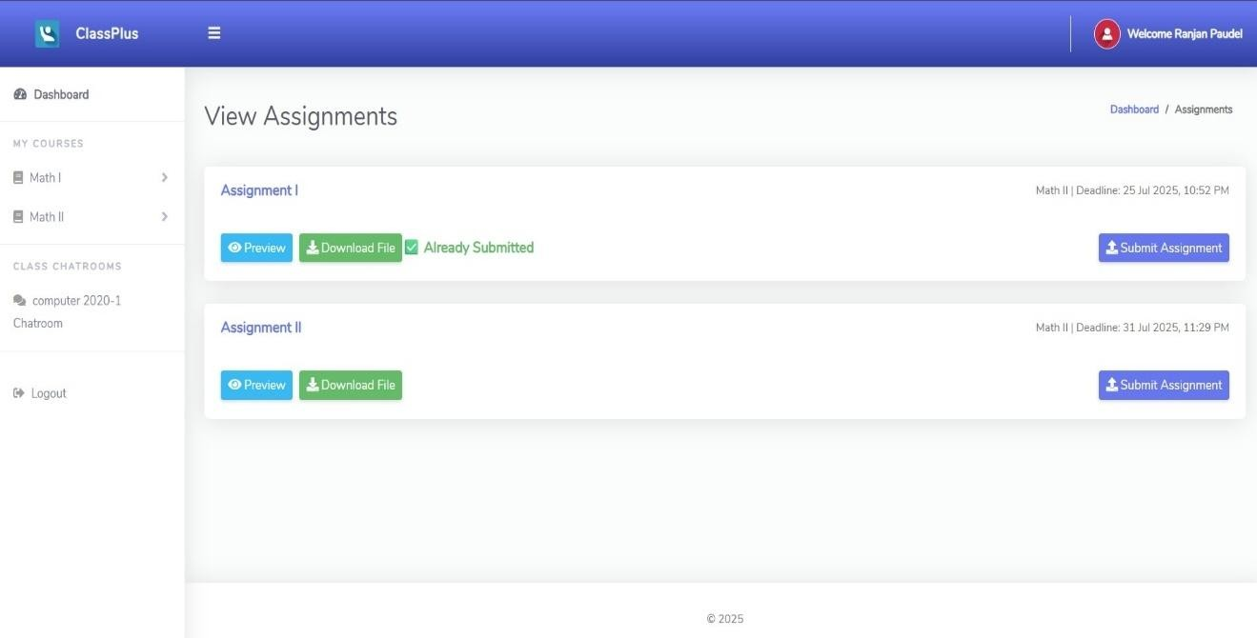

Figure O: Student viewing Assignment

P. Student viewing Notes
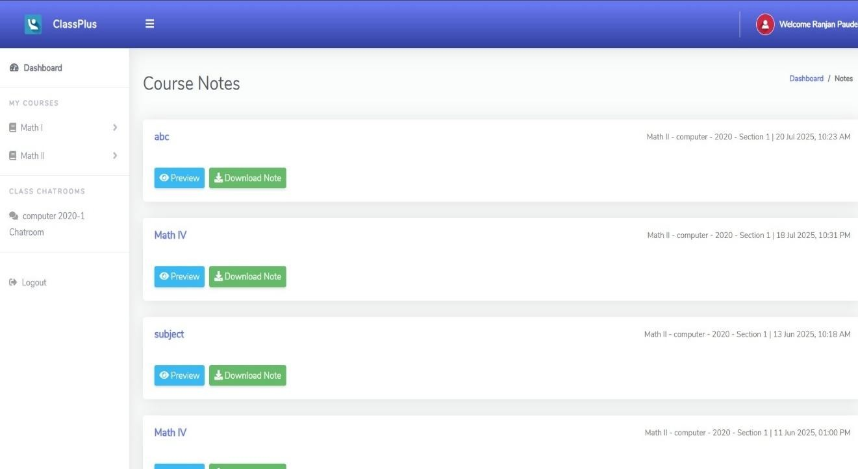

Figure P: Student viewing Notes

Q. Email OTP alert
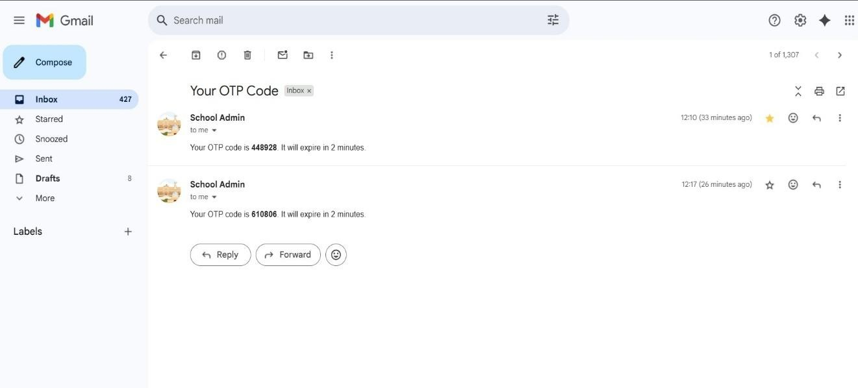

Figure Q: Email OTP alert

R. Email Assignment alert
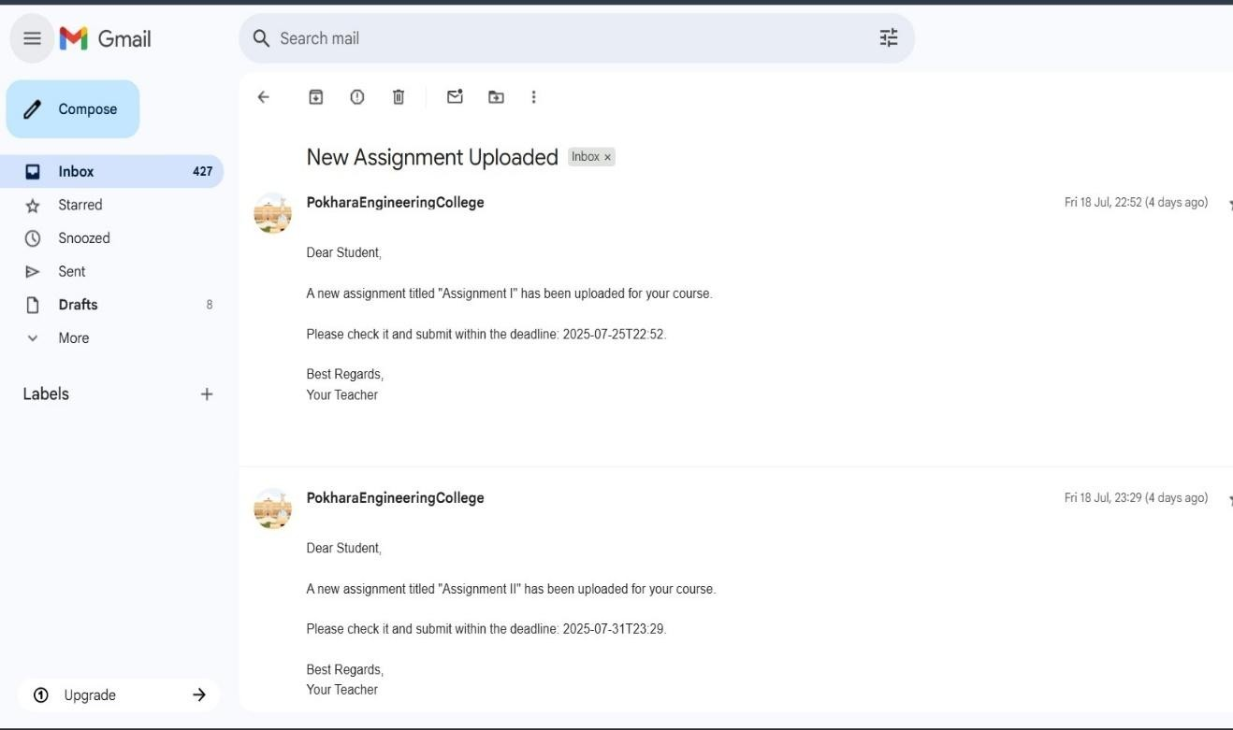

Figure R: Email Assignment alert

S. Mobile UI

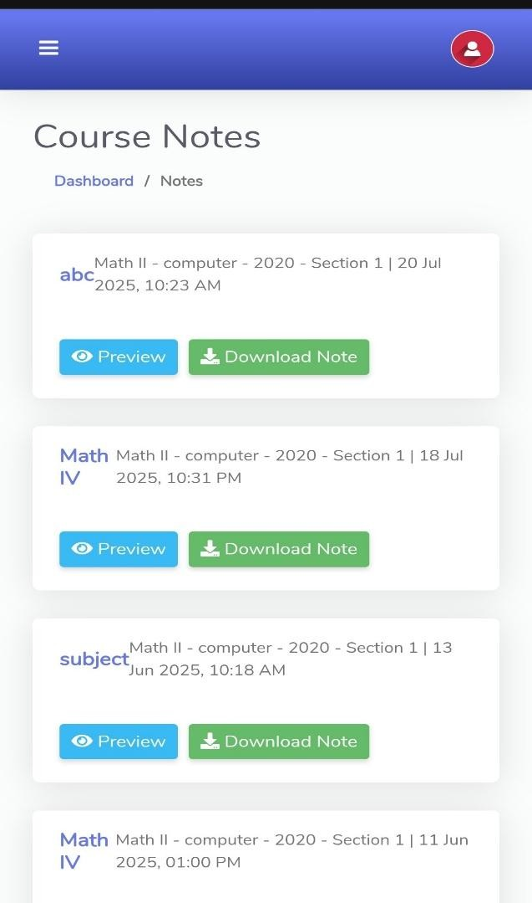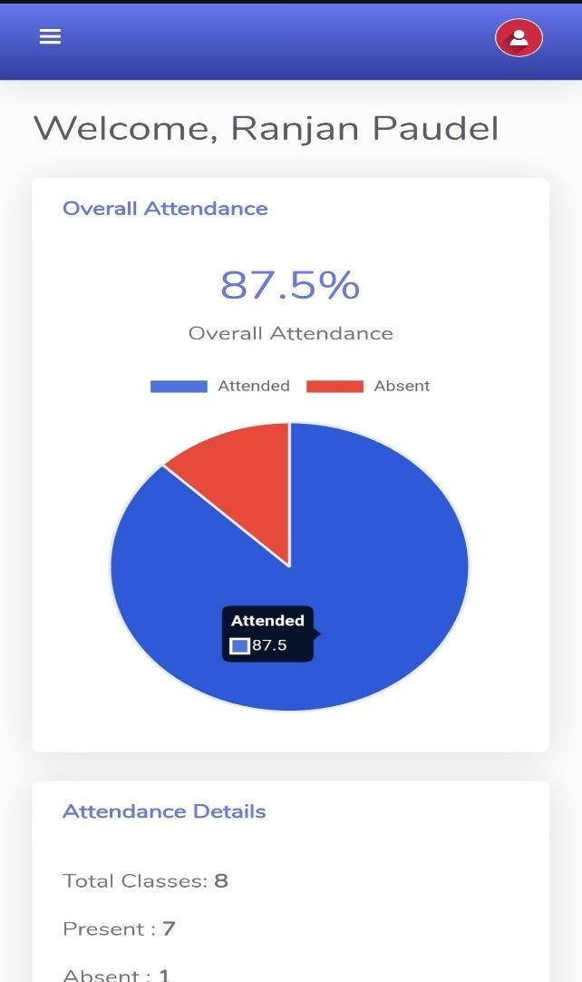

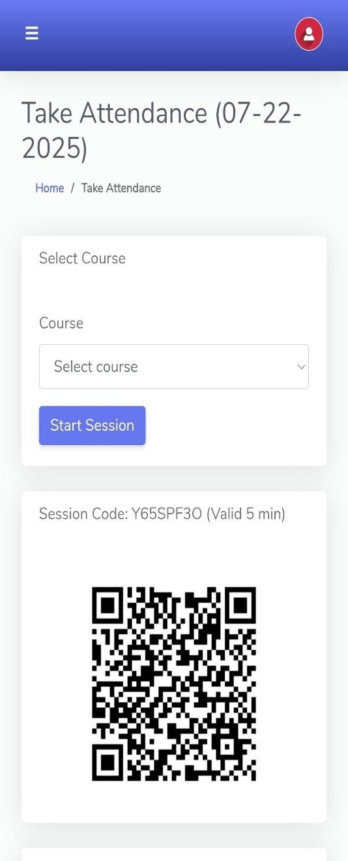
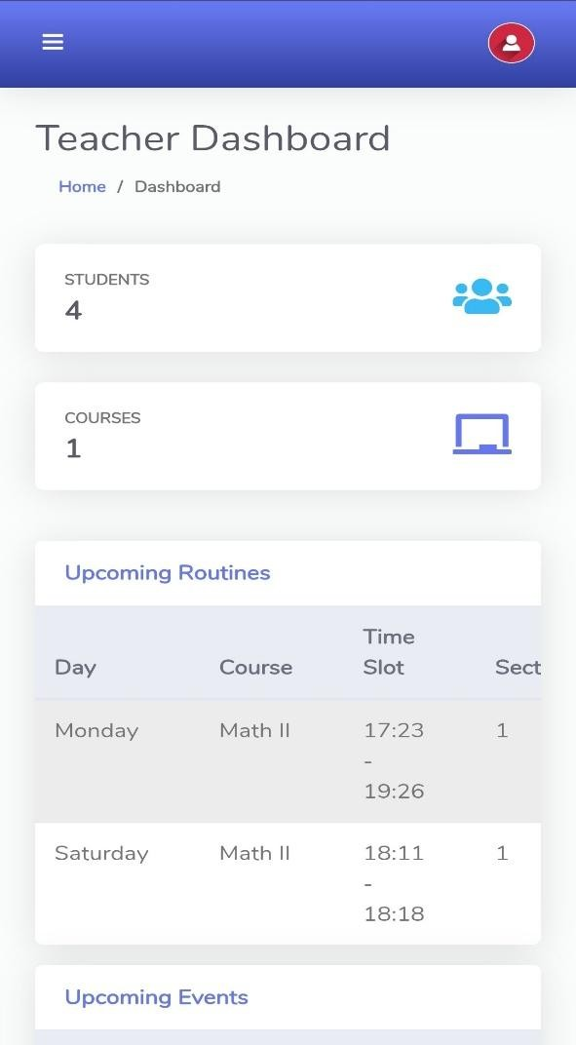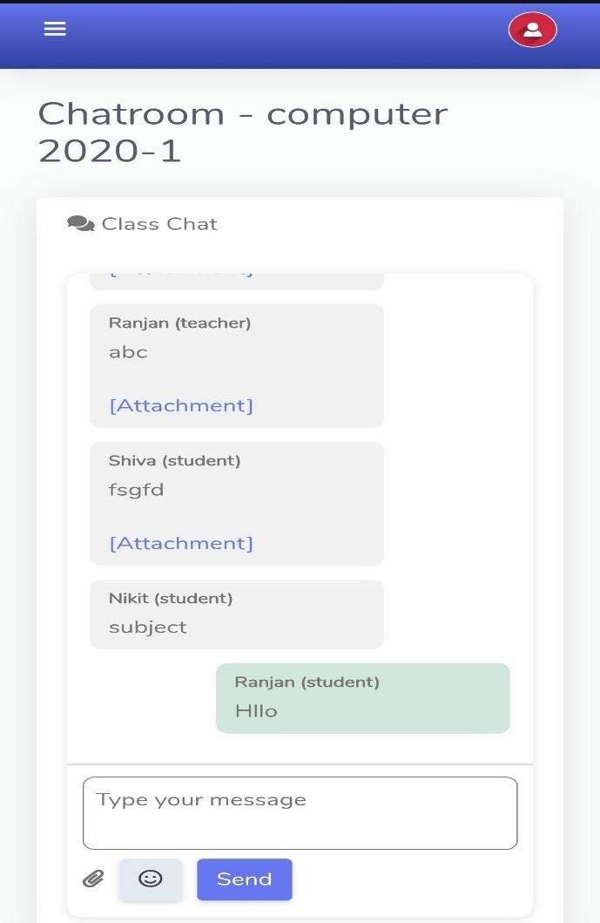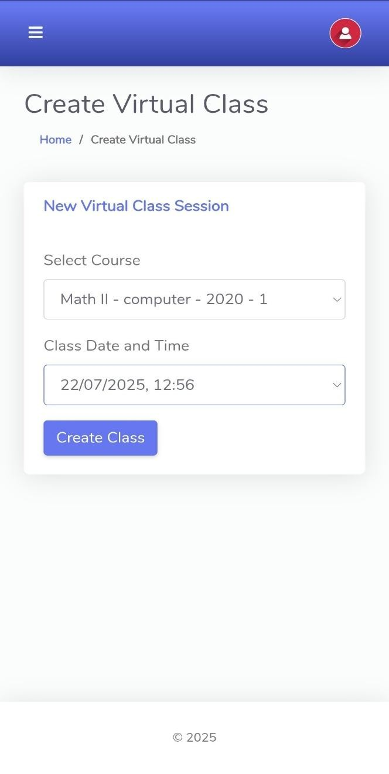
Figure S: Mobile UI

