Forecasting District-Level Paddy Yield in Sri Lanka at Sowing Time
Applied Machine Learning: Final Assignment Report
Buddhika K H W · 269086V · [GitHub repository link]

1. Problem and motivation
Rice is Sri Lanka's staple food. It is grown in two seasons: Maha (north-east monsoon, about October to March) and Yala (south-west monsoon, about April to September). Decisions on fertilizer distribution, Paddy Marketing Board purchasing, storage and imports have to be made before the harvest is known. This project builds a model that, at sowing time, forecasts the average paddy yield (kg/ha) of each district for the season. It is a supervised regression problem on tabular data.
The 2021/22 chemical fertilizer ban, which cut national yields sharply in 2022, showed how valuable early and explainable yield signals are for planning.

2. Data and preprocessing
The data is the district-wise paddy statistics published by the Department of Census and Statistics (DCS), Sri Lanka. It covers 1979–2023 and both seasons, with sown and harvested extent by irrigation type (major irrigation, minor irrigation, rain-fed), average yields and production. A data audit found several issues that needed domain knowledge to fix:
- All numbers were stored as text with thousand separators, and “-” marked missing values. These were converted to numbers, with “-” set to missing.
- 100 exact duplicate rows (2010–2012 were entered twice) were removed.
- Four irrigation-system and regional aggregates (Mahaweli, Udawalawe, Highland, North & East) overlap with real districts and were removed, leaving the 25 administrative districts.
- The yield column is labelled “MT/Ha”, but its values (1,150–6,600) are actually kg/ha. Production = net harvest × yield / 1000 holds exactly (median ratio 1.000), which confirmed the unit.
- Seasons with zero sown area (mainly Northern districts during the war years) have no yield, so they were excluded. They remain as gaps in the history, which turn into missing lag values handled by median imputation.
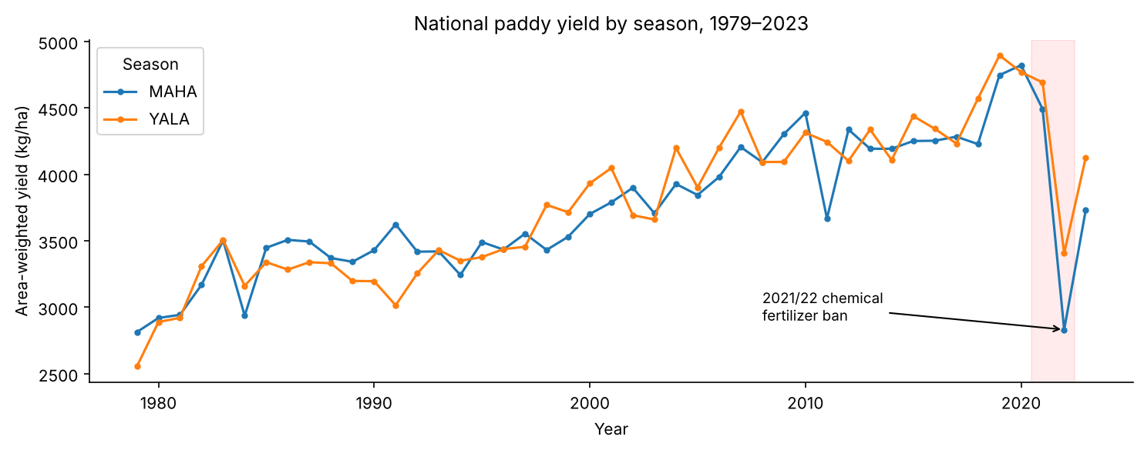
Figure 1. National area-weighted yield by season: a long-term upward trend and the 2022 collapse.
The EDA (Figure 1, plus the notebook's district box-plots and correlations) showed three things. Yields roughly doubled since 1980. The dry-zone districts with major irrigation schemes (Polonnaruwa, Ampara, Hambantota) have the highest yields. The rain-fed share of the sown area is strongly negatively correlated with yield (r = −0.56).

3. Leakage-free feature engineering
Only information available at sowing time is used: District, Season, Year, the log of total sown area, the shares of sown area under major, minor and rain-fed irrigation, the % change in sown area versus the same season last year (farmers sow less when water is short), yields of the previous season, the same season last year and the mean of the last four seasons, and last season's harvested-to-sown ratio (a crop-loss signal). Lags are joined on a chronological season index rather than shifted, so missing seasons are not silently skipped.
Harvested extent, per-source yields and production for the current season are deliberately excluded. Production is exactly net harvest × yield, so including these columns would leak the answer.
Preprocessing runs inside a scikit-learn Pipeline, so it is fitted only on the training folds: median imputation, standard scaling and one-hot encoding (CatBoost uses its native categorical handling instead).

4. Method
Validation. Random splitting would let the model learn from the future. Training uses 1979–2015 and testing uses 2016–2023, which includes the fertilizer shock. Hyperparameters are tuned with a forward-chaining TimeSeriesSplit (4 folds) inside the training period, using RandomizedSearchCV scored on RMSE. One sample, Polonnaruwa Yala 2023, is held out of everything and used only to demonstrate inference from the pickle file.
Existing approaches (baselines): persistence (same season last year), a 4-season moving average and linear regression. Ensembles: Random Forest (bagging), XGBoost, LightGBM and CatBoost (boosting), plus a stacking ensemble of the four with a Ridge meta-learner.
Hyperparameters were designed, not left at defaults. The search spaces follow from the data size (about 1,800 training rows): shallow trees and a small learning rate for boosting, minimum leaf sizes so that single flood or drought years are not memorised, and L1/L2 and subsampling regularisation. The selected values are listed below.
Model | Tuned hyperparameters
Random Forest | n_estimators 428, max_depth 20, min_samples_leaf 8, max_features 0.34, max_samples 0.99
XGBoost | n_estimators 1019, learning_rate 0.017, max_depth 2, min_child_weight 8, subsample 0.83, colsample 0.64, α 1.49, λ 1.75
LightGBM | n_estimators 615, learning_rate 0.010, num_leaves 21, min_child_samples 34, subsample 0.72, colsample 0.78, λ 7.25
CatBoost | iterations 966, learning_rate 0.051, depth 6, l2_leaf_reg 14.3, bagging_temperature 0.79

5. Results and comparison
Model | CV RMSE | Test RMSE | Test MAE | MAPE % | R² | RMSE ex-2022
LightGBM (selected) | 425 | 626 | 451 | 12.9 | 0.51 | 455
Stacking | 430 | 608 | 443 | 12.5 | 0.54 | 451
Random Forest | 430 | 622 | 463 | 12.9 | 0.52 | 485
XGBoost | 431 | 633 | 457 | 13.0 | 0.50 | 465
CatBoost | 437 | 608 | 450 | 12.7 | 0.54 | 465
Moving average (last 4) | 442 | 685 | 496 | 14.2 | 0.42 | 517
Persistence (same season LY) | 477 | 742 | 554 | 15.5 | 0.32 | 583
Linear regression | 513 | 639 | 467 | 13.6 | 0.49 | 461
Table 2. Errors in kg/ha. The model is selected on CV RMSE (training period only); test results are only reported.
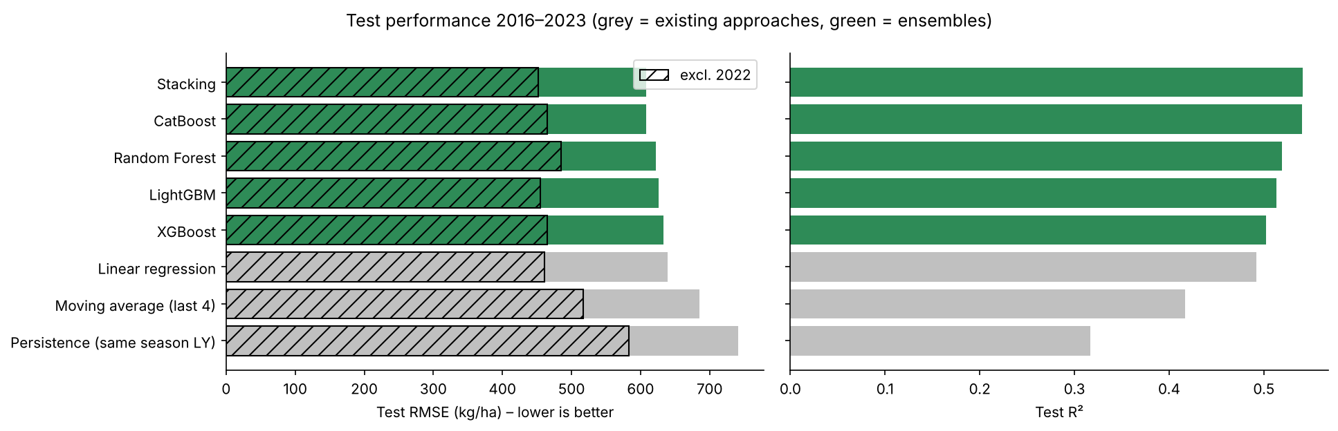
Figure 2. Test RMSE (hatched: excluding 2022) and R². Grey bars are existing approaches.
- Every ensemble beats the existing approaches in cross-validation. LightGBM's CV RMSE of 425 kg/ha is 17 % lower than linear regression (513) and 11 % lower than persistence (477).
- On unseen 2016–2023 seasons, LightGBM's RMSE is 626 kg/ha (MAPE 12.9 %), 16 % lower than persistence and 9 % lower than the moving average. Excluding 2022 it is 22 % lower than persistence. About 60 % of district-season forecasts fall within ±10 % of the actual yield.
- Linear regression comes close on the test period. 2019–2021 brought record yields outside the training range. Tree models predict averages of training leaves and cannot extrapolate a trend, while a linear Year term can. For this reason the deployed model is retrained on all data up to 2023.
- Stacking has the best raw test RMSE (608), but its CV score is slightly worse and it is about four times more complex to deploy and explain. LightGBM was therefore selected, with stacking as a close alternative.
- Every model over-predicts 2022. LightGBM's errors that year are 2.5–4 times larger than in normal seasons, because the fertilizer ban is not visible in any sowing-time feature.

Strengths and limitations
Model | Strengths | Limitations
Persistence / moving avg. | No training; transparent; yields are persistent | Ignores irrigation mix, sown area and trend; lags every change
Linear regression | Fast, readable, extrapolates the trend | No interactions; unstable with collinear shares and lags; worst CV
Random Forest | Robust, low tuning sensitivity, handles collinearity | Cannot extrapolate; largest model file
XGBoost | Strong regularisation; fast hist method | Many interacting hyperparameters; needs one-hot districts
LightGBM | Best CV; fastest; leaf-wise trees capture interactions | Over-fits easily on small data; needed small num_leaves and a large min_child_samples
CatBoost | Native categorical handling; ordered boosting | Slowest to train; district encoding less transparent
Stacking | Combines bagging and boosting errors; best test RMSE | Complex to deploy and explain; small gain

6. Explainability (SHAP and LIME)
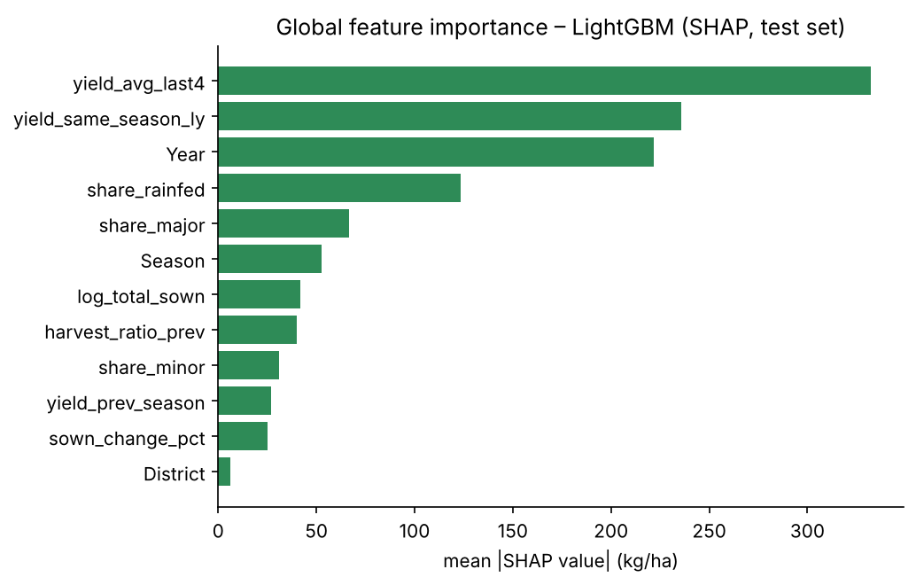
Figure 3. Global importance (mean |SHAP|, LightGBM, test set).
SHAP (Figure 3 and the beeswarm plot in the notebook) shows that the model relies on recent yield history, the Year trend, and the rain-fed share (higher share, lower forecast) and major-irrigation share (higher share, higher forecast). This is consistent with Sri Lankan agronomy: rain-fed paddy has no water control and is exposed to drought and flood. The district name itself adds almost nothing, because the location effect is already captured by each district's history and irrigation mix. The model generalises through agronomic drivers rather than memorising names, which builds trust.
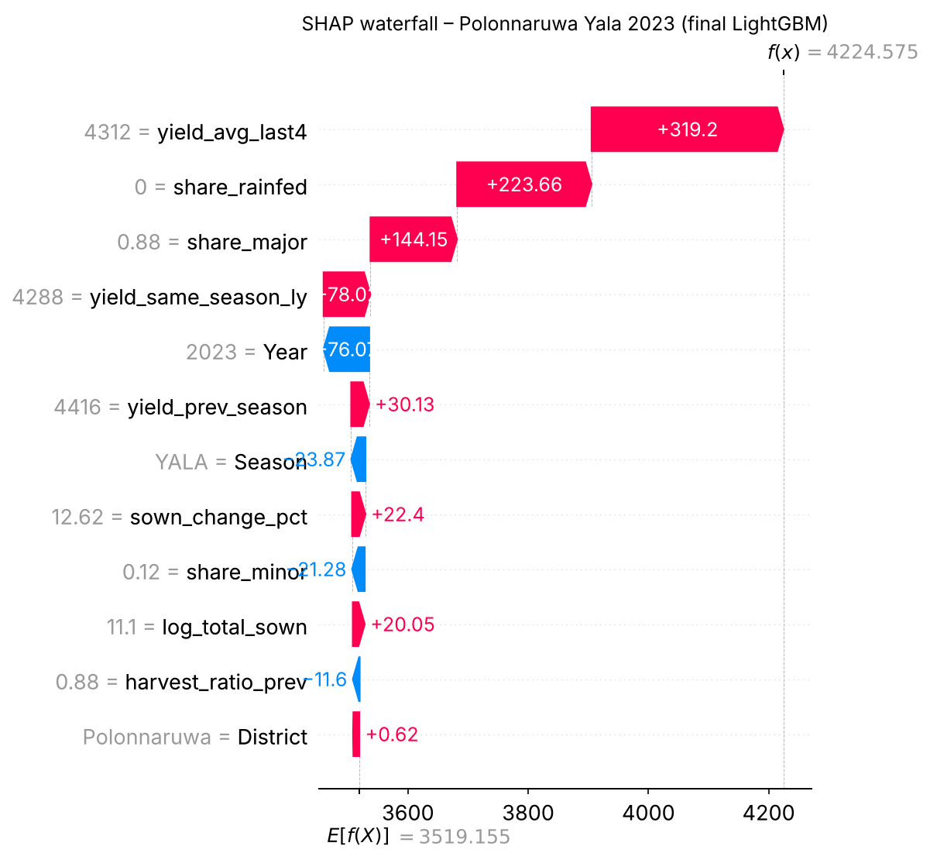
Figure 4. SHAP waterfall for the held-out sample (final model).
Inference on the held-out sample. For Polonnaruwa Yala 2023, the pickled model predicts 4,225 kg/ha. The recorded yield was 4,918 kg/ha, an error of −14 %. The waterfall explains the gap. High history, no rain-fed area and 88 % major irrigation push the forecast up, but Year = 2023 pulls it down because the model learned from the 2022 collapse that the latest years were low. In reality yields recovered in 2023. LIME, a local linear surrogate (R² = 0.63), agrees on the main drivers but scores Year positively because its coarse bin compares “after 2006” with older years. This disagreement shows why SHAP and LIME are useful cross-checks of each other.

7. Front end and deployment
The final pipeline and its metadata are saved as paddy_yield_model.pkl. A Streamlit app, generated with GenAI prompts (documented in the repository), loads the pickle, pre-fills each district's history from DCS records, and returns the predicted yield, an error range and an indicative production. It also shows a SHAP bar chart explaining that specific prediction. For the deployment bonus, a Dockerfile and a GitHub Actions workflow (smoke tests on the pickle and a Docker build) let the app run on Streamlit Community Cloud or Azure Container Apps.
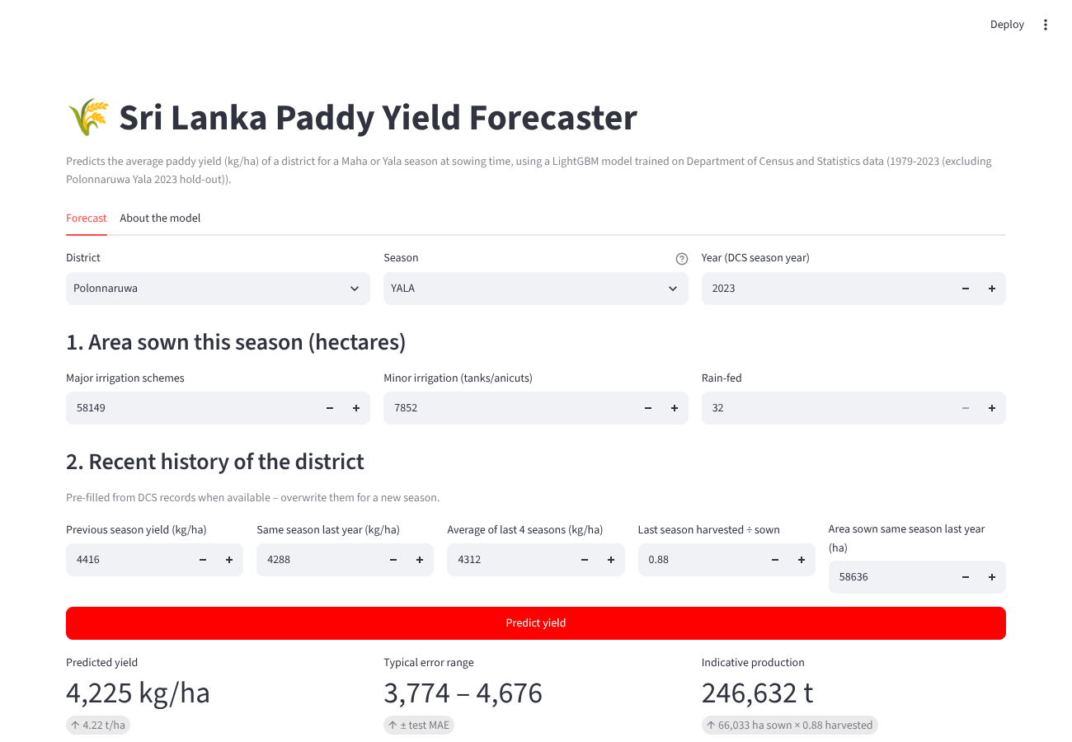
Figure 5. The Streamlit front end.

8. Limitations and future work
- Shocks after sowing (policy, floods, droughts) are not in the features. Adding Department of Meteorology rainfall, reservoir and tank storage, and fertilizer issue data is the clearest next step.
- Tree models cannot extrapolate trends, so the model needs seasonal retraining and data-drift monitoring, as in the MLOps workshop.
- The Northern districts have gaps from the war years; those lags are imputed.

References
Department of Census and Statistics, Sri Lanka. Paddy Statistics (district-wise, Maha and Yala seasons), 1979–2023.
Lundberg, S. M. & Lee, S.-I. (2017). A unified approach to interpreting model predictions. NeurIPS.
Ribeiro, M. T., Singh, S. & Guestrin, C. (2016). “Why should I trust you?” Explaining the predictions of any classifier. KDD.
Chen, T. & Guestrin, C. (2016). XGBoost: A scalable tree boosting system. KDD.
Ke, G. et al. (2017). LightGBM: A highly efficient gradient boosting decision tree. NeurIPS.
Prokhorenkova, L. et al. (2018). CatBoost: unbiased boosting with categorical features. NeurIPS.
Breiman, L. (2001). Random forests. Machine Learning, 45(1), 5–32.

