Can AI Agents See What People See?
Colour saturation and perceived product size: Hagtvedt and Brasel (2017) with AI agents
MBAN 5640 Visualization & Data Mining · Group Project 4 · Short report (deliverable C)
Group 1 · Krishna Soni (A00495153) · Michael Toner (A00494090) · Dale Warner (A00056348)
Draft for team review · generated 2026-11-07 09:32 (ADT) from gp4_main_20261105_191049
AI ATTRIBUTION
Prepared with AI assistance from Claude (Anthropic): the simulation code, statistical analysis, figures and a first draft of this report were produced with Claude, then reviewed and edited by the team. The simulated participants are OpenAI gpt-4o-mini agents.

BOTTOM LINE UP FRONT
- Direction yes, pattern no. The AI agents shifted all three measures the same way as people did, but the size effect was more than double the original (r = +.70 vs +.30), while the large replication found none (+.01).
- The mechanism was missing. Attention barely moved (r = +.15, not significant), the arousal-attention-size chain was not significant, and mood, which people did not change, did (r = +.29): a halo response.
- Answers were near-categorical. 79% of high-saturation agents said 15 inches and 82% of low-saturation agents said 13. AI agents can flag the direction of a visual cue, but their effect sizes should not be read as human ones.

1. Research background
Product colour is one of the cheapest design choices a marketer controls. Hagtvedt and Brasel (2017) asked whether colour saturation (how vivid a colour is) changes how big a product looks. Their theory: saturated colours are more arousing; arousal draws attention; and objects that attract attention are judged larger. If true, saturation is a lever for packaging and product images, and a risk when a product should look small. Our question, from the course brief: to what extent can AI agents reproduce these human perceptions and effects?

2. Human results
In Study 3 (n = 77 undergraduates, between-subjects), each person saw one red laptop in high or low saturation. High saturation raised estimated screen size (15.28 vs 14.41 inches, r = +.30), attention (5.19 vs 4.66 on 1 to 7, r = +.25) and arousal (6.05 vs 5.14 on 1 to 9, r = +.30); mood, a placebo measure, did not differ (5.43 vs 5.49, p > .87). A serial mediation (saturation, arousal, attention, size) was significant (B = .53, 95% CI [.16, 1.01]). The Motoki and Iseki (2022) replication (n = 823 Japanese online adults) confirmed attention (r = +.24) and arousal (r = +.18, 7-point scale) but found no size effect (15.46 vs 15.42 inches, r = +.01). We compare the AI with both.

3. AI-agent design and results
- Agents. 77 agents, as in the original, randomly assigned with a fixed seed (39 high, 38 low). Each agent is one fresh call to OpenAI gpt-4o-mini with no memory of other agents, which reproduces the between-subjects design. Persona: "You are a female/male undergraduate university student" (49% male, balanced within each condition).
- Stimulus and questions. Each agent receives the actual image (one image only, neutral file name) followed by the original questions and scales: screen size in whole inches from 10 to 20, two attention items (1 to 7, averaged), arousal and mood (1 to 9). The prompt never mentions colour, saturation, conditions or the hypothesis; the code checks this.
- Settings and data. Temperature 1.0, low image detail. Answers are forced into a JSON format and checked in Python (whole numbers, in range; up to 3 tries). 77 of 77 agents were valid on the first try; cost about US$0.04. Every call is logged (prompt and image fingerprints, tokens, raw output). All settings were signed off before the first live run and not changed afterwards.
AI results (high vs low). Size 14.67 vs 13.32 inches (F(1, 75) = 71.43, p < .001); arousal 5.62 vs 5.08 (p = .004); attention 5.51 vs 5.47 (p = .182, not significant); mood 7.08 vs 6.82 (p = .011).

4. Human-AI comparison
Measure | Original r [95% CI] | Replication r | AI r [95% CI] | AI vs original r | Verdict
Size | +.30 [+.08, +.49] | +.01 | +.70 [+.56, +.80] | Larger (p < .001) | Exaggerated
Attention | +.25 [+.03, +.45] | +.24 | +.15 [-.07, +.37] | Not different (p = .546) | Same sign, not significant
Arousal | +.30 [+.08, +.49] | +.18 | +.32 [+.11, +.51] | Not different (p = .879) | Reproduced
Mood (placebo) | none (p > .87) | n/a | +.29 [+.07, +.48] | n/a | Halo (should be zero)

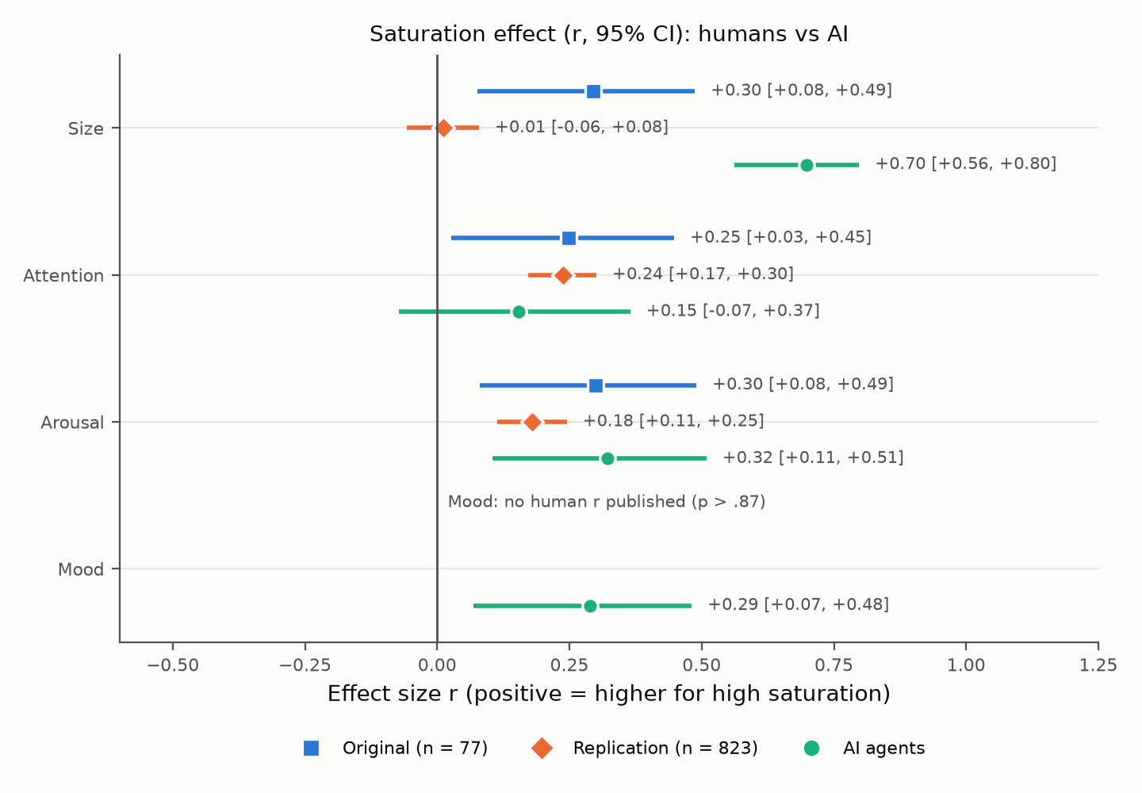 | 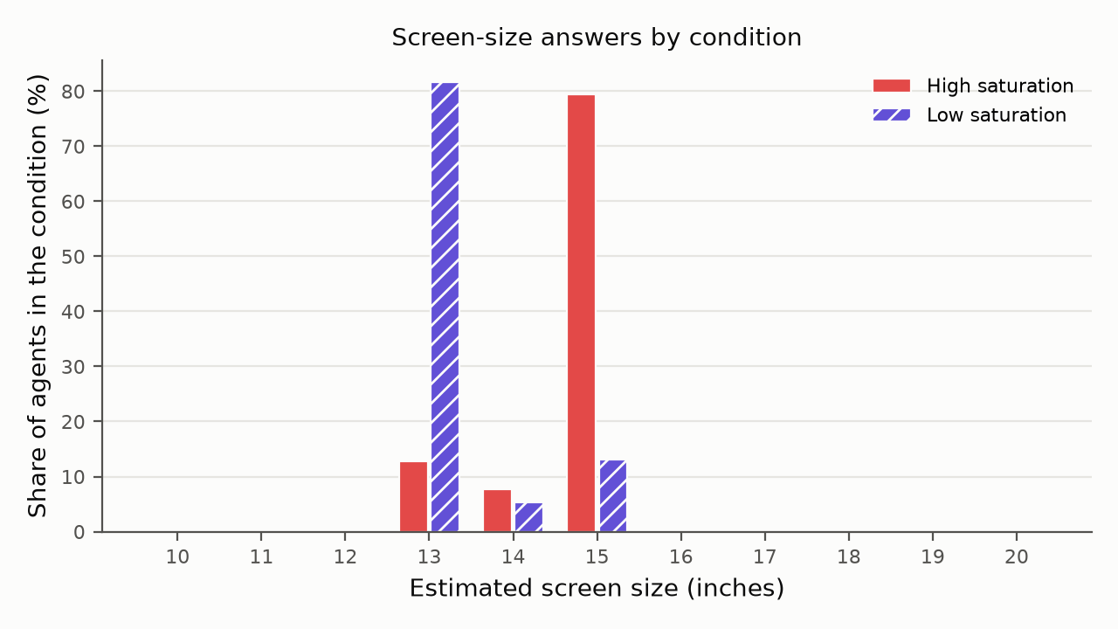
Figure 1. Effect of high vs low saturation (r, 95% CI) for each source. Right of zero = higher for the more saturated laptop. | Figure 2. AI screen-size answers. Agents used only 13, 14 or 15 inches, almost one value per condition.

- Direction and magnitude. All three AI effects point the same way as the original. Arousal matches closely; size is far larger than in either human study; attention is smaller and not significant.
- Size is not a null. The AI difference is 1.35 inches (90% CI [1.08, 1.62]), well outside a plus or minus 0.5 inch equivalence band, so the AI clearly sides with the original, not the replication, and overshoots it. An accidental repeat run gave r = +.63, so the result is stable.
- Variability is not human. AI standard deviations for size are about half the humans' (0.70 vs 1.26), and for attention about a tenth; 86% of agents gave an answer pattern identical to another agent's. The mediation chain was not significant (total indirect B = .09, 95% CI [-.03, +.24]; humans .53).
- Possible explanations. The model has no eyes or arousal system; it most likely maps a vivid image onto learned associations (vivid, premium, larger) and then picks the most typical answer, which removes the spread that real people show. In a 20-agent diagnostic run, all 20 explanations mentioned colour and style; none mentioned size.

5. Conclusion and limitations
Outcome: exaggerated, with a halo. AI agents reproduced the direction of the saturation effects and the size of the arousal effect, but not the human pattern: size is overstated, the attention mechanism is missing, mood moves when it should not, and answers are nearly uniform. AI agents are useful for a fast, cheap first look at whether a visual cue matters, not as a substitute for human participants or for estimating effect sizes.
Limitations. One model and one prompt version; the comparison uses published summary statistics (no raw human data; cell sizes assumed); the image is small and on screen; the replication used a different population and a 7-point arousal scale (compared by effect size only); an AI has no real attention or arousal. All differences from the original design are listed in DEVIATIONS.md.
Code, data and variable dictionary: https://github.com/WarnerMBAN/gp4-sensory-marketing · Dashboard: https://gp4-saturation.streamlit.app/ · Sources: Hagtvedt, H., and Brasel, S. A. (2017), Journal of Consumer Research, 44(2), 396-413. Motoki, K., and Iseki, S. (2022), Frontiers in Communication, 7, 1048896.

