LZSCC.211 Coursework Report – <Your Student ID>

Task 1 – Functionalities [10 Marks]
The code submitted by the young developer is expected to fulfill the following functional requirements:
FR1. The system shall allow only admin users to add additional admin users
FR2. The system shall allow free users to subscribe and change their status to premium users
FR3. The system shall allow premium users to unsubscribe and change their status to free users
FR4. The system shall require free users to submit their payment when subscribing
FR5. The system shall guarantee that all usernames are unique
FR6. The system shall allow all users to edit their profile (i.e., change password, change number of movies shown while browsing)
FR7. The system shall allow all users to browse the movie catalogue, movies are listed in chunks based on user’s profile settings
FR8. The system shall allow free users to stream only with advertisements
FR9. The system shall allow admin and premium users to stream in High Definition
FR10. The system shall allow new users to register
Your first task is to understand the provided code, and fill the following table by putting an X on the relevant cell.
Requirement | Fulfilled | Violated
FR1 | X
FR2 | x
FR3 | x
FR4 | x
FR5 |  | x
FR6 | x
FR7 |  | x
FR8 | x
FR9 | x
FR10 | x

Task 2 – Provided Code Class Diagram [5 Marks]
After studying and understanding the provided code, use the PlantUML tool (https://plantuml.com/) to produce the class diagram representing the given code. Draw your diagram at specification level and do not provide methods with private visibility.

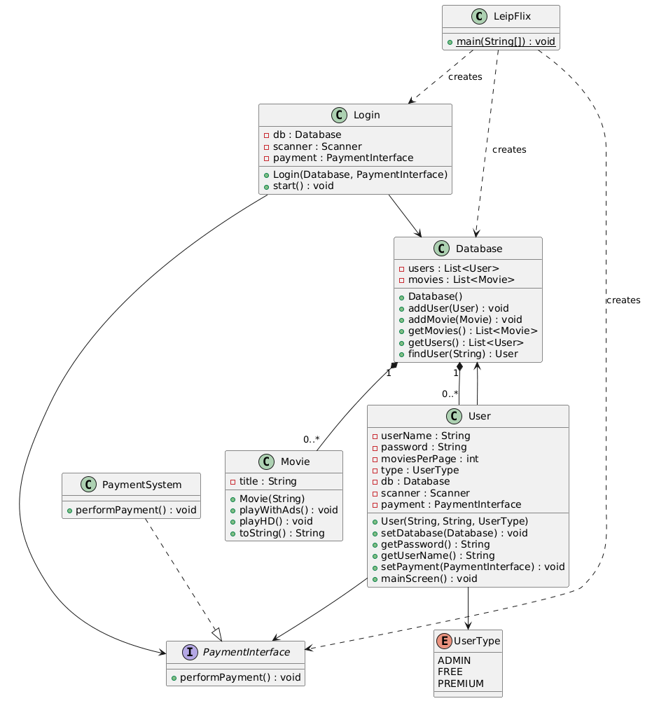

Task 3 – Identify and Explain Design Issues [10 Marks]
The provided code clearly does not follow many of the good design practices. Identify five cases within the provided code, and briefly explain what the problem is.
- No abstraction for content types. Movies are implemented as a class, making the system hard to extend if we wanted to add new content types such as concerts or shows.
- User type checks rely on many conditionals throughout the code base. This violates the open/closed principle and adding a new user type would require hunting down every conditional and adding an additional statement with the new user type.
- The database class violates the single responsibility principle. The database manages both user data and movie data. This coupling makes the code harder to maintain and extend.
- Coupling between UI code and business logic. The user class contains a lot of UI code, making it difficult to read and extend if we were to add new UI types, such as mobile or a desktop app.
- The User and Login classes depend on the concrete Database class which violates the dependency inversion principle. These classes should depend on an interface, like they do with the payment interface. This makes it easier to change the code in the future.

Task 4 – New and Improved Class Diagram [10 Marks]
Use the PlantUML tool to produce a new and improved class diagram representing your proposed solution so that the new structure follows good design principles. Draw your diagram at specification level.
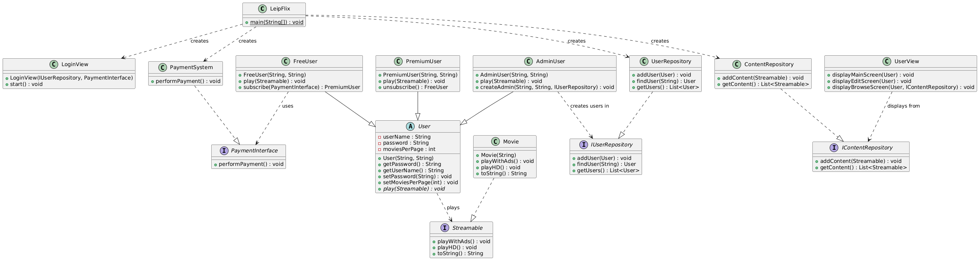

Task 5 – Refactoring [15 Marks]
This task does not impact the report since it focusses on the implementation. Check carefully the coursework description to understand what is needed.

Task 6 – Non-Functional Requirements [10 Marks]
The last task requires you to write down five non-functional requirements for the LeipFlix platform. Note that those requirements do not have to come from your revised implementation, but you are allowed to come up with reasonable non-functional requirements for the final LeipFlix platform.
NFR1. Leipflix shall store all user passwords with industry standard hashing practices and algorithms.
NFR2. Leipflix shall have 99.9% uptime.
NFR3. Leipflix shall be able to handle at least 10,000 concurrent users streaming video content.
NFR4. Leipflix shall be able to handle 1000 new users per month after its launch.
NFR5. Leipflix shall lock out the user after 3 failed attempts to input the password.

Appendix
Put in appendix all your interactions with Gen AI models if you are using them to assist you in the coursework

