计算机组成原理实验报告

姓名： 吴迪 学号：11810716

1. 实验目的

Learn the effective range and storage characteristics of data, master the function of key registers such as $pc,$ra,$sp,$gp. Practice jump/branch instructions to create branches, loops structure and functions, Practice procedure on caller and callee.

1. 实验内容

1. Print out a 9*9 multiplication table.

1) Submit 2 files: one got a global main label as the entrance of the program, another is used to define a function to print.

2) The function is used to print item a*b = c, the value of “a” is from $a0, the value of “b” is from $a1.

3) calculate the number of MIPS basic instructions, compared with the number which statistic by Mars (MIPS32 simulator) to see if them are same or not. record this info on the report.

2. Get a positive integer from input, output an integer in reverse order using loop and recursion separately.

1) Submit 2 files: one use loop, another use recursive.

2) Statistic the number of MIPS basic instructions while by using loop and recursion separately. Record this info on your report. compare the two number while the input is n digit decimal number （n changes from 1,2,3 to 8）,record this info on the report.

3. Read some data from the input, save it in an array, sort them in ascending order, and then print out the array after sorting.

1) Submit 2 files: one got a global main label as the entrance of the program, another is used to define a function to print.

2) The function is used to print the array.

3) The number of array item is determined by user.

1. 实验步骤（阐述代码思路或操作步骤）
2. In the main part, we use two loop, and the inside loop is to add b up, outside loop is to add a up. And we put the value of a and b to $a0 and $a1, then jump to the function print_matrix.
3. I use a while loop and recursion. The while loop will end when the number becomes 0. The recursion will return when number becomes 0.
4. I read the input in the main and get a heap memory to store the array. Then I use the functions defined in another file to sort and output the sorted array.
5. 实验结果（截图并配以适当的文字说明）

The setting of mars:

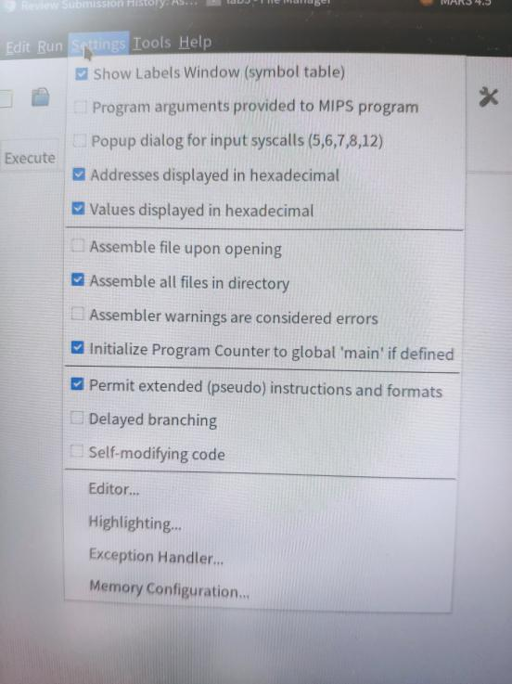

1

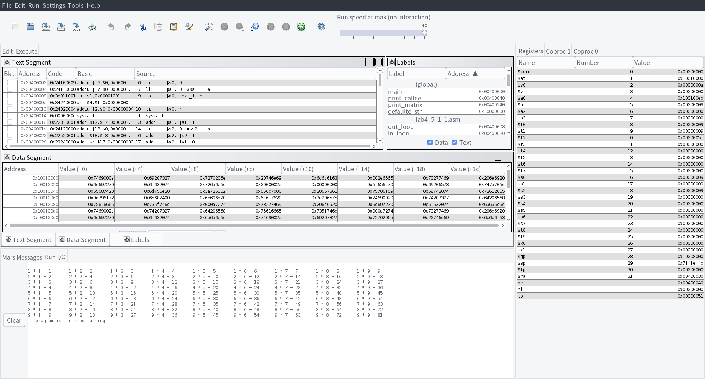

Output is a 9*9 multiplication table.

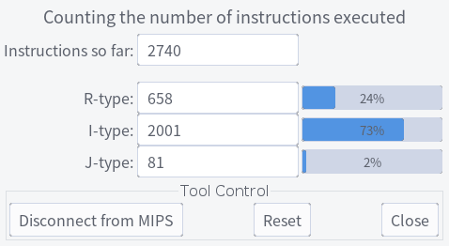

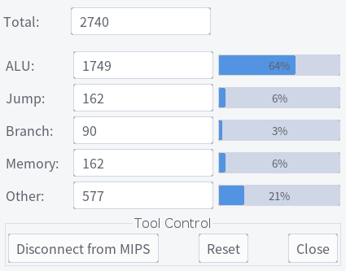

Total number of basic mips instructions is 2740.

2_1

Input is 123456789, output is 987654321

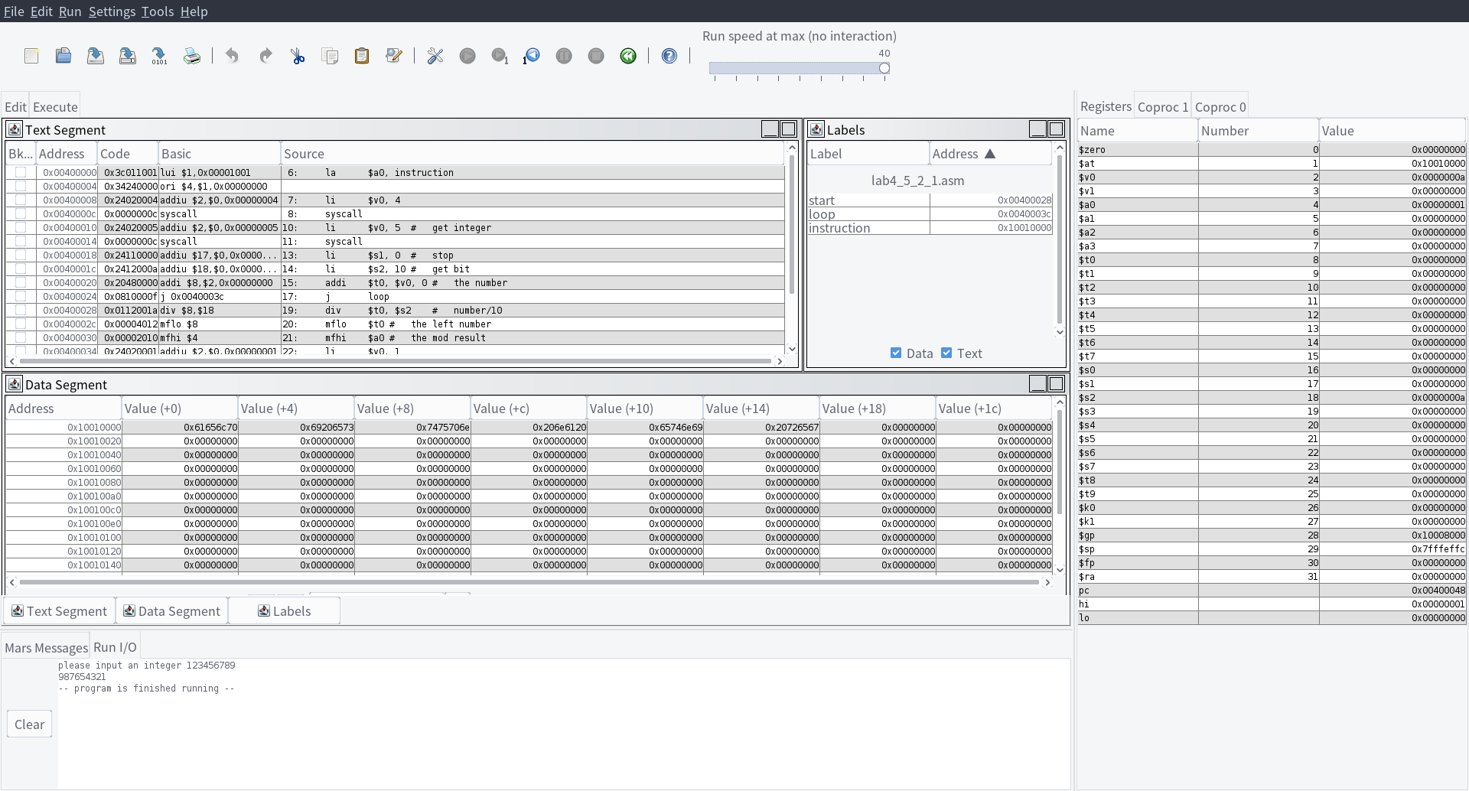

2_2

Input is 123456789, output is 987654321

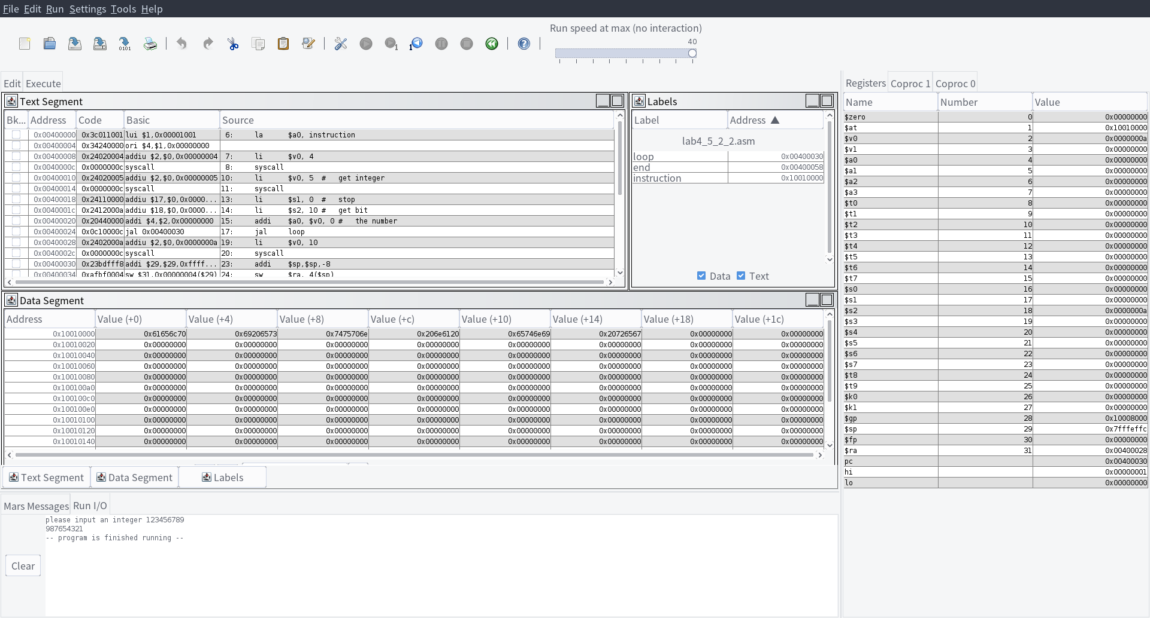

2

Loop Recursion

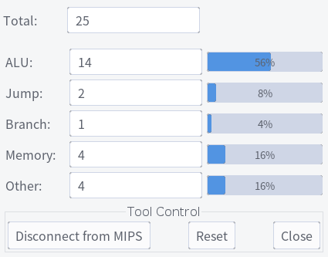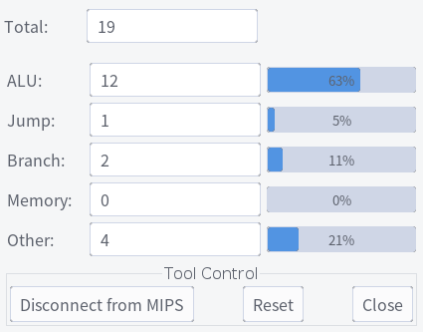

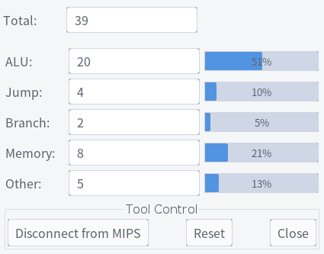

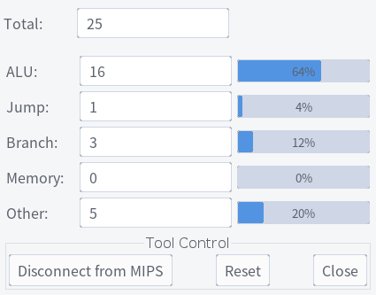

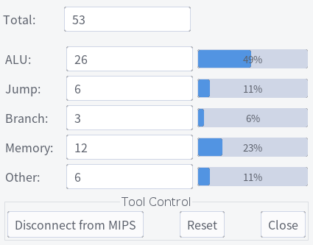

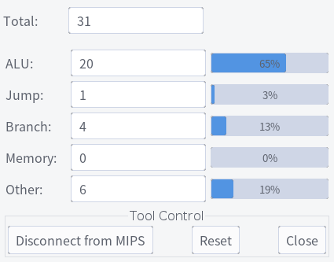

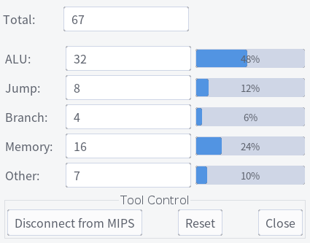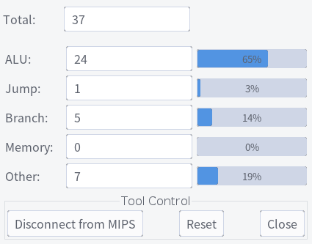

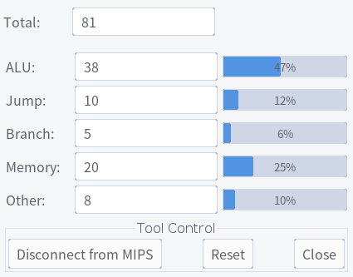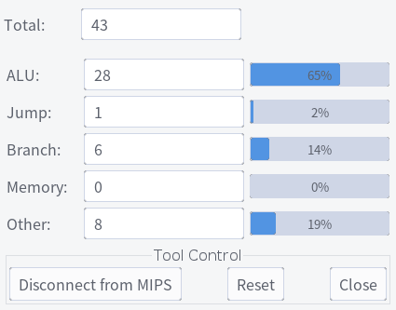

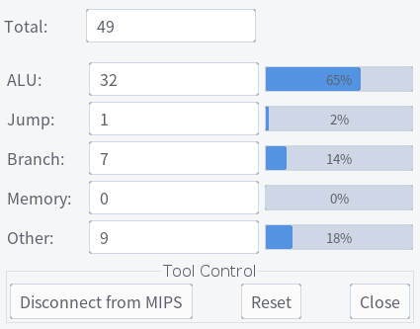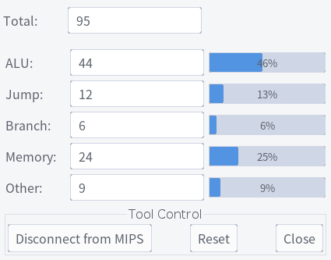

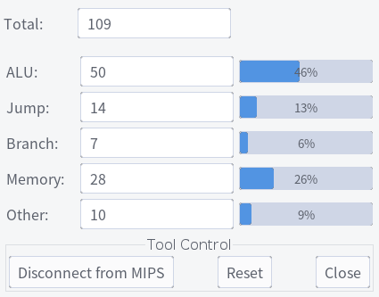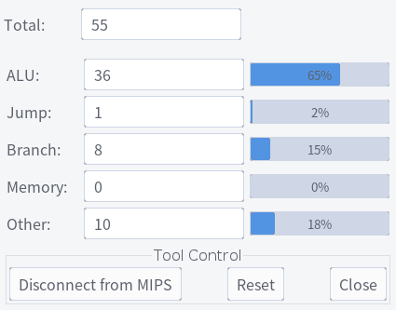

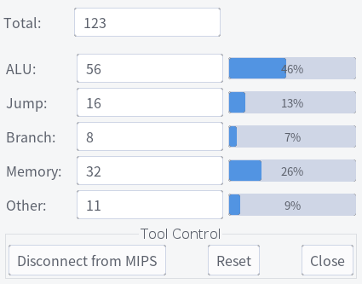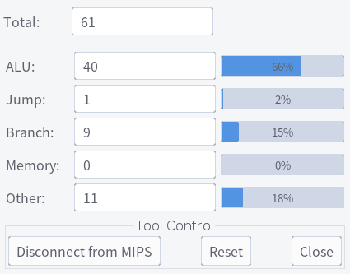

3

Input: 5 6 4 2 3 1

Output: 1 2 3 4 6

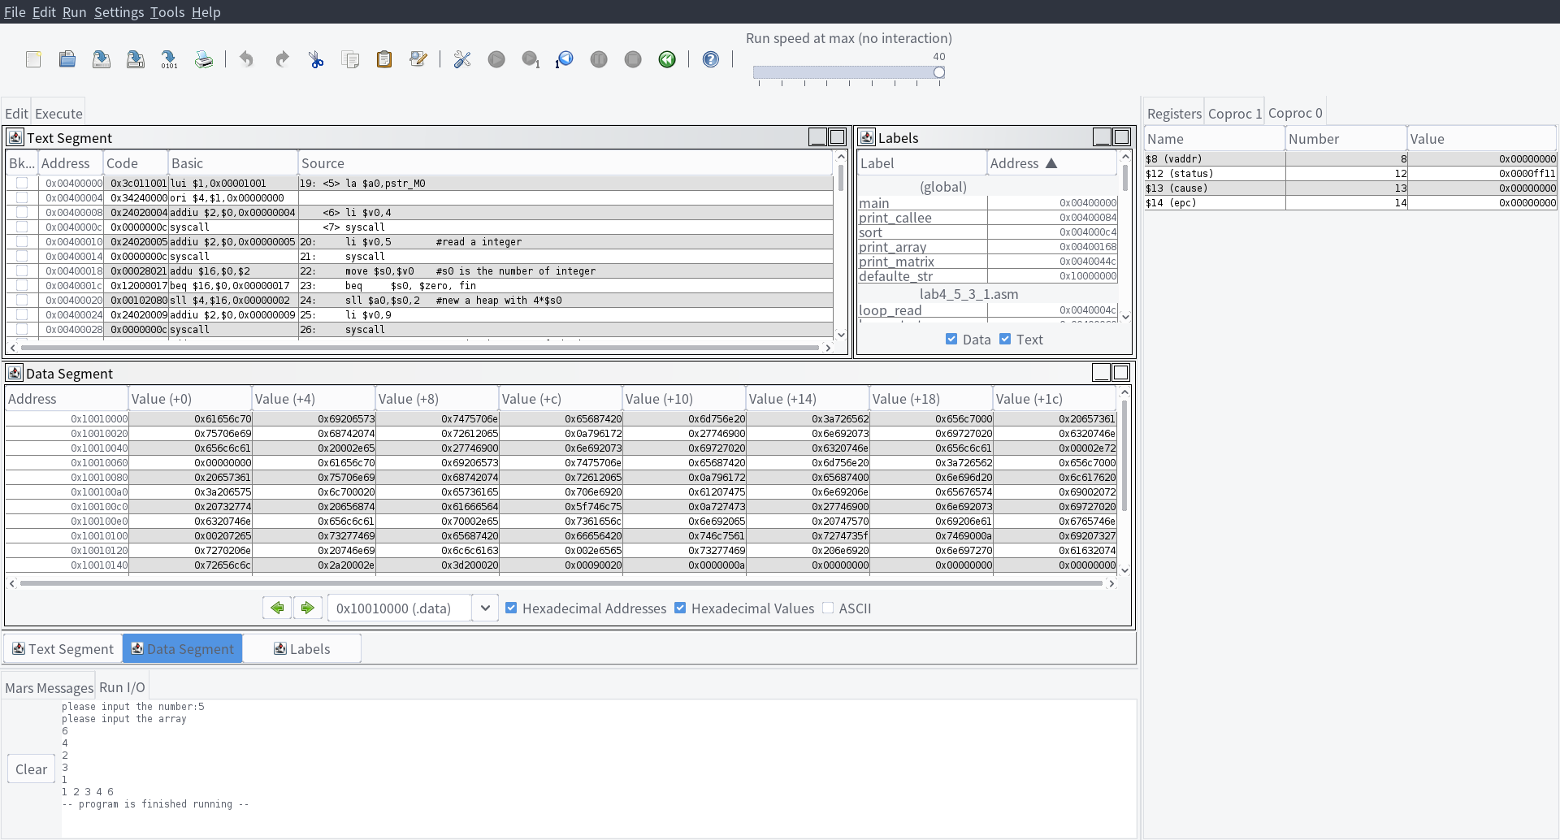

1. 实验分析（遇到的问题以及解决方案）
2. The function takes 28 instructions and it runs 81 times. The inside loop takes 5+28 instructions, and the outside loop part has 7 instructions. The total instructions is calculated by 2+(7+(5+28)*9)*9+2 is 2740. The same as the instruction counter.
3. The recursion version do more instructions under any situation. Because it need to do more memory and jump operations.
4. Because we don’t know the size of the array at first, we can’t use registers to store the data. We need to use heap memory. We can use sbrk to get a space in the memory to store the data. Then we can operate the memory by instructions.
5. 实验小结与体会

In this section, we use a lot of functions and loops. We found that the number of instructions of recursion is greater than functions that have the same usage. The reason is that recursion does more memory operation to protect the data. Sbrk is very useful as sometimes the registers are not enough to store the data.