计算机组成原理实验报告

姓名： 吴迪 学号：11810716

1. 实验目的

Learn the difference between integer and float point data in MIPS,Learn the infinite and NaN in float point data, Practice the usage of floating register and the conditional flags in Co-processor 1, Practice on load,store,move,arithmetic,compare and branch instructions on float point data.

1. 实验内容

Q1. Calculate the square root of an integer number without using “sqrt.s” and “sqrt.d”

1) Get the input data (integer) and the precision value(such as 0.01) from input device

2) If the input data is a negative number, print out the warning message and exit

3) If the input data is a positive number, calculate its square root value which can satisfy the accuracy requirement and print it out

Q2. Suppose 3 students attends a quiz with 5 questions, score of every question could be a float point number ranges from 0 to 5.0(such as 0.5, 1.0, 3.5.etc)

1) Get the scores of each question of each student

Suppose user input the following data, (5 4.5 3.5 4 3 ) is the score list of one student, 5 is the score of 1st question,4.5 is the score of 2nd question.etc.

5 4.5 3.5 4 3

3 2 2 1.5 1

4 3.5 5 4.5 3

2) calculate the total score of this quiz for every students and print out

3) calculate the average of every question and print out

4) calculate the average of all the question and print out

5) find all the index of the question in this quiz whose performance is not so good(the average score of the question is lower than the total average), print the index of this question and its corresponding average score.

1. 实验步骤（阐述代码思路或操作步骤）
2. Get the square root by Newton's method. Output the result when the difference equal or smaller than the precision.
3. Read the inputs by loop and get and output then by loop. Store every input in heap by *swc1* for wider usage, such as configure more inputs in the future.
4. 实验结果（截图并配以适当的文字说明）

1.

* 1. Input: -1

Output: Error. Input integer is negative

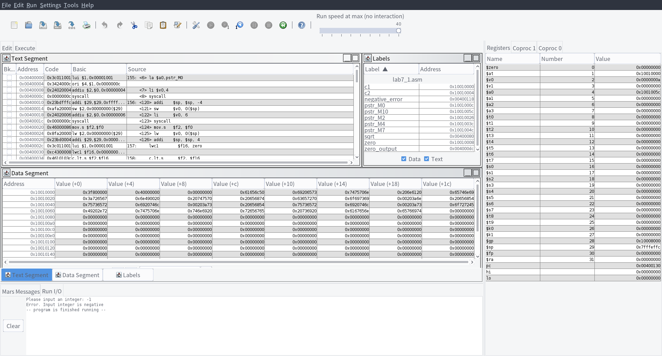

* 1. Input: 0

Output: The result is: 0.0

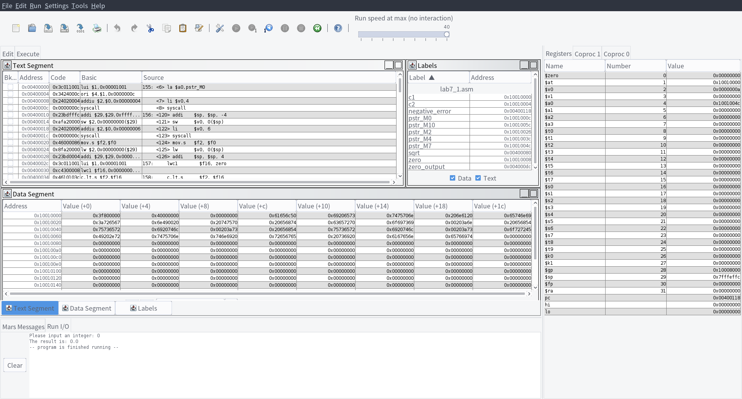

* 1. Input: 2 0.0001

Output: The result is: 1.4142157

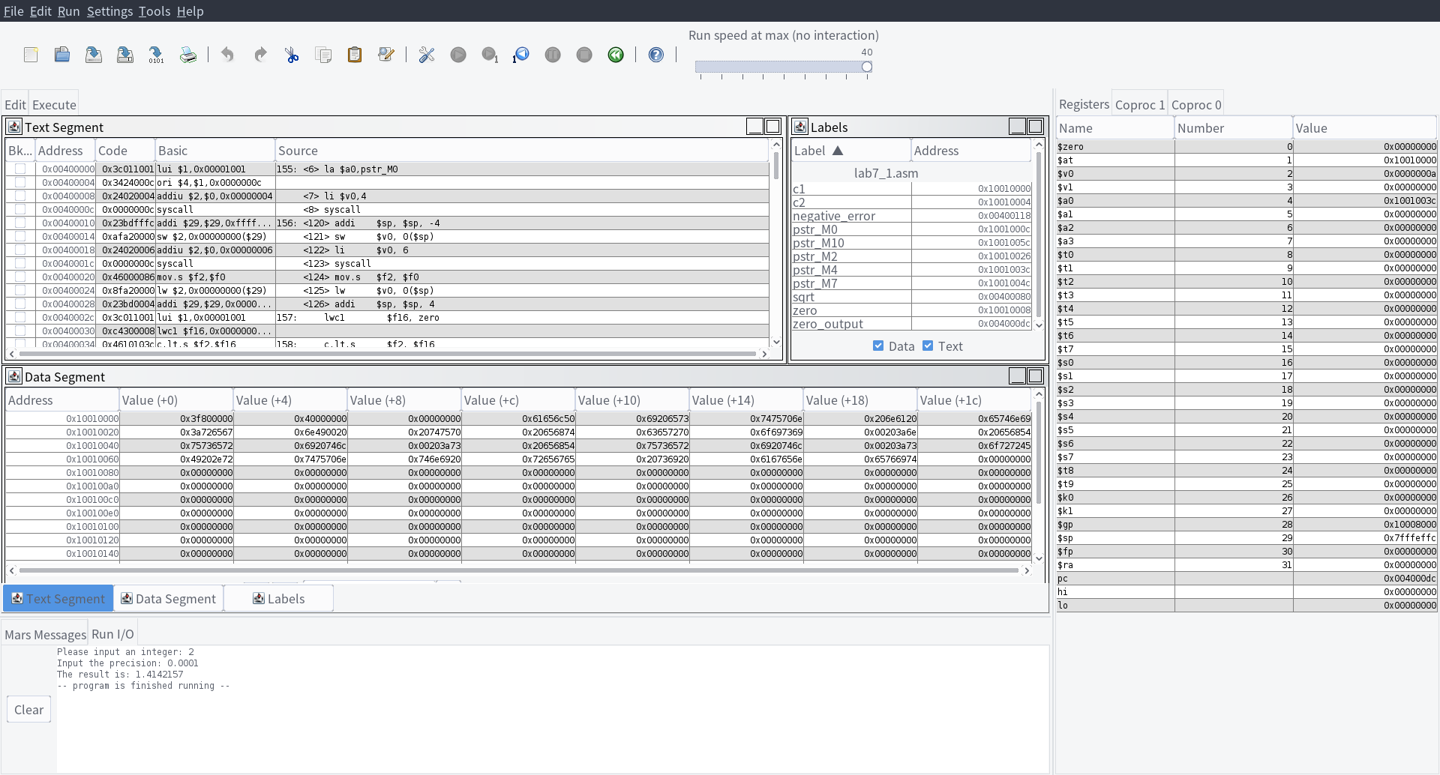

2.

Input:

5 4.5 3.5 4 3

3 2 2 1.5 1

4 3.5 5 4.5 3

Output:

The total score of student 1 is 20.0

The total score of student 2 is 9.5

The total score of student 3 is 20.0

The average score of question 1 is 4.0

The average score of question 2 is 3.33

The average score of question 3 is 3.5

The average score of question 4 is 3.33

The average score of question 5 is 2.33

The total average score of the questions is 3.3

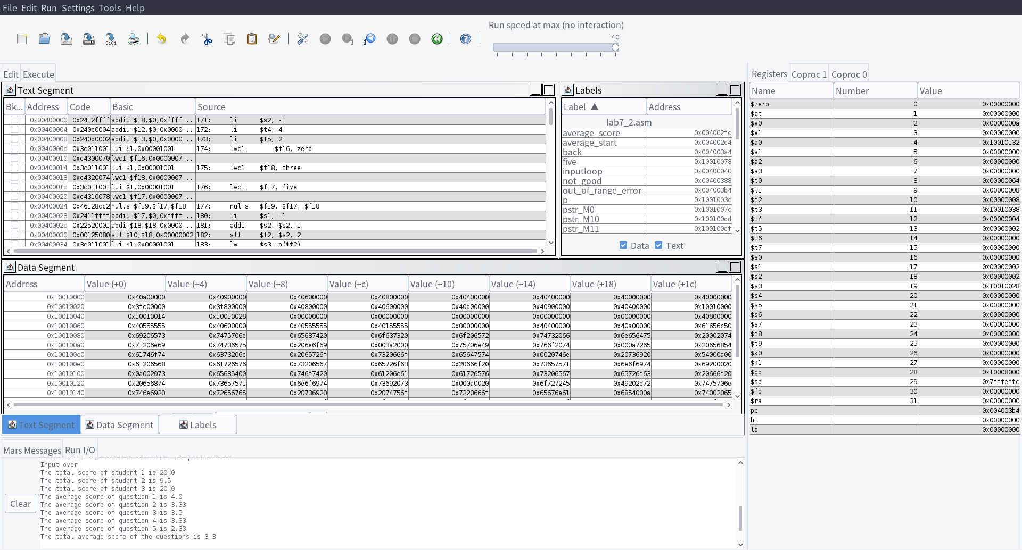

1. 实验分析（遇到的问题以及解决方案）
2. The Newton’s method is good, but may out come some ridiculous results. Such as 0, which may output 0.5 with precision 0.1. We need to handle some, but other situation is based on the users.
3. The average may output many decimal places. It’s better for us to use *round* to normalize the output.
4. 实验小结与体会

There are many operations on float number and double precision numbers. And float number is completely different from integers.