计算机组成原理实验报告

姓名： 吴迪 学号：11810716

1. 实验目的
2. learn and practice on how to design the basic componet in datapath of CPU based on ISA.
3. learn and practice on how to use IP core in design.
4. 实验内容

implement the registers group and alu in CPU(MIPS32)by verilog,practice on using IP cores in vivado.

1. create a registers group and verify its function by simulation

Part 1: do the design

1)the input and output ports should be same as design on page 5 of LAB9.pdf

tips: don't forger clk and Asynchronous reset.

2)the registers group should support R/I/J type instructions in MIPS32

3)there are 32 registers in this group, each register is 32bits width

4)all the registers except $0 are readable and writeable, $0 is readonly.

5)read/write the register which is identified by the address bus

Part 2: build the testbench, do the function verificatoin on following cases:

1) while Asynchronous reset is valid, all the registers is reset as zero.

2) while Asynchronous reset is invalid,regWrite is valid at the posedge of clk, write the register which is addressed by writeRegster with the data on writeData.(write register 0 and regiseter 1 with 32'h1234 and 32'h4321)

3) read datas from the registers which are addressed by readRegster1 and readRegster2.(read register 0 and regiseter 1)

4) others testcase in your test(optional).

2. create an ALU and verify its function by simulation

Part 1: do the design

1)the input and output ports should be same as design on page 6 of LAB9.pdf

tips: "aluSrc" (1-bit) is the input of MUX,"aluControl"(4-bits) is used to control the processing in ALU.

"data1" and "data2" is from registers group,"signExtend" is the immediat data after sign Extend.

"aluResult"(32-bits) is the output of the calculation, "zero"(1-bit) is a state flag of "aluResult".

2)implement a MUX which should be same as design on page 6 of LAB9.pdf

tips:while "aluSrc" is zero, "data2" is selected as the output of MUX, while "aluSrc" is 1, "signExtend" is selected as the output of MUX

3)implement following calculation according to "aluControl":

0_000 logic and

0_001 logic or

0_01x arithmatic add

0_100 logic xor

0_101 logic nor

0_11x arithmatic sub

1_000 shift left logic "data1" with the value of bit4-bit0 in "signExtend"

1_010 shift right logic "data1" with the value of bit4-bit0 in "signExtend"

1_011 shift right arithmatic "data1" with the value of bit4-bit0 in "signExtend"

1_100 shift left logic "data1" with the value of bit4-bit0 in "data2"

1_110 shift right logic "data1" with the value of bit4-bit0 in "data2"

1_111 shift right arithmatic "data1" with the value of bit4-bit0 in "data2"

tips: if "aluResult" is zero,"zero" is 1,otherwise "zero" is 0;

Part 2: build the testbench, do the function verificatoin on following cases:

"data1" is 32'ha011,"data2" is 32'ha011,"signExtend" is 32'h4321

1) "aluSrc" is 0, test all the caluctions list in 2-3)

NOTIC: while it is shift instruction test, test shift with value of bit4-bit0 in "data2" is enough, there is no need to test shift with value of bit4-bit0 in "signExtend"

2) "aluSrc" is 1, test all the caluctions list in 2-3)

NOTIC: while it is shift instruction test, test shift with value of bit4-bit0 in "signExtend" is enough, there is no need to test shift with value of bit4-bit0 in "data2"

3) others testcase in your test(optional).

1. 实验步骤（阐述代码思路或操作步骤）
2. Use two dimension register. With sequential circuit.
3. Use operations with combination circuit.
4. 实验结果（截图并配以适当的文字说明）

1.

The wave result is exactly the same as expect. Read data 1 doesn’t change and Read data 2 changes.

1) while Asynchronous reset is valid, all the registers is reset as zero.

2) while Asynchronous reset is invalid,regWrite is valid at the posedge of clk, write the register which is addressed by writeRegster with the data on writeData.(write register 0 and regiseter 1 with 32'h1234 and 32'h4321)

3) read datas from the registers which are addressed by readRegster1 and readRegster2.(read register 0 and regiseter 1)

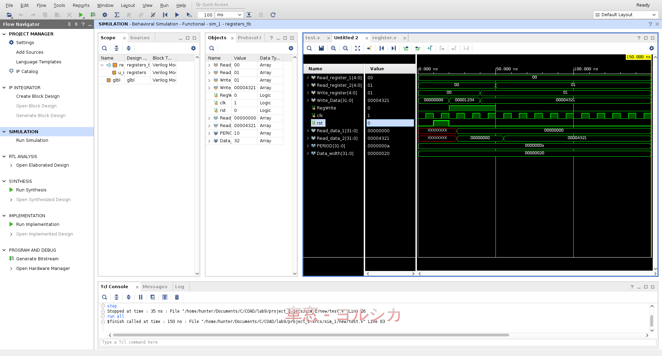

2.

The wave result is exactly the same as expect. The results are the correct result of alu.

"data1" is 32'ha011,"data2" is 32'ha011,"signExtend" is 32'h4321

1) "aluSrc" is 0, test all the caluctions list expect the unneeded

2) "aluSrc" is 1, test all the caluctions list expect the unneeded

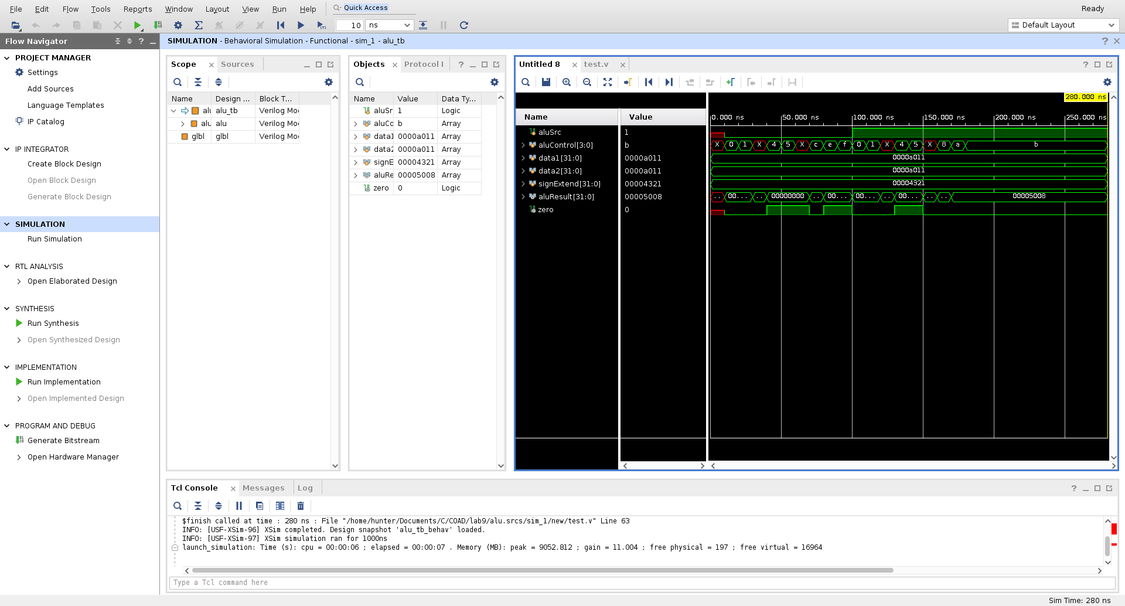

1. 实验分析（遇到的问题以及解决方案）
2. For alu, we need do assign to the output. However, if we use case, it must sensitive to the correspond value. So that must be “constant” as xvlog says. And the output must be reg. I replace them with result = control==xx ? xxx : ... which perfectly match the requirement.
3. It’s impossible to represent x directly in the design source. But we can cut as there’s regulation. I use a wire to connect the first three bits of aluControl, which can let me ignore the last bit when it’s x.
4. 实验小结与体会

Forget a lot and find some new. Great slow vivado.