计算机组成原理实验报告
姓名： 吴迪 学号：11810716
- 实验目的
Practice the instructions related to shift operation, arithmetic operation and logic operation, master the details of data processing.
- 实验内容
1. get an integer from user, put it in a word, print it in hexdecimal as big-endian representation and small-endian representation seperately.
2. get an integer from user, put it in a word, print it in binary, exchange the its bit on 2n + 1 index with bit on 2n index (in a word n is an integer from 0 to 15), print the exchanged word in binary.
3. get an integer from user, calculate the result of 10 times of the integer.
1) DO NOT use mult/mul/multu in your code.
2) add 9 times is also not suggested. try to make your program with higher performance.
3) if the result is overflowed, invoke an arithmetic exception is expected.
4. get the value of a word, Calculate the absolute value of it by basic operations other than use abs instruction. print out the result.
- 实验步骤（阐述代码思路或操作步骤）
- As the difference of big-endian and little-endian is where they thought the address of the number start, so we just simply try load every byte of the stored and add them up with bit shift to form a whole word. Finally just output the result in hexdecimal.
- As 2n andd 2n + 1 index are the even and odd positions, so we need to firstly separate them out, and the two number only have numbers on even or odd positions, other are all zero. Then we shift the even number left and odd number right one bit. Next we xor these two numbers. Because even number now have all even positions 0 and the number go to odd position and odd number vice versa. The xor result will have even numbers at odd positions and odd numbers at even positions, which is just the swap result of odd and even positions of the origin number.
- As the requirement, I choose to calculate the result by x * (8+2). To get 8 times x and 2 times x, I use bit shift. Left shift 3 bits is just the same as multiplying by 8, and 1 bit is multiplying by 2. And then add them up. I tried to detect the overflow situation first at left shift 3 bits. As there is a possibility that the highest bit become 1 after shifting, so I shift it left again and shift back and compare it with the original number. The result overflows if they are not equal. Finally the add operation have an overflow detection it self.
- The input integer could be positive or negative and all the numbers are represented in 2's complement so first we get the first position which represents positive or negative of the number, and then extend the number to all the bits, then xor with the original number, and finally minus the all bits number. y = x >> 31, abs(x) = x ^ y - y(subu) This is how the abs does. But there’s another way. First we get y, then we add x and y up(add), finally xor y. y = x >> 31, abs(x) = (x+y) ^ y If x is positive, then y is 0, the result is it self. If x is negative, then y is -1, x - 1 and then xor y, which is the same as invert all the bits. This is a reverse operation from origin to 2’s complement number.
- 实验结果（截图并配以适当的文字说明）
- Input: 31(0x0000001f)
Output: If little-endian: 0x0000001f
If big-endian: 0x1f000000
The result is exactly what we expect.
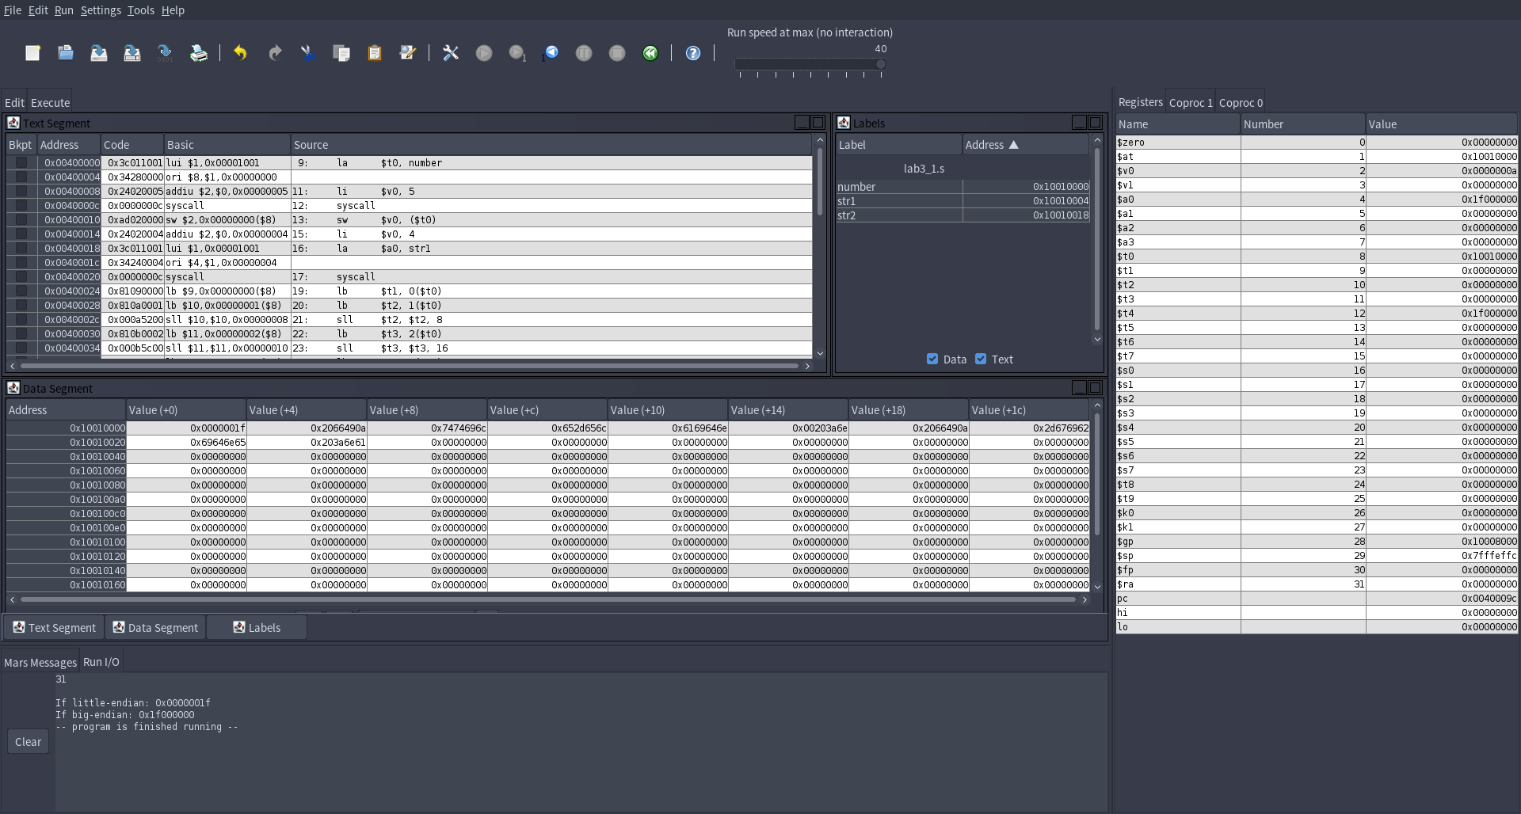
- Input: 85(0x00000055)
Output: 00000000000000000000000010101010(0x000000aa)
The result is exactly what we expect

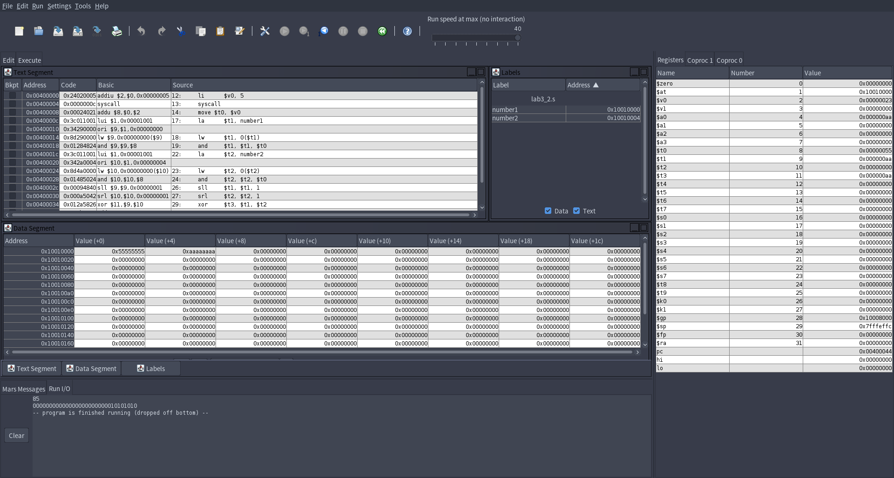
- Input: 34243
Output: 342430
The result is exactly what we expect
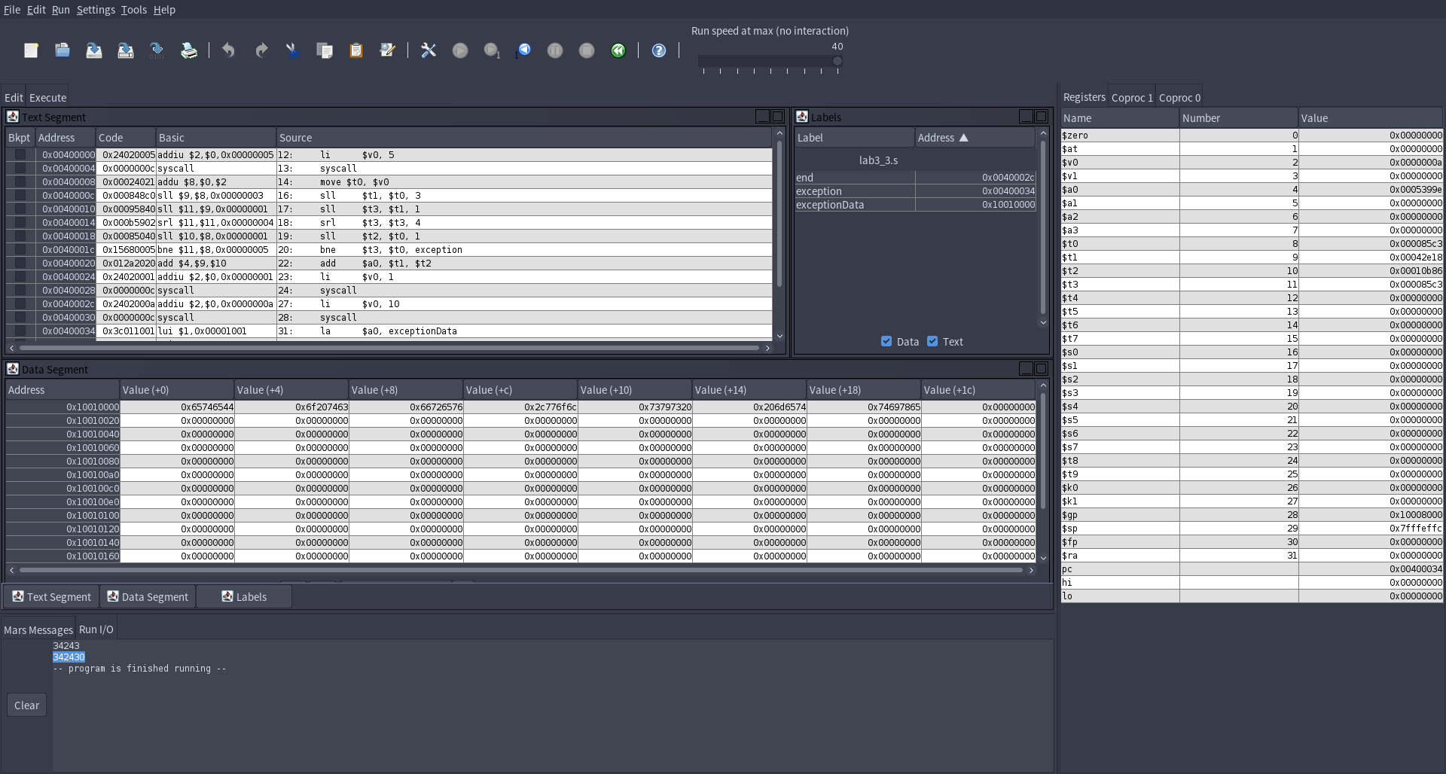
- Input: -1243
Output: 1243(first method)
1243(second method)
The result is exactly what we expect.
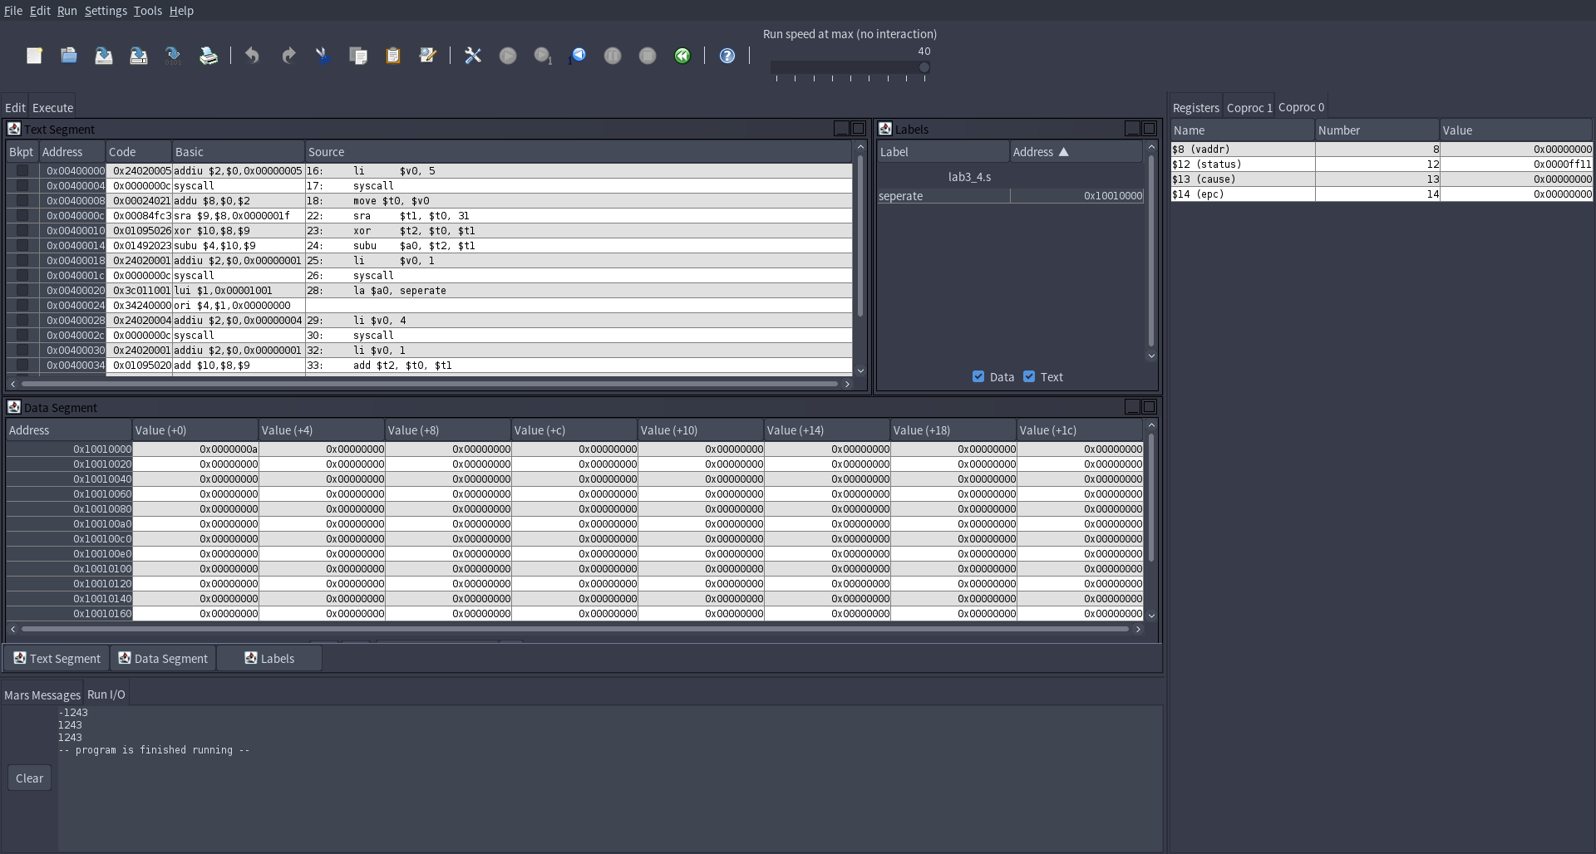
- 实验分析（遇到的问题以及解决方案）
- The big-endian and little-endian are based on how the system designed. So we can just simulate how they works. So we tried to load bytes directly from the address.
- It’s naturally to use loop to swap every two bits one by one. However, it is hard to write, and that’s a difficulty to load just one bit from the word, the bits shift will also take a long time. So we use two special number, 0x55555555 and 0xaaaaaaaa, which one have all 1 at odd bits and one at even bits. Then we can use xor to get all the odd bits and even bits number from the origin data. Then we just simply do bits shift and merge to get the result.
- Detect the overflow can be a hard task. The operation add is with overflow detection, however we can’t use it do 10 times, which is very ugly. When we try to use bits shift, the overflow is a big concern because it doesn’t detect overflow. So we can just do it by another bit shift to test if the most significant number become 1--get it out and complement it with a 0 and then compare to the original number. However, this can only detect a little cases of overflow. What if a number that have 0 at 4th significant position? After what we shift it left by 3 bits, what we do up here still no use. Maybe we will learn something in the follow lectures.
- 实验小结与体会
The way computer store data is amazing. Bits shift is also a very magical operation. So as xor and other logic arithmetic. There are many to play with the data code.

