Major Group Project
Project Plan 10%

Jake Callow
Lukas Stoskus
Callum Breen

Table of Contents
Project Overview 3
Project Title: 3
Description: 3
Scope: 3
Stakeholders 3
Team Members: 3
Project Supervisor: 3
Project Manager: 3
Project Timeline 4
Project Start Date: 4
Key Milestones: 4
Work Breakdown Structure: 5
Resource Management 6
Equipment and Tools: 6
Members: 6
Risk Management 6
Risk Identification: 6
Risk Mitigation Plan: 6
Contingency Plan: 7
Communication Plan 7
Regular Meetings: 7
Reporting Structure: 7
Additional Tools: 7
Success Criteria 8
Time Management: 8
Frequent Communication: 8

Project Overview

Project Title:
Fork: A recipe sharing app that pushes sustainability and user interactivity.

Description:
This is a recipe sharing app that users can upload their recipes to as well as save others that other users have uploaded. One of the main concepts of the app is that users can "fork" a recipe similar to how you would a repository, and make adjustments to the recipe either based on dietary requirements or shortage of ingredients. These additional recipes will be displayed alongside the main ones and ordered based on user ratings.

Another big objective with the app is sustainability. Our secondary goal is to implement a system that shows users which recipes they have saved that share similar ingredients, helping users to reduce food waste and save money on the ingredients they buy by buying versatile foods.

Scope:
The project will require a well designed UI app, that uses a database to save recipes. It will also require a login system so that users can save recipes directly to their account as well as for interacting within the app by leaving reviews and comments.

The database will also allow for viewing shared ingredients between multiple recipes and despite being our secondary goal in this project, should be quite easy to implement.

Stakeholders

Team Members:
The members in our team are Jake Callow, who will also be the project manager and handle project documentation, Lukas Stoskus who will be the programmer in charge of the database and the shared repository, and Callum Breen who will be the programmer for UI design and functionality.

Project Supervisor:
Our project supervisor is Greg South, who will be overseeing our project and giving input where relevant.

Project Manager:
As mentioned above, Jake Callow will be the project manager and overseeing project deadlines.

Project Timeline

Project Start Date:
Our project planning began on the week of the 23rd of September, which included the conceptualisation of our project and the general idea. We also began thinking of the technical requirements for the project and what issues we want to solve. We were in contact with Greg who had reached out to us about being our group project supervisor.

We met with Greg for our first meeting to finalise our project ideas on the 4th of October, and on the week of the 7th of October we finished setting up the foundations of our repository and the resources we would need to begin the project.

Key Milestones:
Our first key milestone is the project plan deadline. We use the time before this deadline to get as much of an idea as possible on the full scope of our project, and document this accordingly for our project plan which we can refer to at any point in our project for a reminder on our deliverables.
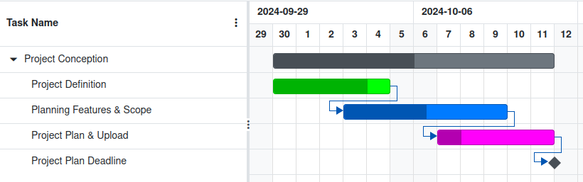
Our next key deadline is getting a basic functional app created that we can work off of. We believe that setting up everything partially at the same time allows us to have a core foundation to build the rest of our features from, so getting a basic version of every feature is our priority in the weeks after our project conception.
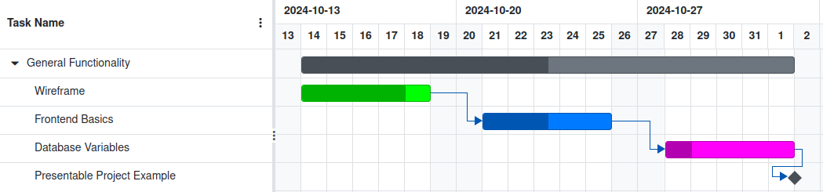

The next deadline in our project is adding more functionality, including a login system and making sure the database is fully functional in regards to all of the information we’ll need to store.
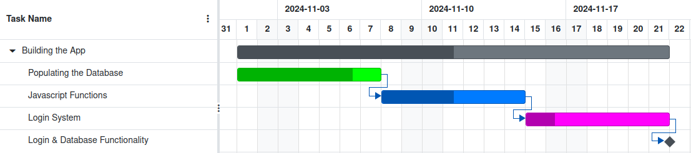
Our final deadline for this semester will be refining the app as much as possible by testing all aspects of our app and bug fixing any errors that we encounter. We will also be focusing on documentating all of our progress and preparing for our presentation on the 12th of December.
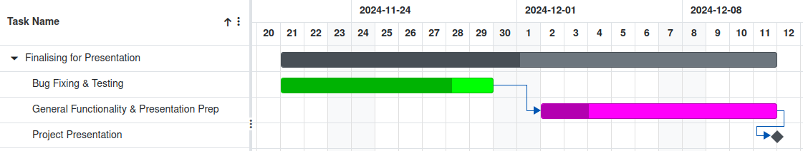
Further planning for the next semester will occur later down the line when we have a better idea of all additional features we will want to add to our project as well as feedback from our project supervisor and any examiners during our December presentation.

A link to the full Gantt Chart and files can be found here: Major Group Project.

Work Breakdown Structure:
- Develop general layout and structure of mobile app.
- Research the themes of our project and write literature review.
- Create and populate database with simple entries and link to the app.
- Add additional functions using javascript.
- Use Tailwind to refine the appearance of the app.
- Testing all of the features and bug fixing.
- Finalising the app.
- Preparing the presentation.

Resource Management

Equipment and Tools:
- SQL Lite for databases.
- JavaScript for local backend, and maybe Java for remote backend.
- Tailwind for CSS.
- HTML for frontend.
- React Native for app development
- Expo for additional frameworks.

Members:
- Jake Callow: Project management, documentation, general programming.
- Lukas Stoskus: Database management, backend programming, repository management.
- Callum Breen: UI and Design, frontend programming, functionality programming and testing.

Risk Management

Risk Identification:
Our biggest risk as a team is time management. We all tend to allocate the same amount of time for each task as we all struggle to identify the time needs of each task individually. Due to how much trouble we’ve had with time management in the past, the likelihood of us struggling with it in regards to this project is low, especially with the risk mitigation plan.

Another risk we have identified is the scope of the project, as we’re currently unsure if we have enough features for the sake of the project definition, but we believe we’ll have room to add additional features as the project goes on.

Risk Mitigation Plan:
For our risk mitigation plan, we have strict deadlines in place and a clearly planned project timeline so that we can keep ahead on time and not run into any situations where we need to do a sprint to get a lot of work done shortly before an important deadline. We also have different branches set aside in our repositories to avoid needing time later for fixing bugs caused by overlapping code.

For the project scope issue, we are documenting every possible idea we have in the case that it ends up being a good addition for the project at a later date, as well as planning on doing a lot of research for our literature review to look into features that are lacking in the current competition.

Contingency Plan:
In the events that we find ourselves behind schedule and struggling with time management, we can use both solutions together to effectively reduce our project scope and focus on the main deliverables, as we have all learned from experience that it is better to have a clean and functional app with reduced features rather than every feature possible but barely functional. We will prioritise main functionality and use our version control system to ensure all work is fully documented even if the features are later removed, as well as being able to roll back any changes in the case of a project breaking error.

Communication Plan

Regular Meetings:
We plan to meet minimum once a week for discussing our projects progress and syncing our work to make sure we are working as efficiently as possible. We also plan to meet up physically once a week additionally to work in the same space so that we can share ideas more easily and assist eachother in issues that might arise as well as ensuring our overlapping tasks are at a similar stage in progress.

Reporting Structure:
The project manager will keep track of meetings in a weekly meeting report where the minutes and general topics will be documented. This will also include meetings with the project supervisor and any comments or ideas that came up during these meetings, and records of these meetings will be uploaded onto a shared repository for all team members viewing.

Additional Tools:
As well as formal meetings, there is a github repository with a separate branch for each member, so the work that we contribute can be easily monitored and reviewed in relation to other parts of the project. We have a Trello board for documenting important milestones and our progress towards them, and a group chat for quick and easy communication on smaller issues that arise between meetings.

Success Criteria

Time Management:
The success of our project very much depends on time management. As we are familiar with eachother from past projects, we're all aware that we struggle to get a sense for how long each task will take and tend to allocate as much time for smaller tasks than we do bigger tasks. Properly adhering to our deadlines and gantt chart will allow us to complete our tasks sooner and use the spare time from completing tasks early for the parts of the project that require it the most.

Frequent Communication:
Part of what made our previous projects successful is our communication. It is vital that we communicate any and all issues that come up on our individual tasks so that other members can assist wherever they can.

