**Introduction**

Over a long time, the web has changed how individuals utilize computers and communicate nowadays. Numerous World Wide Web terms have ended up a portion of people’s ordinary lives. By the turn of the century, data, counting get to the World Wide Web, will be the premise for individual, financial, and political progression.

World Wide Web discover you the most recent money-related news, browse through library catalogs, and numerous more. You'll too trade data with companions. The World Wide Web is additionally the apparatus that will take you past data around our environment and it too gives information to other individuals. Since the internet’s quick development within the past few years, everyday assignments and operations are done online utilizing computers and versatile gadgets. One of these assignments is making a reservation or booking system for diverse administrations.

Excellence Barbershops can make an online site for their other commerce purposes. The primary thing to start in choosing barbershops is to assess what must be done. A client who fair wants his hair trimmed might go to a barbershop. In case a man needs his hair cut expeditiously he can visit a walk-in barbershop and attempt to discover his standard barber. A man needs to think almost of a full-service in by-appointment-only excellence barbershop for another kind of administration. This implies that he will have a barber that knows what he needs to be done. Other than that, clients can have an issue whereas they were going to the closest barbershop, in some cases the service they need is not accessible so they will hold up for it and for a few reasons in some cases clients are anxious so they will go to the other barbershop and do their hair treatment there. Conventional reservation of a Magnificence Barbershop could be a way that the clients are attending to the barbershop and have a plan for treatment and for planning a barber, Whereas the online reservation for a magnificence barbershop, you'll save treatment and select a service that the clients truly needed. It’s simple to have an internet reservation than strolling to a barbershop to have a reservation. It can spare time for those clients with a boisterous plan.

Numerous sorts of booking frameworks exist advertised by different program engineers and companies and there are unending circumstances where they are required. There are booking frameworks for eateries, healing centers, salons, schools’ examinations, etc., booking frameworks are all over. Creating a great booking framework that would work on every single circumstance, gadget, and commerce can be exceptionally complicated since each circumstance is in some way or another diverse. A few companies offer their booking framework as one for all and it may well be coordinated to the company’s existing ERP (Enterprise resource planning) framework. Regularly, when one framework is connected in each circumstance, the result is a compromise. On the off chance that the booking framework is exceptionally adaptable, it is regularly superfluously complicated for the conclusion client and the organization. This implies pointless clicks or touches and an organization side with highlights that are not required. Employing a booking framework ought to be coherent and simple to fulfill all the clients on both sides of the framework. After booking their reservation in the barbershop there is no need to stand in the queue just reach there in the allotted time and the customer will get the service with a little, without a delay or waiting in the barbershop. This reservation system is for customers of Micco’s Barbershop and the customer nearby in that location. This system helps customers to book a reservation in Micco’s Barbershop according to their timetable which provides a hassle-free environment when they arrive at the barbershop.

After booking their reservation in the barbershop there is no need to stand in the queue just reach there in the allotted time and the customer will get the service with a little, without a delay or waiting in the barbershop. This reservation system is for customers of Micco’s Barbershop and the customer nearby in that location. This system helps customers to book a reservation in Micco’s Barbershop according to their timetable which provides a hassle-free environment when they arrive at the barbershop.

**Background of the Study**

The proponents want to know the reasons for barbershops using manual reservations. The proponents conduct a study on the topic because they notice some of the barbershops still use manual reservations.

The study will emphasize the effects of using manual reservations and how a computerized reservation will be substituted in this manner, the proponents implied to discover how to extend the number of customers using a computerized reservation. Interaction and person incitement have continuously been connected to the mechanical accessibility of time and put. With the transition to an information-based society, computers, and transactions have evolved from manual transactions.

One of the arrangements or options to the issues that a barbershop is facing, a framework was being created which can alter, erase, filter, monitor, and store and secured the records of the clients. A Barbershops Reservation system is a transaction processing system that solves the problem encountered during the manual Barbershops Reservation. The computerized Barbershops Reservation System aims to simplify the manual Barbershops Reservation is the fastest and most accurate.

**Statement of the problem**

This study attempts to determine the effectiveness and advantages of online registration/booking employed in a barbershop.

Specifically, it also aims to answer the following questions:

1. How does online reservation/ booking better than traditional reservation?
   1. Efficient time management
   2. Service registry
   3. Hassle-free management
2. Is online system reservation/ booking an effective marketing strategy?
3. Can be employing a simple, coherent, and adaptable booking framework enhance work-related services and recognize the work responsibilities of a barbershop?

**Objectives of the Study**

This study aims to solve the problems encountered and to change the

manual reservation.

1. To save enough time traveling around than looking for another barbershop that is full of customers.

2. Costumers can have spare time and choose a barber-cut style.

3. Having an online reservation system that can gain more customers because of uniqueness.

**Paradigm of the System Project Framework**

**Barbershop Reservation System**

**Proposed System**

**Manual System**



Manual Reservation System

Automatic Reservation System



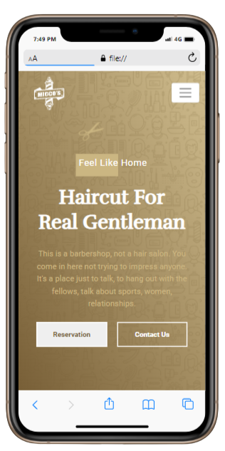

Time saver for Barbers and Customers

Time hassle for Barbers and Customers



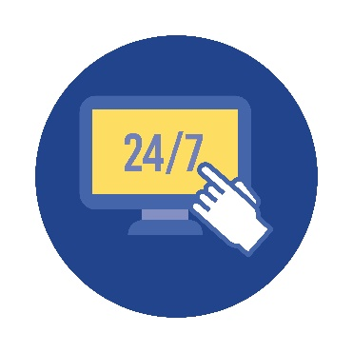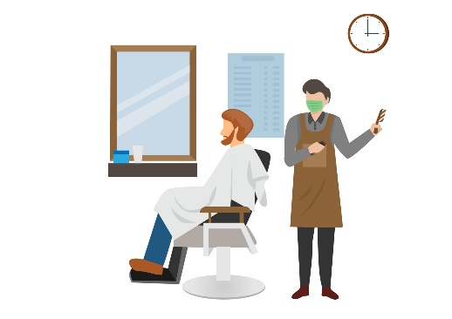

Visual Studio Code

Firebase

Reservation is open around the clock

Reservation is only available when business is open

**Software Development Model:**

**Significance of the Study**

The Barbershop Reservation System is to aims to provide the fastest way to organize the transaction computing of the business.

Customers

- The Customer will get lessen the waiting time.

Barbers

- The proposed system will make it easier for the barbers of Micco’s Barbershop and keep them when it comes to records.

Developers

- To attain more knowledge and to enhance programming skills.

**Scope and Limitation**

**Scope**

In making a reservation the customers need to make an account first to be able to log in and make a reservation. For potential customers that didn’t want to make reservations, they can still visit the website just to know the business. The barbershop will have a website with a user-friendly interface that has cross-platform compatibility. Customers can easily book their desired date and time or plan an event online, giving them an easier way and a hassle-free reservation.

The customer will then give personal information such as full name, cellphone number, email, and the authorized customers will have a unique username and password that has at least eight (8) characters with uppercase (A-Z), lowercase (a-b), and numbers (0-9).

On the log-in page, the user will be allowed three (3) consecutive times of entering an invalid username and password combination. If ever the user exceeded the number of times in entering the invalid password, the system won’t allow the user to try to log in again for five minutes. In this way, the proponents will prevent a potential brute-force hacking of customers’ accounts.

After the customer logs in they can now fill up a reservation composed of name, address, phone number, email, service they want, time, and date of their reservation. To be able to submit the reservation the system will send an OTP (One time password) on their email to verify the contact information and the reservation.

After submitting the reservation form a QR (Quick Response) code will appear on the screen and confirmation of reservation is successfully made, also it will include details about reservation and service amount that customers need to pay after the service is done at the barbershop.

If the user is not a registered member no possible transaction can be done other than viewing the whole website. Also, if customers run tours and activities in remote areas where customers aren’t able to get on the Internet, online booking might not be for the customer. Customers need reliable Internet access to check their reservations and to add bookings that are made online.

**Limitation**

* Automatic confirmation system for reservation.
* Online payment system.
* SMS (Short Message Service).
* Online Account Recovery.