**Name**: Warren Ferrell

**Title**: Code-A-Friend

**Project Summary**: A website for submitting and voting on code samples that solve user submitted problems. Will only support python at first.

**Project Requirements**:

|  |  |  |
| --- | --- | --- |
| **Requirement Id** | **Requirement Name** | **Description** |
| UR-01 | Script Editing | As a user, I want to be able to type up a python script that I want run. |
| UR-02 | Script Saving | As a user, I want to be able to save, delete or retrieve a script that I have written. |
| UR-03 | Script Execution | As a user, I want to be able to have a script that I am working on be run for me. |
| UR-04 | Script Analysis | As a user, I want to be able to see how long my script ran for and how much memory it consumed during execution. |
| UR-05 | Problem Editing | As a user, I want to be able to create a problem with a text description. |
| UR-06 | Problem Saving | As a user, I want to be able to save a problem that I have written and retrieve problems I have saved. |
| UR-07 | Problem Testing | As a user, I want to be to add a set of tests that determine if a script is a solution to a problem. |
| UR-08 | Solution Submission | As a user, I want to be able to submit my script as being a solution to a problem. |
| UR-09 | Problem Solutions | As a user, I want to be able to see all scripts that solve a problem, after I have submitted a correct solution. |
| UR-10 | Solution Voting | As a user, I want to be able to vote on a solution as being a good solution to a problem. |
| UR-11 | Problem Tagging | As a user, I want to be able to tag problems so other people can search for them. |
| UR-12 | Problem Searching | As a user, I want to be able to search through problems by tags to find one that I want to solve. |
|  |  |  |
| AR-01 | Script restrictions | As an admin, I want to be able to limit the amount of memory and cpu time a script can be allocated. |
| AR-02 | Problem deletion | As an admin, I want to be able to delete problems that I believe contain inappropriate content. |

**UI Mockups**:

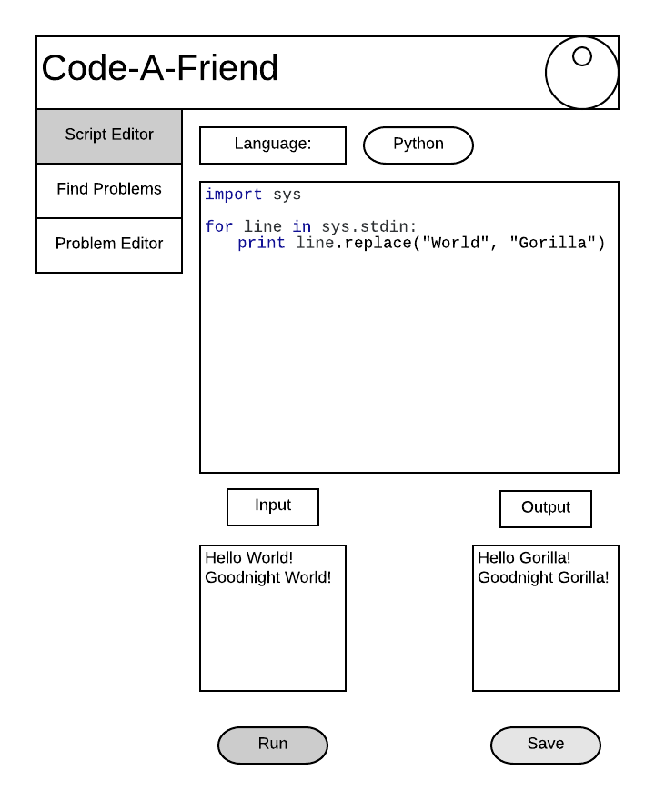

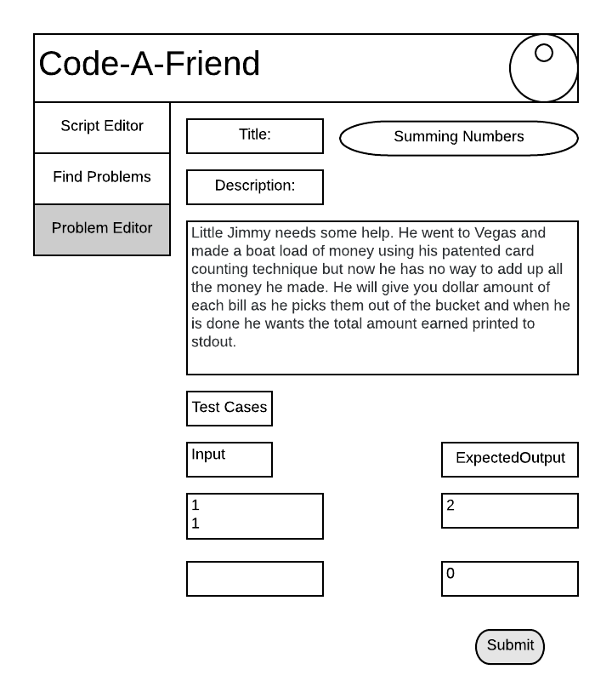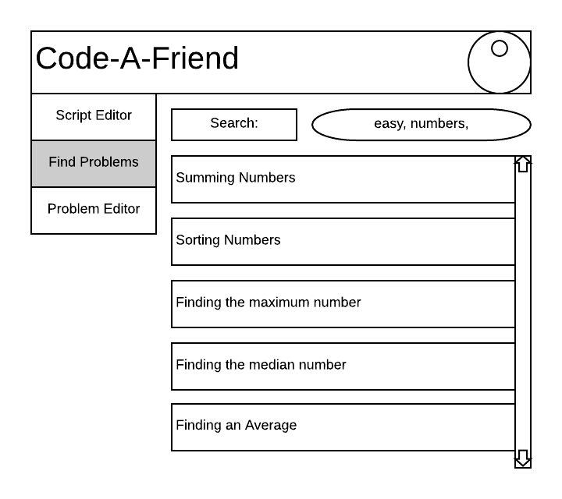

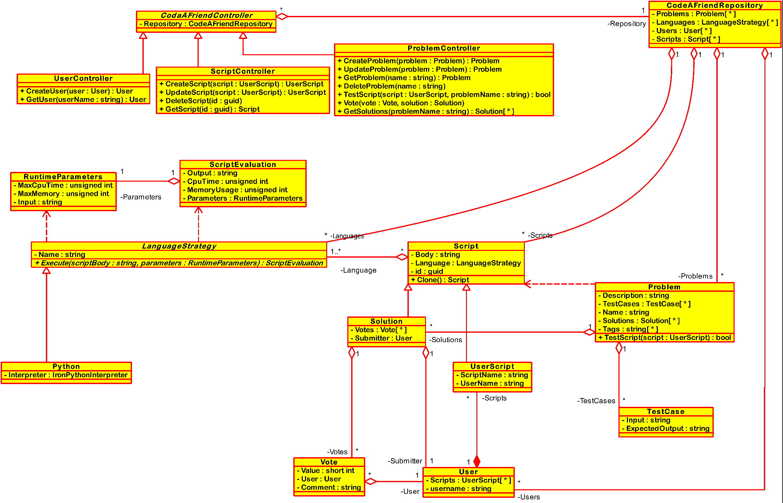**Class Diagram**