1. **Name**: Warren Ferrell
2. **Project Description**: A website for submitting and voting on code samples that solve user submitted problems. Will only support python at first.
3. **Implemented Features**:

|  |  |
| --- | --- |
| **Requirement Id** | **Requirement Name** |
| UR-01 | Script Editing |
| UR-02 | Script Saving |
| UR-03 | Script Execution |
| UR-04 | Script Analysis |
| UR-05 | Problem Editing |
| UR-06 | Problem Saving |

1. **Not Implemented Features**:

|  |  |
| --- | --- |
| **Requirement Id** | **Requirement Name** |
| UR-07 | Problem Testing |
| UR-08 | Solution Submission |
| UR-09 | Problem Solutions |
| UR-10 | Solution Voting |
| UR-11 | Problem Tagging |
| UR-12 | Problem Searching |
|  |  |
| AR-01 | Script restrictions |
| AR-02 | Problem deletion |

1. 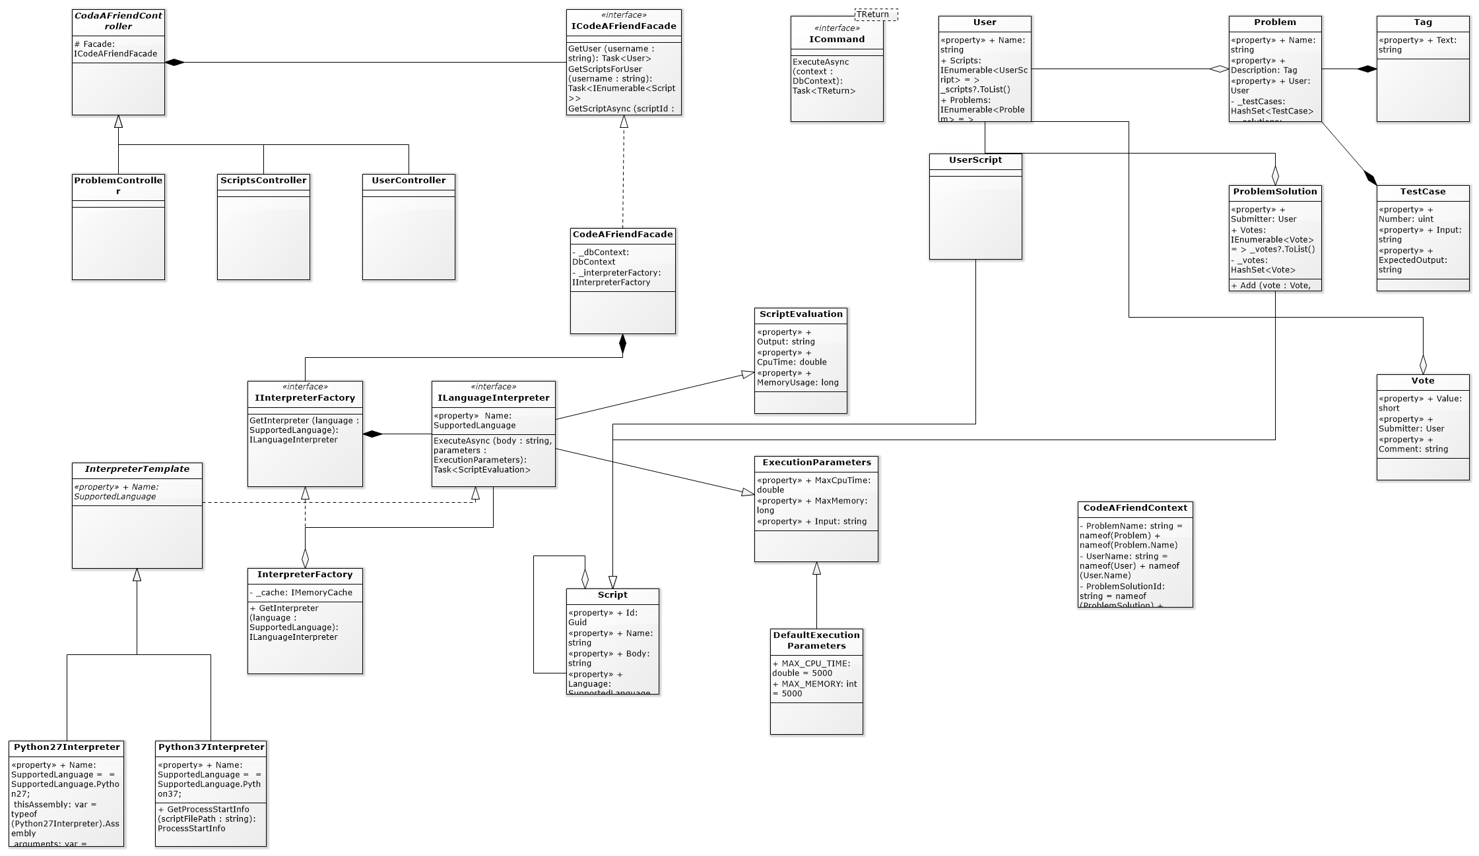**Class Diagram:** I don’t have access to VS Enterprise so I couldn’t have the VS architectural model generated for me so Iused Software Ideas Modeler to generate my class diagram from source code. Unfortunately, it did not do a very good job and tidying up the class diagram is a lengthy process. My class diagram did not change a great deal. The names of many classes changed and I added a few layers of abstraction but the overall design was very close to the design I originally generated. Having the class diagram and auto-generated code from my UML was very helpful as it gave me a lot of direction while working on the project. One of the main issues I had with it was that Umbrello’s C# code generation did not make use auto-properties which is one of the most import features of C# features that make it easier to work with than java.
2. 6.