# SLAMM 6.7 beta, User’s Manual

July 2016

(minor update June 2017)



PO Box 315

Waitsfield, VT 05673

(802)-496-3476

# SLAMM 6.7 beta, User’s Manual

Contents

Acknowledgements 1

Introduction 1

Opening Screen 2

Starting a New Project 3

Expanded opening screen 4

SLAMM File Setup 5

Edit Sites and Sub-sites 9

SLAMM Execution Screen 14

Custom SLR Time Series 17

Run Latin-Hypercube Analysis 18

Carbon Sequestration Analysis 24

Sensitivity Analysis 25

Set Map Attributes 26

Elevation Analysis 30

3D Graphing 32

Profile Tool 34

Freshwater Flow Parameters 35

Salinity Analysis 36

Salinity Rules 38

## Acknowledgements

This document is maintained Warren Pinnacle Consulting, Inc. (Jonathan Clough, Amy Polaczyk, and Marco Propato) and has undergone revision in 2016 to reflect interface updates funded by The Nature Conservancy. Release 6.7 of SLAMM includes many California-specific updates as well as a significant upgrade to the marsh-erosion component. The model code is a significant step closer to allowing landscape categories to be flexible and editable within its interface. This work has been funded by The Nature Conservancy under the guidance of Walter Heady. Critical partners in terms of creating this version and the science behind it were ESA, and particularly Matt Brennan and Bob Battalio.

In 2013, this document was updated to include SLAMM 6.3 updates funded by USGS and the United States Fish and Wildlife Service. The original version of this document was prepared by Jonathan Clough and Evan Larson for Roger Fuller, a Landscape Ecologist with The Nature Conservancy in Mount Vernon, WA. Many thanks for his help in recognizing the need for such a document and assisting with the document production.

## Introduction

SLAMM 6 was a significant step forward with regards to graphical model interface. Many features that had been hidden within the source code have been brought forward into the graphical user interface (GUI) allowing for additional flexibility when operating the model. The interface has also increased in complexity. SLAMM 6.7 has built on this functionality by:

* Increasing the degree of model flexibility accessible though the GUI
* Addition of uncertainty and sensitivity modules
* Conversion of the program to a 64-bit platform (A 32-bit version is also available)
* Incorporation of a module to assess the effects of sea-level rise on road infrastructure

This document is intended to help the user navigate the SLAMM 6.7 interface.

Please use the [SLAMM-Forum](http://warrenpinnacle.com/SLAMMFORUM/) to ask SLAMM interface questions as well as other technical questions about the SLAMM Model. It is our goal for the forum to serve as a knowledgebase for model users.

Opening Screen

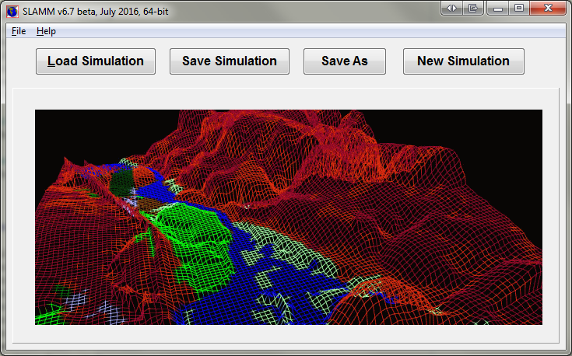

Figure 1: SLAMM 6.7 opening screen.

After opening the SLAMM 6 executable the user is presented with several options (Figure 1):

* Load Simulation – Loads existing SLAMM 6 projects. Due to the many changes in data structures, at this time, SLAMM 6.7 cannot read files produced in SLAMM 6.6 and before. Fortunately, moving parameters from that version into SLAMM 6.6 is relatively easy (by copying and pasting parameters and matrices). The capability to import SLAMM 6.6 data files should be forthcoming shortly.
* Save Simulation -- Saves current project in SLAMM 6 binary format or text format (see below)
* Save As – Used to save the project under a different name or file-type.
* New Simulation -- Starts a new SLAMM 6.7 project. Make sure to set up the file structure in File Setup before Executing. The user is prompted as to whether to set up the California-specific wetland categories, or the general SLAMM categories at this time. See the *Technical Documentation* for more about these different categories.

A **SLAMM6** file is a binary file that contains all site parameters, file names and directories, color choices, input and output site locations, model parameters, scenarios chosen, and execution options. In other words all project data is saved here with the exception of the required ASCII raster maps.

The project can also be saved into a text file format. Choose “**Save As**” and then change the file-type to “*.txt”. Each line of the saved text file will labeled to clarify the format of the file. A complete technical specification for this file-type is not available at this time but questions can be answered by examining the open source code or asking questions on the SLAMM Forum.

An additional feature available within the text file format is the allowance of batch-mode runs. To run the simulation automatically and then terminate the application on completion the last line of the text file must be changed to "ExecuteImmediately: True". If the text file is passed to the SLAMM executable as a parameter, the model will execute and terminate. If, when loading a text file, SLAMM finds a line missing or something out-of-place it will produce an error message describing exactly what the problem is and on which line of the text file it occurred.

The file menu presents the user with the options noted above, as well as a list of recently opened SLAMM 6 project files.

The **help menu** provides access to this *Users Manual* file as well as the “About” SLAMM window. The “About” window displays the mode’s build number and also provides buttons to link to the source code and information about SLAMM’s License. SLAMM is open-source software and is licensed under the Common Public License (CPL).

## Starting a New Project

To start a project from scratch, click **New Simulation**. The next steps are to locate the required site data layers, entering the site parameters and modifying the map attributes. First, locate the data layers by clicking File Setup.

## Expanded opening screen

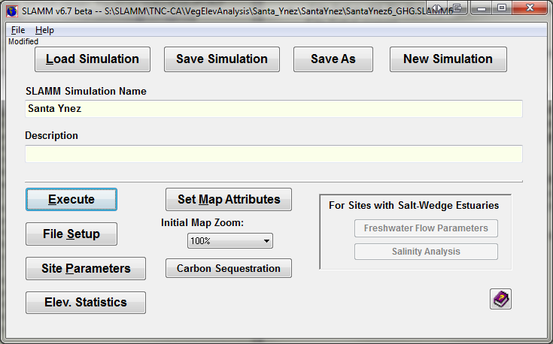

Figure 2: Expanded opening screen

Once a project is loaded the user is presented with a variety of options (Figure 2):

* Execute *(Alt-E)*– Leads to the **Simulation Execution** screen.
* File Setup *(Alt-S)*– Specify file locations and memory management options. Leads to the **File Setup** screen.
* Site Parameters – Specify dates, accretion rates, etc. for each site and sub-site. Leads to the **Site Parameter** screen.
* Elev. Statistics – This allows the user to examine elevation statistics and the SLAMM conceptual elevation model for the given site without going through the “Set Map Attributes” button. Until the statistical analysis has been run for the first time, it is not possible to run an “elevation analysis” unless the user goes through the “Set Map Attributes” interface. Leads to the **Elevation Analysis** screen.
* Set Map Attributes (*Alt-M)* – Set up maps of attributes and also examine initial condition maps. Project maps are loaded prior to display of this screen. Input sub-sites, output sites, and freshwater flow locations may be specified here. Leads to the **Map Attributes** screen.
* Carbon Sequestration – A matrix of carbon sequestration parameters as discussed in the section on Carbon Sequestration below and the *Technical Documentation.*
* For sites with specified freshwater flows there is an option to run a **Salinity Analysis** and calibrate **Freshwater Flow Parameters.**

SLAMM File Setup 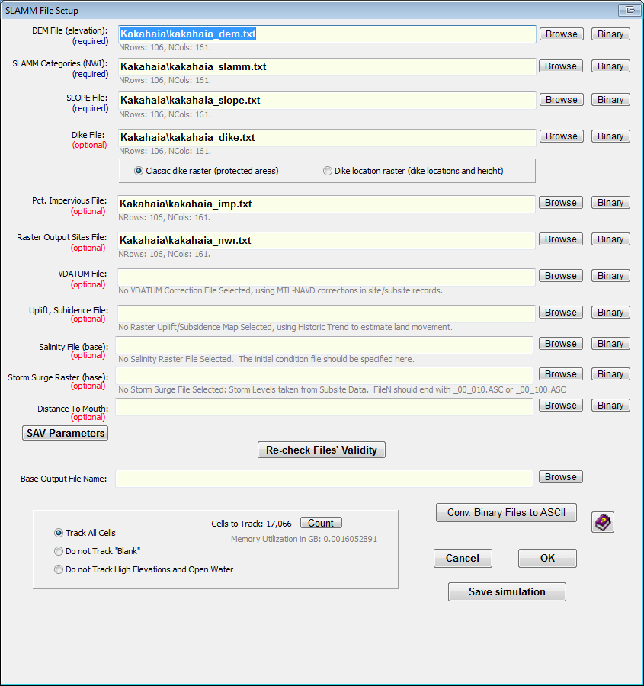

This window allows the user to add ASCII raster GIS files to a project. All raster files must have identical dimensions, projections, and locations.

* DEM File (elevation) – Links the DEM GIS layer to the project. Required to run a simulation. Units are meters above the vertical datum (usually NAVD88).
* SLAMM Categories (NWI) – Links the wetland categories GIS layer to the project. Required to run a simulation. Integers corresponding with SLAMM categories. See the *Technical Documentation* for a complete list.
* SLOPE File – Links the slope GIS layer to the project. Required to run a simulation. Units are degrees.
* Dike File – Links the dike/levee GIS layer to the project. Two types of dike files may be used:
  + A “classic” dike raster in which regions marked with zero (or “no-data”) are not assumed to be protected by a dike but regions with integer values above zero are assumed to be protected by dikes or levees. This model requires all cells that are *protected by* dikes to be designated as diked, not merely the location of the dikes themselves.
  + A “dike location raster” which specifies the location of the dikes themselves. Any potential for water penetration beyond the dikes is calculated using the SLAMM connectivity module. In this case, the heights of the dikes above MTL are specified in each raster cell that contains a dike.
  + To use both models simultaneously, both data types must be combined into a single raster with the number “negative five” (-5) representing regions that should be protected using the “classic” dike model, and any positive number representing dike elevations. When using both models combined, the user should characterize this hybrid raster as “dike location raster” within the file-setup interface.
  + See the *Technical Documentation* for further information on these options and how to combine these two models in a single simulation run.

In addition, Dike layers may be variable by year. To load a new dike file on a particular year in which the model produces output, add another dike layer to the project directory with the four digit year following the dike layer name. (For example **Base_dike.txt**, **Base_dike2025.txt**, and **Base_dike2050.txt**.)

* Pct. Impervious File – Links the percent impervious GIS layer to the project. Units are integers from 0 to 100% impervious.
* Raster Output Sites File – Optional. A “Raster Output Site” file is an integer-based raster file in which each cell is uniquely identified as being “in” or “out” of a set of output summaries. This allows for all cells in a particular polygon (city or county boundaries, for example) to be included in a set of maps and tables of output. Cells outside of the raster layer should be identified with zeros. Multiple raster output sites may be specified in a single input raster using sequentially increasing integers (“1” for the first site, “2” for the second, etc.)
* VDATUM File – Links an optional spatial representation of VDATUM elevation corrections to the project. Raster contains conversions from the vertical datum input to mean tide level as required by the model. If this raster is specified the site or sub-site based “MTL minus NAVD88” correction factor is not utilized (except for “no-data” regions within the raster file).
* Uplift, Subsidence File – Links an optional spatially variable uplift/subsidence GIS layer to the project. Allows land movement to be specified where data permits in units of cm/year.
* Salinity File (base) – Either an Excel file or a “base” raster file must be specified here for linkage to an external salinity model.
  + A “base” raster will represent cell-by-cell salinities for the initial condition-- other years will be specified as part of the raster file-names adding the year before the file extension.
  + An example of such a series of file names would be "SALINITY.ASC" as a base file name followed by "SALINITY2025.ASC" "SALINITY2050.ASC" etc.
  + The salinity rasters corresponding to different times must be located in the same folder of the salinity raster base file.
  + A salinity raster must be available for all years SLAMM produces an output.
  + Once a salinity raster has been specified, you can run a "salinity analysis" once the raster map has been loaded into memory
    - Go to "Set Map Attributes" to load the map then "Salinity Analysis"
    - Press "Run Salinity Analysis" for histograms and statistics.
    - "Define Salinity Rules" allows you to specify habitat switching on the basis of salinity.
    - The salinity analysis statistics will be saved along with the SLAMM6 file.
* If a Salinity Excel file is used, follow the template provided as “Salinity_Excel_Example.xlsx” to link point data into SLAMM
  + The first tab of the Excel file includes the number of locations with salinity and the locations of the point data sorted by location from upriver to oceanic. The X and Y locations for each point must use the same projection specified for the project input rasters.
  + The second tab of the Excel file includes salinity data for each location specified as a function of RSLR and flow.
  + To run a “salinity analysis” the model must be run through time-zero at least.
  + You may then examine the “salinity analysis” and set up “salinity rules” by selecting the “salinity analysis” button on the main window.
* Storm-Surge Raster (base)
  + This file is used for the optional assignment of a spatial storm surge layer (water height in meters, relative to NAVD88) for calculating infrastructure effects and storm-surge extent.
  + The file name should end with 00_100.ASC or 00_010.ASC. SLB files may also be used.
  + The 100 or 010 at the end of the file name represents the return interval in years (100-year return or 10 year return). SLAMM will search for the 100 or 10 year storm based on the specification of a single 10 or 100 year storm file.
  + The 00 prior to the 100 or 010 string indicates zero inches of SLR. If available, incremental SLR files may be specified in six inch increments with no more than 12 inches between rasters.
  + If no SLR file is present beyond 00, SLR will be added to the water height specified in the 00 raster.
* Distance To Mouth –
  + This file is used for the optional “Submerged Aquatic Vegetation” (SAV) model. The specified raster file should contain values for distance to estuary mouth in meters, generally derived using “cost-path” calculations.
  + Including a distance-to-mouth file is required for the creation of SAV prediction maps and the estimation of total square km of SAV in each time step.
  + You can then perform an SAV calculation through "Set Map Attributes" and then selecting "Map Type" "Probability SAV"
  + SAV coverage in square km by year will be included in the output CSV file.
  + SAV maps can be output to GIF or MS Word by selecting "Extra Maps" on the "Execute" window.

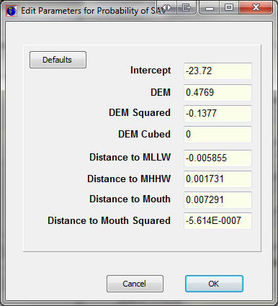

If a distance-to-mouth file is specified then the “SAV Parameters” button and interface becomes relevant. This interface allows a user to specify the mathematical model describing the relationship between physical site-specific parameters and the probability of SAV in a given cell. Default parameters as defined from Yaquina estuary in Oregon are shown above, and can be recreated by pressing the “Defaults” button. The equation utilized is shown in the Technical Documentation.

“Re-check Files’ Validity” – Verifies that the files are in a valid format with all the same dimensions. Located below each file name are values NRows and NCols. The user will be notified if the dimensions a GIS layer varies from the DEM dimensions (the benchmark) or other error occurs.

Base Output File Name – Specifies the location to save CSV output files and GIS outputs. CSV outputs will be the base output file name with CSV appended. GIS outputs will include the site or sub-site name, the year, and the ascii file extension.

With 64-bit SLAMM, memory management is now less important than in the 32-bit version. However, it may nonetheless be useful to track only a subset of cells for large sites to save memory. The user has the ability to select which cells are analyzed during the simulation. Once the cell tracking selection is made, pressing the **Count** button reveals the number of cells that will be tracked and the corresponding amount of memory that these cells will occupy.

* Track All Cells – Tracks every cell in the GIS layers.
* Do Not Track “Blank” – Tracks every cell except for cells that have “blank” NWI value.
* Do not Track High Elevations and Open Water – Tracks every cell except those with open water and those that are 8 meters and above (relative to MTL).

SLAMM memory management has improved in that available memory is no longer required to be contiguous to be used by the software. This results in far fewer “out of memory” errors. However, the 32-bit version of the software remains limited by its memory manager (4GB is the upper-limit for memory utilization).

## Edit Sites and Sub-sites

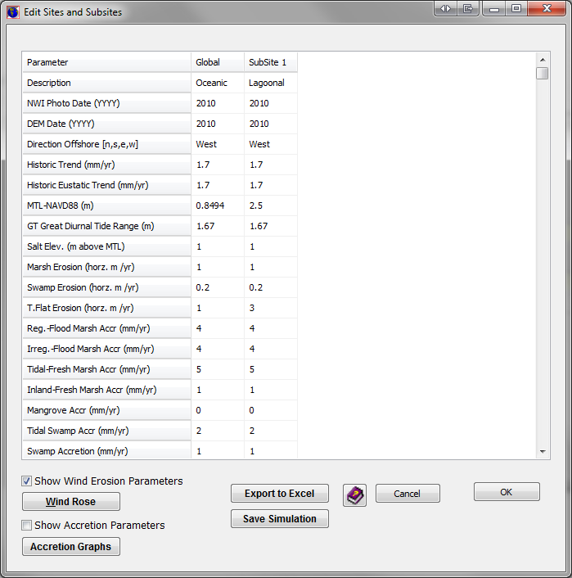

Site parameters can be applied to an entire raster map. Alternatively, polygonal **sub-sites** can be created for areas within the raster that may contain unique parameters. These parameters include

* Description – Name of site or sub-site.
* NWI Photo Date – Year that the National Wetland Inventory photo was taken. This represents the starting date for the simulation.
* DEM Date – Year of the flight or survey for the elevation data.
* Direction Offshore – Direction of water from the shoreline. Multiple directions can be parameterized using sub-sites. This is often used by the model to get a sense of context for a particular cell (e.g. ‘is a cell adjacent to the open ocean?’ which determines whether inundated dry land converts to ocean beach or marsh wetlands.) This is also used for the elevation pre-processor, if relevant.
* Historic Trend – The historic rate of sea level rise in mm/year. Used to estimate subsidence or uplift unless a raster file of land movement is specified.
* MTL minus NAVD88 – The elevation correction based on the mean tide level. Variations of this correction across the site can be represented with sub-sites. This is not used if a “VDATUM Raster” is specified in which case this correction is made on a cell-by-cell basis.
* GT Great Diurnal Tide Range – Equivalent to the difference between MHHW and MLLW.
* Salt Elevation – The elevation at which dry land and fresh water wetlands begin. Often defined as the elevation that is inundated by salt water less than every 30 days.
* Marsh/Swamp/Tidal Flat Erosion – Horizontal erosion rates for each land type. (For marsh only relevant if wave-action erosion is not used)
* Marsh Erosion Fetch (km). The maximum fetch that must be exceeded for horizontal marsh erosion to start to be applied. (not relevant to wave-action erosion model.)
* Marsh/Swamp/Mangrove Accretion – Values of vertical accretion for each land type. This may be overridden by the additional accretion models if specified, as discussed below.
* Beach Sedimentation Rate. Vertical accretion for tidal flats and beaches.
* Irreg-Flood Collapse (m). A vertical loss of elevation when irregularly-flooded marsh falls below its lower elevation boundary and is converted to regularly-flooded marsh. Based on shallow compaction of soil, bacteriological changes, or “peat collapse.”
* Reg-Flood Collapse (m) A vertical loss of elevation when regularly-flooded marsh falls below its lower elevation boundary and is converted to tidal flats.
* Use Wave-Eroson Model – For marshes erosion rates can be calculated as a function of wind-direction, fetches along each wind direction, and water depth (see the *Technical Documentation*). If this parameter set to true then a “wind-rose” should be specified along with an “alpha” parameter as discussed below.
* Use Elevation Pre-processor – Turns the elevation pre-processor on or off. The elevation pre-processor is used for low-quality elevation data and assigns wetland elevations on the basis of the wetland type, the direction offshore, and the tide range for the site.
* H1-H5 inundation, m above MTL. Usually used to specify the 30-60-90 day inundation levels and then the 10 year and 100-year storm intervals. These parameters govern the inundation-frequency maps and calculations of inundation frequency for infrastructure.
  + Note, H4 and H5 are overwritten by rasters of storm-surge elevations if those have been entered in the file setup.
  + Note, H5 must be greater than H4 which must be greater than H3, all the way down to H1, which will be the lowest inundation elevation.

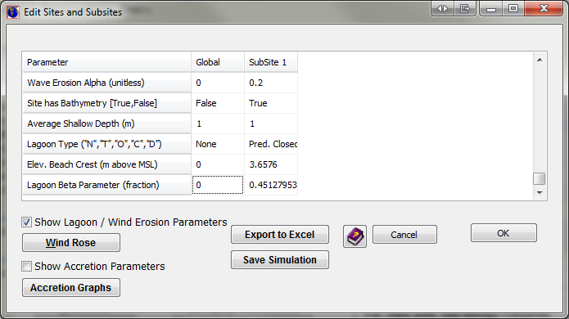

**Lagoon / Wind-Erosion Parameters.** When this check box is selected at the bottom of the matrix, six additional parameters are available as shown above.

The top three parameters pertain to wave erosion. As specified in the *Technical Documentation* an alternative wave-action-erosion model is now incorporated in the model that calculates marsh erosion rates as proportional to the total wave energy absorbed by the marsh edge each year.

* Wave Erosion Alpha: This is the proportionality constant that relates horizontal erosion rates to wave power. References in the literature have values of a ranging between an alpha of 0.5E-3 to 1.2E-3 m2/yr/W (Marani et al.  2011). These values could be used as a first parametrization of the erosion model when no other data are available. Calibrating this parameter to site-specific horizontal erosion rates would be ideal.
* Site has Bathymetry (Boolean): If bathymetry data is available, the model will use those data in calculating wave depths. If not, an average shallow depth may be entered in the row below.

Marani, M., d’Alpaos, A., Lanzoni, S., and Santalucia, M. (2011). “Understanding and predicting wave erosion of marsh edges.” *Geophysical Research Letters, 38(21).*

The bottom three parameters pertain to lagoon setup. The lagoon type may be specified first. Entering the following characters will the following lagoon types display:

* “N” -- 'None': This is not a perched lagoon. This is the default value. No perched lagoon calculations will take place.
* “T” -- 'Open Tidal'
* “O” -- 'Predominantly Open'
* “C” -- 'Predominantly Closed'
* “D” -- 'Drainage Outlet’

The type of lagoon specified is for information only. If any of the lagoon types are specified then perched water levels will be calculated using the beach-crest elevation and the beta parameter as specified in the Technical Documentation. As also discussed in that document, the type of lagoon may provide information in terms of setting the beta parameter as well.

The second parameter is the beach-crest elevation provided in meters above MSL. The third parameter is the lagoon beta parameter which is a unitless fraction. Water levels within the lagoon will be perched above MSL in the quantity of beta multiplied by the beach-crest elevation. The range of water levels in the lagoon may be assumed to be similar to oceanic tide ranges unless site-specific information is available to set the “GT” and “salt-elevation” parameters for the perched-lagoonal subsite.

Typical range for β based on lagoon subtype.

|  |  |
| --- | --- |
| **Lagoon Subtype** | **Typical range for β** |
| Open tidal | 0-0.1 |
| Predominantly open | 0.1-0.3 |
| Predominantly closed | 0.2-0.4 |
| Drainage outlet | 0.2-0.5 |

**Wind-Rose Data:**

The figure below shows the required wind-rose inputs for the wave-action erosion model. The model will calculate wave power for each of the 16-points of a compass and also for the ten wind speeds bins shown below.

Units are in percent of occurrence and need not sum to 100% if the site is “calm” for a portion of the year. A wind rose diagram is produced to help QA/QC data inputs. Data may be pasted into the wind-rose matrix from Excel or other spreadsheet software.

Wind rose data should be used at 10 meter height and with a 10-minute averaging period if these data are available. This matches the data used in generating the wind-energy calculations (Young and Verhagen, 1996).

Wind rose data may be available from the following site: <http://www7.ncdc.noaa.gov/CDO/cdoselect.cmd?datasetabbv=SUMMARIES&countryabbv=&georegionabbv=&resolution=0>

Young, I. R., and Verhagen, L. A. (1996). “The growth of fetch limited waves in water of finite depth. Part 1. Total energy and peak frequency.” *Coastal Engineering*, 29(1), 47–78.

**Accretion Parameters.** As specified in the *Technical Documentation* an alternative accretion model is now incorporated in the model that allows for feedbacks between cell elevation (as a surrogate for frequency of inundation), salinity, and distance to channel and the rate of accretion for a given cell. Separate models can be specified for “regularly flooded marsh,” “irregularly flooded marsh,” “tidal flats,” and “tidal-fresh marsh.” For more information on these models see the *Technical Documentation.* Also, the user may benefit from working with the “SLAMM6_Accretion” Excel file that is included in the model’s installation directory. For each wetland type the following optional accretion parameters may be specified:

* Use Model (Boolean)—defines whether the variable accretion model is utilized or whether constant accretion rates by wetland class are utilized.
* Max Accretion Rate (mm/year)—the maximum accretion rate that can be assigned by the model as a function of elevation.
* Min Accretion Rate (mm/year)—the minimum accretion rate that can be assigned.
* Accretion Rate Coefficients, a (cubic), b (square), and c (linear), and d (intercept). These parameters define the shape that describes the relationship between accretion and elevation. See the *Technical Documentation* for more information on how to parameterize this relationship and the equation used.
* Notes. A text string to document chosen model.

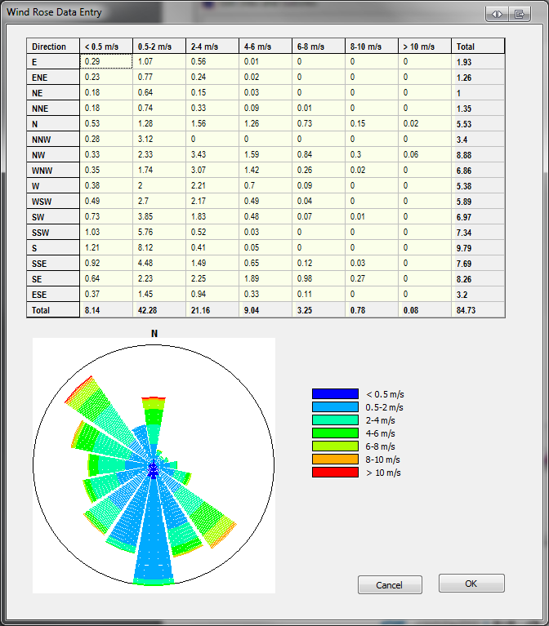

## SLAMM Execution Screen

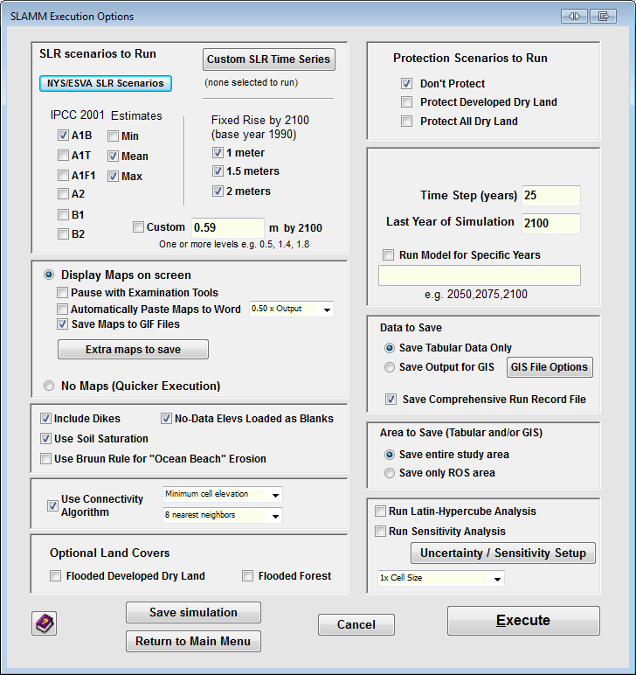

SLR Scenarios to Run

* Scenarios and Estimates– A list of IPCC sea level rise scenarios to choose from. See *Technical Documentation* for more detail. Each scenario that is selected may be run for min, mean, or maximum within a single run.
* Fixed Rise by 2100 – A list of 3 heights of sea level reached by 2100. 1 meter of eustatic SLR, 1.5 meters, or 2 meters of eustatic SLR by 2100. These scenarios are generated by scaling up Scenario A1B-Maximum from the IPCC simulations. See *Technical Documentation* for more detail.
* Custom “Fixed” SLR in meters by 2100. A user may specify a set of SLRs by 2100. Year-by-year changes are estimated by scaling up (or down) Scenario A1B-Maximum from the IPCC simulations. (If the user wishes to specify a unique time-series, the user may specify custom SLR curves as described below in the “Custom SLR Time Series” section.)
* NYS/ESVA SLR scenarios represent sea-level-rise scenarios specific to New York State and the East Coast of Virginia applications. Please see <http://warrenpinnacle.com/prof/SLAMM/TNC_ESVA/> and <http://warrenpinnacle.com/prof/SLAMM/NYSERDA/> for more information about these scenarios if interested.

New to SLAMM 6.7: Custom SLR Time Series: See the new section “Custom SLR Time Series” following the description of the Execute Window options.

**Protection Scenarios to Run**

* Don’t Protect – All land is potentially vulnerable to SLR.
* Protect Developed Dry Land – All land is potentially vulnerable to SLR except developed dry land which is not allowed to change.
* Protect All Dry Land – No dry land is vulnerable to inundation from SLR.

In SLAMM 6.7, the model is always run for the NWI Photo Date (T0). The running of a “time-zero” year is an important step in model calibration; it ensures that the model is accurately able to represent current conditions.

**Time step (years)** – indicates the number of years between model solutions (and output of tables and maps). The first time step is variable so that the model can then step through the specified time-steps size and end in the year 2100.

**Last Year of Simulation** – the end of the simulation. Currently capped at 2100 as nearly all available estimates of SLR end on this date.

**Run Model for Specific Years**—the user may enter a time-series of years that the model will then run through. The entry format is a list of years separated by commas. This is very useful for hindcasting, for example, or if the user has a reason that outputs on specific years is desirable. (Years run prior to 1990 will be subject to the “historical SLR” specified and years run after 1990 will be subject to the SLR scenario selected for the given model run.)

**Data to Save**

* Save Tabular Data Only – Saves tabular results from model runs, but **not** ASCII raster outputs.
* Save Output for GIS – Saves both tabular results and the raster outputs from model runs. An individual set of years may be selected in the “GIS File Options” window.
* Save Binary Files saves smaller files, but ones that must be read by SLAMM or converted to ASC files by SLAMM before reading into GIS software.
* GIS File Options – Provides options to list specific years for GIS output. New to SLAMM 6, Rasters of Elevations (relative to MTL or NAVD88), Salinity, and Inundation-Frequency rasters may be output.

**Save Comprehensive Run Record File** -- New to SLAMM 6.7, each time a model is run a “run-record” file is output into the same directory as the “SLAMM6” file.

* The file name includes the time and date stamp of the run  
   (i.e “FILENAME_YYYY-MM-DD_(HH.MM.SS).txt”).
* Within the file, the time of the run and the SLAMM version is shown, following by the name and “date modified” of the SLAMM6 file.
* Then an “external data summary” shows all external data (rasters) that are being read by the model and their dates modified. This will help the user understand if any of these files have changed since the time of the model run.
* If the “Save Comprehensive” option is chosen, all model parameters are then displayed. For very large SLAMM6 files this may cause excessively large log files, which is why this can be optionally turned off. If the option is turned on, however, the log can actually be loaded directly into SLAMM as a viable input data file (SLAMM6 file in text format). To do this, all lines above and including the line reading “ALL SLAMM PARAMETERS SHOWN BELOW” must be removed from the run-record file.
* Finally, all model outputs are listed including any new or appended “CSV” files, all “GIF” files created, and all raster data files produced, and the directories in which they have been placed, and their “modified dates.”
* This new option enables a user to clearly understand which model parameters are associated with which set of results, and also to easily understand the difference between two different model runs (using a text-compare utility such as “WinMerge.”)

**Display Maps on Screen**

* Pause with Examination Tools – Pauses before model execution. Allows for controlled progression of simulation and examination of maps and diagnostic tools for each step of a scenario run. Often referred to as running the model in “debug mode.”
* Automatically Paste Maps to Word – Outputs map results to new Microsoft Word document created by SLAMM. The size of the raster (1x to 4x) may be specified.
* Save Maps to GIF Files – outputs GIF maps for each timestep
* Extra Maps to Save
  + Save Salinity Maps –outputs salinity maps to the same Word document as wetland maps, and/or to GIF files as specified above.
  + Save Accretion Maps – outputs time-varying accretion maps
  + Additional Simplified Category Maps – outputs maps using simplified categories to the same Word document as SLAMM category wetland maps (provided for Ducks Unlimited)
  + Save SAV Maps – if the SAV model is included, probability of SAV maps are produced for each time step
  + Save Connectivity maps – Shows connectivity information for each timestep

**No Maps (Quicker Execution)** – With this option selected, simulation progress will not be illustrated for the user and no maps output.

**Include Dikes** – Select this option if you have specified a dike raster layer and want to include it in the simulation execution. Un-checking this option will result in a model run assuming no dike protection is present.

**Use Soil Saturation**—Occasionally, the soil saturation algorithm is not desirable because it causes streaks to appear on model outputs. This sub-model may be turned off by unchecking this box.

**No-Data Elevs Loaded as Blanks** – When there is no-data in the digital elevation map the default model behavior is to load these values as “blanks” as otherwise the model may produce misleading output. This behavior may be modified here.

Use Connectivity Algorithm —Turns on or off the SLAMM connectivity sub-model. This model determines whether dry lands or freshwater wetlands will be subject to saline inundation based on an uninterrupted low-elevation pathway to estuarine or ocean water. See the section on *Connectivity* in the SLAMM 6.7 *Technical Documentation.* For connectivity, the “minimum” or “average” cell elevation can be used to estimate whether a portion of the map has regular connectivity to tidal water, and a 4-side or 8-side search rule can be used. The most cells would be assumed connected if minimum cell elevations were chosen (which are lower, allowing more water to pass through) and an 8-nearest-neighbor search was chosen (which allows water to move diagonally from cell to cell). Fewer cells might be assumed connected if average cell elevations were used (which are higher) and diagonal water movement was disallowed (4-nearest-neighbor search). Local data about connected and unconnected areas can be used to select which settings are most appropriate for a particular SLAMM application.

**Use Bruun Rule for “Ocean Beach” Erosion** – if checked, Ocean beach erosion is modeled using a relationship reported by Bruun whereby recession is 100 times the change in sea level. Otherwise the beach erosion rate is set to the value specified for tidal flat erosion.

**Execute** – Runs the SLAMM simulation with the current configuration.

**Save simulation** – Saves current project configuration to the SLAMM6 file on disk.

**Return to Main Menu** – returns to the opening screen saving any changes made.

Uncertainty and Sensitivity analysis options are discussed below.

## Custom SLR Time Series

Clicking on the “Custom SLR Time Series” button brings up a screen in which multiple time-series of SLR may be input. To add a new time-series, click the “new” button. You may name the series in the “Name” edit box” and choose whether you wish to run this scenario in the current simulation or keep it for a future simulation.

The base year must be specified, which is the starting year of the time-series—the year in which SLR is assumed to be zero. As is the case with all SLAMM SLR scenarios, if the model is run prior to the base year, the historic SLR will be applied for all years prior.

SLR (in units of “meters above the base year”) for any number of years may be specified after the base year. If a modeled year falls between two years, the model will estimate the SLR through linear interpolation. The model must not be run beyond the last year of the time-series specified, however (SLAMM will not extrapolate). At this time SLAMM still does not run beyond 2100 but this will be changed in the near future.

Additionally, for ease of use, data may be pasted into the table from Microsoft Excel or Google Sheets.

Finally, the “Save” and “Load” buttons allow the suite of SLR scenarios that is associated with one simulation to be saved to a text file with a “SLAMMSLR” extension. This enables a set of SLR scenarios to be shared among simulations and researchers.

Included with the SLAMM6 installation are a set of SLR scenarios taken from NRC 2012. (See Chapter 5 and Tables 5.2 and 5.3 in: National Research Council (U.S.), National Research Council (U.S.), and National Research Council (U.S.) (Eds.). (2012). *Sea-level rise for the coasts of California, Oregon, and Washington: past, present, and future*. National Academies Press, Washington, D.C.)

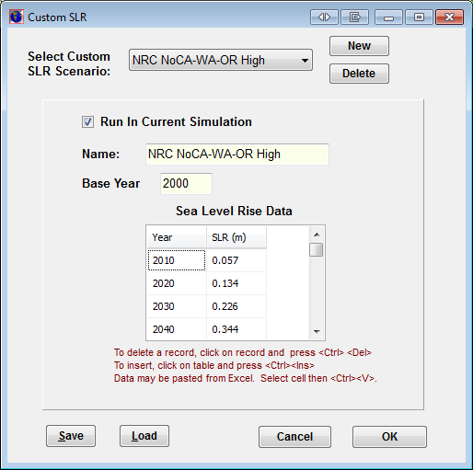

## Run Latin-Hypercube Analysis

SLAMM now includes a Monte-Carlo uncertainty analysis module to provide likelihood and confidence statistics of the results as a function of input uncertainties and errors. A user may specify uncertainty distributions for almost all input variables, included the rate of sea level rise by 2100. Changes in most parameters are specified using "multipliers" of existing parameter values.

Users may select the number of iterations run and specify the use of a random or non-random seed. By running uncertainty analyses with a non-random seed, the random sequence of random numbers generated will be reproducible.

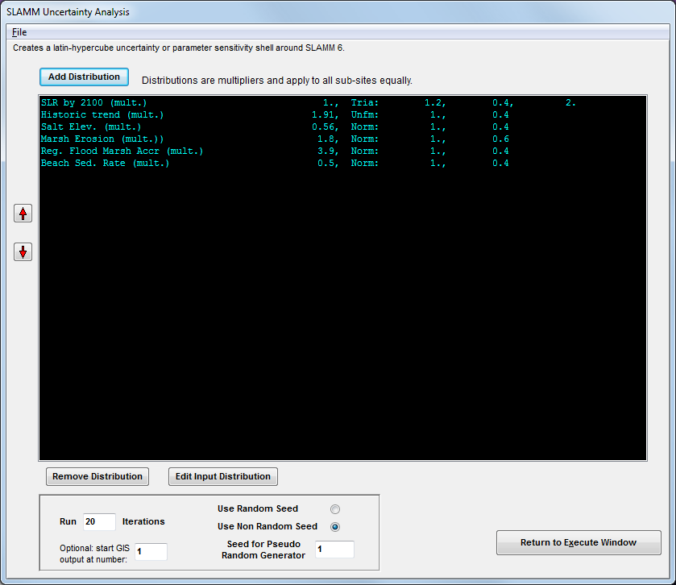

Clicking the Add Distribution button first provides a list of variables that can be represented as distributions.

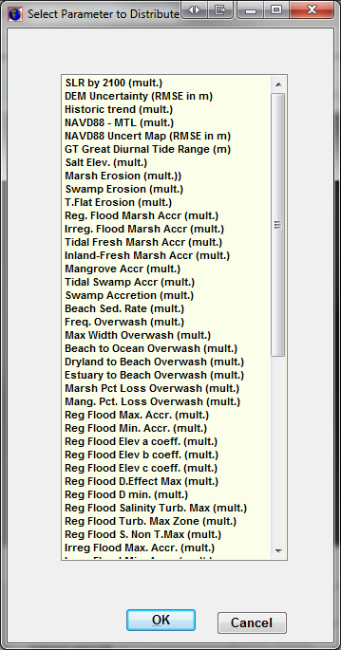

Selecting one distribution presents the “Distribution Information” screen. In this screen the user specifies the input parameter distribution and the mean and standard deviation of the multiplier used to represent the uncertainty around a parameter. In most cases, this distribution should be centered around 1.0 or the most-likely point estimate. In the current model version, one multiplier is used for the same parameter for all subsites in the simulation.

The graph can be shown as either a probability or a cumulative distribution.

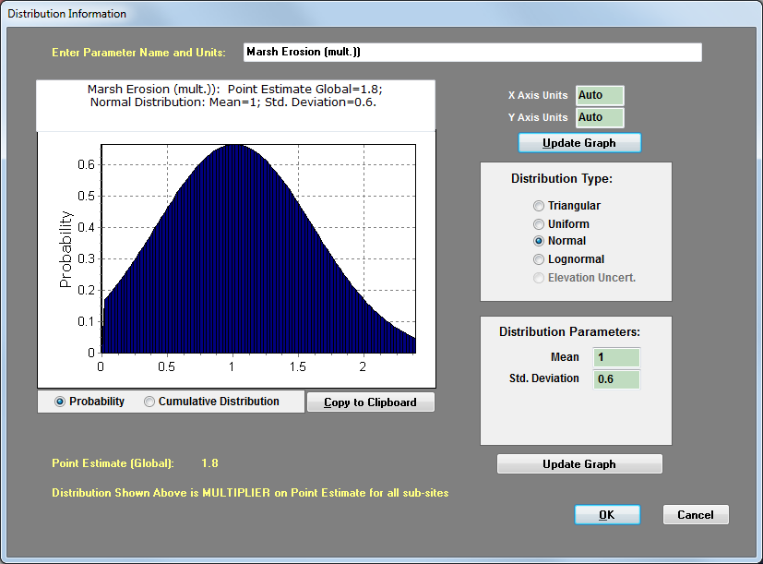

Within this interface, the user can specify:

* The axis minimum scale units or leave them as default
* The type of distribution
* The parameters defining the distribution.

**IMPORTANT NOTE:** The distribution values are multipliers. The reason that distribution values are multipliers is it assists with modifying variables that may be spread out over multiple subsites. In other words, if accretion rates are assumed to increase by 10% they increase by 10% over all subsites simultaneously.

Uncertainty in the elevation layer is represented using a spatially-autocorrelated map. Adding spatial autocorrelation to the elevation errors accounts for likely spatial clustering of measurement error (Hunter and Goodchild 1997).

An example of a spatially autocorrelated map is drawn in a red-to-blue gradient using the “Spatial A.C.” parameter selected. You may mouse over the map to see the vertical error estimate in a given location. The “Spatial A.C.” parameter varies from zero (no correlation) up to 0.25 (perfect correlation). A value of 0.25 is not possible as the entire map cannot have perfect correlation, but values approaching 0.25 (e.g. 0.2495) will result in strong spatial autocorrelation. When the model is run iteratively as part of an uncertainty analysis, a similar map will be derived randomly for each iteration and added to the DEM (or NAVD88 correction) map specified.

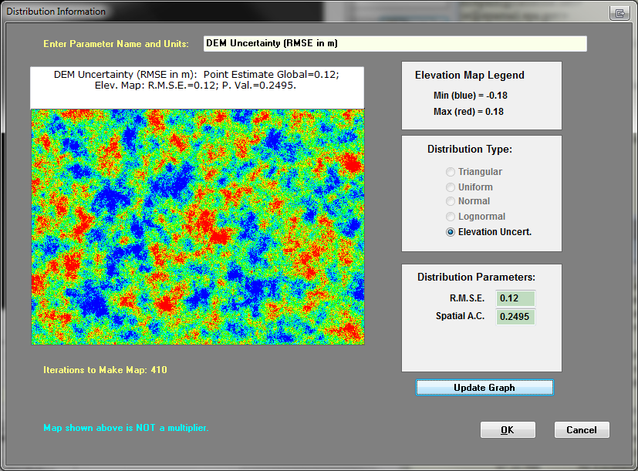

Once all the uncertainty distributions for the desired input parameters have been entered, the user specifies the total number of scenarios to run using a random or a user defined seed for initializing the pseudo random number generator. Use of a user-defined seed will ensure model result repeatability.

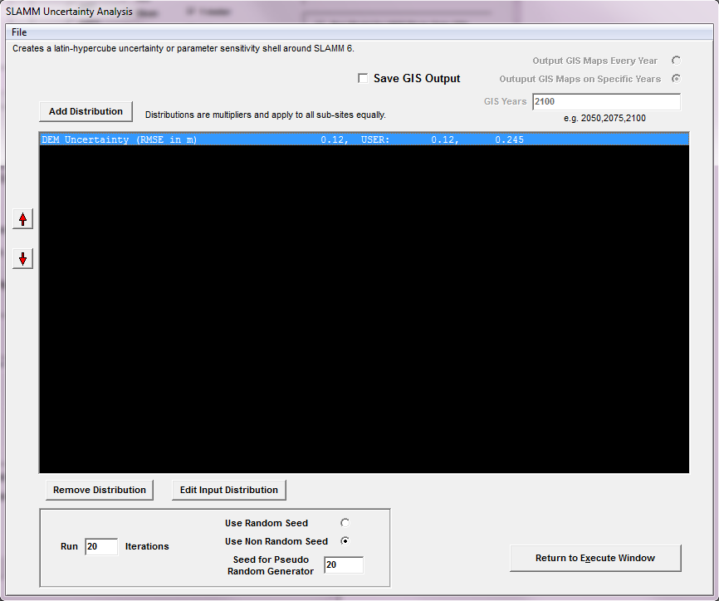

Select to run uncertainty analysis from the SLAMM Execute window. If you have chosen to evaluate the uncertainty in SLR as a driving variable, ensure that you have selected a “custom” SLR scenario to run for your deterministic analysis. Otherwise, choose a single SLR scenario that you wish to evaluate.

If you wish to save GIS outputs for every time-step for later spatial analysis, be sure that this is selected in the “Data to Save” window.

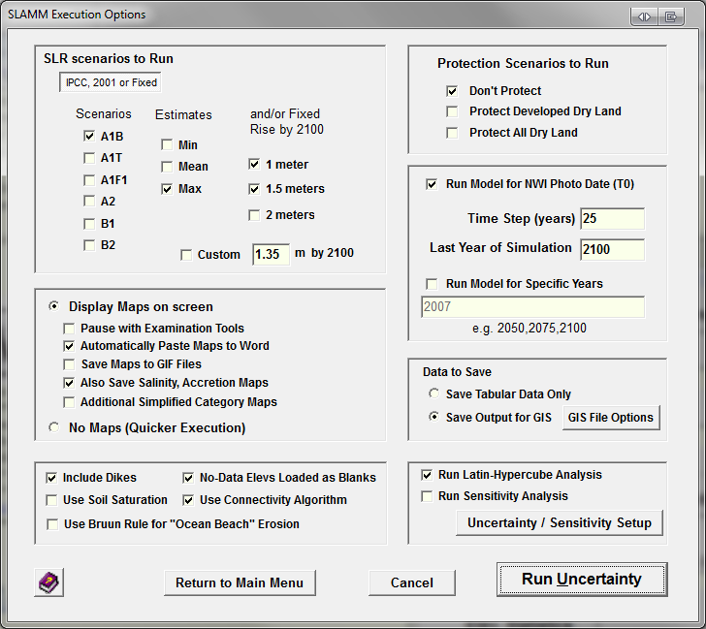

You will be prompted for a CSV file after you have selected “run uncertainty” from the SLAMM Execute window. The model will now run the number of iterations were selected sampling from all input distributions simultaneously. After execution, the selected CSV file may be opened in Excel. This file summarizes all of the samples from each input distribution for each model iteration as well as land categories for the last time step of the model for each model realization. Summary statistics are also listed below the raw data.

Hunter, G. J., and Goodchild, M. F. (1997). “Modeling the uncertainty of slope and aspect estimates derived from spatial databases.” *Geographical Analysis*, 29(1), 35–49.

## Carbon Sequestration Analysis

Carbon sequestration calculations will be performed for all time-steps and output steps for all simulations performed and all modeled subsites. These data are appended as a column to CSV outputs produced by the SLAMM model. The final results are expressed in units of sequestered greenhouse gasses in thousands of kilograms. A negative result would suggest that methane emissions are greater than carbon sequestration within a given spatial area. See the *Technical Documentation* for information about the assumptions and calculations that provide these results.

To access the inputs that are used to drive the carbon-sequestration module, select the “Carbon Sequestration” button on the main interface. The following editable matrix of parameters will be shown to allow the user to edit assumptions with regard to aboveground biomass, soil carbon storage rate, and methane emission rate for all categories modeled. Data may be pasted from Excel or other spreadsheet software.

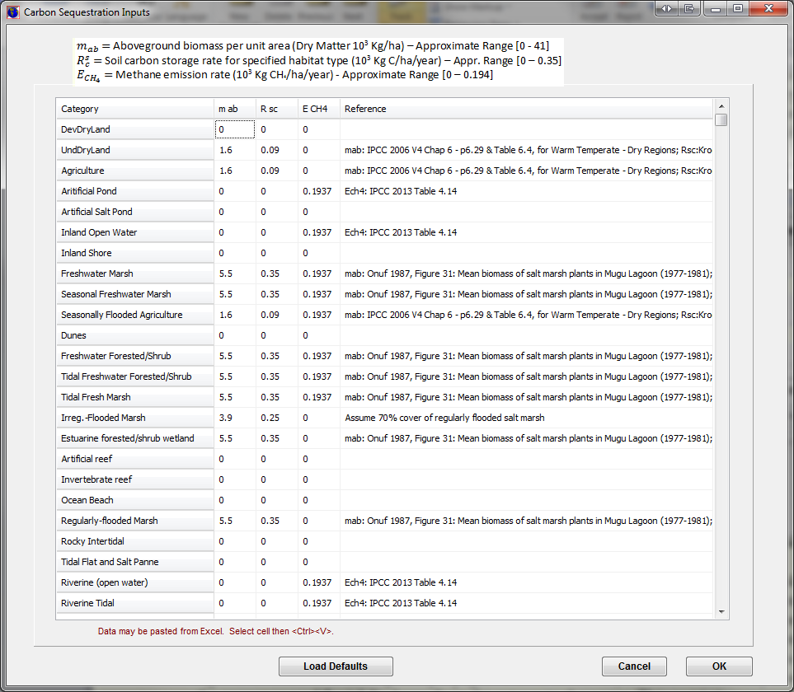

## Sensitivity Analysis

SLAMM 6.7 includes a built-in sensitivity analysis module, which may be used to examine the sensitivity of multiple model outputs to multiple model input parameters. The user first selects which model parameters to vary and specifies the percentage by which to vary them. When executed, the model iteratively steps through each of the parameters and varies them by a specified percent in the positive and negative direction and saves model results in an Excel file.

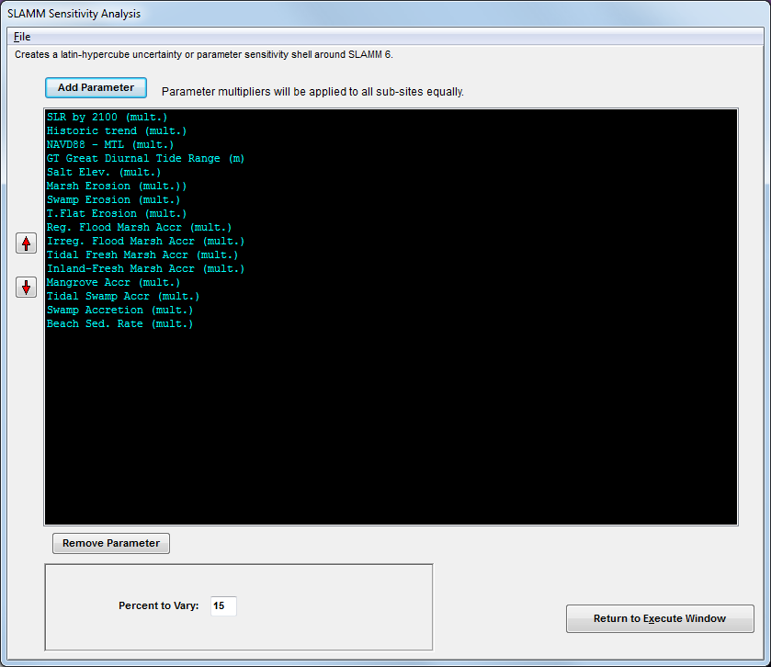

## Set Map Attributes

This window includes many tools to define and examine model inputs and outputs and is now organized in a tabbed ribbon format.

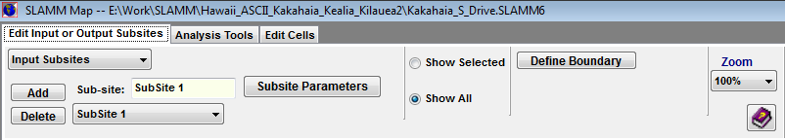

On the Edit Input or Output Subsites tab, the following options are available:

* **Input Sites** – Input sites are polygonal areas used to modify model parameters in a specific region.
  + First **Add** an input site, then give it an identifying name.
  + Click **define boundary** to define the location of the sub-site. Each click on the map represents another point in the polygon. Double clicking or right-mouse-button clicking will close the polygon.
  + Show sub-site parameters – Enables user to change sub-site parameters (ie. Dates, accretion, erosion, etc.). See **sub-site parameters.**
* **Output Sites** – Output sites are used to create Word maps, raster, and tabular results for a specific location within the study area.
  + Click **define boundary** to draw the rectangular output-site. Clicking once will define one corner of the rectangle. After moving the mouse, clicking again will place the rectangle on the map.
* **Fresh Flows** – Fresh-water flows may be defined that are required for the salinity sub-model.
  + First add a freshwater flow then define a boundary over which this fresh-water flow has influence.
  + Next, define the pathway of the river including the modeled origin of the river and the mouth of the river (where it empties into the estuary and a semi-circular flow pattern away from the mouth of the river is assumed to start). Multiple line segments may be specified to define this pathway, starting up river and moving downward towards the mouth of the river.
  + **Fresh water flow parameters** may then be edited.
  + If the user wishes to define a freshwater-influenced area only, but not to run the salinity model, select the “**F.W. Extent only”** checkbox. In this case, the path of the river (origin/mouth) does not need to be defined. The salinity model will not be executed for this portion of the map, but an alternative flow chart of habitat switching will be utilized as discussed in the Technical Documentation.
* **Roads Layer** – The user may import one or more roads layers directly from an ESRI “line” shapefile. Note that the shapefile must have the same projection as the raster being used in the project. The frequency of inundation for each road segment that passes over a SLAMM cell will then be calculated.
* **Infrastructure Layer –** The user may import one or more infrastructure layers directly from an ESRI “point” shapefile. The frequency of inundation for each infrastructure point will be calculated under normal tides and storm-surge conditions.
* Zoom – Changes the dimensions of the output map on the screen. **Note**: this change is not saved and reflected in the Word document output maps.
* Show lines/Show All – Shows either the lines of the currently-selected object only, or all of the objects with the currently selected object highlighted in yellow.

The user has access to elevation tools, 3D mapping, and profile tools on the **Analysis Tools** tab:

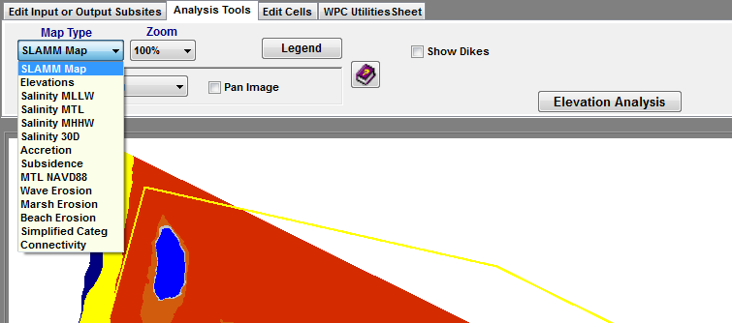

* Map type drop-down – SLAMM can display several types of maps.
  + The default **SLAMM map** is a land-category map;
  + An **elevation** map may be displayed (with a color gradient ranging from -2.0 meters to 7.0 meters)
  + If the optional **salinity** model is included, while running the model in debug mode (“pause with examination tools”), once the salinity model has been initialized, a salinity map may be displayed with color gradients ranging from 0 to 30 ppt.
  + The vertical **accretion** rate for various wetlands may also be displayed with a color gradient ranging from 0 to 10 mm/year.
  + Estimated **subsidence** rates in m/year
  + **MTL_NAVD88 correction** can be viewed for QA/QC
  + **Wave Erosion.** Selecting this map illustrates predicted wave erosion rates based on the wind-rose, water depths, and “alpha” specified. See “Wave Erosion Maps” below for more information.
  + Cumulative **Marsh and Beach Erosion** while running the model in debug mode. As this is a cell-specific result, the maximum erosion displayed for each cell will be the cell width.
  + **Simplified category** maps may be displayed in which all SLAMM categories are grouped into the “upland,” “freshwater non-tidal,” “open water,” “low tidal,” “saltmarsh,” “transitional,” and “freshwater tidal” categories.
  + **“Probability SAV”** maps show the probability of SAV for each cell.
  + A **Connectivity** map may be derived which shows which cells have clear pathways to open water and which low lying areas are not connected to a saline source at the current time step.
  + Inundation Frequency maps show lands that are flooded every 30, 60, and 90 days (or not flooded at all) based on

Deriving a legend for any of these map types will provide useful information about their meaning. In addition, see the SLAMM 6.7 Technical Documentation for more information on SLAMM modules used to derive these maps.

**Wave Erosion Maps**

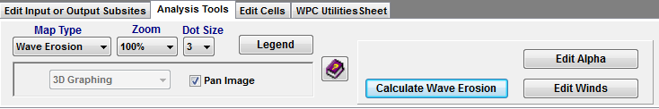

When wave erosion maps are selected, the model will present a number of new buttons as shown above. “Calculate Wave Erosion” will go through all wave-power calculations for every marsh-edge cell and display the predicted erosion rate as a gradient. The “legend” button should be used to get a sense of the scale. The “edit alpha” button may be used to go into the site parameters and select another “alpha” parameter (alpha is the proportionality constant between total wave power hitting the marsh edge and predicted horizontal erosion rates.) After this has been entered, you may “calculate wave erosion” again to see the updated map. This process can be very useful if there are site-specific spatial horizontal erosion data to test the model against and to calibrate the parameters with. The “Edit Winds” button will bring up the wind-rose interface as described above. After wave erosion has been calculated, a user may also see the wave power predicted using the “cell attributes” option described on the next page.

**Other Interface Options**

* Zoom – Changes the dimensions of the output map on the screen. **Note**: this change is not saved or reflected in the Word document output maps.
* Legend – Displays an editable legend of colors for SLAMM land categories. Legends are also available for the accretion, connectivity, simplified category, and salinity maps.
* SLAMM tool drop-down menu

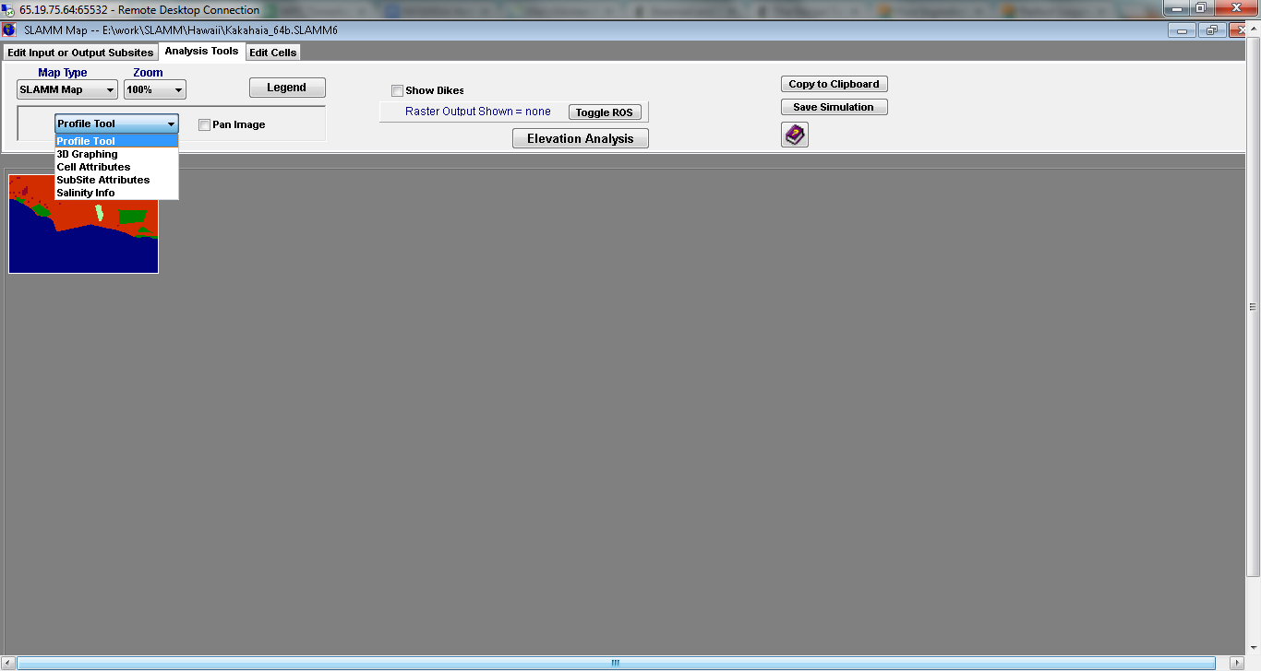

* + Profile Tool – Displays a 2-dimensional cross section of a 1-Demensional slice of the map. See **Profile Tool**.
  + 3D Graphing –Displays a 3D representation of the area selected in the map. See **3D Graphing**.
  + Cell Attributes – Displays attributes of whatever cell the cursor is hovering over. Attributes include cell categories, elevations, accretion rates, maximum fetch, salinity, slope, and uplift.
  + Sub-site Attributes – Displays attributes of the sub-site the cursor is currently hovering over including the name and a summary of the parameters associated with that sub-site..
  + Salinity Info -- Displays salinity information for a cell such as the river kilometer, distance to channel, retention time, and the predicted salt wedge height at MHHW. The first time-step must have occurred so that the salinity model is initialized to see these outputs.
* Show Dikes – Visually shows or hides the dike layer on the map. Dikes are displayed in a yellow color.
* Show Roads/Inundation – Displays the roads in the study area as well as their inundation status
* Elevation Analysis – For areas that are not pre-processed, elevation analysis displays statistics of elevation distribution across land types. See **elevation analysis**. This important screen also allows a user to edit the assumed elevation range for each wetland class.
* Toggle ROS – Displays “Raster Output Sites,” if included in project. The cells included in the raster output site will be shown in white.

A user may also perform simple edits to a SLAMM Raster map using some simple drawing and fill tools located in the **Edit Cells** tab:

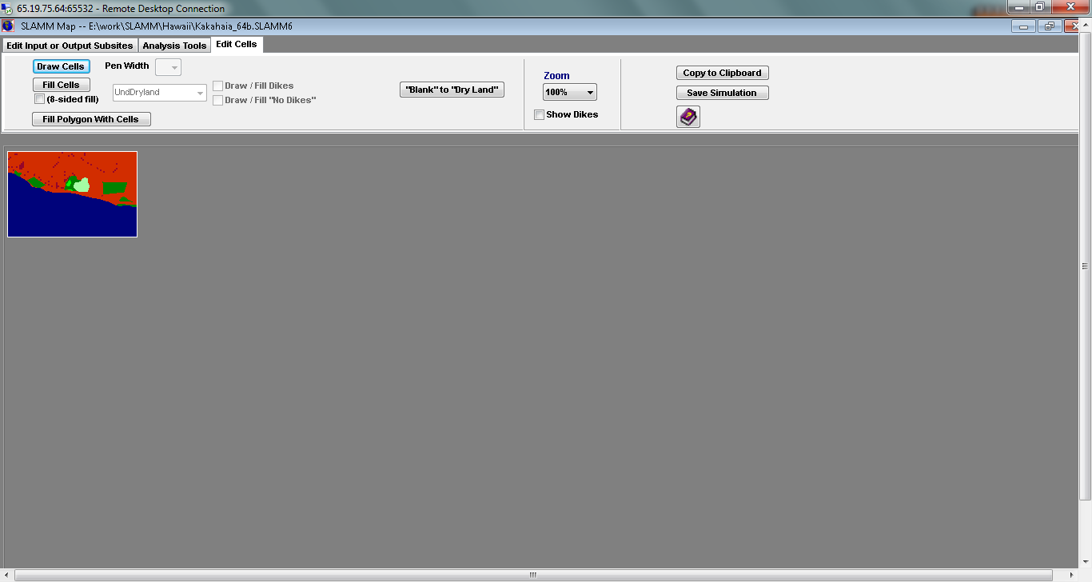

* Draw Cells – Used to manually draw particular SLAMM wetland classes on the map. The dropdown menu to the right indicates the cell width of the drawing pen. A second dropdown menu contains all of the SLAMM wetland categories. After this option is checked, clicking on the map will draw the selected wetland category onto the NWI raster. When leaving the map attributes screen the user is asked if these edits are to be saved to the ASCII input file.
* Fill Cells – Like the fill feature in Microsoft Paint, this option is used to change the value of a contiguous chunk of one SLAMM land category to another category. If eight-sided fill is checked then the fill function will also fill same-type cells that are diagonally attached to the area (a.k.a. “bishop’s position” fill).
* Fill Polygon Within Cells – Allows users to draw a polygon of a wetland type specified by the dropdown menu containing the SLAMM categories.
* Draw/Fill Dikes or “No Dikes”– With this selected, the draw/fill cell features edit the dike raster by adding or removing dikes.
* Blank to Dry Land – because the NWI does not code dry land, these cells often remain blank after GIS processing of the wetland layer. This button allows a user to quickly fill in the blank cells that contain elevation information as dry land. SLAMM will automatically distinguish between dry land and developed dry land through the percent impervious file (if used).
* Toggle ROS – Visually displays or hides the raster output sites (ROS) for a given map.

## Elevation Analysis

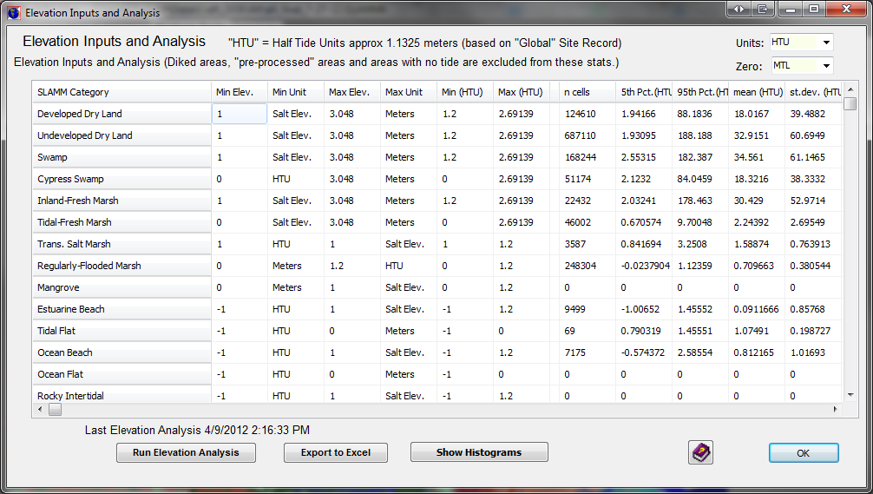

The elevation analysis window is a powerful tool that allows for site characterization and makes SLAMM assumptions regarding elevation ranges are now editable for site-specific adjustments if required.

Columns displayed include:

* Min Elev.: Editable. The elevation that SLAMM assumes is the minimum elevation for this class, in the units shown in the cell to the right. This is a critical parameter as it defines the elevation, relative to MTL, below which a wetland is assumed to convert to another wetland class or open water.
* Min Unit: Editable. Units may be
  + “Salt Elev.” or the distance from the salt boundary to the mean tide level
  + “HTU” or one half-tide unit, (MHHW minus MTL).
  + “Meters” above MTL.
* Max Elev.: Editable. The maximum elevation that SLAMM assumes for this land category. This only has an effect if the Elevation Pre Processor is utilized to estimate elevations for each wetland cell. *(Dry lands elevations below the salt boundary will be pre-processed so dry land upper elevations should be set to the lowest contour interval from the map being utilized.)* SLAMM is not currently set up to model “sea level fall” or aggradation. In other words wetlands do not change to other types when their maximum elevation is exceeded.
* Max Unit: Editable. Units as above (“Salt Elev.,” “HTU,” or “Meters.”)
* Min HTU or m: Non Editable: The minimum SLAMM-assumed elevation as converted to half-tide or metric units, depending on the “Units” selection in the box at the upper right. This is converted for comparison with map data as discussed below.
* Max HTU or m: Non Editable: The maximum SLAMM-assumed elevation as converted to half-tide or metric units, depending on the “Units” selection.

To the right of these columns are columns that remain empty until an “elevation analysis” is run. An “elevation analysis” is an examination of statistics when the NWI cover-class raster is combined with the digital elevation map. SLAMM then returns statistics describing the elevation range of wetlands. For these statistics to be accurate it is important that the NWI date and DEM date are reasonably close. Otherwise, for a given cell, the elevation data may describe a land cover class that has converted to another class in the interim.

An elevation analysis is only run for cells that are not set to be processed with the pre-processor. The assumption is, if elevation data are poor enough to require the elevation pre-processor, statistics regarding those elevations are unlikely to be useful to the user. Also, diked cells are excluded.

Note, to run the elevation analysis, the entire digital elevation map must be loaded through the Set Map Attributes button (or execute in debug mode.) You cannot run an elevation analysis if this screen is accessed through the main SLAMM interface.

Statistics can then be compared against SLAMM assumptions for each wetland category to ensure that the SLAMM conceptual model matches up with the available elevation data for the site. If significant differences exist then the user will need to determine if this is because of

* Elevation data (e.g. problems with vertical datum corrections)
* NWI data problems (e.g. out-of-date map or horizontal inaccuracy)
* Problems with the conceptual model for some site-specific reason that hopefully can be determined and described.

Available Statistics include:

* n cells: The number of cells covered by that land category. Statistics based on small sample sizes should probably be discounted to some degree.
* 5th percentile and 95th percentile: The 90% confidence interval for this particular land category in half-tide units. These can be compared with the “Min HTU” and “Max HTU” conceptual model columns.
* Mean, St. Dev.: The average elevation value and standard deviation in half tide units.
* Min, Max: The minimum and maximum elevation for this cell in half-tide units. These data are usually less useful as horizontal error in a single cell’s classification can produce strange results.
* % < Min: The current percentage of cells below the minimum elevation specified.

Note: Double clicking on any column header will sort the entire table in ascending or descending order.

The Units dropdown box at the top of the window allows a user to convert the elevation analysis into units of “half-tide units” or HTU or meters. Using meters is usually more useful for microtidal systems. The Zero dropdown box at the top of the window allows a user to convert the vertical datum used for the elevation analysis.

Using the buttons at the bottom of this screen a user can export these data to SLAMM or examine histograms of frequency vs. elevation for selected wetland types, as shown below.

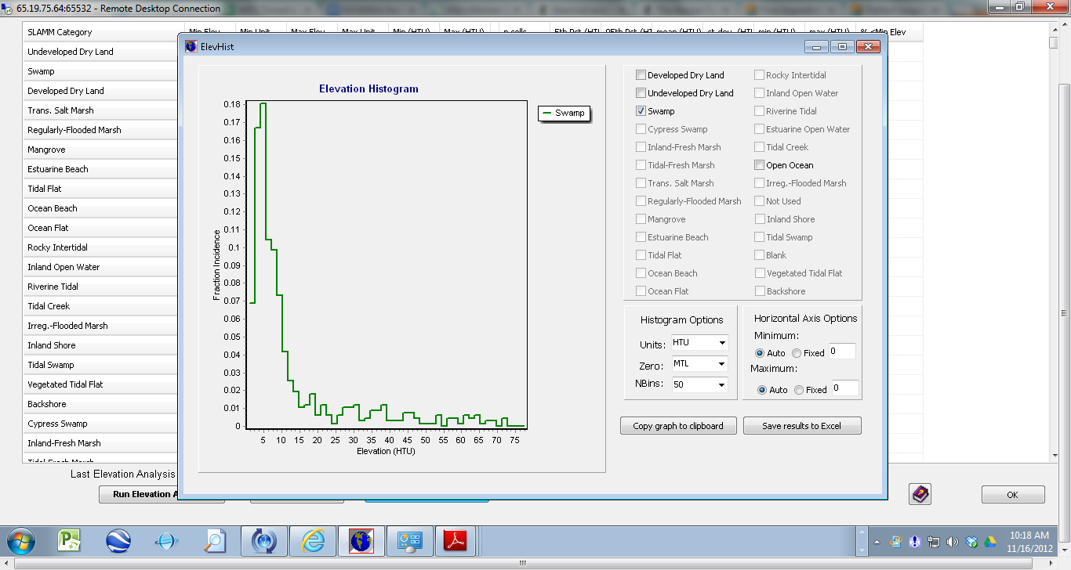

## 3D Graphing

This feature of SLAMM 6 has been completely retooled from previous versions. Users can still view and navigate a selection of land but, as with the **profile tool**, each node is now passed a land-cover value as well as an elevation value. OpenGL rendering is used to produce useful maps that really help a user to understand the relationship between elevation, slope, and cover class.

To use this feature, the user’s computer and graphics card must be capable of rendering OpenGL images (the vast majority of modern computers are…) Otherwise the software will exit with an error message. (Graceful error trapping is not yet possible given the open-source OpenGL toolbox that we are currently working with.)

To use, select the 3D graphing tool from the drop-down box and then draw a rectangle on the SLAMM map.

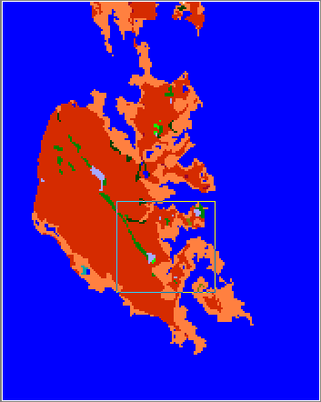

With the area selected, a new window appears.

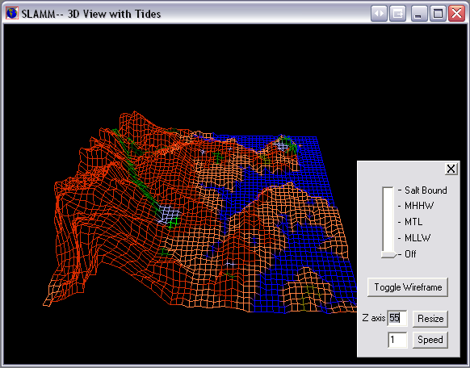

3D Features:

* Navigation – The up arrow keys zooms in and the down arrow zooms out. The left and right arrow keys slide the vantage point to the left and right. Changes to camera orientation can be made by pressing the left mouse button and moving the mouse.
* Toggle Wireframe – Provides a 3D view in wireframe mode as opposed to opaque polygons. This view is usually better for revealing elevation distinctions.
* Tide range slider – Draws water at the salt boundary, mean higher high water, mean tide level, or mean lower low water. This can be used to examine the elevations of tides against land-cover classifications.
* Z-axis Resize – Magnifies elevation values. This is particularly useful when viewing areas with low vertical relief.
* Speed – Changes the navigation speed.

## Profile Tool

This feature enables the user to view either a vertical or horizontal “slice” of a segment of land.

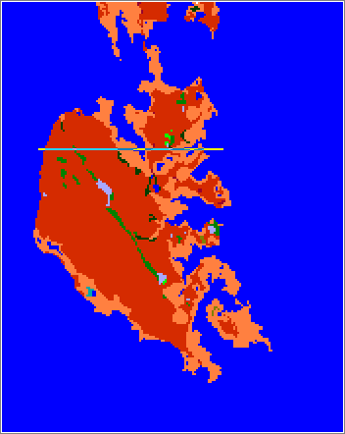

Cell elevations are presented in meters above mean tide level, and each cell color corresponds to its NWI value in the SLAMM raster. Clicking on a cell in the profile window will reveal its elevation.

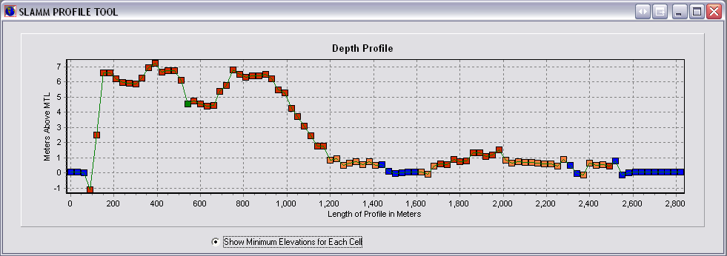

## Freshwater Flow Parameters

For each freshwater flow specified, a characterization of river flow, salinity, and other physical characteristics must be entered.

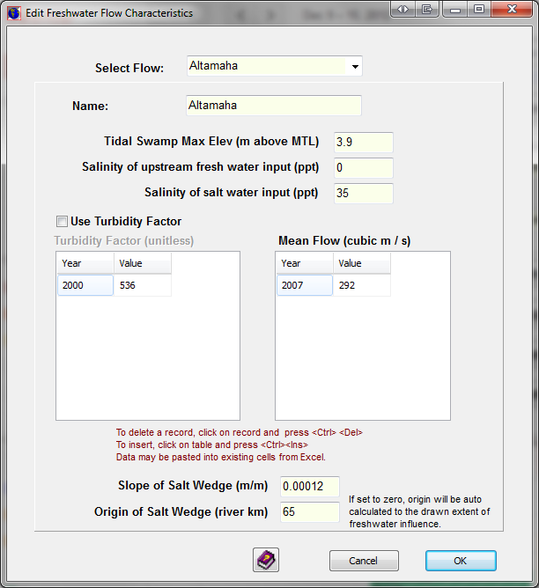

Within areas that have defined freshwater flows, swamp can be predicted to convert to tidal swamp on the basis of elevation. This is the purpose of the “Tidal Swamp Max Elev.” parameter. When swamp falls below this elevation it will become tidal swamp.

Fresh water salinity may also be specified though it often is assumed to be 0 ppt.

A time-varying turbidity factor may be specified. If the turbidity factor is not utilized or is set to 1.0 then accretion inputs are not modified. Otherwise calculated accretion rates are multiplied by the specified turbidity factor within this area of freshwater influence. This experimental factor may be used to investigate potential impacts of changes in turbidity on wetland fate.

A time-varying freshwater flow may be specified which affects salinity calculations. Additionally the slope of the salt wedge may be specified. This is a calibration parameter which affects the depth at which fresh water and salt water meet. The depth of the salt-wedge is back-calculated from the farthest extent of fresh water influence as a function of river-mile and the tide range.

The origin of the salt wedge may also be specified as a function of “river km” calculated with kilometers increasing when moving from the defined origin to the mouth of the river. If this parameter is not specified, the origin is set to the most oceanic defined extent of fresh water influence. The calculated river km for each defined estuary may be viewed using the following procedure:

* Execute the model, select “pause with examination tools.”
* Select the “next step” button until the salinity initial condition has been calculated.
* Select the salinity tools from the analysis tools and hover the mouse over a portion of the map.
* The RiverKM for the cell is now displayed along with other descriptive statistics describing the geometry of the salt wedge.

## Salinity Analysis

Similar to an elevation analysis, a Salinity Analysis displays statistics about predicted salinities as a function of land-cover type.

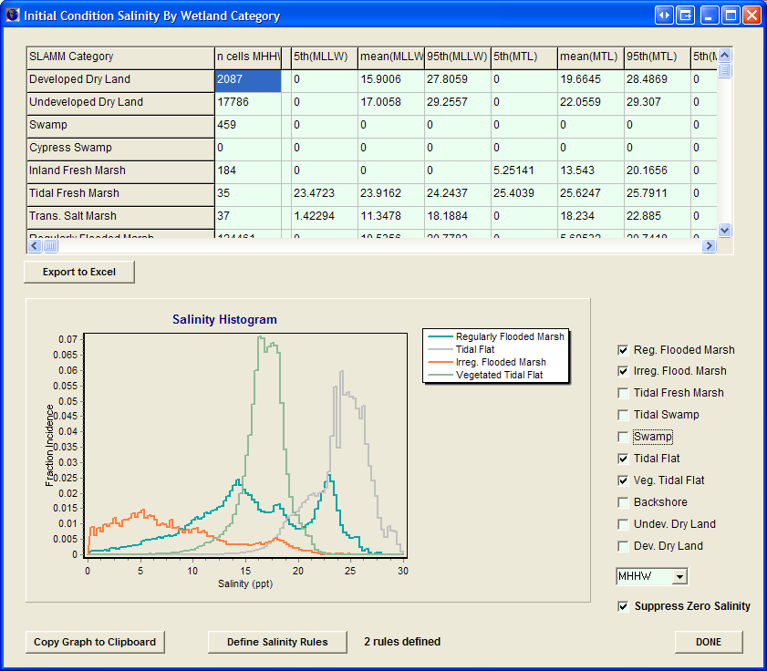

The salinity matrix is not editable and includes the 5th and 95th percentile and mean salinities for a given wetland type at low tide (MLLW), mean tide (MTL) and high tide (MHHW), and the salt elevation, usually defined as the 30-day flood tide (30D).

Like the elevation analysis, a graphic histogram of salinities by land-cover may be produced. This is quite useful for understanding the relationship between salinities and wetland types. These relationships can then be used to specify a set of **Salinity Rules** that affect model behavior.

If the project is saved after a salinity analysis has been run, the statistics information is stored and can be accessed the next time the project is opened without loading the map through the Salinity Analysis button in the main program window.

**NOTES**

* When linking salinity raster data, salinity statistics for the loaded salinity raster can be accessed, once map attributes have been loaded, by pressing the *Other tools* and *Salinity Analysis* buttons. A new form will open and by pressing the *Run Salinity Analysis* button, the statistical information will be processed and made available in table and graphical form. When linking salinity point data via an Excel file, the model must first be run through the initial condition prior to producing salinity statistics.

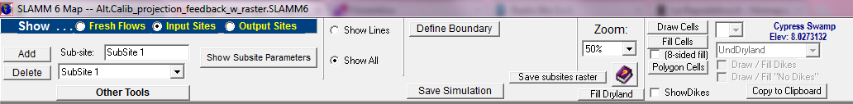

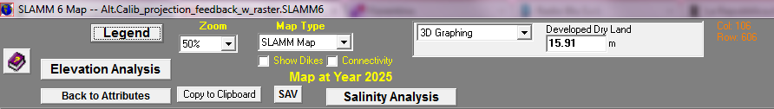

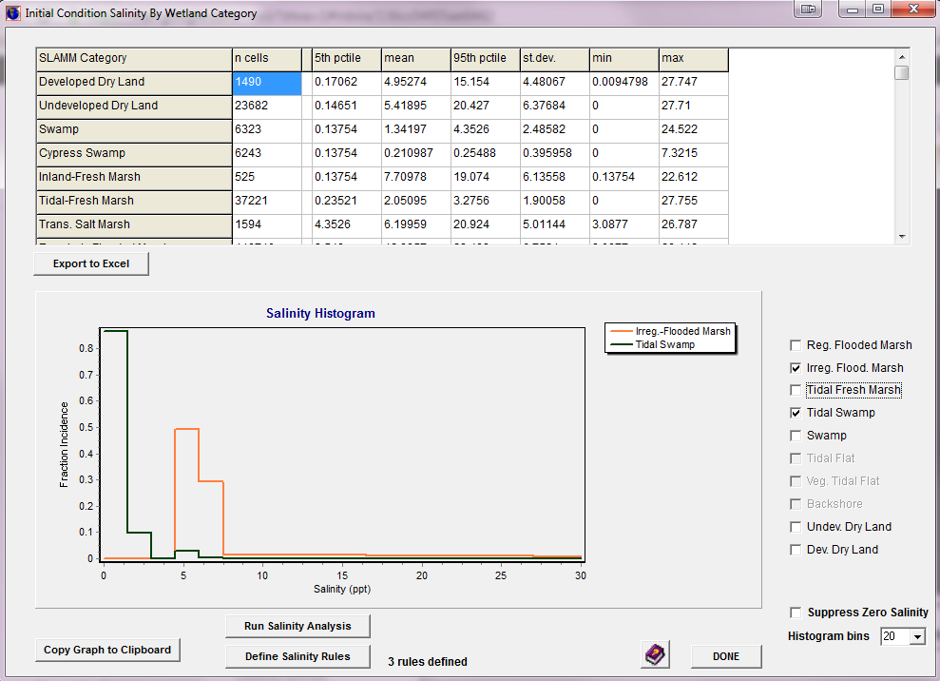

## Salinity Rules

The salinity model provides for disambiguation between wetland types when their elevation ranges overlap. In this case, salinity may be used to define when one category is predicted to change to the next. The user may define as many salinity rules as may be useful for their particular model run.

In order to define wetland conversion rules by salinity, press the *Define Salinity Rules* button in the Salinity Statistics form.



A new form will open and the conversion rules for salinity can be defined.

In the example below, tidal swamp is predicted to convert to tidal-fresh marsh when the salinity exceeds 5 ppt at flood tide.

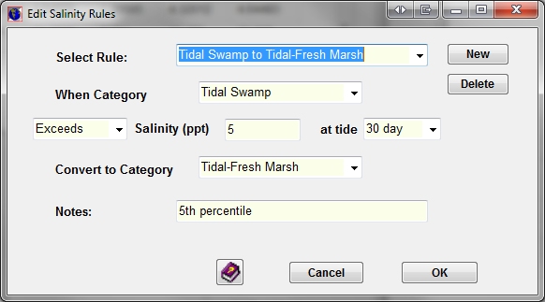

The model will first make any changes in wetland classes as a function of elevation and tidal range and will then make changes on the basis of salinity, if warranted.