VPB 680C Infectious Disease Epidemiology
Lectures 7&8: Reed-Frost model

- mathematical model of the shape of the epidemic curve in a propagating epidemic in a defined population
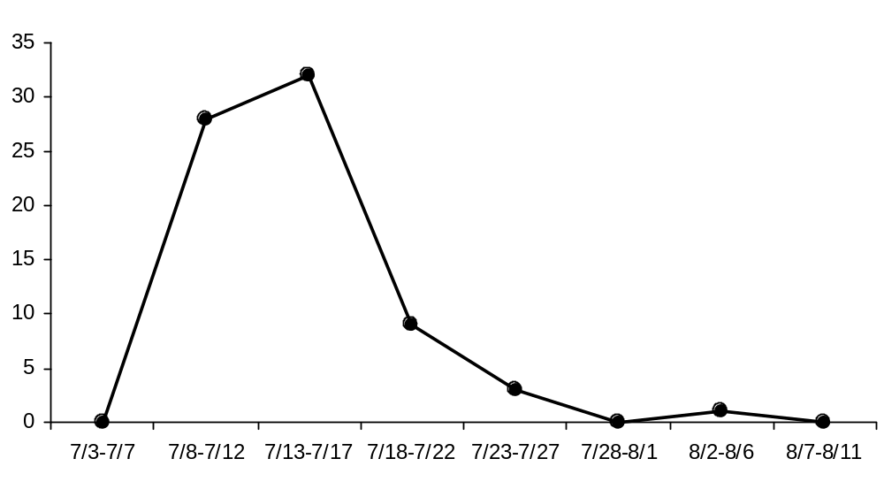
A point-source epidemic: human leptospirosis associated with contamination water supply, Rostov-on-Don, USSR

- one of the basic models is the Reed-Frost model
- population: susceptible, infected (case) and immune animals
- number of individuals in each group determines the shape of the epidemic curve and the pattern of immunity in the population
- Reed-Frost model is a “state-transition” model
- each individual in the population is assumed to exist in mutually exclusive states (susceptible S_{t}, case C_{t} or immune I_{t})
- transition between states described by probabilities:
effective contact, p
development and loss of immunity

- number of effective contacts between an infectious animal and susceptible animals depends on p and herd size
- model formulation:
C_{t+1} = S_{t} (1−q^{Ct})

where q = 1−p
t is the time period
C_{t+1} = number of infectious cases in time period t+1
S_{t} = number of susceptible animals in time period t
q = probability of an individual not making effective contact

nb. time period usually defined as the incubation period or the latent period of the infectious agent

- p, probability of a specific individual making “effective contact” with another individual which would result in infection if one individual were susceptible and the other were infectious

- (1-q^{Ct}) arises because it represents the probability that at least one of the C_{t} infectious cases makes effective contact

- magnitude of p is a matter of chance
- p depends on a variety of factors
- defined according to the appropriate mode of transmission for a specified infectious disease agent
- e.g. measles: coughs; malaria: mosquito bites
- infectiousness of the agent dependent on inherent characteristics
- Reed-Frost model, frequency of contact + transmission
= “effective contact”

- p is usually estimated empirically from real epidemics
- modifications: stochasticity, open population, control measures (e.g. vaccination, culling)

- six assumptions are implicit in the Reed-Frost model:

  - infection is spread directly from infectious to susceptible individuals only by adequate contact;

  - any susceptible individual − after adequate contact with an infectious individual during a given time period − will become infected and will be infectious during the following time period then immune in the subsequent time period;

  - each individual has a fixed and equal probability of adequate contact with other individuals within one time period;

  - the study population is closed;

  - model parameters, variables and conditions remain constant during the simulation period;

  - simulation time intervals (t) are equal to the average period of infectiousness for the disease simulated.

- if period of infectiousness of infected animals is short, and the incubation period or latent period is constant, then, starting with a single case (or several simultaneously infected cases), new cases will occur in a series of stages
- cases occurring during each time period ∼ binomial distribution, depend on no. susceptible, infectious during previous time period
… chain of binomial distributions ∴ expected
(Reed-Frost model is referred to as a “chain-binomial model”)

e.g. assume p = 0.06 and q = 0.94

t | S_{t} | I_{t} | R_{t} | N_{t} | p | pS_{t}
0 | 100 | 1 | 0 | 101 | 0.06 | 6.00
1 | 94 | 6 | 1 | 101 | 0.06 | 5.64
2 | 65 | 29 | 7 | 101 | 0.06 | 3.90
3 | 11 | 54 | 36 | 101 | 0.06 | 0.66
4 | 0 | 11 | 90 | 101 | 0.06 | 0.00
5 | 0 | 0 | 101 | 101 | 0.06 | 0.00
- epidemic can only occur when p* S_{t} >1
- epidemic declines (or cannot initially occur) when p*S_{t} <1
- number of new cases decreases as soon as p*S_{t} <1
… control epidemics by reducing contact (e.g. quarantine) or the number of susceptible animals (e.g. vaccination)

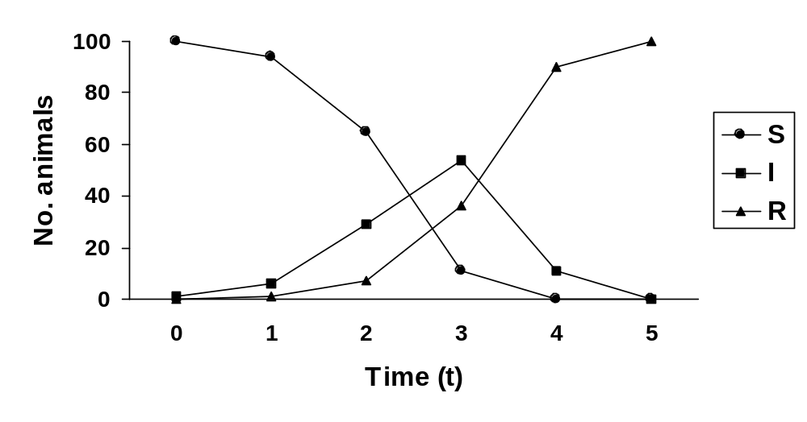

⇒ likelihood of an epidemic occurring, shape of the epidemic curve
∴ functions of the probability of effective contact, no. susceptible animals

- proportion of the population that is susceptible is often used as a general guide to the likelihood of an infection spreading
… commonly, at least 20-30% of the population
(> 70-80% of population immune, infection will not spread)

- although 70-80% immunity will prevent a major epidemic occuring, infection can still spread with a relatively low proportion of susceptible animals if there are sufficient susceptibles → p*S >1

- Reed-Frost model particularly suited to:

diseases with a short infectious period compared to incubation period
direct disease transmission
complete immunity after infection
when the group of individuals is “homogeneous”
Chain binomial Reed-Frost model in groups of size 3, with 1 initial infectious and 2 susceptible animals (Thomas and Weber, p.77)

 |  |  |  |  |  |  |  |  | I
I, I |  |  |  |  | I,S |  |  |  |  |  |  | S,I |  |  |  |  | S,S
I, I |  |  | I, I |  |  |  | I, S |  |  | I, I |  |  |  | S, I |  |  | S, S
p² |  |  | qp*p |  |  |  | pq*q |  |  | qp*p |  |  |  | qp*q |  |  | q²
= p² |  |  | = p²q |  |  |  | = pq² |  |  | = p²q |  |  |  | = pq² |  |  | = q²

Chain | Chain Probability | P=0.4 | P=0.7 | Total infected
1 → 0, 0 | q² | 0.360 | 0.090 | 1
1 →1 →0 | 2pq² | 0.288 | 0.126 | 2
1 →1→1 | 2p²q | 0.192 | 0.294 | 3
1 → 1, 1 | p² | 0.160 | 0.490 | 3
Total | 1 | 1.0 | 1.0 | …

n.b. two different chains by which animals could become infected

- if we are unable to observe the actual chains, we would not know which path the chain had taken
- in this case, we would have only final value data, that is, data on how many were infected in each herd/household/farm at the end
- this is also called the final size distribution

- assuming that the duration if infectiousness is one time unit, R_{O} = pN [or p(N-1) if there is one initial infective]

e.g. if p=0.4 → R_{O} = 0.4(3-1) = 0.8 … non-epidemic
if p=0.7 → R_{O} = 0.7(3-1) = 1.4 … epidemic possible

- probability that an epidemic will occur from the initially infected introduction is called the probability of no spread (P_{ns})

- P_{ns} calculated from transmission probability (p) … or escape probability q = 1−p; and the number of initially susceptible people X₀
- probability that a susceptible person escapes infection from all Y₀ initial infectives = (q)^Y₀
- probability that all X₀ of the susceptible animals escape infection from all the infectives, P_{ns} = (q^Y₀)^X₀

e.g. p=0.4, P_{ns} = (0.6¹)² = 0.36
p=0.7, P_{ns} = (0.3¹)² = 0.09

→ minor versus major epidemics
… little spread from initial infectives versus situations in which an epidemic gains momentum and is self-sustaining

- chain binomial models can be used to estimate transmission probabilities:

- from data gathered on each generation of infection, or
- from the final distribution of infectives within a group of herds or other small transmission units after an epidemic has occurred

- assumption of independence: exposure to two or more infectious animals at the same time = independent exposures
- Greenwood model: exposure to two or more infectious animals at the same time ≈ exposure to one infectious person

constant probability of infection:

- individuals move between classes according to a specified, fixed probability eg. P_{SI}, probability that an animal moves from S → I
- closed population: S_{t}=(1- P_{SI}) * S_{t}
- represented by a Markov chain: states (variables) and transitions (parameters)
- probability of transition solely determined by the current state

transition matrix:

 |  |  | To:
 |  | Susceptible | Infectious | Recovered
 | Susceptible | 0.9 | 0.1 | 0.0
From: | Infectious | 0.0 | 0.8 | 0.2
 | Recovered | 0.0 | 0.0 | 1.0

e.g. one infectious animal introduced into a herd of 200 susceptible animals:

Period | Susceptible | Infectious | Recovered
0 | 200 | 1 | 0
1 | 200*0.9+1*0+0*0=180 | 200*0.1+1*0.8+0*0=20.8 | 200*0+1*0.2+0*1=0.2
2 | 180*0.9+20.8*0+0.2*0=162 | 180*0.1+20.8*0.8+0.2*0=34.6 | 180*0+20.8*0.2+0.2*1=4.36
3 | 162*0.9+34.6*0+4.36*0=73 | 162*0.1+34.6*0.8+4.36*0=43.9 | 162*0+34.6*0.2+4.36*1=11.3

open population:

 |  |  | To:
 |  | Susceptible | Infectious | Recovered | Dead
 | Susceptible | 0.81 | 0.09 | 0.00 | 0.10
From: | Infectious | 0.00 | 0.72 | 0.18 | 0.10
 | Recovered | 0.00 | 0.00 | 0.90 | 0.10
 | Dead | 1.00 | 0.00 | 0.00 | 0.00

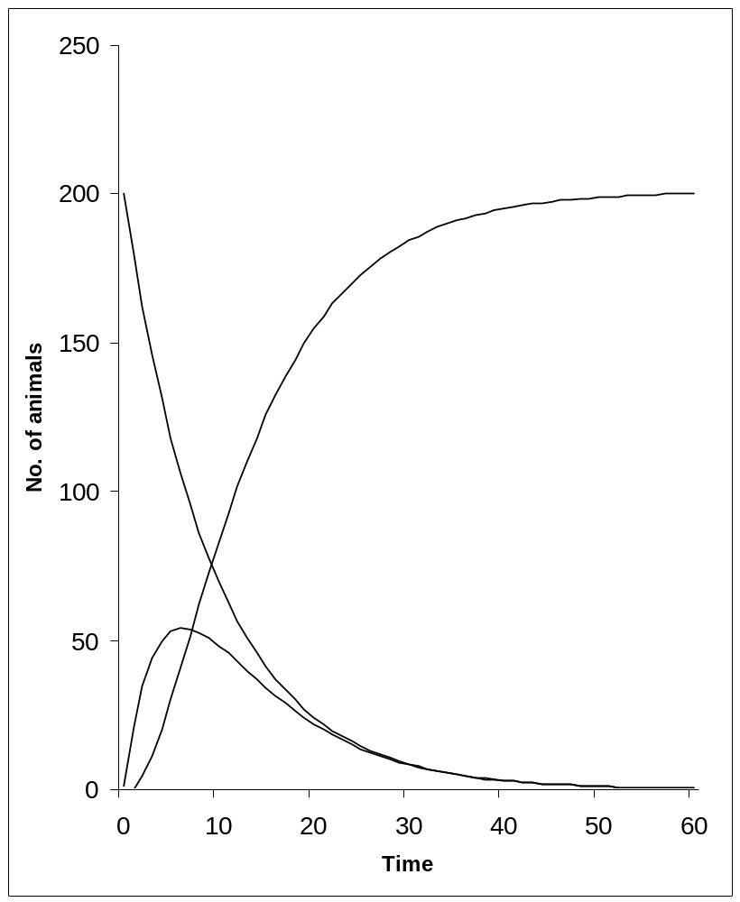  susceptible  recovered  infectious | 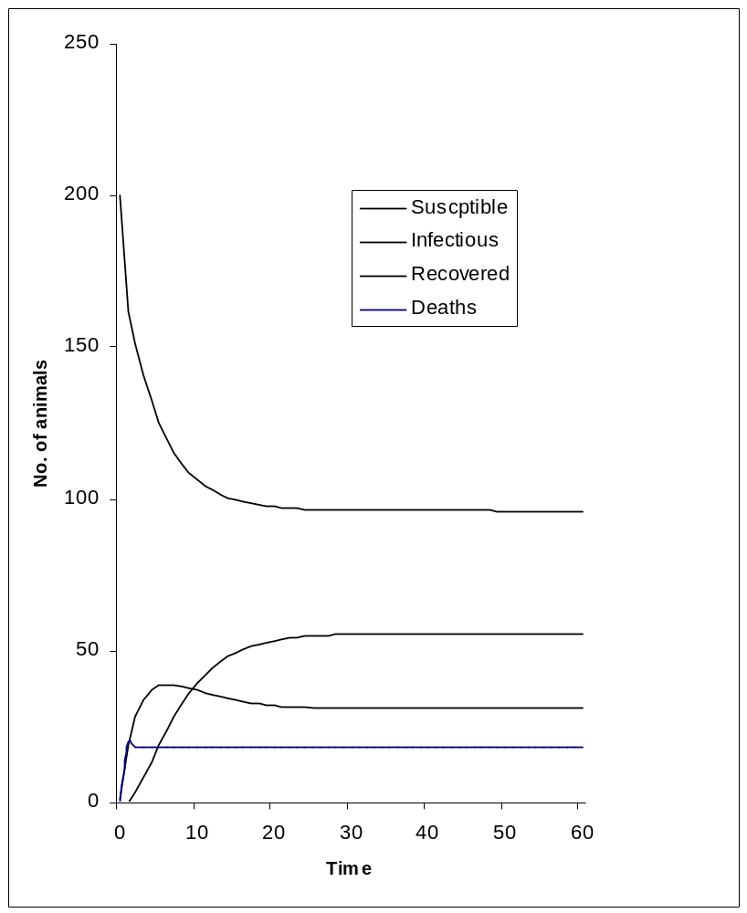  susceptible  infectious  recovered  deaths

