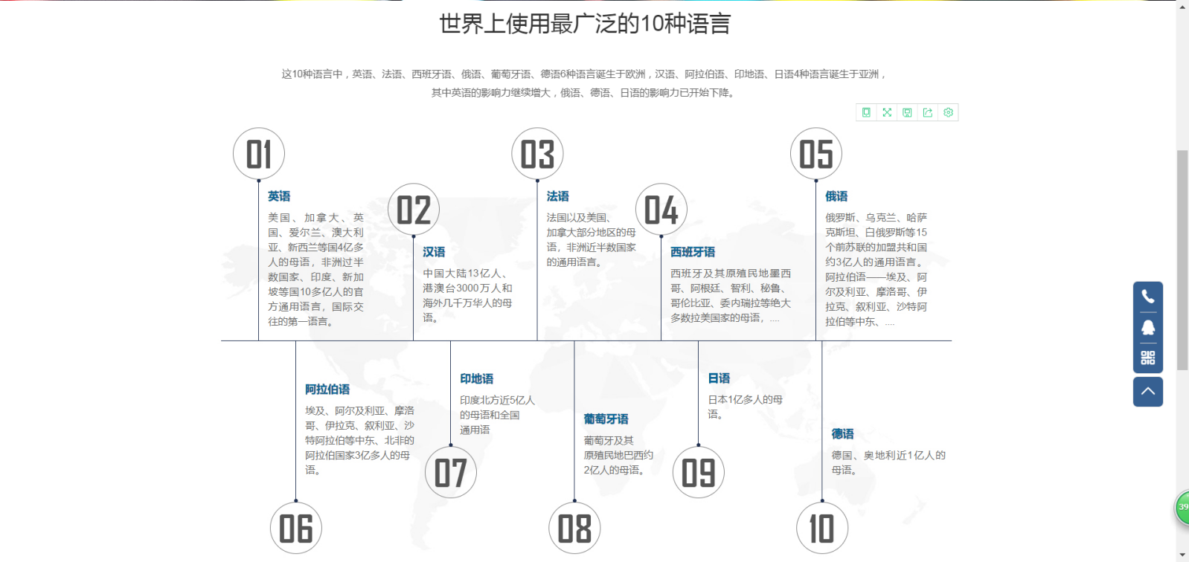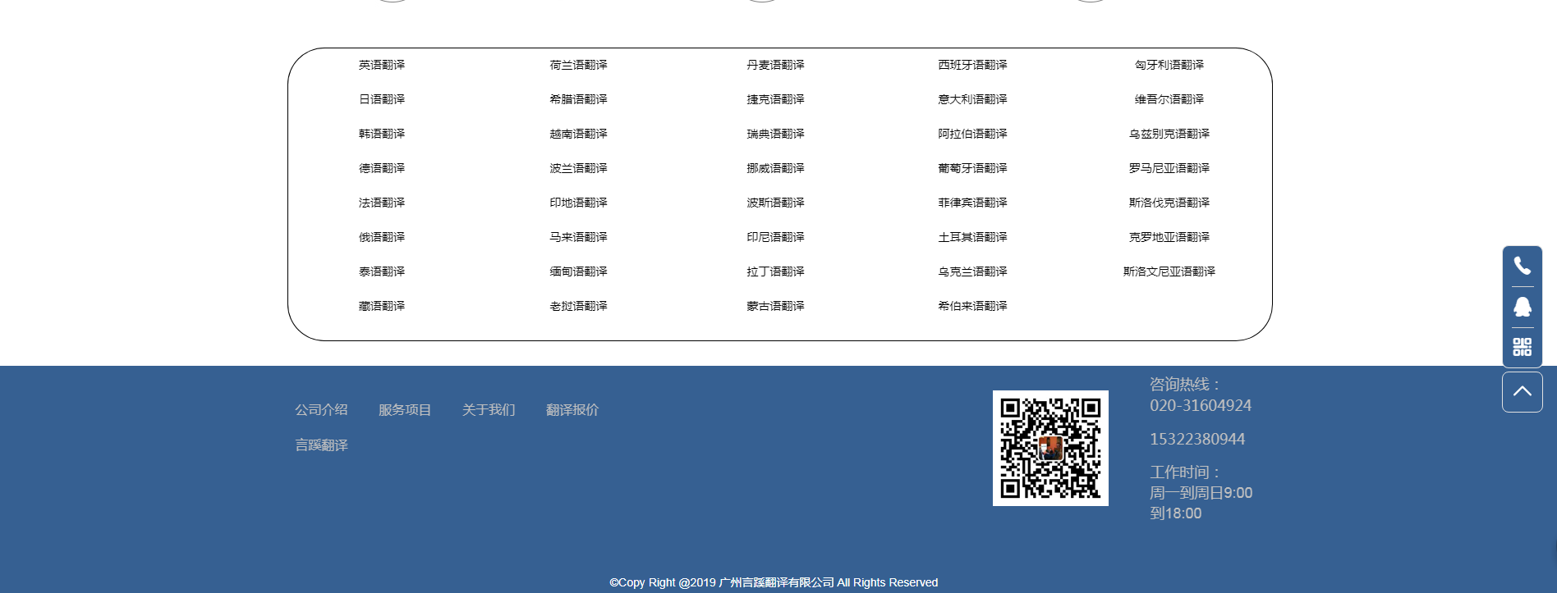

[首页](http://www.yanxifanyi.com/" \t "http://www.yanxifanyi.com/Content/_self)

[关于我们](http://www.yanxifanyi.com/Content/559046.html" \t "http://www.yanxifanyi.com/Content/_self)

[服务项目](http://www.yanxifanyi.com/Content/559047.html" \t "http://www.yanxifanyi.com/Content/_self)

[翻译语种](http://www.yanxifanyi.com/Content/559048.html" \t "http://www.yanxifanyi.com/Content/_self)

[质量保证](http://www.yanxifanyi.com/Content/559049.html" \t "http://www.yanxifanyi.com/Content/_self)

[合作案例](http://www.yanxifanyi.com/Content/559052.html" \t "http://www.yanxifanyi.com/Content/_self)

[在线报价](http://p.qiao.baidu.com/cps/chat?siteId=14085638&userId=29255444&cp=www.yanxifanyi.com&cr=www.yanxifanyi.com&cw=www.yanxifanyi.com" \t "http://www.yanxifanyi.com/Content/_blank)

[联系我们](http://www.yanxifanyi.com/Content/559055.html" \t "http://www.yanxifanyi.com/Content/_self)



世界上使用最广泛的10种语言

这10种语言中，英语、法语、西班牙语、俄语、葡萄牙语、德语6种语言诞生于欧洲，汉语、阿拉伯语、印地语、日语4种语言诞生于亚洲，  
其中英语的影响力继续增大，俄语、德语、日语的影响力已开始下降。

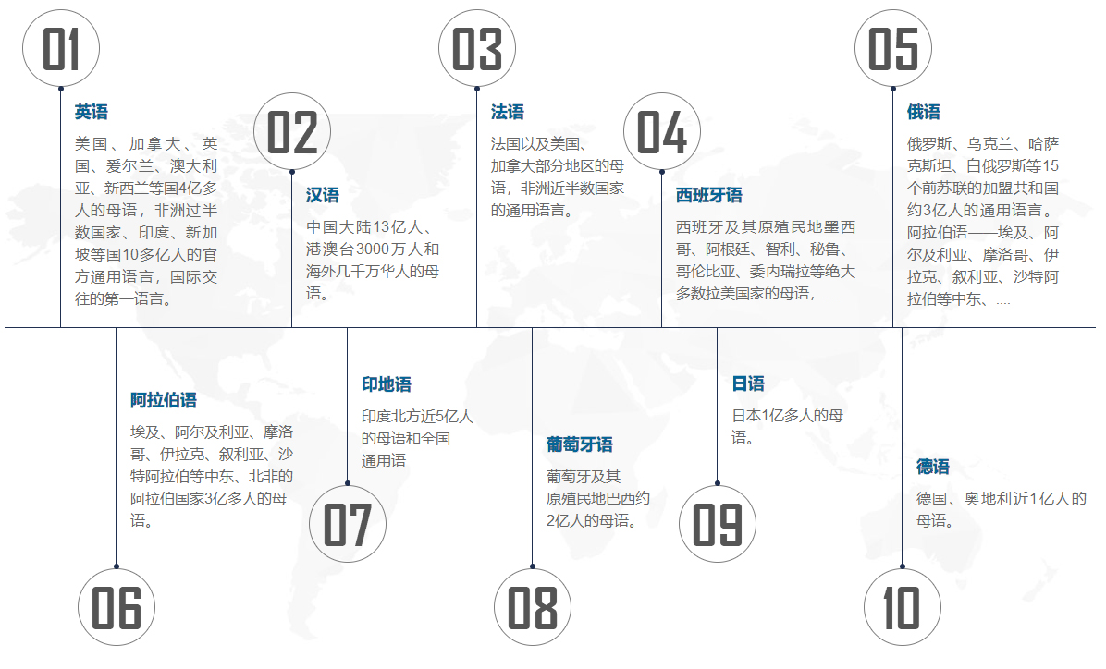

[英语翻译](http://www.yanxifanyi.com/NewsDetail/1445011.html" \t "http://www.yanxifanyi.com/Content/_self) [日语翻译](http://www.yanxifanyi.com/NewsDetail/1445024.html" \t "http://www.yanxifanyi.com/Content/_self) [韩语翻译](http://www.yanxifanyi.com/NewsDetail/1445047.html" \t "http://www.yanxifanyi.com/Content/_self) [德语翻译](http://www.yanxifanyi.com/NewsDetail/1445532.html" \t "http://www.yanxifanyi.com/Content/_self) [法语翻译](http://www.yanxifanyi.com/NewsDetail/1445542.html" \t "http://www.yanxifanyi.com/Content/_self) [俄语翻译](http://www.yanxifanyi.com/NewsDetail/1447047.html" \t "http://www.yanxifanyi.com/Content/_self) [泰语翻译](http://www.yanxifanyi.com/NewsDetail/1447066.html" \t "http://www.yanxifanyi.com/Content/_self) [藏语翻译](http://www.yanxifanyi.com/NewsDetail/1445016.html" \t "http://www.yanxifanyi.com/Content/_self) [荷兰语翻译](http://www.yanxifanyi.com/NewsDetail/1445031.html" \t "http://www.yanxifanyi.com/Content/_self) [希腊语翻译](http://www.yanxifanyi.com/NewsDetail/1445066.html" \t "http://www.yanxifanyi.com/Content/_self) [越南语翻译](http://www.yanxifanyi.com/NewsDetail/1445534.html" \t "http://www.yanxifanyi.com/Content/_self) [波兰语翻译](http://www.yanxifanyi.com/NewsDetail/1447038.html" \t "http://www.yanxifanyi.com/Content/_self) [印地语翻译](http://www.yanxifanyi.com/NewsDetail/1447055.html" \t "http://www.yanxifanyi.com/Content/_self) [马来语翻译](http://www.yanxifanyi.com/NewsDetail/1447068.html" \t "http://www.yanxifanyi.com/Content/_self) [缅甸语翻译](http://www.yanxifanyi.com/NewsDetail/1445017.html" \t "http://www.yanxifanyi.com/Content/_self) [丹麦语翻译](http://www.yanxifanyi.com/NewsDetail/1445068.html" \t "http://www.yanxifanyi.com/Content/_self) [捷克语翻译](http://www.yanxifanyi.com/NewsDetail/1445536.html" \t "http://www.yanxifanyi.com/Content/_self) [瑞典语翻译](http://www.yanxifanyi.com/NewsDetail/1447039.html" \t "http://www.yanxifanyi.com/Content/_self) [挪威语翻译](http://www.yanxifanyi.com/NewsDetail/1447058.html" \t "http://www.yanxifanyi.com/Content/_self) [波斯语翻译](http://www.yanxifanyi.com/NewsDetail/1447070.html" \t "http://www.yanxifanyi.com/Content/_self) [印尼语翻译](http://www.yanxifanyi.com/NewsDetail/1445019.html" \t "http://www.yanxifanyi.com/Content/_self) [拉丁语翻译](http://www.yanxifanyi.com/NewsDetail/1445042.html" \t "http://www.yanxifanyi.com/Content/_self) [蒙古语翻译](http://www.yanxifanyi.com/NewsDetail/1445075.html" \t "http://www.yanxifanyi.com/Content/_self) [西班牙语翻译](http://www.yanxifanyi.com/NewsDetail/1445072.html" \t "http://www.yanxifanyi.com/Content/_self) [意大利语翻译](http://www.yanxifanyi.com/NewsDetail/1445073.html" \t "http://www.yanxifanyi.com/Content/_self) [阿拉伯语翻译](http://www.yanxifanyi.com/NewsDetail/1447062.html" \t "http://www.yanxifanyi.com/Content/_self) [葡萄牙语翻译](http://www.yanxifanyi.com/NewsDetail/1447073.html" \t "http://www.yanxifanyi.com/Content/_self) [菲律宾语翻译](http://www.yanxifanyi.com/NewsDetail/1445020.html" \t "http://www.yanxifanyi.com/Content/_self) [土耳其语翻译](http://www.yanxifanyi.com/NewsDetail/1445043.html" \t "http://www.yanxifanyi.com/Content/_self) [乌克兰语翻译](http://www.yanxifanyi.com/NewsDetail/1445092.html" \t "http://www.yanxifanyi.com/Content/_self) [希伯来语翻译](http://www.yanxifanyi.com/NewsDetail/1445538.html" \t "http://www.yanxifanyi.com/Content/_self) [匈牙利语翻译](http://www.yanxifanyi.com/NewsDetail/1447046.html" \t "http://www.yanxifanyi.com/Content/_self) [维吾尔语翻译](http://www.yanxifanyi.com/NewsDetail/1447065.html" \t "http://www.yanxifanyi.com/Content/_self) [乌兹别克语翻译](http://www.yanxifanyi.com/NewsDetail/1447075.html" \t "http://www.yanxifanyi.com/Content/_self) [罗马尼亚语翻译](http://www.yanxifanyi.com/NewsDetail/1445022.html" \t "http://www.yanxifanyi.com/Content/_self) [斯洛伐克语翻译](http://www.yanxifanyi.com/NewsDetail/1445046.html" \t "http://www.yanxifanyi.com/Content/_self) [克罗地亚语翻译](http://www.yanxifanyi.com/NewsDetail/1445093.html" \t "http://www.yanxifanyi.com/Content/_self) [斯洛文尼亚语翻译](http://www.yanxifanyi.com/NewsDetail/1445539.html" \t "http://www.yanxifanyi.com/Content/_self)

公司介绍        服务项目        关于我们        翻译报价

言蹊翻译



咨询热线：

020-31604924

15322380944

工作时间：

周一到周日9:00到18:00

©Copy Right @2019 广州言蹊翻译有限公司 All Rights Reserved

IMG_260IMG_261IMG_262IMG_263IMG_264