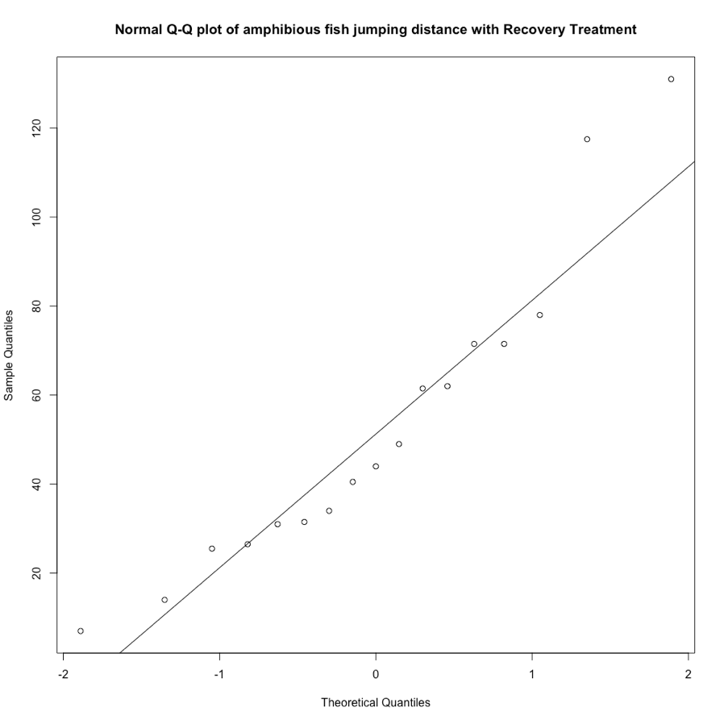
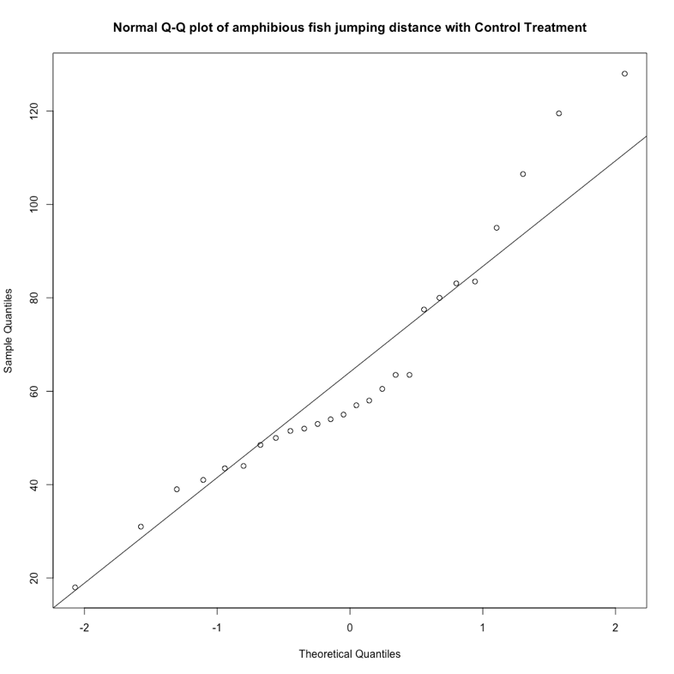
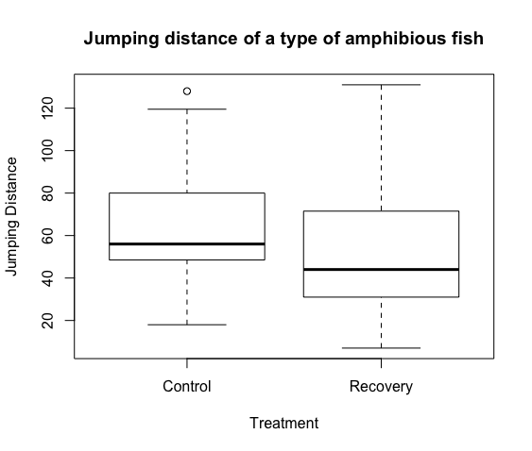
Due to this data not being explicitly taken from a normally distributed population, the t procedures are not exactly justified. For each sample, the t procedure will usually perform reasonably well due to the sample size, but for both samples, outliers do exist. For fish sampled using recovery treatment, you can see outliers near the tails, which as a result causes a slight right skewness, but if you interpret the plot ignoring the outliers then the data is approximately normal. But for fish sampled using control treatment, you can see points near the end of the line that are decently far off the line, but still following the patterns which results in a slight right skewness. Due to the outliers and skewness in the two samples, there could be problems in satisfying the assumptions.

I used a pooled-variance t procedure due to the samples coming from the same population, and therefore the variances of the two populations would be equal and using a pooled t procedure would be more beneficial.

data: fish
t = 1.1924, df = 41, p-value = 0.24
alternative hypothesis: true difference in means is not equal to 0
95 percent confidence interval:
-7.623487 29.604030
sample estimates:
mean in group Control mean in group Recovery
63.69615 52.70588

After interpretation, we have found that the measure of the strength of the evidence against the null hypothesis is 0.24, and due to this p-value being greater than the 95% significance level, we can conclude that there is not statistically significant evidence against the null hypothesis.

