FINANCING A BUSINESS VENTURE AND LEGAL ASPECTS

Table of Contents
1. Introduction and Overview of the Business Idea 3
2. Financial Viability Assessment 3
2.1 Funding Sources and Allocation 3
2.2 Revenue Model and Cost Structure 5
2.3 Three-Year Financial Plan 7
2.4 Scenario Testing and Risk Evaluation 10
3. Legal Structure and Requirements 13
3.1 Legal Structure and Justification 13
3.2 Legal and Regulatory Obligations 13
4. Financial and Legal Documentation 16
4.1 Application and Interpretation of Financial and Legal Documentation 16
4.2 Critical Evaluation of Documentation 16
5. Conclusion 18
References 19
Appendices 21

Introduction and Overview of the Business Idea
The Cake & Crumb Co. UK is a small bakery business that will focus on celebration cakes, cupcakes, and bakery boxes. Online pre-orders and local collection/delivery. The company will focus on providing customers with convenient, custom-made products to celebrate birthdays, special occasions, and everyday events. The value proposition is that it brings together the concept of made-to-order bakery products and digital ordering, allowing for the selection of products, the detailing of requirements, and the convenient fulfilment. The business needs £90,000 in start-up funding in the form of £20,000 from the founder's savings, a £30,000 start-up loan, and £40,000 from angel equity. This will be used for commercial bakery equipment, premises fit-out, initial ingredients and packaging, website development, marketing, compliance, and a working capital reserve of £20,000. The financial model forecasts revenue of £162,000 in Year 1, increasing by 25% annually to £202,500 in Year 2 and £253,125 in Year 3. This report evaluates whether the proposed venture is financially and legally viable. It compares funding, revenue, costs, profitability, cash flow, and quantified best, base, and worst-case scenarios.

Financial Viability Assessment

Funding Sources and Allocation
The Cake & Crumb Co. UK needs £90,000 in start-up funds, consisting of a mix of founder contribution and external debt and equity funds. The proposed funding structure is a combination of founder savings of £20,000, a start-up loan amount of £30,000, and angel equity of £40,000. This will cut down on the reliance on a single financing source and will show that the founder has put some of his own capital into the business (Lopes, 2025). The founder contribution also gives them an initial risk-bearing investment, and the loan adds a fixed obligation to pay back, thereby putting pressure on cash flow in the initial trading stage. Angel equity is not a repayment model, but can dilute founder ownership and control. Therefore, the equity arrangement should be clearly written, including: Share ownership; Voting rights; Rights of investors; Rights to exit; Before accepting any funds.
Table 1. Sources of Funding
Start-up use | Amount (£)
Commercial bakery equipment | 18,000
Premises fit-out | 12,000
Initial ingredients & packaging | 7,000
Licences, legal & food compliance | 4,000
Branding & launch marketing | 7,000
Working-capital reserve | 20,000
Pre-launch salaries/training | 4,000
Website & e-commerce | 8,000
Delivery & logistics setup | 8,000
POS/software/IT | 2,000
Total | 90,000

The £30,000 loan is at 8% over three years, and monthly repayments have been taken into account within the financial model. Debt becomes a relatively fixed ratio, but also a problem of financial risk, as it continues to be paid even if monthly profits aren't generated. Angel investors, on the other hand, share the risk of the business and cause a dilutive effect. Unlike other sources of financing, the cost of founder savings is zero, but they are considered to be personal capital at risk. Other sources of finance, such as further borrowing from banks or crowdfunding, were not chosen as there is a risk that further borrowing would put pressure on repayments, and crowdfunding would need a significant amount of campaigning and might not be suitable for a start-up with a local focus.
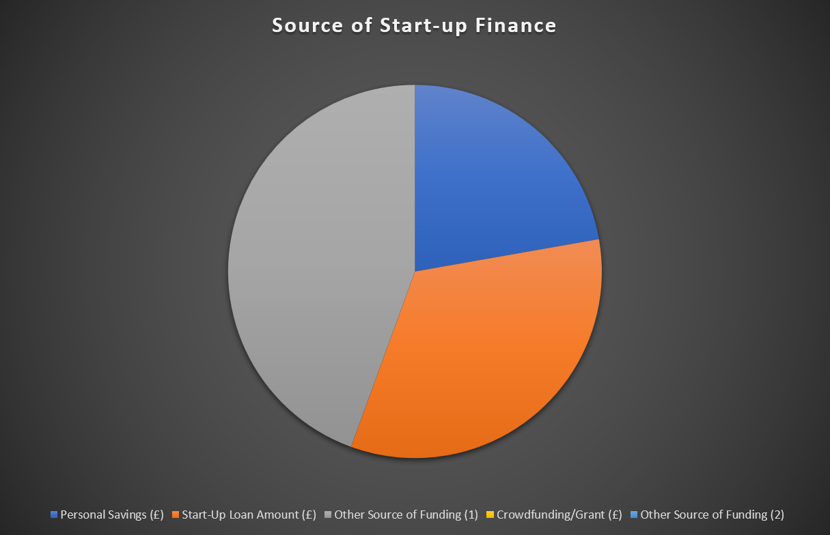
Fig. 1. Source of Start-up Finance
(Source: Generated in Excel)
The funds are committed, with £18,000 going to the commercial bakery equipment, £12,000 to premises fit-out, £7,000 to initial ingredients and packaging, £4,000 to licences, legal and food compliance, £7,000 for the branding and launch marketing, £4,000 for pre-launch salaries and training, £8,000 on the website and e-commerce system, £8,000 on delivery and logistics set-up, and £2,000 on POS, software and IT. An additional £20,000 is kept as working capital in case of trading losses in the early years and unforeseen expenditure.

Revenue Model and Cost Structure
The revenue model assumes an initial 300 orders per month and an average order value of £45. Consequently, Year 1 revenue is calculated as £45 × 300 × 12 = £162,000. It is then predicted that revenue will rise by 25% each year in Year 2 and Year 3 and is expected to be £202,500 and £253,125, respectively. This offers a consistent growth trajectory and a direct connection to the volume/pricing assumption and the three-year forecast, instead of showing unsupported revenue growth.
Table 2. Key Revenue and Cost Assumptions
Assumption | Year 1 | Year 2 | Year 3
Average price/order | £45 | £45 | £45
Average orders/month | 300 | 375 | 469
Revenue growth | — | 25% | 25%
Annual revenue | £162,000 | £202,500 | £253,125
COGS (% revenue) | 40% | 40% | 40%
Gross margin | 60% | 60% | 60%
Operating expenditure | £99,600 | £104,580 | £109,809
Opex growth | — | 5% | 5%

Variable production costs are assumed to be 40% of revenue, including ingredient costs, packaging costs, and other costs that vary with sales volume. This gives a gross margin of 60% for the period of the forecast (Li et al., 2022). The cost of goods sold (COGS) for year 1 is then £64,800, meaning that their gross profit is £97,200. In Year 3, revenue of £253,125 generates COGS of £101,250 and gross profit of £151,875.
The annualised rent is £24,000, utilities £4,800, salaries and wages £54,000, marketing is £12,000, insurance is £2,400, and other operating expenses are £2,400, making a total of annualised operating Expenditure of £99,600 for year 1. There is a 5% per annum increase in operating expenditure that is less than the revenue growth assumed, which is 25% per annum. This differential really matters to viability because it means it will be possible to deliver a growing stream of sales to a rising operating profit.
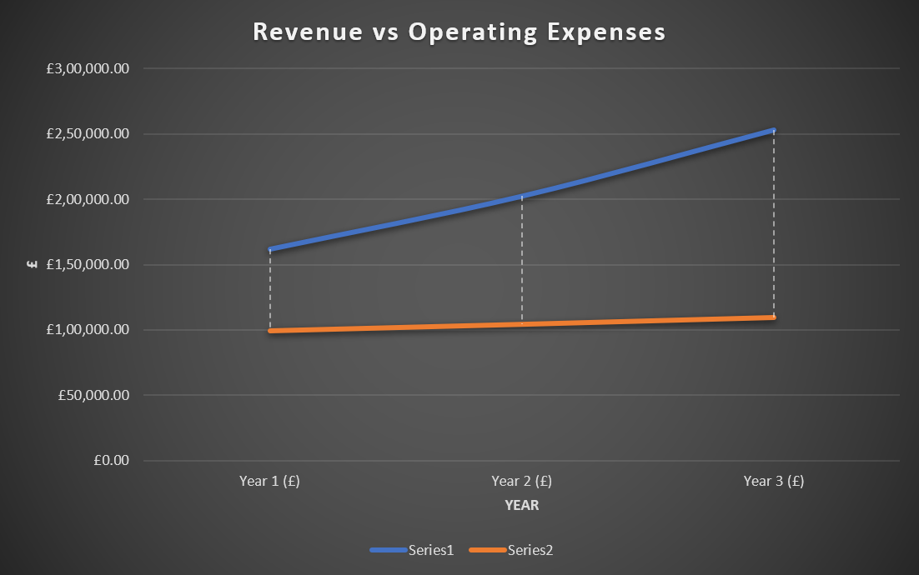
Fig. 2. Forecast revenue and operating expenditure
(Source: Generated in Excel)
There is also a quantified break-even assessment in the model. The contribution per order is £27 at an average selling price of £45 and a variable cost per order of £18. Break-even volume is around 308 orders per month or 3,689 orders per year (costs of £99,600 per annum). Break-even sales are around £166,000 per annum. The £162,000 forecasted revenue in Year 1 is just below the break-even point, which is why the forecasted loss is so relatively small, and it is also a point of concern - a critical performance point.

Three-Year Financial Plan
The three-year prediction shows that the transition from establishment to profitability will be slow and gradual. In Year 1, revenue of £162,000 produces gross profit of £97,200. EBIT is about –£2,400 after operating expenditure of £99,600. The expected loss before tax, with the loan interest of around £2067 is projected to be about £4467, no corporation tax is assumed because the model postulates a loss. This does not necessarily reflect an unviable business idea; it is just a reflection of the financial strain that has to be put on the business to open the bakery and is a strong argument for the benefit of the £20,000 working capital reserve.
In Year 2, the 25% revenue increase raises sales to £202,500, while COGS rises to £81,000. The gross profit, then, comes to £121,500. OPEX rises by 5% to £104,580, which results in EBIT of £16,920. The interest and profit before tax are about £15,618, and profit after tax is about £1,302. The modelled tax provision results in a net profit after tax of around £12,650. The fact that the movement from a Year 1 loss to a Year 2 profit shows the impact of revenue growth being greater than operating cost growth.
Table 3. Three-Year Projected Income Statement
£ | Year 1 | Year 2 | Year 3
Revenue | 162,000 | 202,500 | 253,125
COGS | (64,800) | (81,000) | (101,250)
Gross profit | 97,200 | 121,500 | 151,875
Operating expenses | (99,600) | (104,580) | (109,809)
EBIT | (2,400) | 16,920 | 42,066
Interest | (2,067) | (1,302) | (474)
Profit before tax | (4,467) | 15,618 | 41,592
Tax | — | (2,967) | (7,902)
Net profit after tax | (4,467) | 12,650 | 33,690
Net profit margin | −2.8% | 6.2% | 13.3%

This improvement is reinforced in Year 3. Revenue is worth £253,125, gross profit £151,875, and operating expenditure is around £109,809. EBIT thereby increases by about £42,066. As the outstanding balance on the loan decreases, the interest drops to approximately £474, and the profit before tax is approximately £41,592, and the net profit after tax is approximately £33,690 under the model assumptions. The net profit margin is then improved from a negative value of ~-2.8% to +6.3% in Year 2 and +13.3% in Year 3. This is a positive trend that shows that operations are becoming more efficient and profitability is improving.
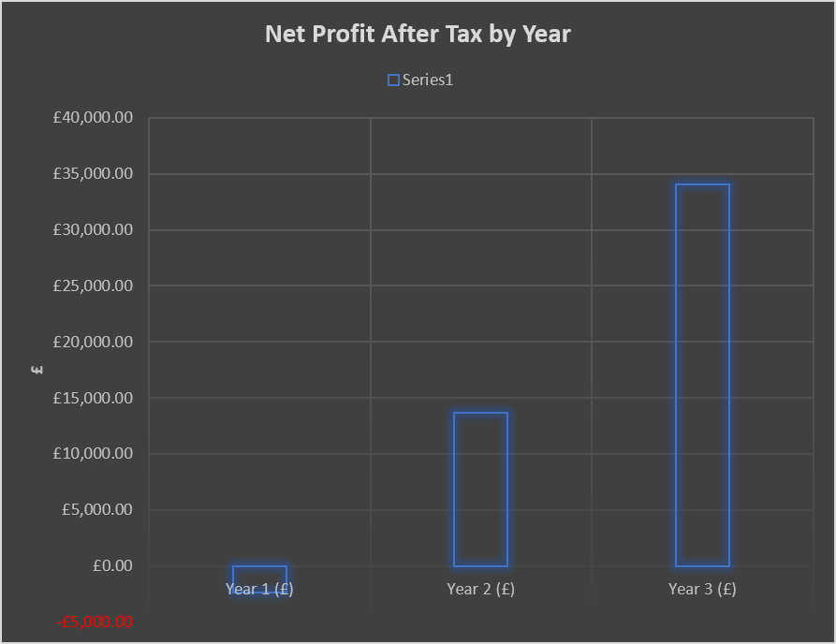
Fig. 3. Forecast net profit after tax over the three-year planning period
(Source: Generated in Excel)
Cash-flow analysis offers an investor's viewpoint, since accounting profit does not necessarily translate to cash flow. The model starts with a cash reserve of £20,000 after start-up costs, with the monthly loan repayments of c. £940 establishing a long-term funding obligation. During Year 1, Forecast cash is under pressure, due to revenue being just below break-even. However, the initial deficit is offset by the reserve. Under the baseline scenario, cash will strengthen as profitability grows until it hits around £31,873 at the end of the third year. This implies that the business can sustain itself after the start-up phase, if the income and expenditure projections are met.
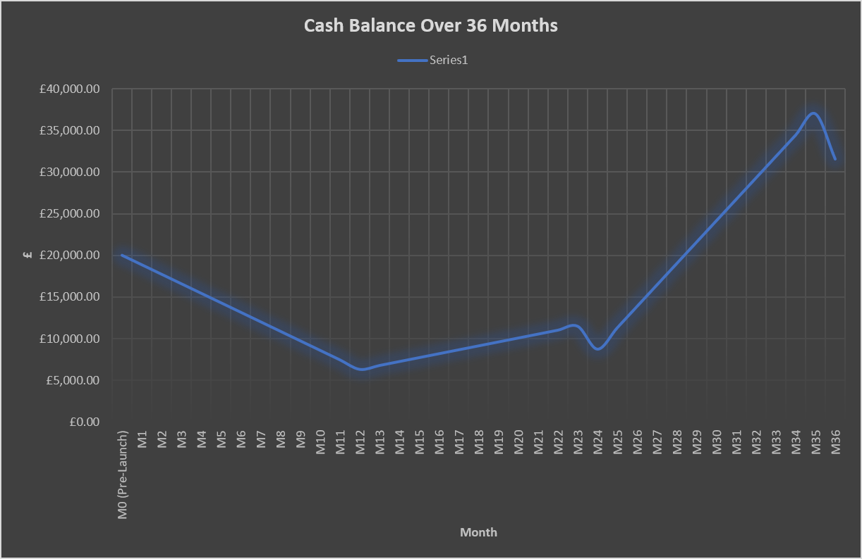
Fig. 4. Cash Balance Over 36 Months
(Source: Generated in Excel)
The model also has a simple LTV: CAC ratio of c. 4.05:1, assuming that £40 is the cost of customer acquisition and £162 is the lifetime-value proxy. This may be desirable because it has the potential to be more valuable than the cost of acquisition, but should be approached with care since it is a planning proxy and not evidence from customer cohorts.

Scenario Testing and Risk Evaluation
The purpose of scenario analysis is to determine if the investment is still worth making if the key assumptions change. The best-case scenario is based on 35% annual revenue growth, COGS of 35%, and operating-cost growth of 4%. In this case, the net profit after tax for Year 3 is about £67,803; closing cash is about £90,934, and the break-even volume drops to about 3,405 orders. This indicates that there is a lot of potential for this product to have a positive return should there be a spike in demand and a decrease in production efficiency and cost control. In the base case, revenue growth remains at 25% annually, COGS remains at 40% of revenue, and operating-cost growth is at 5%. Net profit after tax is expected to be around £33,690, closing cash is expected to be around £31,873, and break-even volume is expected to be around 3,689 orders (Table 4).
Table 4. Quantified Scenario Analysis
Indicator | Best case | Base case | Worst case
Revenue growth | 35% | 25% | 10%
COGS | 35% | 40% | 45%
Opex growth | 4% | 5% | 8%
Year 3 NPAT | £67,803 | £33,690 | −£7,158
Year 3 closing cash | £90,934 | £31,873 | −£42,264
Break-even orders | 3,405 | 3,689 | 4,024
Year 3 net margin | 23.0% | 13.3% | −3.6%
Overall implication | Strong upside | Viable base case | Liquidity risk
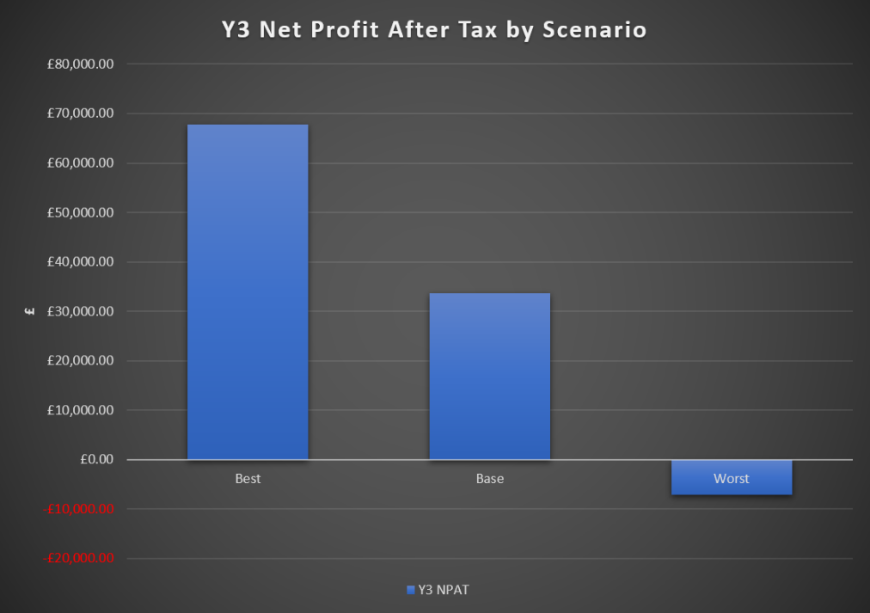
Fig. 5. Year 3 Net Profit After Tax by Scenario
(Source: Generated in Excel)
The worst-case scenario is based on the following assumptions: Annual revenue growth will be 10%, annual growth in cost of goods will be 45%, and annual growth in operating costs will be 8%. However, the net profit after tax for Year 3 is around –£7,158 and closing cash is around –£42,264; the break-even number of orders increases to around 4,024.
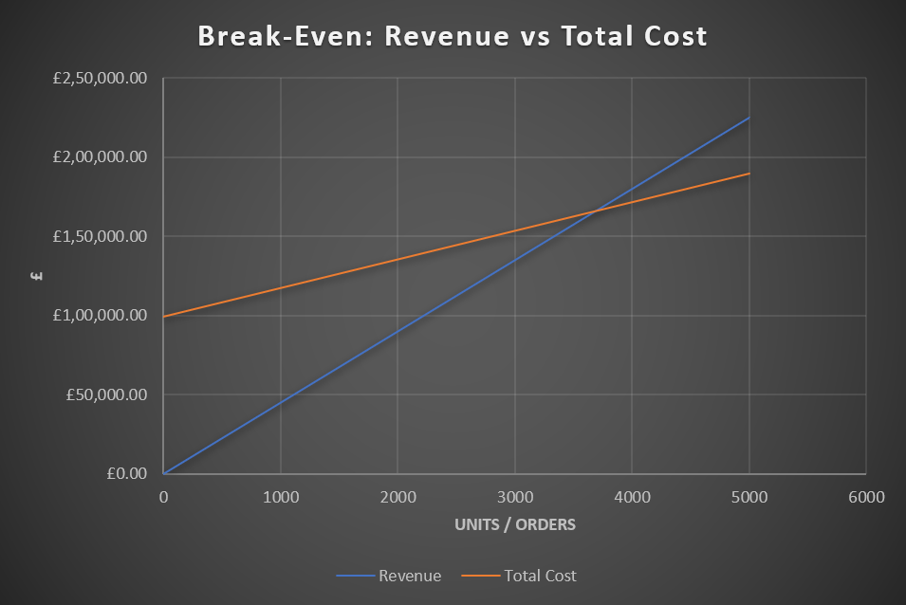
Fig. 6. Break-Even Analysis
(Source: Generated in Excel)
Fig. 6 demonstrates the break-even analysis curve. The scenarios illustrate that growth in sales and cost control are the real keys to viability, and it is important to have sufficient liquidity to ensure downside risk is not imposed on investors.

Legal Structure and Requirements

Legal Structure and Justification
The Cake & Crumb Co. UK should have its incorporated form of business be a private limited company with share capital. This is suitable as the venture needs £90,000 of funding, and it is proposed that £40,000 of this will come from angels. A limited company is a separate legal entity, which means that the assets, liabilities and contracts of the company are separate from the founder's personal assets, liabilities and contracts. It thus typically offers a limited liability framework and establishes a formal means to bring in external investments.
A sole trader structure would be simpler, but would offer less business vs personal liability separation and would not be well suited to the proposed angel investment. Shared ownership and shared governance would be added to the mix of considerations in a partnership, but would lack the simplicity of a corporate structure (Debellis et al., 2024). A private company limited by shares thus provides an appropriate balance of the protection of limited liability and the readiness for investment and future growth.
A company must be incorporated with Companies House and have directors, shareholders, people with significant control (PSC), registered office information, and company constitutional documents. There are a minimum of three members of the governance body as stipulated by UK government law, one being a director of the company legally responsible for running the company and ensuring that accounts and reports are prepared (Primec and Belak, 2022). The £40,000 angel investment should be accompanied by investment and shareholder documentation covering the ownership and voting rights, as well as investor protections.

Legal and Regulatory Obligations
The bakery has to comply with food-business, consumer, employment, data-protection, and financial requirements as a producer and seller of online and offline food. The first step is to register as a food business with the local authority before opening. Counselling from the government must be adhered to by the food business, and the operator has a responsibility for food safety. Registration and food-safety procedures will therefore be prerequisites – not optional administration.
Table 5. Key Legal and Regulatory Obligations
Legal/regulatory area | Requirement for the business | Relevance to viability
Company law | Register and maintain the private limited company; maintain statutory records and filings | Establishes legal identity and investor governance
Food-business registration | Register the bakery with the relevant local authority before trading | Required before food operations commence
Food safety | Implement appropriate food-safety procedures and staff controls | Protects customers and reduces operational/reputational risk
Allergen management | Provide required allergen information and control cross-contamination | Critical because bakery products commonly contain regulated allergens
Consumer protection | Provide clear product, price, delivery and contractual information | Reduces disputes and supports customer trust
Data protection | Protect customer personal data and provide appropriate privacy information | Essential for online ordering and delivery
Employment | Comply with employment, payroll and workplace requirements | Reduces workforce and legal risk
Tax/VAT | Maintain appropriate records and meet HMRC obligations; monitor VAT registration threshold | Protects cash flow and financial compliance
Insurance | Maintain appropriate business/employer/public liability cover as applicable | Reduces exposure to operational claims

Consumer protection is crucial because orders will be made electronically. Product descriptions, pricing, delivery procedures, cancellation terms, and contractual details are clear and transparent (Luzak et al., 2023). Use clear website terms, order confirmations and complaint procedures to minimise disagreements and enhance customer confidence, especially when ordering customised cakes.
The company will handle customers' information via its website, payment and delivery procedures. It is therefore required to meet the relevant UK data-protection requirements. For organisations, the ICO says that they are required to safeguard personal data from loss, destruction, alteration and disclosure without their consent. A privacy notice, access control, secure payment systems, data retention policies and an incident-response process should be put in place in the business. These controls are a form of responsible governance to investors.
Financial compliance is also of paramount importance. The company has to ensure that it has proper accounting and company records, and ensures that it fulfils Companies House and HMRC filing and tax requirements. VAT registration needs to be monitored as forecasted income for Year 2 of £202,500 and Year 3 of £253,125 is above the current threshold of £90,000 (assuming turnover is taxable). Corporation Tax should also be built into financial planning, and the rate of tax on profits should be applied.

Financial and Legal Documentation

Application and Interpretation of Financial and Legal Documentation
The financial and legal documents are to be used as decision-making tools for The Cake & Crumb Co. UK. The most important financial statement is the three-year model supported by the three-year cash-flow forecast, the income statement, the break-even analysis and the scenario analysis. These documents combine and convert operating assumptions into measurable outcomes. The following assumptions are made: £45 average order value (AOV), 300 orders per month in Year 1, 40% cost of goods sold (COGS), £99,600 operating expenditure in Year 1 and an annual revenue growth of 25%. These assumptions generate revenue of £162,000, £202,500 and £253,125 across Years 1–3. Forecasts can be used to determine if sales increases can meet fixed costs and financing obligations.
This analysis is complemented by the cash-flow forecast. The loss in Year 1 is expected, but the working-capital reserve of £20,000 gives a safety cushion in terms of liquidity. The monthly cash-flow information highlights times when cash-flow may be stressed by repayments, expenditure and tax payments. Rewrite the following forecast into an operational target: At £27 contribution per order and £99,600 annual fixed operating cost, about 3,689 orders need to be processed to break even, corresponding to about £166,000 of sales. This provides management with an indicator of a level of performance.
Incorporation records, articles of association, shareholder and investment documentation, loan documentation, food business registration, food safety and allergen procedures, employment paperwork, insurance documents, website terms, and privacy documents, and tax and accounting records should be included in legal documentation. These documents lay out responsibilities and evidence compliance. The financial model does not determine the percentage stake of the investor in the proposed £40,000 angel investment, and this should be addressed by written terms that outline ownership, voting rights, and investor protections.

Critical Evaluation of Documentation
The financial model's credibility is based on the underlying assumptions and actual performance versus predicted performance. The model is a valuable tool because revenue, costs, profitability, cash flow, break-even, and scenarios are all interrelated (Hossen, 2026). Forecasts are still only projections, though. The 25% revenue increase per year is the best estimate for a new bakery and should be proven by the actual volumes of orders, average transaction value, repeat purchases, and marketing performance. The 40% COGS assumption should be evaluated with regard to actual ingredients, packaging, and wastage. A spreadsheet can give a false sense of security without variance analysis.
Scenario analysis tests revenue growth and cost changes and makes decisions more useful. The best case results in an NPAT of around £67,803 in year 3 and a negative closing cash of around £42,264 in the worst case. This is a good illustration of the concern about the downside of liquidity. Where the prices or the contribution margin are below plan, management should define trigger points for corrective action such as considering the price, reducing discretionary marketing and renegotiating the supplier price, or requiring additional funds.
There should be regular reconciliation of cash-flow records with bank statements, sales records, supplier invoices, payroll records and tax liabilities. Limited companies are required to keep sufficient accounting records detailing transactions, assets and liabilities as part of financial control and to facilitate tax reporting, according to GOV.UK (Stewart and Connolly, 2024). The business should keep its own business banking and accounting records, and separate from personal records.
There is a governance role for legal documentation. There are indications of ownership and control from the Companies House Register, shareholder registers and investment agreements. Food-safety and allergen records are used to show compliance and mitigate consumer and reputational risk. Online terms are used to explain commercial arrangements, and a privacy notice is used to explain how customer information is being processed (Lagioia et al., 2022). ICO guidelines suggest that companies involved in handling personal information disclose their privacy information and implement appropriate security measures for personal information. These documents thus increase customer confidence and guarantee legal compliance.
The business should put in place a review program for financial assumptions, supplier prices, food-safety procedures, insurance, customer terms, privacy information, and statutory filings (Bovay, 2023). Financial documents should be changed on a monthly basis, and legal/compliance documents are to be reviewed when the business changes product, delivery, technology, or staffing. This provides an audit trail of data and enables investors to identify forecasts from actual results.

Conclusion
Based on the financial and legal assessment, The Cake & Crumb Co. UK is potentially viable to operate, but needs to achieve adequate sales growth with a sustained contribution margin and liquidity. Founder savings, a start-up loan and proposed angel equity make up the £90,000 funding requirement, and the proposed working-capital reserve of £20,000 will safeguard against potential trading losses in the early stages. The three year forecast suggests that the business will be profitable in Years 2 and 3 after a loss in Year 1, with a base case profit of about £33,690 in Year 3 after tax. However, scenario testing reveals that material downside exposures exist, especially if sales growth is not as strong and expenses are increased, as negative cash flow may necessitate further financing. A private limited company, within a properly managed framework of statutory, food-safety, consumer, employment, data-protection and taxation requirements, is an appropriate structure for investment and limited liability.

References
Bovay, J., 2023. Food safety, reputation, and regulation. Applied Economic Perspectives and Policy, 45(2), pp.684-704. https://onlinelibrary.wiley.com/doi/abs/10.1002/aepp.13315
Debellis, F., Rondi, E., Buckley, P.J. and De Massis, A., 2024. Family firms and the governance of global value chains. Journal of International Business Studies, 55(8), pp.962-975. https://link.springer.com/article/10.1057/s41267-024-00716-4
Hossen, M.M., 2026. Financial Planning to set up a new Restaurant (Café) and Break-Even Analysis. https://www.theseus.fi/handle/10024/929868
Lagioia, F., Jabłonowska, A., Liepina, R. and Drazewski, K., 2022. AI in Search of Unfairness in Consumer Contracts: The Terms of Service Landscape: F. Lagioia et al. Journal of Consumer Policy, 45(3), pp.481-536. https://link.springer.com/article/10.1007/s10603-022-09520-9
Li, H.C. and Liang, J.K., 2022. Service pricing strategy of food delivery platform operators: A demand-supply interaction model. Research in Transportation Business & Management, 45, p.100904. https://www.sciencedirect.com/science/article/pii/S2210539522001250?casa_token=ayAj5ETJW3EAAAAA:NPuqu3CyW12RlFXGdJqW_rsFEJZ6Oo9Sxs9aF81sxhIeWvEH2LMljDaGtgoObgR7v_q8Os8mBHQ
Lopes, S.A., 2025. Funding Approaches. In Innovation in Nephrology (pp. 209-218). Academic Press. https://www.sciencedirect.com/science/chapter/edited-volume/pii/B9780323956802000168
Luzak, J., Wulf, A.J., Seizov, O., Loos, M.B.M. and Junuzović, M., 2023. ABC of Online Consumer Disclosure Duties: Improving Transparency and Legal Certainty in Europe: J. Luzak et al. Journal of Consumer Policy, 46(3), pp.307-333. https://link.springer.com/article/10.1007/s10603-023-09543-w
Primec, A. and Belak, J., 2022. Sustainable CSR: Legal and managerial demands of the new EU legislation (CSRD) for the future corporate governance practices. Sustainability, 14(24), p.16648. https://www.mdpi.com/2071-1050/14/24/16648
Stewart, E. and Connolly, C., 2024, April. UK public sector fiscal reporting: clear and contradictory. In Accounting Forum (Vol. 48, No. 2, pp. 331-355). Routledge. https://www.tandfonline.com/doi/abs/10.1080/01559982.2022.2133339

Appendices

